Introduction to data profiling and modelling with Altair Analytics Workbench

Contents

Chapter 1: Course introduction 1

Introduction 1

Chapter 2: Introduction to Altair Analytics Workbench 2

Introduction 2

What is Altair Analytics Workbench 2

Two Perspectives 3

SAS Language perspective 3

Workflow perspective 5

Common perspective elements 7

Preferences 8

Help 9

Interactive Questions 11

Demonstration 13

Interactive Questions 16

Coding in the SAS Language perspective 19

Interactive Questions 29

Interactive Questions 45

Workflow options and making connections 47

Interactive Questions 54

Summary 57

Exercises 58

Chapter 3: Data acquisition 63

Introduction 63

Fundamental 63

The Import group 63

Excel Import block 64

Text file Import block 65

Interactive Questions 67

Database Import block 69

Database references 71

Settings tab 72

Interactive Questions 73

Demonstration 75

Excel Import 75

Text File Import 76

Interactive Questions 77

Database Import block 79

Settings tab 82

Interactive Questions 84

Summary 85

Chapter 4: Data exploration and profiling 86

Introduction 86

Interactive Questions 89

Demonstration 92

Interactive Questions 97

The Data Profiler 98

Interactive Questions 105

The Chart Builder 107

Interactive Questions 112

Using the SAS Language perspective to profile data 114

Interactive Questions 120

Accessing Workflow code 122

Summary 124

Exercises – Interactive 125

Chapter 5: Data preparation and manipulation 131

Introduction 131

Interactive Questions 134

Demonstration 136

Merge block 138

Interactive Questions 140

Aggregate block 142

Join block 145

Interactive Questions 147

Binning variables with the Binning block 149

The Mutate block 156

Interactive Questions 158

Summary 160

Exercises – Interactive 161

Chapter 6: Modelling with Altair Analytics Workbench 165

Introduction 165

Interactive Questions 168

Regression / Scorecards 169

Decision tree 170

Neural networks 171

Ensemble methods 171

Interactive Questions 172

Clustering / PCA 174

Association rules 175

Technology and data 176

Interactive Questions 179

Summary 181

Chapter 7: Introduction to decision trees 182

Introduction 182

Decision tree algorithms 183

Decision tree mechanism 184

Interactive Questions 188

Demonstration 190

Interactive Questions 196

Interactive Questions 202

Interactive Questions 208

Summary 210

Exercises - Interactive 211

Chapter 8: Improving the model 215

Introduction 215

Interactive Questions 218

Summary 220

This lesson focused on model improvement, included an introduction and highlighted aspects that 220

Chapter 9: Evaluating and validating a decision tree model 221

Introduction 221

Interactive Questions 225

Interactive Questions 234

Demonstration 236

Interactive Questions 241

Interactive Questions 250

Summary 251

Exercises – Interactive 252

Chapter 10: Challenging the model 255

Introduction 255

Interactive Questions 257

Demonstration 263

Interactive Questions 268

Interactive Questions 273

Summary 275

Exercises - Interactive 276

Chapter 11: Model deployment 279

Introduction 279

Demonstration 281

Adding Outcomes 281

Deploying programs as APIs using Altair SmartWorks Analytics Hub 282

Interactive Questions 285

Summary 287

Exercises - Interactive 288

Chapter 12: Exporting data 291

Introduction 291

The Export group 292

Interactive Questions 296

Demonstration 298

Interactive Questions 302

Exporting to a Text File 303

Exporting to a Microsoft Excel File 303

Exporting to a ALTAIR Dataset 305

Exporting to Tableau 305

Interactive Questions 307

Summary 309

Chapter 9: Course summary 310

Introduction 310

# Chapter 1: Course introduction

## Introduction

Welcome to the course: Introduction to data profiling and modelling with Altair Analytics Workbench. This course comprises a set of interactive modules illustrating the application and use of Altair Analytics Workbench to process data.

As a result of completing this course attendees should be able to use Altair Analytics Workbench to connect, acquire, profile, prepare, manipulate, model, deploy and export data and results.

Course modules are laid out in a progressive manner and the course begins in earnest with an introduction to Altair Analytics Workbench.

* Course introduction!
* Introduction to Altair Analytics Workbench (+ Exercises)
* Data acquisition
* Data exploration and profiling (+ Exercises)
* Data preparation and manipulation (+ Exercises)
* Modelling with Altair Analytics Workbench
* Introduction to decision trees (+ Exercises)
* Improving a decision tree model
* Evaluating and validating a decision tree model (+ Exercises)
* Challenging the model (+ Exercises)
* Model deployment (+ Exercises)
* Exporting data
* Conclusion

Subsequent chapters outline and illustrate Altair Analytics Workbench capabilities for data acquisition, data exploration and profiling, data preparation and manipulation and available modelling capabilities.

Decision trees are introduced and the process of building a decision tree model is demonstrated in the lesson: Introduction to decision trees. Additional lessons focus on aspects associated with improving and evaluating and validating a decision tree model.

The lesson: Challenging the model compares the decision tree to other modelling techniques and ways to deploy model code using Altair Analytics Workbench are outlined in the lesson: Model deployment. A final lesson focuses on exporting results.

All lessons are interactive and must be viewed in sequence such that subsequent lessons become available once previous lessons are complete. Note that some lessons have associated exercises. Click any lesson to open and press play to begin.

Data used throughout the course and for exercises is available from the files section, *data.zip* contains all data, output and projects referenced throughout lessons and it is advised to unzip this to a known and accessible location.

# Chapter 2: Introduction to Altair Analytics Workbench

## Introduction

Contents for this lesson include an introduction, a look at Altair Analytics Workbench, the SAS language and workflow perspectives and common elements. We'll then speak about preferences and help options prior to getting onto to a demonstration and then returning to slides to highlight important points before wrapping up with a summary.

* Introduction
* Two perspectives
* SAS Language
* Workflow
* Common perspective elements
* Preferences
* Help
* Demonstration
* Things to remember

## What is Altair Analytics Workbench

So what is Altair Analytics Workbench? its a data processing tool designed to work with and for SAS programmers but also incorporates the capability to code in SQL, R and Python. The ability to create processing chains using drag and drop functionality is also available via Workflow.

Figure 1: Altair Analytics Workbench

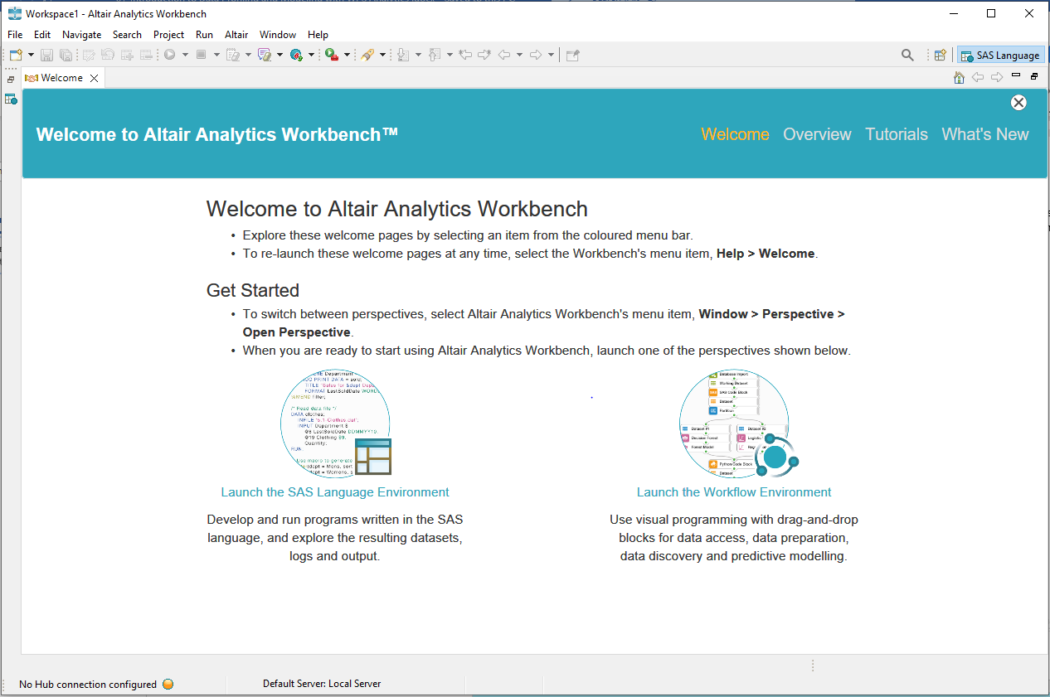

Altair Analytics Workbench is a customized eclipse environment. As a result of this some features such as menus and options are not used.

## Two Perspectives

Altair Analytics Workbench comprises two perspectives: the SAS Language perspective and the Workflow perspective.

The SAS Language perspective provides a fully equipped integrated developer environment for coding in the languages of SAS, R, Python and SQL and the Workflow perspective enables visual programming via drag and drop functionality with point and click wizards to configure.

Figure 2: SAS Language and Workflow Perspectives

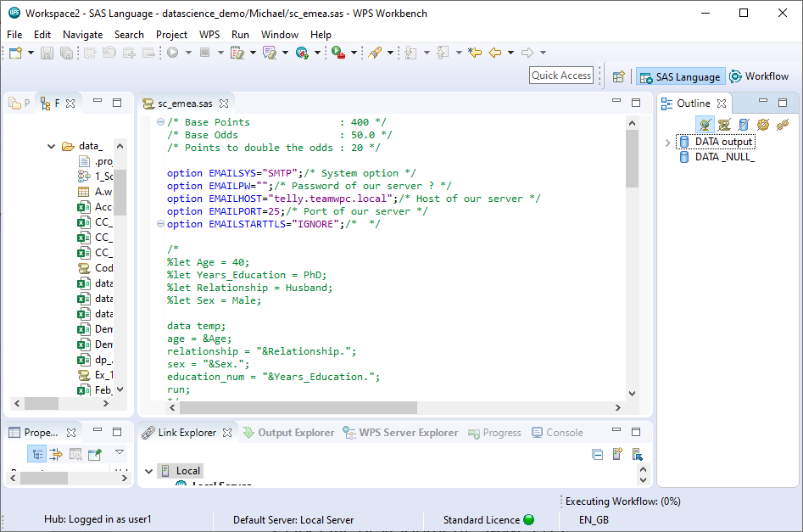

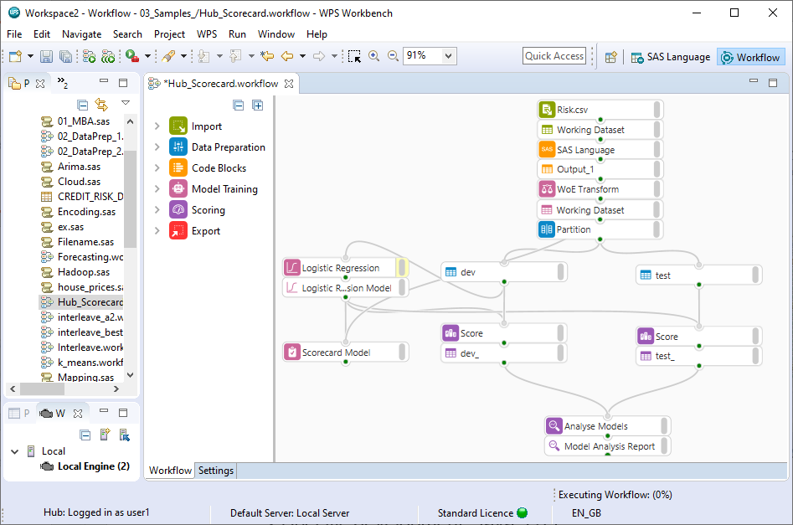

## SAS Language perspective

As stated, the SAS language perspective provides the ability to code in the languages of SAS, Python, R and SQL. Code assistance features are available including drag and drop options for filenames and variables, as well as providing a log for error tracking, verbose code and computation time.

Figure 3: SAS Language perspective



Output is sent to the Output Explorer and all session data is processed in a temporary location called the Work folder. The Work folder is destroyed when the program is closed and is an important aspect to bear in mind when using the SAS Language perspective. The location of the work folder can be viewed and set from Window > Preferences.

Figure 4: Window ... Preferences

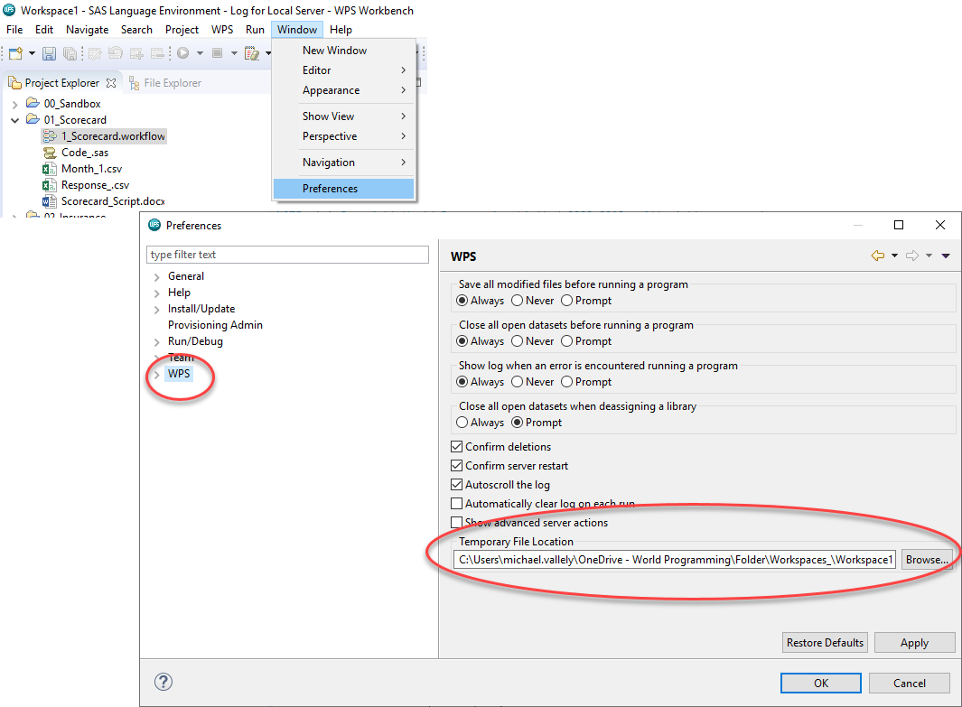

The SAS Language perspective also uses servers to process code and many servers can be configured.

## Workflow perspective

The Workflow perspective provides the ability to design processing chains using drag and drop and point and click functionality via blocks which are stored in groups, for example the Import group contains import blocks.

Figure 5: Workflow perspective

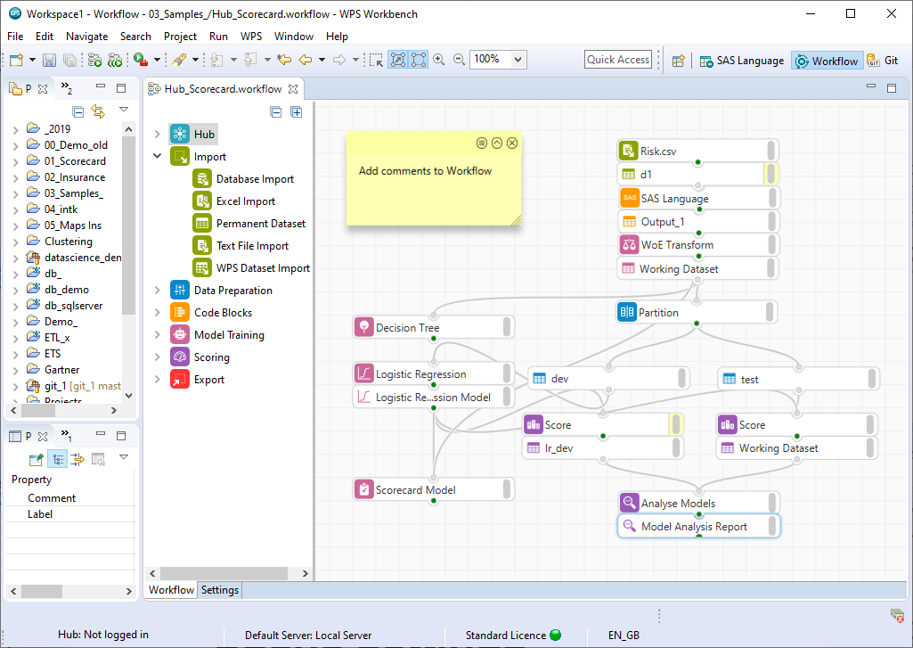

Once dragged from a group and placed on the Workflow, right-click any block for options. Options may differ depending on the type of block selected.

For example, right-clicking a model block includes options to configure, run, edit functions are available and the ability to include comments is also present.

Right-clicking a block that generates output, such as an import block provides options to configure the block and its outputs, access the block log, edit and add comments.

The dataset block includes options to open, save, run, rename, show/hide observation count and add comments.

Figure 6: Right-click block options

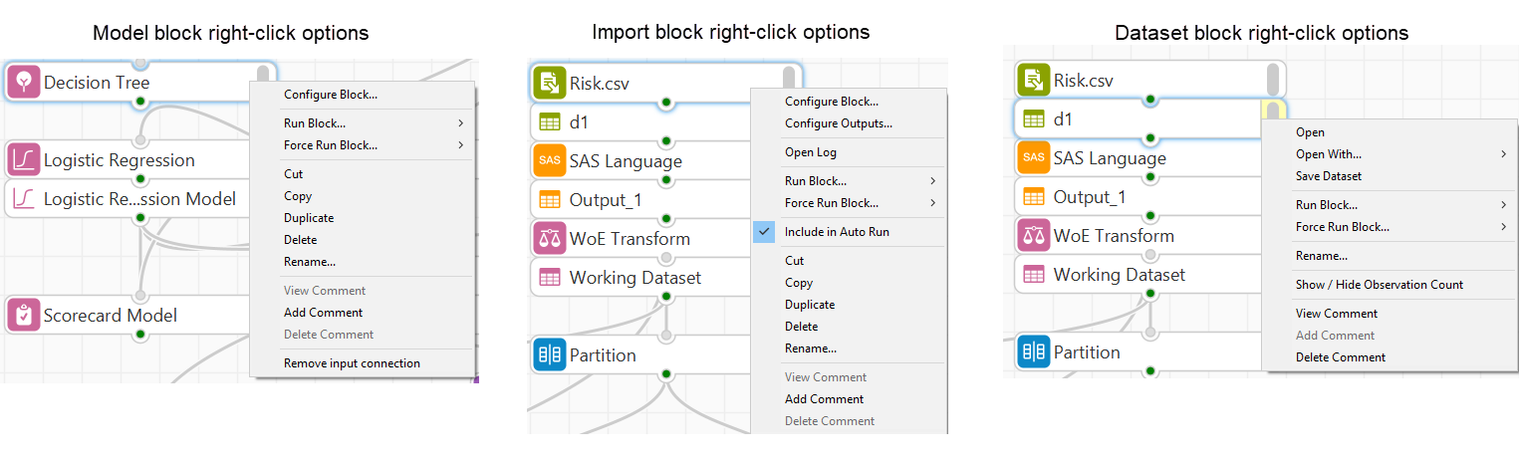

Options are also available when the canvas is right-clicked. Right-clicking the Workflow canvas provides options to run the Workflow and export the entirety of a Workflow to a SAS language program.

There is an option to show observations counts for all Workflow datasets, comments can be added and the Workflow located in Project Explorer, System Explorer or the Properties view.

Figure 7: Block and Workflow right-click options

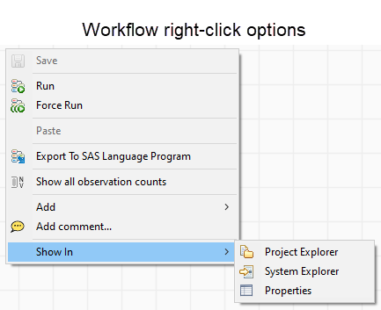

The Workflow perspective does not include a Work folder. It retains the Workflow for a set period in a cache, the cache location and time to retain can be changed by modifying cache options from Window > Preferences > ALTAIR > Workflow.

Figure 8: Workflow cache options

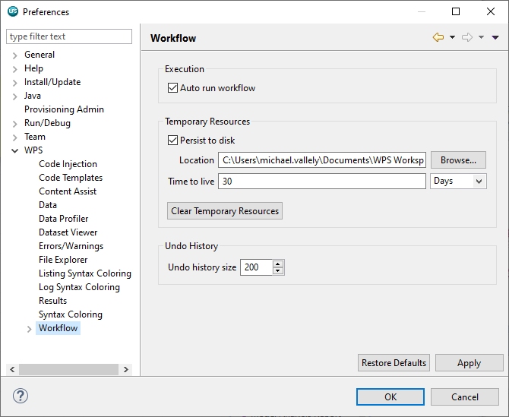

## Common perspective elements

There are many windows and views available in the Workbench and theses can be accessed and opened from within a perspective from Window > Show View.

Figure 9: Accessing views

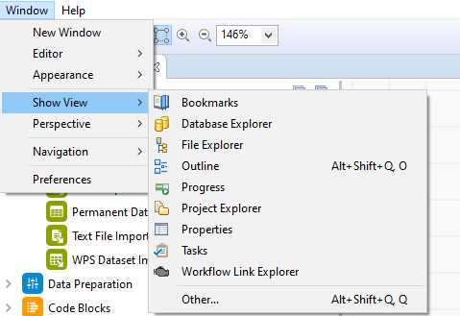

There are some common elements and windows evident across perspectives. Menus are evident with many options, the most used include File, Project and Window.

The File Explorer and Project Explorer provide the ability to navigate a file system and create and manage projects respectively and the facility to navigate perspectives is available by clicking the appropriate icon in the top right-hand corner.

Figure 10: Navigate perspectives

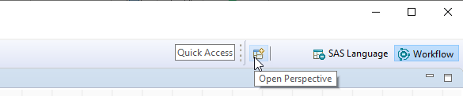

Another common element that is not explicit is a Workspace. Regardless of the perspective chosen to operate within this is a required aspect and is chosen at start up. A workspace is a location, any location, that stores session settings and many Workspaces can exist.

Figure 11:Setting a Workspace at start-up

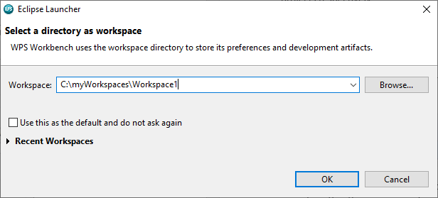

## Preferences

The menu item Window > Preferences provides the facility to set everything! There are a lot of options and as stated previously, some Eclipse features are not used and these include:

* Help,
* Install/update
* Provisioning Admin
* Run/Debug
* Team

Figure 12: Window .... Preferences

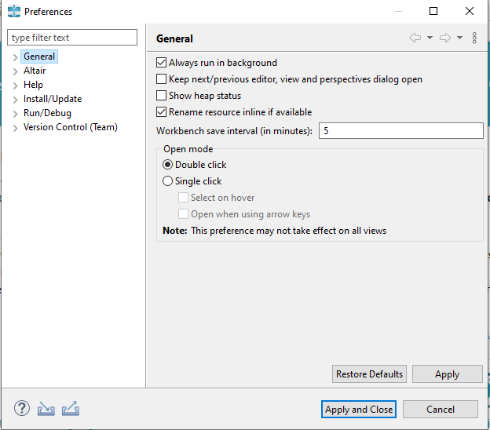

Useful preferences are contained in the General and ALTAIR options. General provides options to specify Workbench and interface settings and ALTAIR provides SAS Language and Workflow perspective options.

## Help

The Help menu contains help options. Options available include the Welcome screen that pops

up when the program is first run to in-depth help files, contextual help, tips and tricks and cheats sheets.

Figure 13: Help options

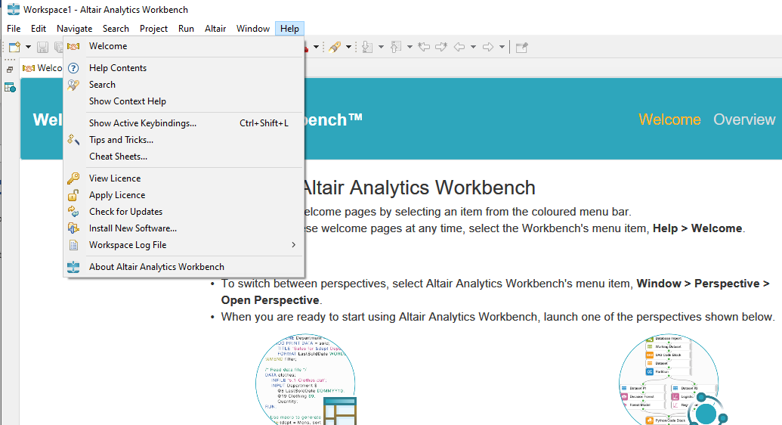

The help menu also contains license and product information and a shortcut to keyboard shortcut settings via the option: Show Active Keybindings…

## Interactive Questions

Q1:

Altair Analytics Workbench is based on an open source Eclipse platform?: **t**/f

A:

The Altair Analytics Workbench user interface is based on an open-source Eclipse platform.

Q2:

Altair Analytics Workbench provides the ability to program in the language of SAS only. t/**f**

A:

Altair Analytics Workbench provides the ability to program in the languages of SAS, Python, R and SQL.

Q3:

Altair Analytics Workbench includes an IDE. **t**/f

A:

Altair Analytics Workbench includes an IDE via the SAS Language perspective.

Q4:

The Altair Analytics Workbench SAS Language perspective writes the following to its log:

Errors

Computation time

Verbose code

**Errors, computation time and verbose code**

A:

The Altair Analytics Workbench SAS Language perspective writes errors, computation time and verbose code to the Log.

Q5:

Match the following items with the appropriate perspective icon.

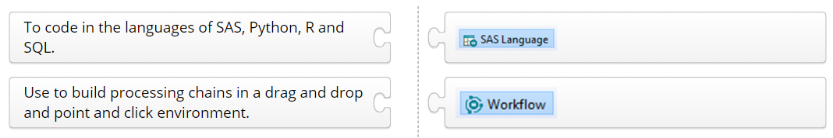

Q6: Select all correct statements:

**The Workflow perspective is drag and drop.**

**Comments can be added to any Workflow block(s).**

Python and R code cannot be included in a Workflow.

**Comment(s) can be added to a Workflow.**

A:

The Workflow perspective is drag and drop, comments can be added to any workflow block(s) and to any Workflow. Additionally, Python and R code CAN be included in a Workflow.

Q7: Drag the words to complete the sentence correctly.

__________________ information is available from the Help menu.

**Licence and version**

Project and Workflow

License and Workflow

Project

Workflow

A:

License and version information is available from the Help menu.

## Demonstration

So let's get on with a demonstration. The first thing to do is start the program, on first start a Workspace must be set and this can be any folder with any name in any location. The Workspace stores all sessions settings and bear in mind that multiple workspaces can exist.

Figure 14: Setting a Workspace

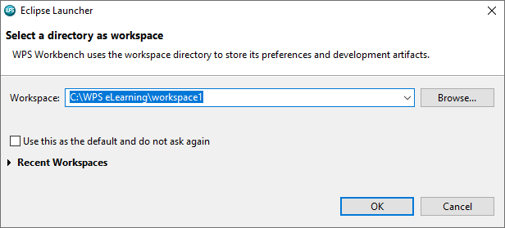

When setting the Workspace always point to a known and accessible location, here the Workspace is set to a folder called *workbenchworkspace*  in a folder called *ALTAIR eLearning* in the local *c\:drive.*  The program opens at the welcome screen which is split into three sections.

Figure 15: Welcome

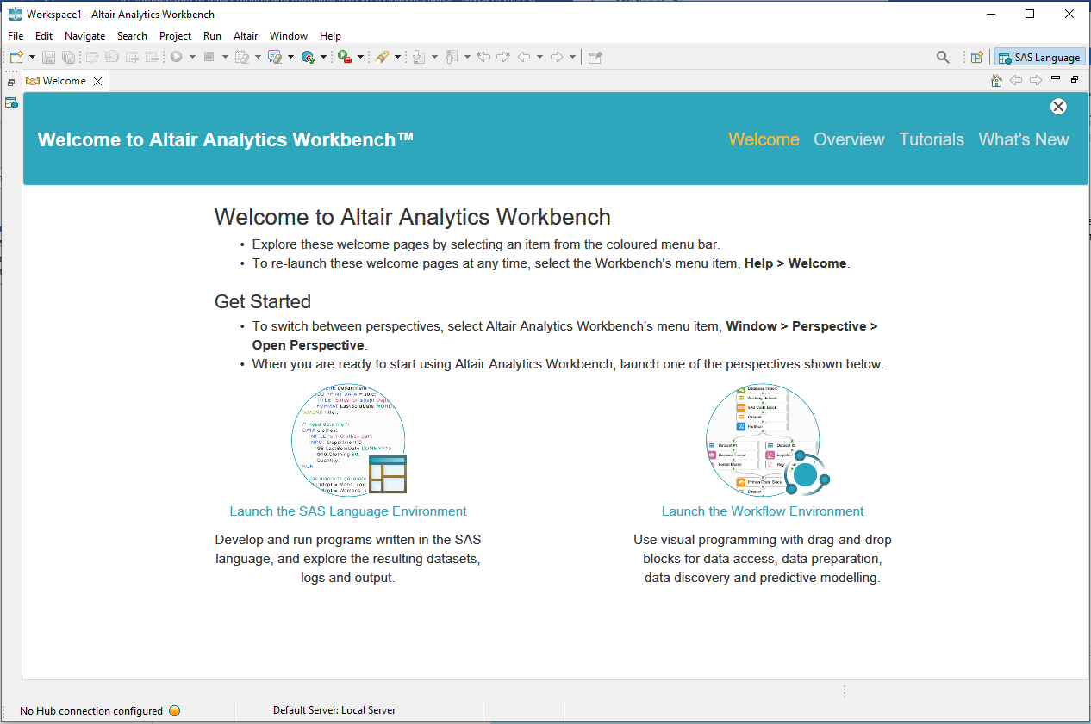

Help options are available from the menu bar including links to an Overview, Tutorials and What’s New.

The steps to return to the welcome screen via help menu option are relayed in the central section along with Information on how to switch between perspectives with quick launch links to open either the SAS Language perspective or the Workflow perspective.

Rather than choose one of the options to launch either the SAS Language or Workflow perspective, the Welcome screen is closed, and the SAS Language perspective is visible.

Figure 16: SAS Language perspective

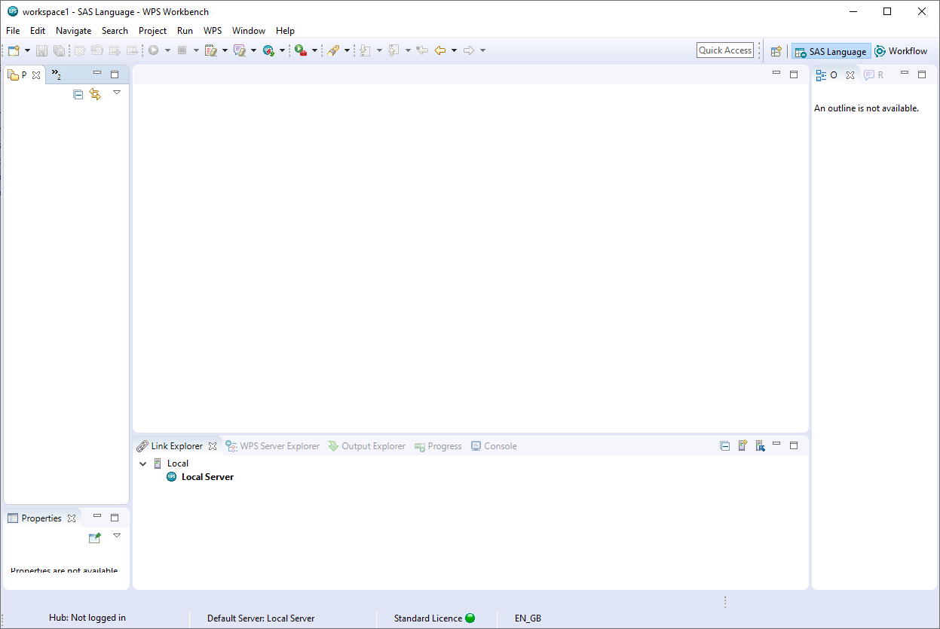

As has been stated the Workbench comprises two perspectives, the SAS Language perspective and the Workflow perspective. Each perspective comprises a set of views that can be moved, docked, closed and configured to suit needs.

The menu system and some views such as the Project Explorer, File Explorer, Database Explorer and Properties view are visible by default across both perspectives.

Some views are perspective specific. For example, the Link Explorer , the outline and

Results explorer views are specific to the SAS Language perspective. Although they can be open in the Workflow perspective, are redundant to it.

The menu system provides familiar options accessible across perspectives and the taskbar provides shortcuts for commonly used menu options, hover for tool tip.

Figure 17: File menu options

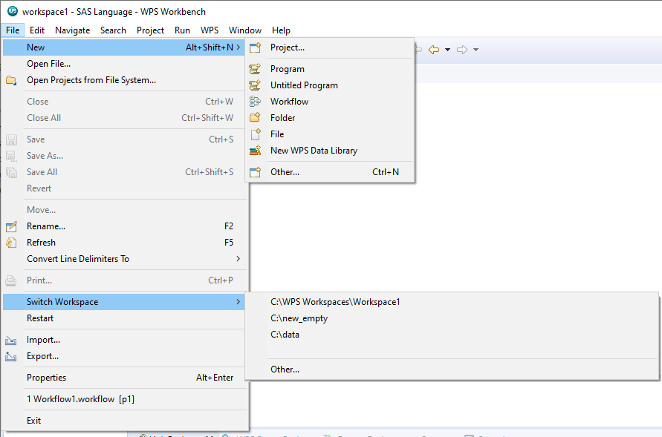

**The File menu** provides options to create new projects, programs, Workflows, folders, files and libraries or open already existing ones.

Notice also the option to Switch Workspace to either a previously existing one or a new one via Other…

**The Edit menu** in general contains generic edit options.

**The Navigate, and Search menus** provide the facility to locate and navigate resources and other artifacts displayed in the Workbench.

**The Project menu** provides project options including access to selected project properties.

**The Run** menu enables configuration of third-party tools that can integrate with the Eclipse environment.

**The ALTAIR menu** provides the ability to login to Altair SmartWorks Analytics Hub; a web-based facility which includes user and data access governance with program deployment capabilities. This menu also includes run, log and server and link options.

Figure 18: ALTAIR menu

**The window menu** provides options to split the screen, show views and switch perspectives as well as providing access to system Preferences, more on this later.

Figure 19: Window menu

## Interactive Questions

Q1:

A Workspace is a pre-requisite when using Altair Analytics Workbench and can be any location. **t**/f

A:

A Workspace is a pre-requisite when using Altair Analytics Workbench and can be any location. A Workspace can be set at start-up and/or can be changed from File ... Switch Workspace.

Q2:

Multiple Workspaces cannot exist. t/**f**

A:

Multiple Workspaces can exist and it is possible to change the Workspace or create a new one from within the program from: File ... Switch Workspace.

Q3:

The default perspective opened is the Workflow perspective. t/**f**

A:  
The perspective to open can be selected when Altair Analytics Workbench starts for the first time. Note that the SAS Language perspective is visible if the Welcome screen is closed.

Q4:

Select the incorrect statement:

Views can be moved.

Views can be docked, closed and configured to suit needs.

If closed, a view can be opened.

**Views can be renamed.**

A:

You chose the correct response. Views cannot be renamed.

Q5:

All views are relevant across all Altair Analytics Workbench perspectives. t/**f**

A:

You chose the correct response. Some views are specific to some perspectives.

Q6:

Drag the words to complete the sentence correctly.

The _________ view is relevant and specific to the SAS Language perspective only.

Link Explorer Database Explorer Workflow Link Explorer

A:

The Link Explorer view is relevant and specific to the SAS Language perspective only.

A considerable number of options available from the menus are available by right-clicking a view. For example, a new project can be created from the File > New menu option or by right-clicking the Project Pane and selecting the same option.

Figure 20: Right-click Project Explorer options

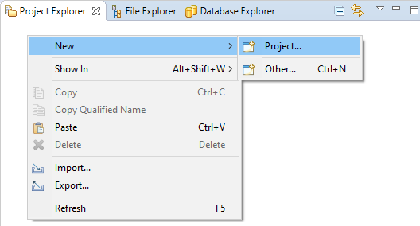

Prior to starting any endeavour, its best to create a project to store everything. Here, this is accomplished by right-clicking the Project Explorer view and selecting New > Project…

This opens the New Project wizard. There is more than one project type to select from. Here, General is expanded and Project selected. This is the appropriate option for most projects. Next is clicked and an appropriate name is assigned, here, *eLearning*.

Figure 21: New Project wizard

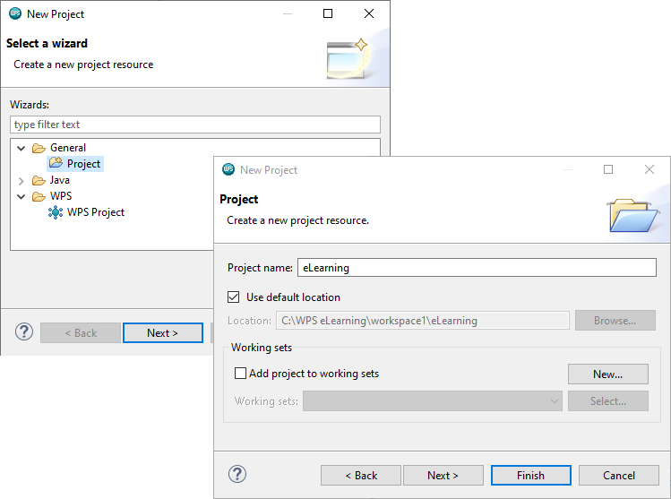

The project is stored by default in the Workspace selected at start up unless otherwise specified. Clicking Finish creates the project and it appears as a folder in the Project Explorer.

Figure 22: New project folder in Project Explorer view

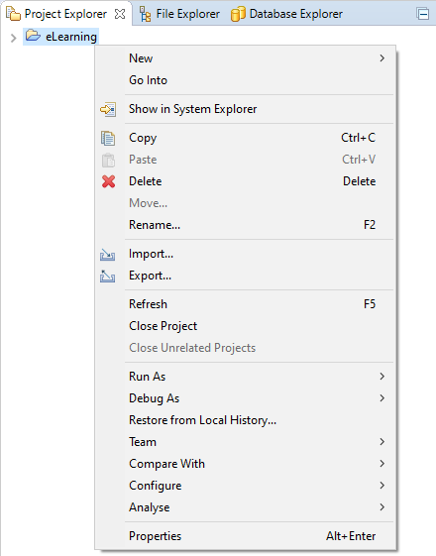

Note the host of additional options available by right clicking the project folder. Show in System Explorer opens the Project in an explorer window which is a very handy option.

Edit functions are also present as well the ability to import/export, compare with previous versions and access project properties. Note that properties are available from multiple locations.

Selecting any Workspace object displays its properties in the Properties view, selecting the project displays its properties, including its name and path.

Figure 23: Properties view

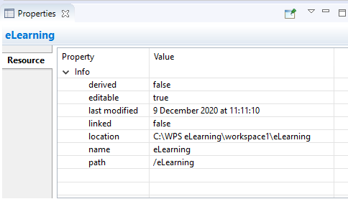

## Coding in the SAS Language perspective

To begin coding a new program file must be added. To add a new program: the project folder is right-clicked and New > Program selected. A name is assigned, here *introAltair.sas.* Finish is clicked and the file appears in the project folder and opens in the code view.

Figure 24:New program creation

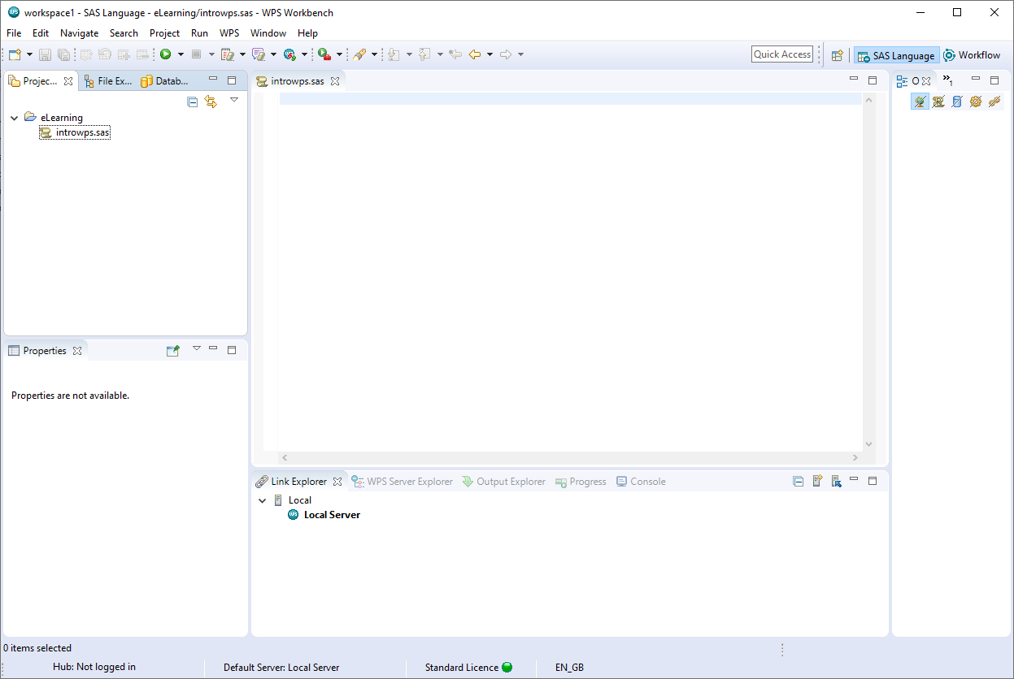

Code can be manually entered and run using this view but here some code will be copied from a file located using the File Explorer view.

The File Explorer can be used to navigate a file system and select and open files. For example, clicking a known file format opens the file in a new pane, selecting a proprietary file format, for example, a Microsoft Excel file will open in Microsoft Excel.

Here a code file *test.sas*, located in the eLearning data folder is selected and opened, the code file could be saved to the project folder, but here the code is copied and pasted to the file created earlier. All other files are closed.

Figure 25: Code pasted from test.sas

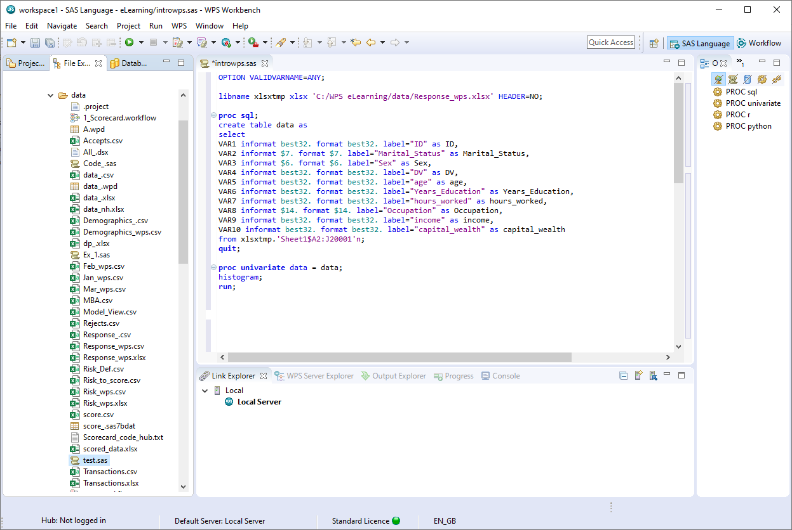

The code reads the file *response.xlsx* from the eLearning data directory and runs some analysis on its contents. In order to run a program written in the language of SAS, Altair Analytics Workbench requires a connection to an ALTAIR server.

The term server here is used to refer to a server process. The process may be running on the local workstation machine - a local host connection, or on an installation of ALTAIR on a remote machine - a remote host connection.

Servers running under the local connection are termed local servers and servers running under a remote connection are termed remote servers.

With a full workstation installation of ALTAIR there will be a single host connection called Local and a server called Local Server. This server will be started by default when Altair Analytics Workbench is started.

Figure 26: Local Server

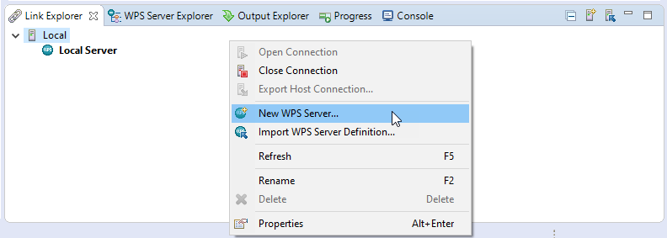

Additional local servers can be configured by right-clicking Local from within the Link Explorer view and choosing the option New ALTAIR Server, this will create a new local connection.

A remote server connection, which is used to configure a thin client to a server, can be added from the ALTAIR menu by selecting Link and then New Remote Host connection. Server details will need to be supplied to create the connection.

Figure 27: New Remote Host Connection...

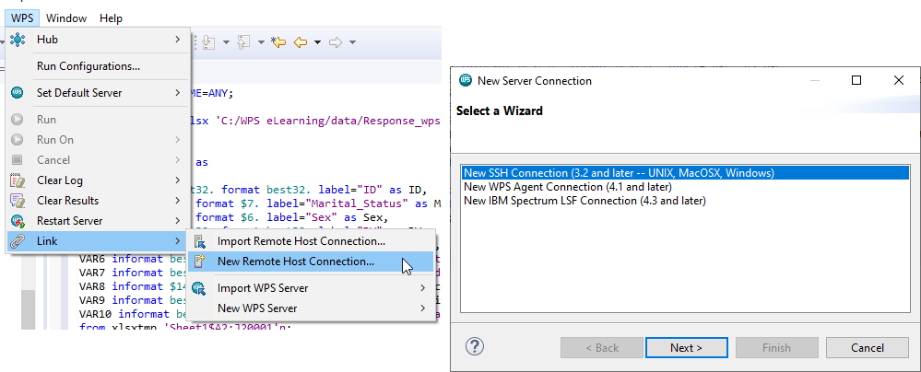

Regardless of whether a local or remote connection is evident, the Workbench functionality, look and feel remain the same.

The Link Explorer tab displays all hosts and servers connected to those hosts. Here this is only one - on the local machine and this will process all code, right click for options including properties.

Figure 28: Local Server options

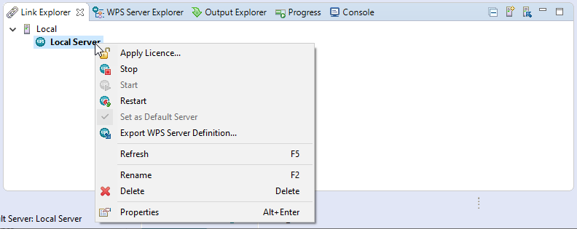

The ALTAIR Server Explorer view is simply that: a view of the contents of connected servers, in this instance the local server.

Figure 29: ALTAIR Server Explorer

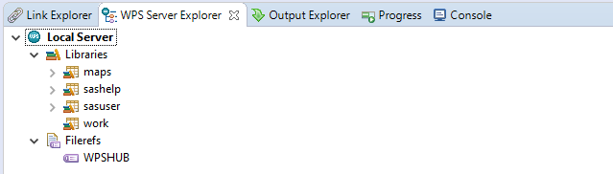

This view displays a List of Filerefs, libraries, catalogs and datasets generated from running a SAS language program on a ALTAIR server. Notice the work folder, this is the default temporary location that houses all data and is flushed when the program is closed.

The code in a file can be run by selecting the run option on the task bar or by right clicking anywhere in the code view and selecting an appropriate option or by using the keyboard shortcut CTRL+R.

Figure 30: Run options

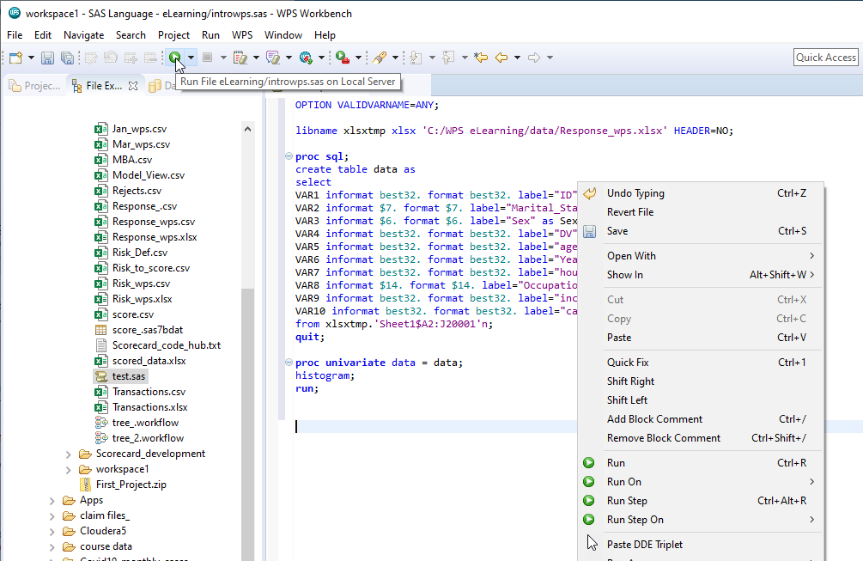

Code can be run in full or partially by selecting the code to run and choosing a run option. Here this code to import the file and name it: **data** is selected and CTRL+R is used to run the code.

Figure 31: Save and Run

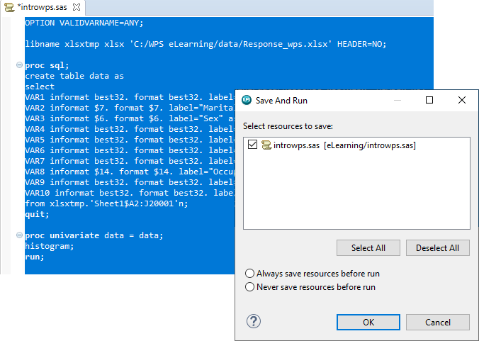

A message appears when running code for the first time, the message relays information about the file save status. Note the asterisk - meaning the file has been modified but not yet saved.

Selecting either *Always save resources before run* or *Never save resources before run* will ensure this dialog never appears again. A similar dialog will appear prompting in relation to closing data files that are referenced in code that are currently open.

Clicking OK saves the file is saved, note the asterisk has disappeared, the code runs and a file is output to the work directory.

Figure 32: Work directory

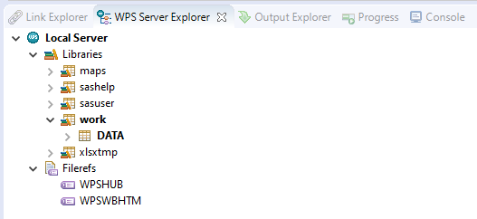

The file can be accessed in a number of ways, doubling clicking opens the data in the Dataset File Viewer: this provides a spreadsheet style display with sort, edit and filtering options available.

Figure 33: Dataset File Viewer

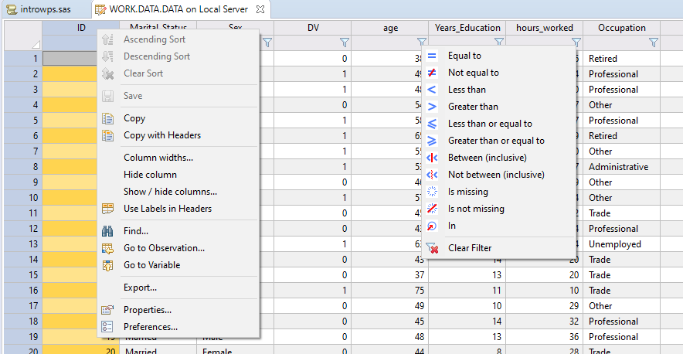

Returning to the Work folder and right-clicking the dataset and selecting Open With provides options to open the data with the Dataset File Viewer as just illustrated, or the Data Profiler.

Figure 34: Data Profiler

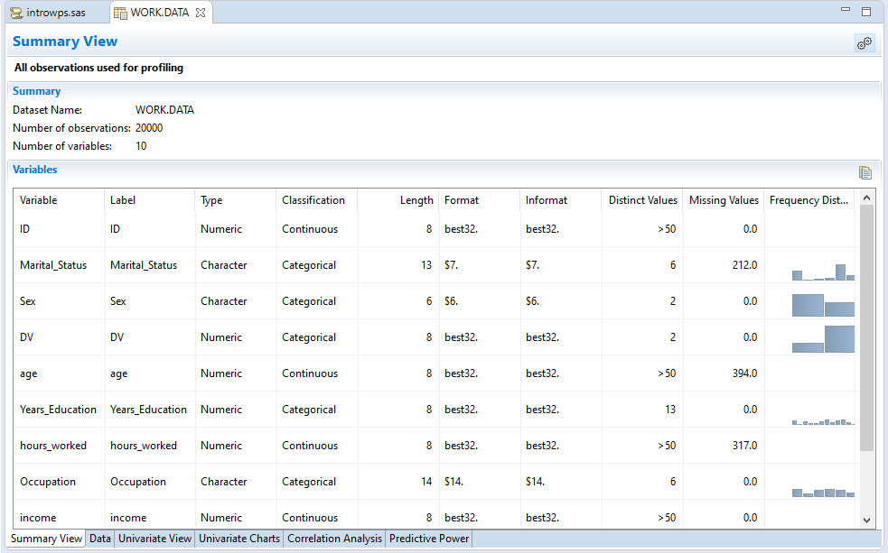

The Data Profiler includes the Dataset File Viewer via the data tab, but also provides others profiling

tabs for more in-depth assessment.

The Output Explorer provides access to logs and HTML output. Thankfully as screens can be split the log can be viewed side by side with code.

Figure 35: Output Explorer

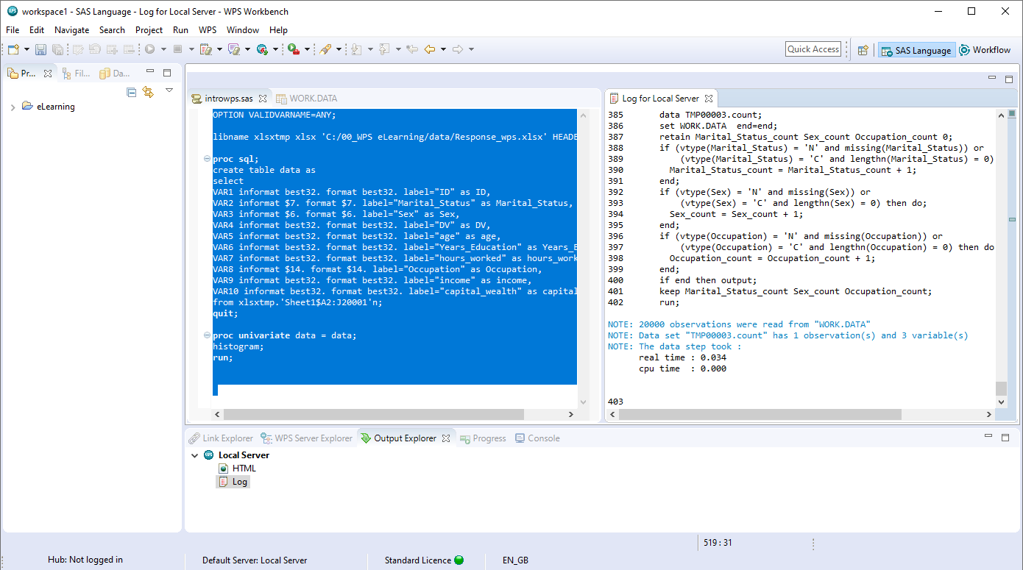

The log contains verbose code, computation time and any warnings or errors. Notice the log populating as the remaining code is selected and run. This code analyses the file and outputs results. Clicking the HTML node opens the HTML Viewer with output generated available.

Figure 36: HTML Viewer

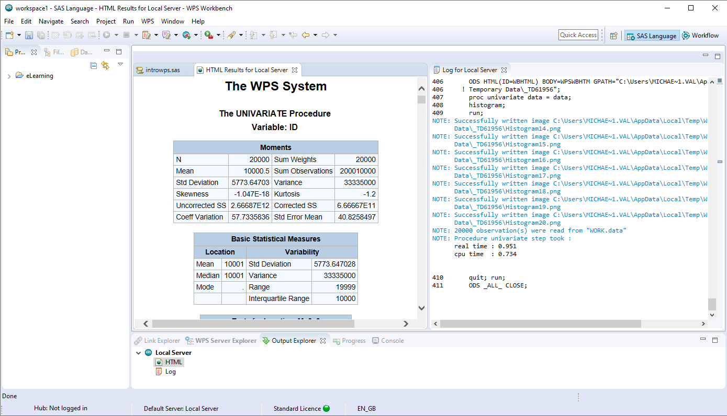

Note that the screen can be split further to accommodate more items.

Code assistance features are available including the ability to list relevant elements via holding the CTRL key and hitting the space bar. Coloring coding and error tracking are also included.

Here the data set in the Work directory is duplicated and a new variable added. Notice the dataset and variable names can be dragged from the work directory to assist when building code.

Highlighting and running the code, the log scrolls and the data is created and evident in the Work directory.

The Progress tab displays messages relating to processing code from the Local Server, for example selecting a piece of code and running shows an execution bar scrolling. The console tab is similar however this displays messages produced by ALTAIR Server.

The Outline view and Results view to the right, provide the facility to navigate code elements and output. For example, selecting any code element from the outline view highlights it in the code view, correspondingly selecting any entry from the results view navigates to it in the HTML output.

Figure 37: Outline view

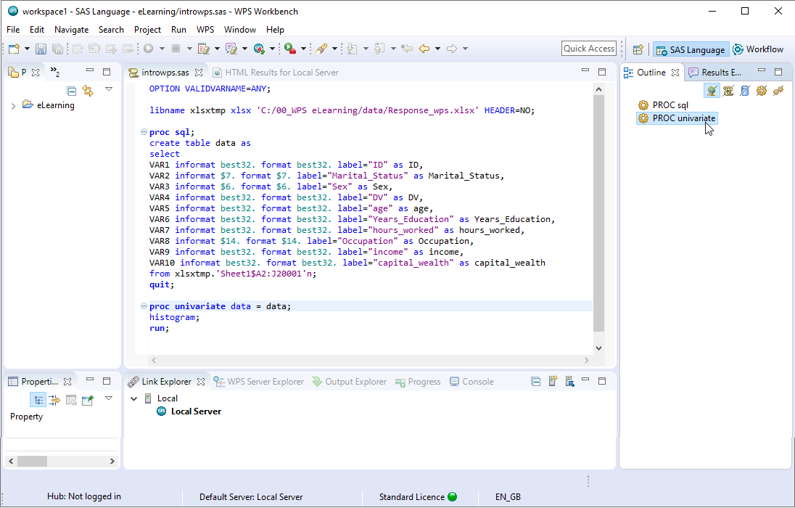

The SAS Language perspective has many features for programming not only in the language of SAS but also for interleaving SQL, Python and R code

R and python code can be passed via the PROC R and PROC PYTHON wrapper procedures respectively. R or Python code is entered between the *submit* and *end submit* statement for each procedure.

Figure 38: PROC R and PROC PYTHON

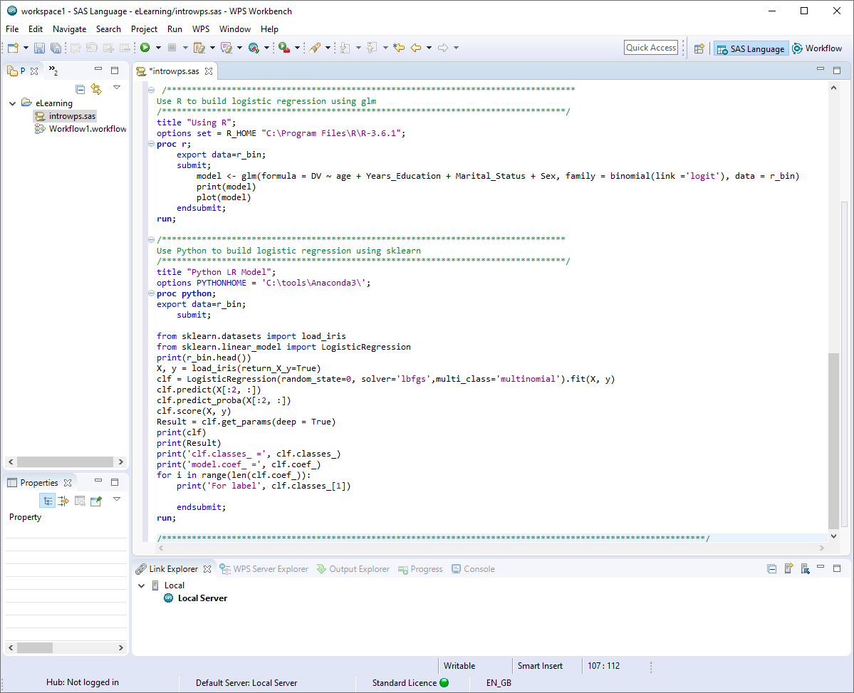

Note that R and Python are neither installed or managed by Altair Analytics Workbench. R and Python can be installed either prior to or after installing Altair Analytics Workbench.

Altair Analytics Workbench enables R and Python code to be written in R and Python, the code is passed to the respective tools, processed and a response returned and displayed in the HTML viewer.

More information on using these languages can be found in the Help files.

## Interactive Questions

Q1:

Select all correct answers:

**Projects can be created by right clicking in the Project Explorer view.**

Projects can only be created in the default location: the Workspace selected at startup.

Projects cannot be deleted.

**Projects cannot be renamed.**

A:  
Projects can be created by right clicking anywhere in the Project Explorer view and projects can be renamed. Projects can also be be deleted and can be created in any selected location.

Q2:

A file system can be navigated and files opened from the File Explorer view.**t**/f

A:  
A file system can be navigated and files opened from the File Explorer view.

Q3:

The ALTAIR Server Explorer view provides a view of the contents of connected servers. **t**/f

A:  
The ALTAIR Server Explorer view provides a view of the contents of connected servers regardless of whether they are local or remote.

Q4:

Drag the words to complete the sentence correctly.

The ________ is a temporary location storing data that is flushed when Altair Analytics Workbench is closed or when the ________ is restarted.

**Work folder ALTAIR Server** Workflow Link Explorer View Database Explorer view

A:

The Work folder is a temporary location storing data that is flushed when Altair Analytics Workbench is closed or when ALTAIR Server is restarted.

Q5:  
What features does the Altair Analytics Workbench SAS Language perspective support? Select all correct options:

The keyboard shortcut CTRL+R cannot be used to run code.

**Code assistance features are available to assist when building code.**

**Dataset names can be dragged and dropped from the Work folder directly into code.**

A:

Code assistance features are available to assist when building code and dataset names can be dragged and dropped from the Work folder directly into code. Additionally, the keyboard shortcut CTRL+R can be used to run code.

Systems settings are available from Preferences in the Window menu.

Figure 39: Preferences

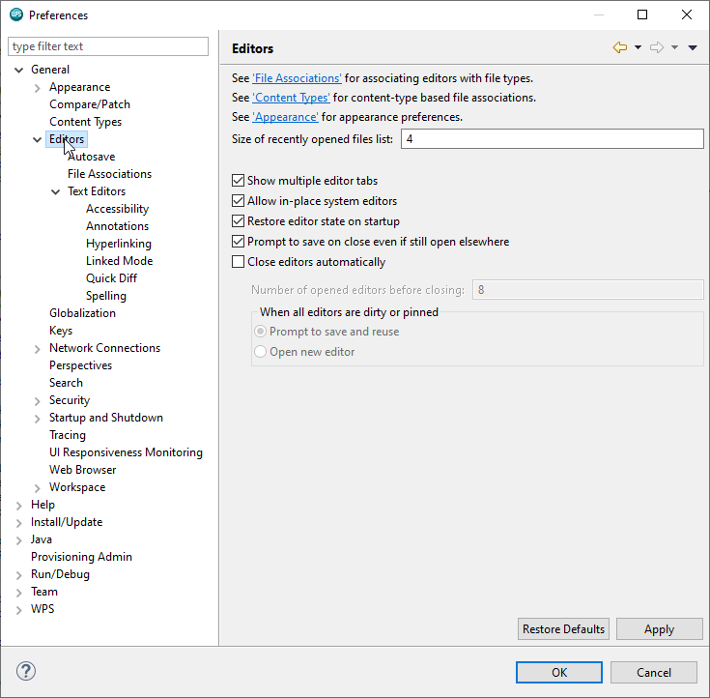

The General section provides global settings in relation to program operation, for example, select editors to set options for marking up program files. Keys provides the ability to modify and set keyboard shortcuts.

Clicking on Workspace provides insight into Workspace options such as how often to save and the Workspace path.

The ALTAIR entry can also be expanded and contains items specific to the SAS Language perspective. For example, the Temporary File Location is the location of the Work folder.

Figure 40: ALTAIR

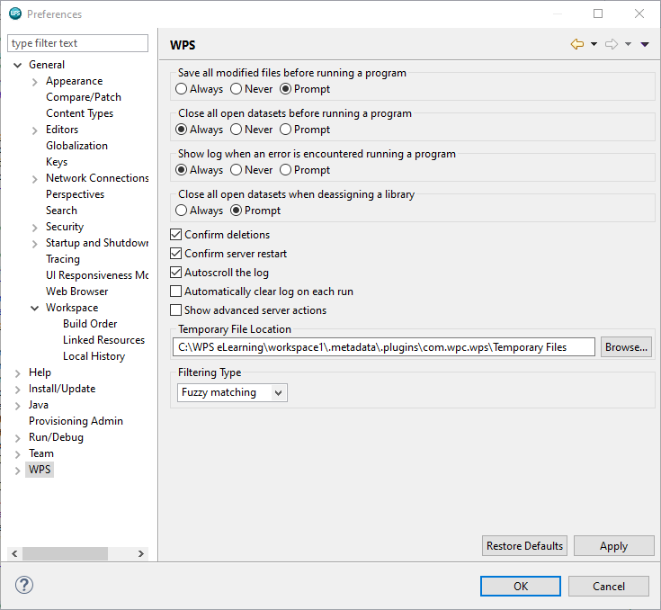

Other options are either generic or specific to the SAS Language perspective, for example from code injection, a piece of code can be injected into every program and run prior to and/or after the program.

Figure 41: ALTAIR Options

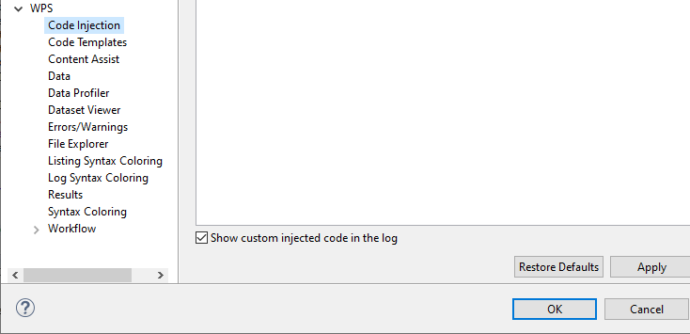

The Code Templates entry enables the creation, use and application of code templates and options can be set for syntax and errors.

The Data, Data Profiler and Dataset Viewer options are used to set appropriate options for data.

Figure 42: Data, Data Profiler, Dataset Viewer

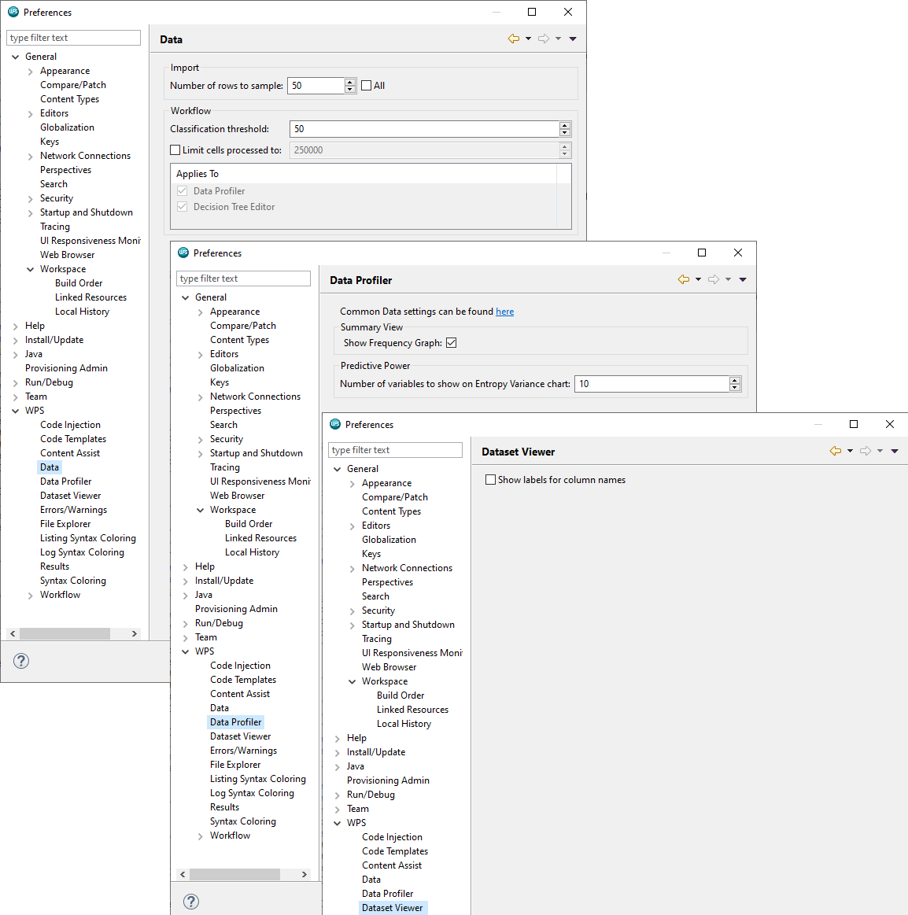

For example, variables are classified by viewing the first 50 observations. The Data Profiler entry provides options for the Data Profiler and the Dataset Viewer provides one option: Show labels for column names.

The Workflow section contains options related to the Workflow and will be introduced a little later.

Altair Analytics Workbench provides two perspectives which can have multiple views configured as desired:

the SAS Language perspective which is currently open and the Workflow perspective. Icons available in the top right corner relate to these perspectives and currently there are two: SAS Language and Open Perspective.

Figure 43: Perspective Icons

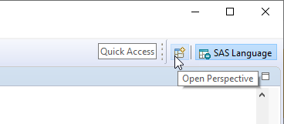

Clicking the open perspective icon provide the facility to access the workflow perspective by choosing Workflow and clicking OK.

Figure 44: Open Perspective

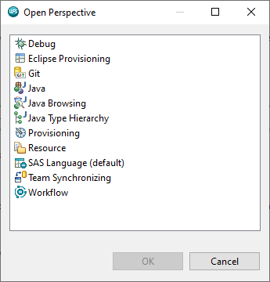

As a result, notice that an additional icon has been added: Workflow, and the Workflow perspective has been opened.

Figure 45: Workflow icon added

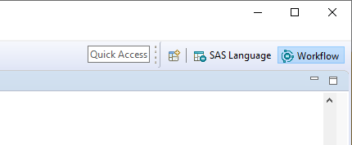

Note that the Window menu also provides the ability to toggle between the SAS Language perspective and the Workflow perspective from the Window menu by selecting Perspective > Open Perspective.

Figure 46: Window > Perspective

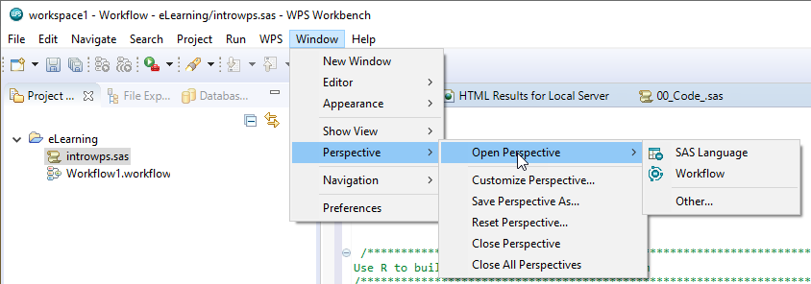

Currently, as a result of navigating to the Workflow perspective, nothing seems to have changed. This is because a Workflow must be added.

To do this either click File > New > Workflow or choose the same option by right-clicking any project folder from the Project Explorer view.

Figure 47: Adding a Workflow

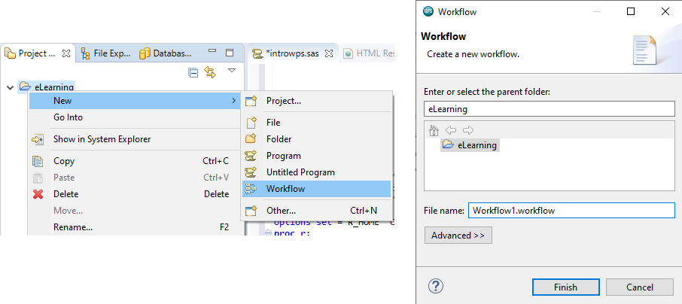

A name can be provided or the default accepted. Here the Workflow is named: *introtoAltair* and once entered, clicking Finish creates and opens the Workflow.

Figure 48: Workflow added

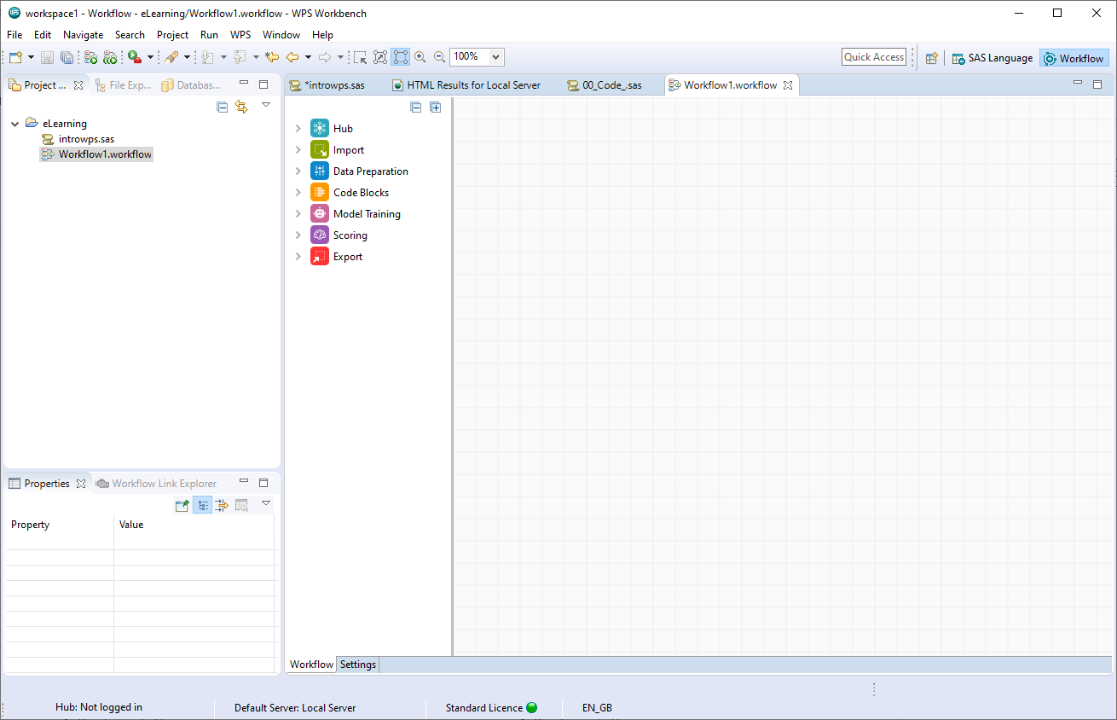

The Workflow perspective has some similarities to the SAS Language perspective in that the menus, Project Explorer, File Explorer, Database Explorer and the Properties view are visible.

Figure 49: Database Explorer and Workflow Link Explorer

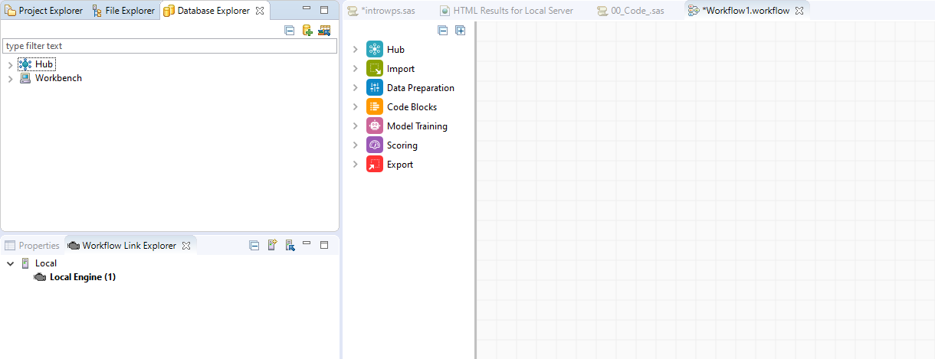

Also notice the Workflow link explorer tab, this shows the engine used for processing, in this instance Local Engine.

This differs from the SAS Language perspective which uses servers and where many can be configured. The Workflow perspective uses engines and only one engine can exist.

The bulk of space in this perspective is taken up with the Workflow canvas. This is used for creating Workflows by dragging and dropping point and click processing blocks from groups to build processing chains.

Blocks are contained in groups and as can be seen there are seven: Hub, Import, Data Preparation, Code blocks, Model Training, Scoring and Export.

Each group house blocks with similar functionality, for example, the import group contains blocks that enable data to be imported to the Workflow.

Figure 50: Import group

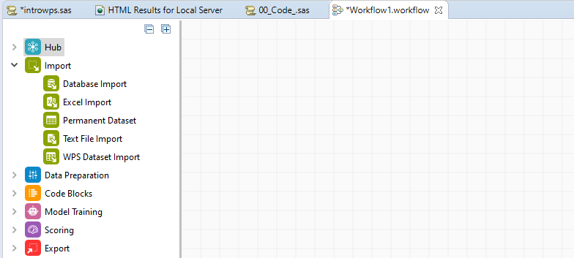

The Data Preparation group contains an array of point and click blocks for data manipulation including Aggregate, Binning, Filter, Impute, Join, Sort Select, Transpose and more.

Figure 51: Data Preparation group

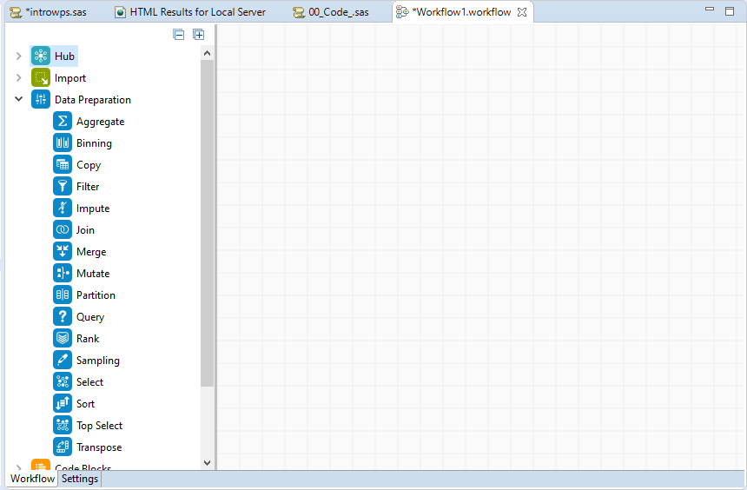

Code blocks enable the language of SAS, R, Python and SQL to be included in a Workflow. This provides expansive capabilities to incorporate additional processing in a Workflow via code.

Figure 52: Code Blocks

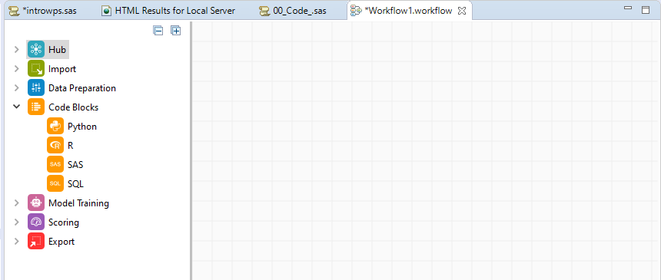

The Model Training group contains modelling blocks including Decision Forest and Decision Trees, clustering methods, regression, neural networks, and scorecard specific elements: Reject Inference, Scorecard Model and WoE Transform.

Figure 53: Model Training group

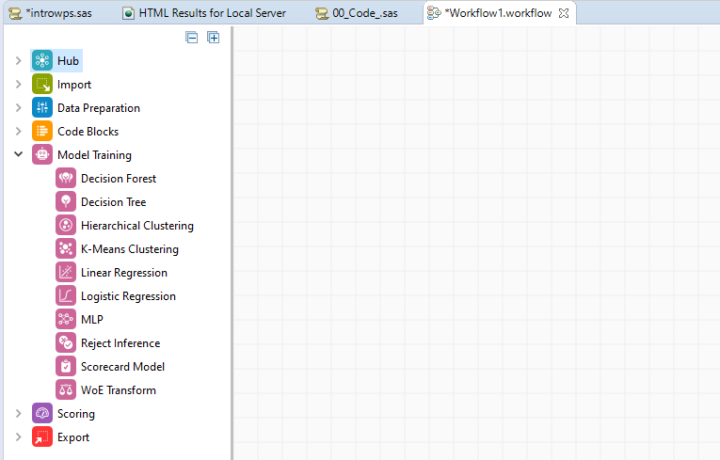

The scoring group contains blocks for scoring and evaluating data and models and the Export group provides capabilities to build and export charts and data in a variety of formats.

Figure 54: Scoring and Export groups

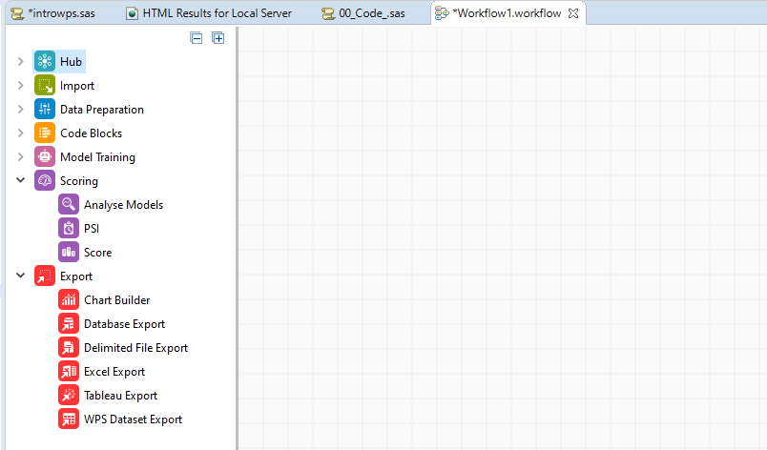

To illustrate generic use and functionality, an Excel Import block is dragged onto the canvas.

Figure 55: Excel Import block

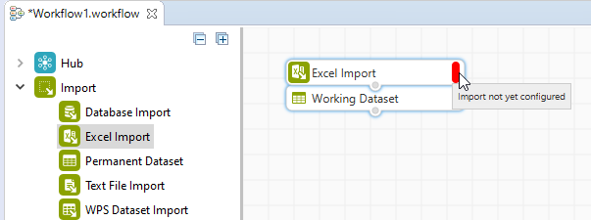

A few things to note about the block, First the block output is created automatically, here an empty dataset, and the blocks configuration status is red. All blocks have a configuration status area relaying connection and configuration messages. Hovering provides detail.

Here, the message import not yet configured is evident, this is not a mystery as the block has yet to be configured. The empty dataset created is as a result of the Workflow block being set to Auto Run. Options for the block can be accessed via right-click.

Figure 56: Block options

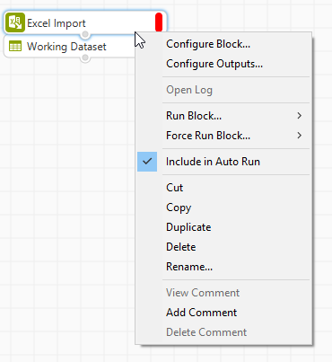

Configuration options can be accessed via Configure Block… or by double clicking the block. If additional output is generated by the block these can be configured via Configure Outputs….

Block run options are available and notice the option Include in Auto Run is selected and this is the reason why an empty dataset was created when the block was initially dragged onto the Workflow canvas.

Edit options are available including cut, copy, duplicate, delete, and rename and comments can also be added. Selecting Configure Block opens the block configuration dialog.

Figure 57: Excel Import block

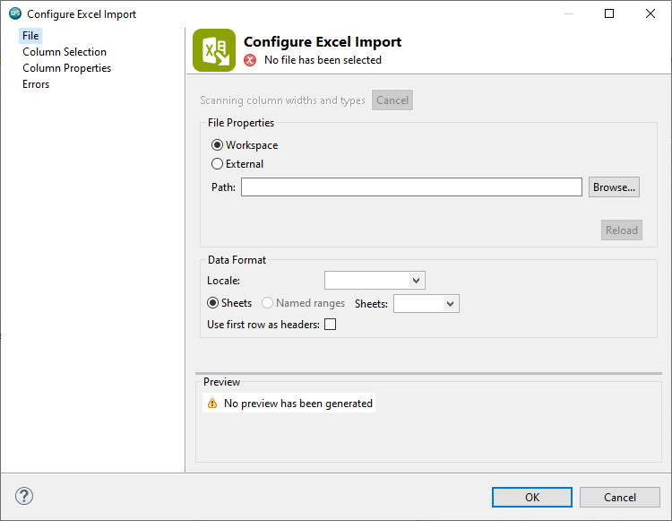

The block contains four configuration pages: File, Column Selection, Column Properties and Errors. From the File page the file path and format can be specified, and a preview of the data is also available, this cascades to all pages.

The Column Selection page enables the selection of variables to read and the Column properties page displays editable variable metadata.

The Errors page provides an option to Remove rows with errors. These observations are sent to a new dataset which can be output by right-clicking the block, selecting Configure Outputs and moving the Errors entry from the Unselected Outputs list to the Selected Outputs list.

For illustrative purposes, the Configure Outputs dialog is accessed and Errors moved to the Selected Output list.

Figure 58: Configure Outputs

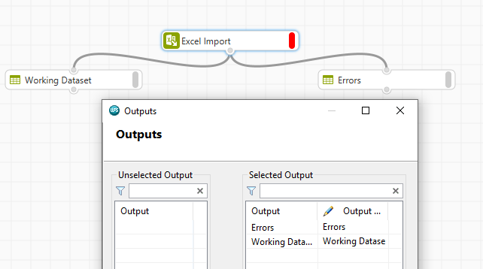

Notice that as a result of this, an additional dataset is evident on the canvas. This is currently empty and output as a result, again, of the block being included in Auto Run.

Returning to the block configuration and the File page, the data to import can be specified from File Properties. This can be a file in the current Workspace or in an external location.

Here External is chosen and the file: *risk_Altair.xlsx* contained in the eLearning data folder, is selected.

The Data Format area provides options to specify the locale, select sheets or named ranges and use first rows as headers. If locale specifications are evident in the file being imported, this field is populated automatically. If there are locale specific variables in the file but no locale specifications are evident a guess is made and this is picked from a list but the locale field will not be populated. Bear in mind that the locale can be selected manually also.

A final option is provided to read variable names from the first row of data via use first row as headers.

Notice the help icon to the bottom left of the dialog, clicking this opens the Help facility with guidance on block usage. Click the icon again to collapse.

Figure 59: File page

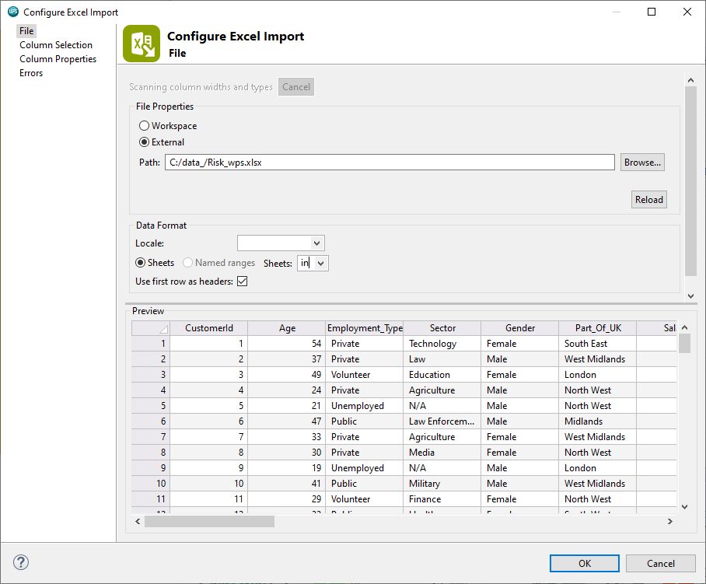

For this demonstration, all other setting are retained at their default. OK is clicked and the import runs.

Figure 60: Import complete

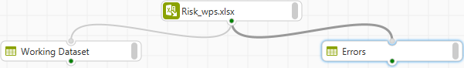

The block indicator status is now grey, reflecting the fact that the block has been configured correctly and the execution status indicators for all blocks is green, meaning successfully run processes, red means errors.

The resulting dataset is given a generic name by default. This can be changed via the right-click option: Rename, here the name *risk_Altair* is entered and applied by clicking OK.

Figure 61: Rename

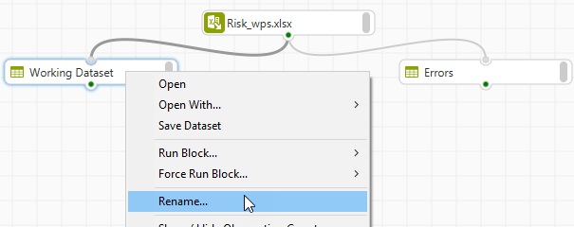

Note that this is not necessary for the Errors output as it is named Errors by default. Right-clicking any dataset provides the option to Open or Open With. Open With… has two options: Data Profiler and Dataset File Viewer.

Figure 62: Open and Open With...

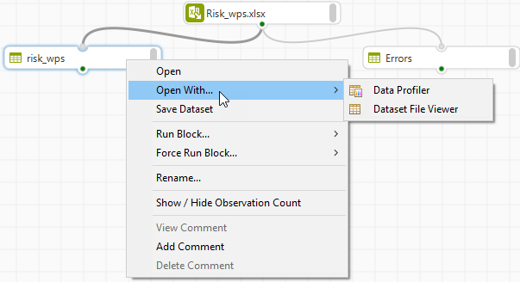

Clicking Open or selecting the Dataset File Viewer option or double-clicking the dataset will give the same result in that the data opens in the Dataset File Viewer. This opens in a new tab and is a spreadsheet style display with variables in columns and observations in rows.

Returning to the Workflow, right-clicking the dataset and choosing Open With > Data Profiler, opens the dataset with the Data Profiler.

The Data Profiler includes the Dataset File Viewer and additional profiling tabs for more in-depth analysis.

Figure 63: Data Profiler

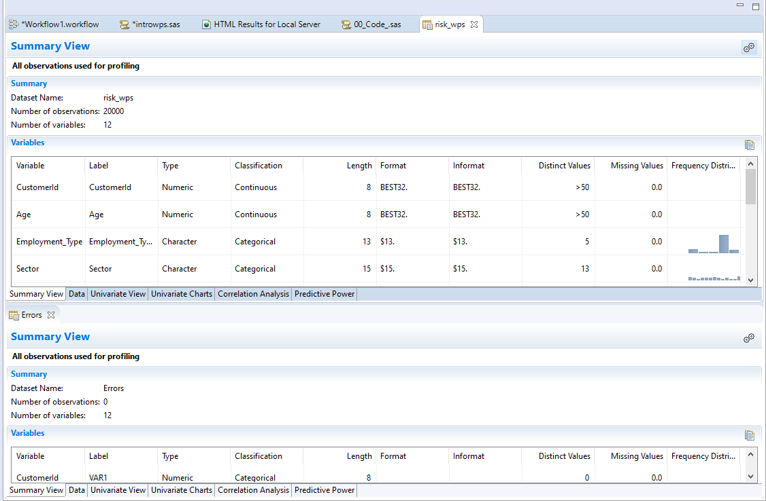

Both the imported data and the Errors can be illustrated simultaneously using split-screen. Notice that the Errors dataset includes all variables and 0 observations, meaning that there are no observations with errors in this file.

Right clicking the imported dataset again and clicking Save Dataset opens the Save Dataset dialog. The default, any only type available is .*wpd* - this is ALTAIR’ proprietary file format.

Figure 64: Save Dataset

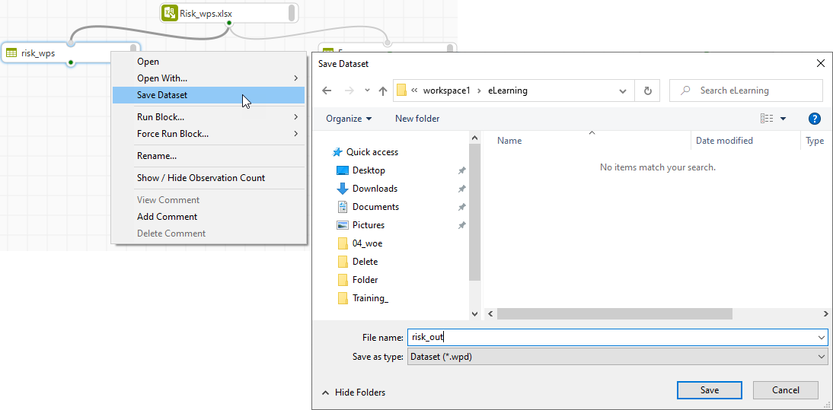

Here the data is output to the project folder and named risk_out. Clicking Save completes the process. The project must be refreshed by right-clicking it and selecting the option Refresh for the exported data to be displayed and notice it has the extension *.wpd*.

Figure 65: Project with saved WPD dataset

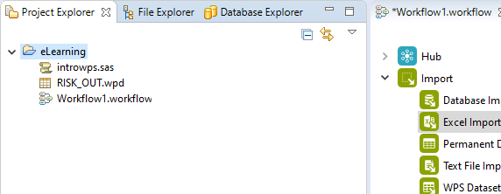

Right-clicking any Workflow dataset also provides run options, the ability to Show/hide Observation Count, and add comments.

Show/Hide observations count displays the number of observations and variables in the dataset and once a comment has been added, clicking the block indicator collapses or reveals the comment.

Additionally, for any configurable block, the block log can be accessed via Open Log.

Figure 66: Open Log

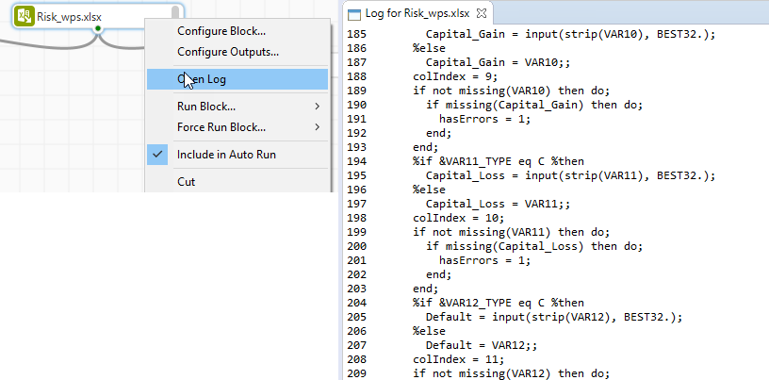

This reflects the log generated in the SAS Language perspective and includes verbose code, computation time and any errors or warnings.

## Interactive Questions

Q1:

Workflows can be added from the File menu only. t/**f**

A:  
Workflows can be added from the File menu or by right-clicking the Project Explorer view.

Q2:

The menus, Project Explorer, File Explorer and Properties views are visible and relevant across both the SAS Language perspective and the Workflow perspective.**t**/f

A:  
The menus, Project Explorer, File Explorer and Properties views are visible and relevant across both the SAS Language perspective and the Workflow perspective.

Q3:

Select the incorrect statement:

Code blocks can be used to interleave SAS, SQL, Python and R code in a Workflow.

Code blocks can be used to process data using code.

**The Code Blocks group include SAS and SQL blocks only.**

Open source code can be included in a Workflow.

A:

Code blocks are available for the languages of SAS, Python, R and SQL.

Q4:

Drag the words to complete the sentence correctly.

______________ relay connection and configuration messages and ______________ messages relay execution messages.

**Configuration status messages execution status** Workflow message Block messages

A:

Configuration status messages relay connection and configuration messages and execution status messages relay execution messages.

Q5:

Select all correct answers. Right clicking any block provides options to:

**Access the log.**

**Add comments.**

**Configure the block.**

Add code to the block.

**Cut, copy, duplicate, delete and rename.**

**Run the block.**

Modify the block appearance.

A:

Right clicking any block provides options to configure the block, access the block log, run the block, cut, copy, duplicate, delete, rename and add comments to the block.

## Workflow options and making connections

The output data can be detached from its source by clicking and dragging, this makes the connection visible.

Moving and panning around the Workflow canvas can be achieved by holding down the left mouse button while simultaneously moving the mouse. The middle mouse button controls zoom, this is also available from the task bar. Additionally, a grid and snapping features are also present.

Adding more blocks can be accomplished in three ways:

First, by dragging and dropping, here a Select block is dragged from the Data Preparation group to the dataset: *risk_Altair*, the block automatically docks and connects and the block indicator status shows that no variables have been selected.

Figure 67: Adding a Select block

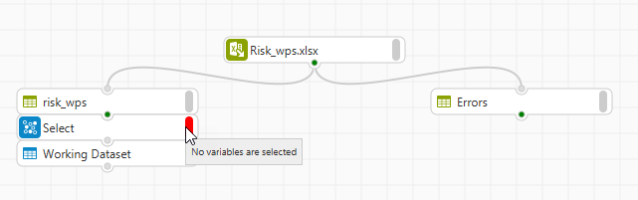

Here, the block configuration dialog is accessed by double-clicking the block.

Figure 68: Configure Select

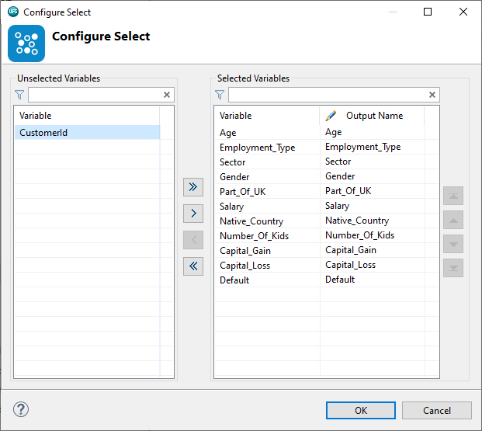

With the select block specific variables can be chosen for inclusion in a new dataset, here all variables bar *CustomerId* are moved from the unselected variables list to the selected variables list.

The process is executed by clicking OK. Notice the generic name assigned to the resulting dataset, here this is renamed to **removed_id**.

Figure 69: Rename dataset

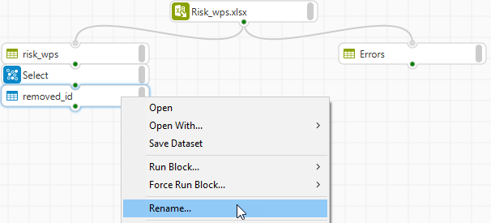

The second method is similar but requires making a manual connection once the block is dragged onto the canvas. At this point, the block indicator status relays that the block requires one input connection and variables to be selected.

Figure 70: Manual connection

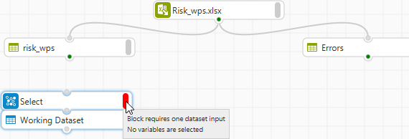

To connect the data to the block, the mouse is hovered over the output port of the dataset *risk_Altair*, the left mouse button is held and the mouse dragged and the connection released over the input port of the Select block.

The connection has been made and the indicator status for the select block has now only one message relating to configuration: No variables selected. Here the variable *age* is removed and the dataset renamed to *removed_age* to reflect.

A third way to add blocks is by double-clicking anywhere on the Workflow canvas. All blocks are listed as they appear in their respective groups.

Figure 71: Adding blocks by double-clicking the canvas

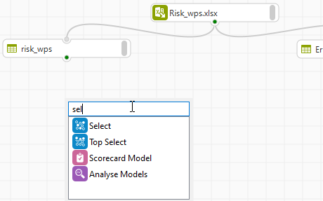

Simply scroll to any block or use the search bar to automatically locate any block. Once located, double-clicking includes the block on the Workflow and it can be connected and configure as outlined previously.

Blocks are disconnected by right-clicking and selecting the option: Remove input connection.

Figure 72: Remove input connection

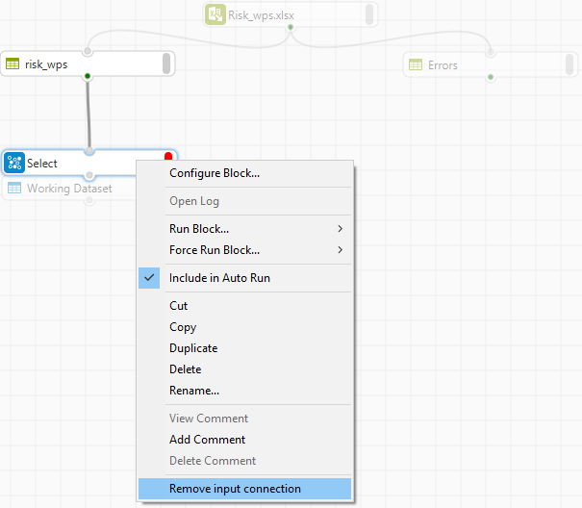

If multiple connections are evident then all are listed. Alternatively, the block can be easily deleted by clicking the *delete key* on the keyboard. Undo is also available by clicking CTRL+Z or by selecting Undo from the Edit menu.

Blocks and chains can be duplicated and pointed to new data. To select more than one block, the CTRL key on the keyboard is clicked and held until the crosshairs appear on the Workflow canvas, the left mouse button is clicked and the mouse dragged to select an area, any blocks included in that area are automatically selected.

Alternatively, blocks can be selected by holding down the CTRL key and selecting blocks individually.

Figure 73: Selecting multiple blocks

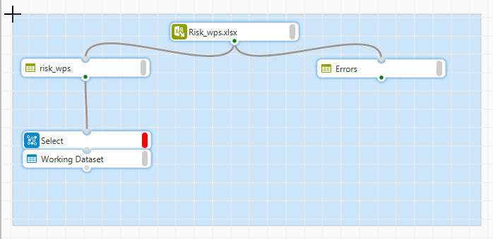

Using the keyboard shortcuts CTRL+C and CTRL+V, or identical options from the edit menu, the blocks can be copied and pasted.

This is useful when a large processing chain has been developed and needs to be applied to new data.

Right clicking the Workflow canvas provides options to add comments to the Workflow and export the entire Workflow to a SAS language program. Note that this option is only available if all Workflow blocks have a green execution status indicator.

Figure 74: Workflow canvas options

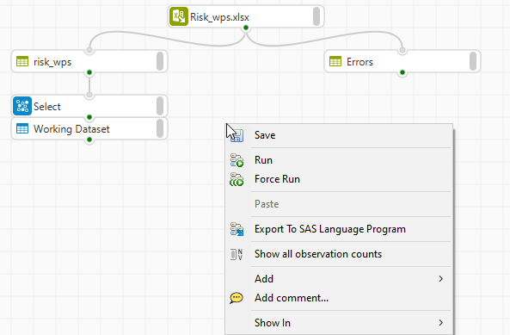

Here the Workflow is exported to a SAS language program to the project folder previously created. The file is named *import_code.*

Figure 75: Export to SAS Language Program

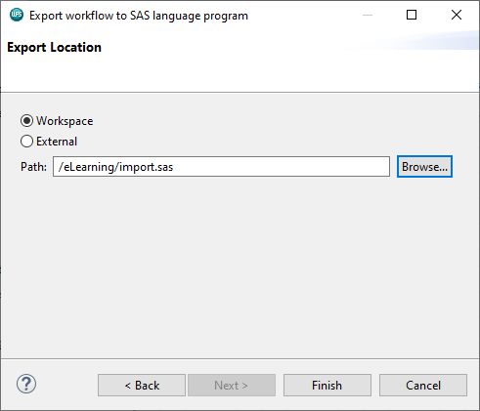

When complete, refreshing the project shows the exported file. This can be easily opened by double clicking.

Figure 76: Opening a code file in the Workflow

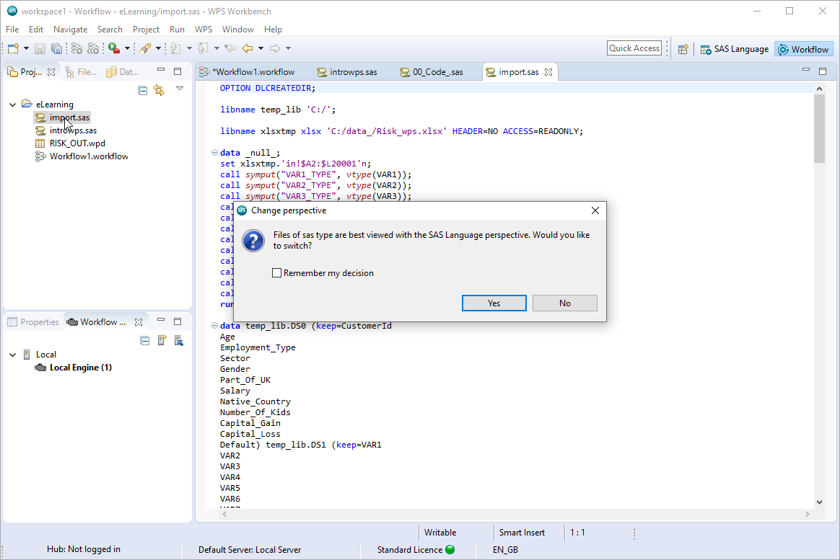

As the file contains code and is being opened in the Workflow a message appears suggesting to open the file in the SAS Language perspective. Clicking the option: Remember my decision will ensure that in future the switch to the SAS Language perspective happens automatically if a code file is opened from the Workflow perspective.

Clicking Yes, opens the file in the SAS Language perspective. A similar message appears if a Workflow is opened from the SAS Language perspective.

Note that if the Workflow is already opened the message will not appear and the perspective will need to be manually selected by clicking the Workflow icon in the top right- hand corner.

Options related specifically to the Workflow can be found from Preferences in the Window menu by expanding ALTAIR and clicking Workflow.

Figure 77: Workflow preferences

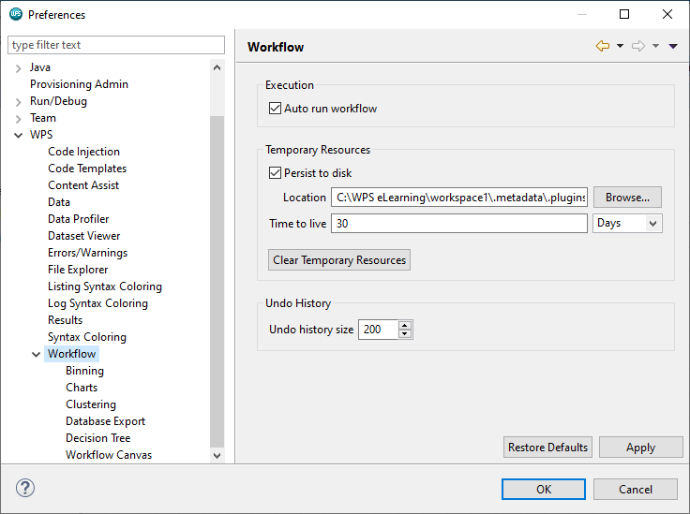

Located here are options to auto run the Workflow, which is selected by default. Deselecting Auto run Workflow will mean that each block will need to be manually right clicked and a run option selected.

Additionally, options to set the Workflow cache are also evident here. The Workflow is stored in a cache and includes all data and code which means the Workflow can be loaded quickly.

The Workflow cache expires after 30 days but this can be modified. Undo options are also contained here.

Expanding Workflow provides options for Workflow blocks and the Workflow canvas.

The Help menu provides access to help facilities and license information. This menu also includes the option About Altair Analytics Workbench which displays Version information.

Figure 78: Help menu options

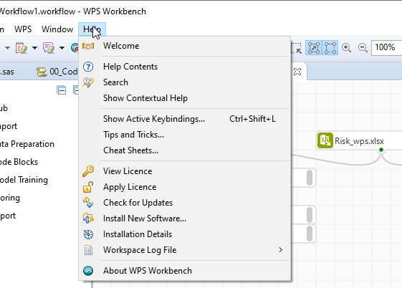

The first Help menu item: Welcome, opens the Welcome page introduced earlier. This is visible when the program is first opened or when switching to a new Workspace.

Help contents opens an expandable set of dictionaries on program use including Whats New. A search bar provides the facility to search for specific content.

Search opens a pane to the right-hand side of the currently open perspective with options to view contents, search, locate related topics and add bookmarks.

Figure 79: Help > Search

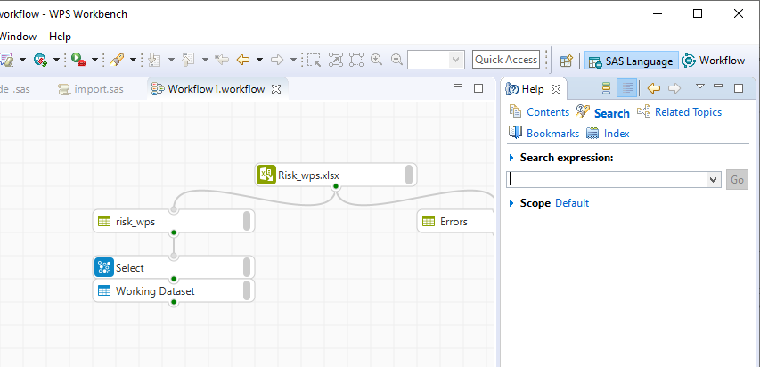

The Contents, Search and Related Topics options correspond with options from the Help menu: Help contents, Search and Show contextual help. Show contextual help automatically opens specific topics associated with any item selected in any perspective.

Additional help items include keyboard shortcuts via keyboard bindings, tips and tricks and cheat sheets.

## Interactive Questions

Q1:

Identify ALTAIR' proprietary file format by dragging it onto Altair Analytics Workbench.

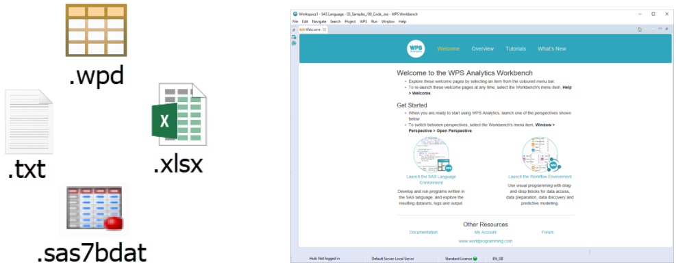

A:

The *.wpd* format is proprietary to ALTAIR.

Q2:

Known file formats including *.wpd*, .*xlsx* and *.txt* can be dragged onto the Workflow canvas from the File Explorer view to import. **t**/f

A:

File formats including .wpd, .xlsx and .txt can be dragged onto the Workflow canvas from the File Explorer view to import.

Q3:

The keyboard shortcuts CTRL+C and CTRL+V can be used to copy and paste blocks and entire Workflows. **t**/f

A:

The keyboard shortcuts CTRL+C and CTRL+V can be used to copy and paste blocks and entire Workflows.

Q4:

Select the incorrect statement:

**A Workflow cannot be exported to a SAS language program.**

SAS, Python, R and SQL code can be included in a Workflow.

The Altair Analytics Workbench SAS Language perspective uses servers to process data.

Groups house blocks which are used to build Workflows.

A:

SAS, Python, R and SQL code can be included in a Workflow. Groups house blocks which are used to build workflows. The Altair Analytics Workbench SAS Language environment uses servers to process data and workflows can be exported to a SAS language program.

Q5:

Select the correct statement:

The Data Profiler identifies errors in the Workflow.

**The Data Profiler contains the Dataset File Viewer and additional views for more in-depth analysis.**

The Data Profiler includes a database configuration wizard.

None of these are possible with the Data Profiler.

A:

The Data Profiler contains the Dataset File Viewer and additional Views for more in-depth analysis.

Q6:

Workflow changes cannot be undone. t/**f**

A:

Workflow changes can be undone. Workflow Undo History size can be set via: Window > Preferences > ALTAIR > Workflow.

So thats a walk through the program and the SAS Language and Workflow perspectives. Prior to wrapping up lets speak about nomenclature and Altair Analytics Workbench specific things to remember.

Figure 80: Things to remember

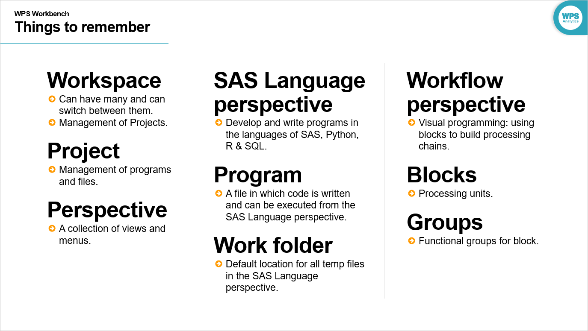

A Workspace stores session settings. Any accessible location can be selected as a Workspace, bear in mind that multiple Workspaces can exist.

Projects store project elements such as programs, files and Workflows. Projects provide a means to easily gather all project elements.

A perspective is a collection of views and menus. The SAS Language perspective provides the ability to develop programs in the languages of SAS, Python, R and SQL.

A program is a file in which code can be written and executed from the SAS Language perspective.

The Work folder is the default storage location for all temporary files created in the SAS Language perspective. The Workflow perspective is a drag and drop and point and click facility providing the ability to visually design processing chains using processing units called blocks which are stored in groups.

Figure 81: Perspectives and their interaction

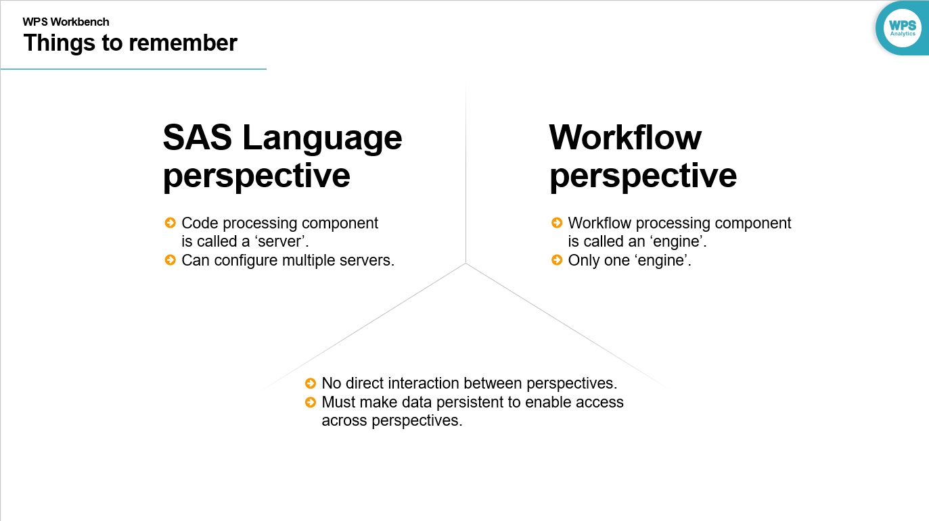

The SAS language perspective uses servers to process data and multiple servers can be configured.

The Workflow perspective uses engines to process data and only one engine is available.

There is no direct interaction between perspectives. To make data from one available to the other. Data in one perspective must be made persistent to be accessible from the other.

## Summary

This lesson focused on the Altair Analytics Workbench, the SAS Language and Workflow perspectives, common elements, Help and Preferences prior to a demonstration then returning to slides and highlighting points to remember.

# Exercises

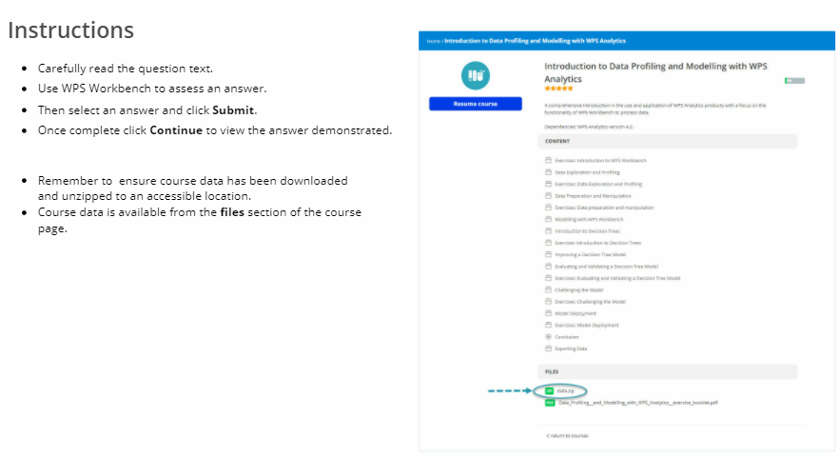



* Open Altair Analytics Workbench and close the Welcome screen.
* Create a new project called Project_1.
* From the File Explorer view locate and open the program file: *Ex_1.sas.*
* Run the import part of the code.

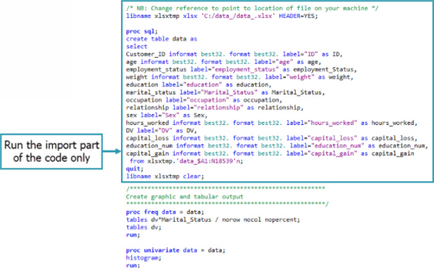

**Question:** does the code run correctly? y/**n**

**Answer:** Following instructions, the program is opened. The Workspace is set to a folder in the *C:/directory* called: *exercises_*. A new project is added called *project_1* and the file *ex_1.sas* opened, and the import code selected and run. The code does not run correctly.

2.

**Question:** Can the code be modified to run correctly?

No, the data file does not exist, there will always be a code error.

**Yes, by changing the file path to point to the correct location and file.**

**Answer:** Viewing the log the error shows the file does not exist. The code can be modified to update the path to the folder that contains the file: data_.xlsx. Once complete the code is selected and re-run, there are no errors and the data is now available from the Work library.

3.

**Question:** How many variables and observations are there in the file?

14 and 18539 respectively.

The data file is empty.

13 and 18538 respectively.

**14 and 18538 respectively.**

**Answer:** There are a number of ways to assess this detail. With the dataset selected, and from the Properties view it can be seen that there are 14 variables and 18538 observations. This detail can also be assessed from the Summary tab of the Data Profiler.

4.

* Highlight and run all remaining code.
* This will generate charts and statistics accessible from the HTML node.

**Question:** What is the median *capital_gain*?

**726.2**

0

5303281

162104

**Answer:** Selecting the remaining code and running generates output accessible from the HTML node

of the output explorer. From the outline view Expand the univarate procedure and click *capital_gain* to navigate to the relevant output.

The median *capital_gain* is 726.2.

5.

* Save the SAS program file to the project folder: *Project_1*.

**Question:** How can the project path be known so that the file can be saved to it? Select all correct options.

By double-clicking the project folder from the Project Explorer view.

Write the path down when a project is created.

Using File > Save As will automatically navigate to the project folder.

**Select the project folder from the Project Explorer view. Its path is visible from the Properties view.**

**Right-click Project_1 and select either Properties or Show in System Explorer.**

**Answer:** Righting clicking the project and selecting either: Properties or Show in System Explorer

provides access to the project folder location. This is copied using the keyboard shortcut CTRL+C. From File > Save As, the path can be pasted and the file exported. Refreshing the project shows the export was successful and the file has a .*sas* extension.

6.

* Confirm the program has been saved in the Project_1 folder and it has a *.sas* extension.
* Create a Workflow called Workflow_1 in the project folder.
* Ensure the Workflow perspective is active.
* Import the file data_.xlsx into Workflow_1 by either:
  + Using an Excel Import block from the Import group.
  + Locating the file from the File Explorer and dragging it onto the Workflow canvas.
* Do not import the variables: *Customer_ID* and *weight*.
* Rename the resulting dataset on the Workflow canvas to: Filtered.
* Export the dataset, including headers, as a *.wpd* dataset called Filtered to the Project_1 folder.
  + HINT: Right-click the dataset on the Workflow canvas and select the option: Save Dataset.
  + NOTE: This option is only available when using a desktop version of the software. If using a server version of ALTAIR, the ALTAIR Dataset Export block, found in the Export group can be used to accomplish the same results.
* Drag the dataset: Filtered, from Project_1 and drop it onto the Workflow canvas.

**Question:** How many variables and observations are in the file?

14 and 18538 respectively.

**12 and 18538 respectively.**

14 and 18539 respectively.

12 and 18539 respectively.

**Answer:** Right click the project folder and choose new ... Workflow assign the name workflow_1 and click finish. A notification appears stating: File of Workflow type are best viewed with the Workflow perspective. Would you like to switch? Here, the option Remember my decision is selected and Yes clicked. The Workflow is now open in the Workflow perspective.

The *data_xlsx* is located using the File Explorer and dragged onto the canvas and its configuration dialog accessed. From the Column Selection page all variables bar *Customer_ID* and *weight* are moved to the Selected Columns list and OK clicked to execute the import.

The dataset is renamed to: Filtered and exported to the project folder by first obtaining the location of the project folder by right-clicking the project folder and selecting the option: Show in System Explorer. The path is copied using CTRL+C.

The dataset is right-clicked and Save Dataset selected. The project path is pasted and the file is named: Filtered. Save is clicked, the project refreshed and the file is dragged onto the Workflow canvas.

Opening the file with the data profiler it can be seen there are 12 variables and 18538 observations.

7.

* Add comments…
* … “data imported from training folder” to a dataset block.
* … ”simple Workflow” to the Workflow canvas: simple Workflow.
* Collapse the block comment.
* HINT: use the appropriate icon in the upper-right of the comment box.

**Question:** How can it be known that a block has a comment?

**The block indicator is highlighted. Clicking the indicator opens/collapses the comment.**

Block comments are always visible and readable.

**Answer:** Comments are added to any block by right-clicking and selecting Add Comment. Comments are added to a Workflow by right-clicking any empty space on the Workflow and selecting the same option.

Once a comment has been added to a block and the comment is collapse, the block indicator is highlighted showing a comment has been added, double click to access.

8.

* Workflow objects are a temporary resource retained in a cache which flushes after a set period

of time.

**Question:** What length of time is the cache set to and can it be changed? HINT : Window ... Preferences ... ALTAIR ... ?

30 days, no.

**30 days, yes.**

20 days, no.

20 days, yes.

**Answer:** The Workflow environment stores temporary resources in a cache. Options for the cache are accessible from Windows > Preferences > ALTAIR and Workflow. As can be seen the cache is flushed after 30 days, meaning that the entire Workflow will have to be refreshed if it is not opened within that time period.

9.

**Question:** Can the language of SAS code for the Excel Import block only be accessed, and how?

No, this is not available in isolation.

**Yes, by right clicking the block and selecting Open Log.**

**Answer:** The language of SAS code for the import block only can be accessed via the block log. If the import block is the only block in the Workflow then it can be more easily accessed by right clicking and choosing the option Export to SAS Language Program.

10.

* Contextual Help is help that is automatically displayed for selected items in the Workbench.

**Question:** How can Contextual Help be displayed for the Excel Import block?

**First select Help ... Show Contextual Help. Then click the Excel Import block. Alternatively, click the Help icon from the Excel Import block configuration dialog.**

Click Help ... Help Contents.

Right click the block and select Help.

Help is available for the Excel Import block, but not as Contextual Help.

**Answer:** Contextual help is available either by selecting Help ... Show Contextual Help and then clicking the Excel Import block. The same help is also available by clicking the help icon from the Excel import block configuration dialog.

**For the brave!**

11.

* Ensure that only the originally imported dataset is on the canvas.
* Modify its configuration to import all variables.
* Add a Select block from the Data Preparation group and connect to the Workflow dataset.
* Remove the variables *Customer_ID* and *weight.*
* Rename the resulting dataset to *New.*

**Question:** Is it possible to export the Workflow to a SAS language program and run this in the SAS Language perspective error free?

**Yes.**

No, this is not possible.

**Answer:** The canvas is cleared such that the originally imported dataset is the only one visible and its configuration dialog is accessed. From the Column Selection page, the variables *Customer_ID* and *weight* are moved to the Selected Columns list and OK clicked. A Select block is added and connected to the dataset. All variables bar *Customer_ID* and *weight* are moved to the Selected Variables list and ok clicked. Once complete the dataset name is changed to *New.*

The Workflow is right-clicked and the option Export to SAS Language program selected. A temporary directory must be set, this can be anywhere, here the C:\data directory is chosen for convenience.

Clicking NEXT shows the code and clicking next provides access to options to set the export path and here, the file is named *first_ex.sas* and saved to the project folder by choosing the option: Workspace from the Export Location page

The project is refreshed and the exported .sas file opened in the SAS Language perspective. First, the screen is split with the log visible on the right hand side.

Highlighting the code and running it can be seen that the code runs and there are no errors as can be seen from the log.

Two dataset are evident in a newly created library called: temp_lib. DS0 is the originally imported dataset and DS1 is the same dataset with the variables: *Customer_ID* and *Weight* removed.

# Chapter 3: Data acquisition

## Introduction

Contents for this lesson include an introduction and focuses on the Altair Analytics Workbench Import group and blocks available to read from various data sources.

Each block is introduced with settings highlighted and special attention is focused on importing from databases, creating connections and database references. This is followed by a demonstration and then a summary.

## Fundamental

Acquiring data is a foundational and underlying aspect to conducting any analytics, whether for etl, reporting, profiling, modelling or simple data investigation.

Few analytics endeavours rely on one data source and predominately a variety of sources are required and a tool enabling connections to all of these is a must. Altair Analytics Workbench provides functionality to connect to data sources locally, on servers, mainframes and in the cloud whether that be flat files such as *.csv*, *.txt*, *.dat*, *.tab* and others. Proprietary file formats such as Microsoft Excel or databases, of which there are many.

A comprehensive list of the Altair Analytics Workbench data engine modules outlining connectivity capabilities can

be found by navigating to: [www.worldprogramming.com/information/sas-language/modules/data_engine](http://www.worldprogramming.com/information/sas-language/modules/data_engine)

## The Import group

Altair Analytics Workbench Workflow perspective functionality to connect to and import data from a variety of sources is available via blocks found in the import group.

Figure 1: Import group blocks

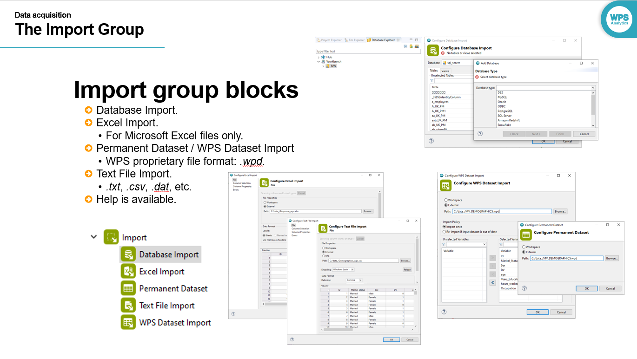

Five blocks are available: Database Import, Excel import, Permanent dataset, Text file import and ALTAIR Dataset Import.

Databases references can be configured using the Database Import block or by right-clicking the Workbench node from the Database Explorer view and selecting New Database.

The Excel Import block can be used to read data from Microsoft Excel files only. Flat files including *.csv*, *.txt*, *.dat* and *.tab* can be imported using the Text File Import block.

The Permanent Dataset and ALTAIR Dataset Import blocks are used to read ALTAIR proprietary file format: *.wpd* only. The Permanent Dataset block is a legacy block and the ALTAIR Dataset Import block is a later addition providing more import options.

Note that help is available from any dialog by clicking the help icon. This will be illustrated when demonstrating.

### Excel Import block

The Excel Import block, as previously mentioned, is used to import data from Microsoft Excel files. The block configuration dialog has four pages: File, Column Selection, Column Properties and Errors.

Figure 2: Excel Import block

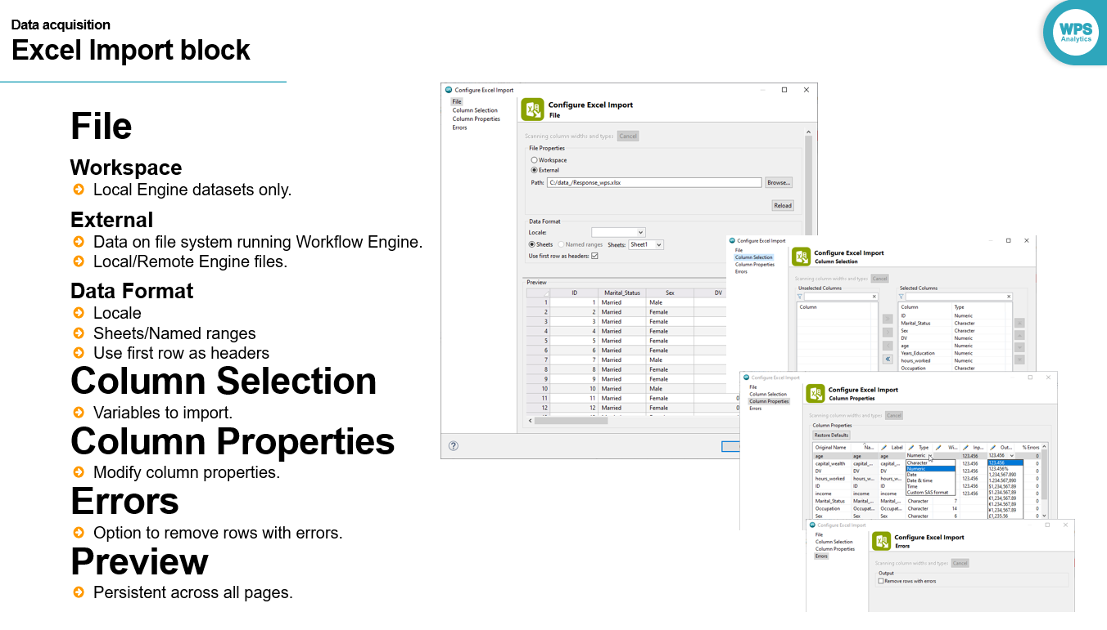

From the File page, the file to import is specified and two options are available: Workspace or External with the ability to browse to and select the file to import. If Workspace is selected, only local Engine datasets are listed when Browse is selected. Choosing the option External, enables the ability to import an Excel file from any location regardless of whether using a Local or Remote Engine.

The Data Format area provides options to specify the locale, select sheets or named ranges and use first rows as headers. If locale specifications are evident in the file being imported, this field is populated automatically. If there are locale specific variables in the file and no locale specifications are evident, a guess is made and this is picked from a list but the locale field will not be populated. Bear in mind that the locale can be selected manually also.

The Column Selection page allows filtering of variables and those to be imported are simply moved from the Unselected Columns list to the Selected Columns list.

The Column Properties page provides the facility to set and modify variable properties. The original variable name is listed with the ability to change this and the variable label as well as modify other properties via drop-down.

The Errors page contains one option: Remove rows with errors. This will exclude any rows deemed to be erroneous.

The Preview displays the data as per options specified and is evident across all pages.

### Text file Import block

The Text File Import block is used to import various flat file formats. The dialog layout is similar to that of the Excel Import block and the pages: Column Selection, Column Properties and Errors are identical in that they provide the ability to select and specify variables and their properties as well as remove rows with errors with a Preview available across all pages.

Figure 3: Text File Import block

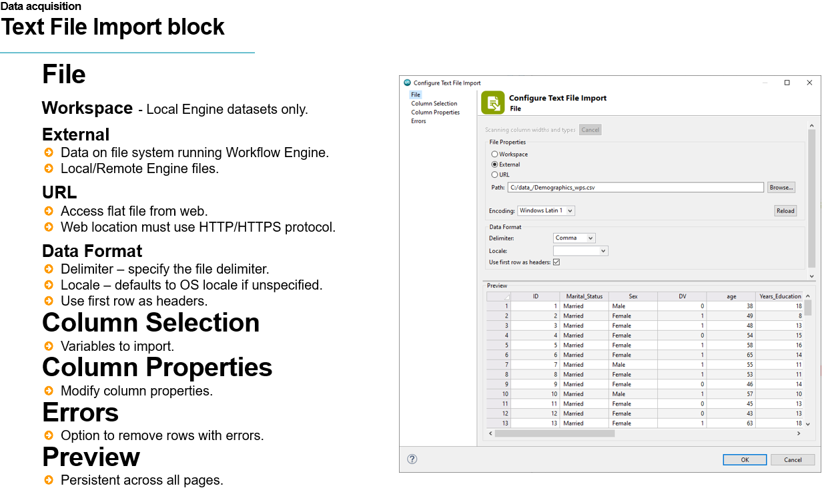

The file page also has similarities in that the file to import can be either Workspace or External. The Text File Import block also includes an additional option: URL. This enables the import of files located on any accessible web site. Only files specified using the HTTP or HTTPS protocols can be imported.

This section also provides the ability to set the file encoding which is detected automatically but can be changed via drop-down.

The Data Format section provides the ability to specify the file delimiter, locale and read the first row of data as variable names. The Delimiter drop-down provides common options and also the ability to select Other and specify a delimiter if not available from the drop-down. The locale option here functions in the same way as the locale option on the Excel Import block and bear in mind this can be set manually.

### Permanent Dataset / ALTAIR Dataset Import block

The Permanent Dataset and ALTAIR Dataset Import blocks are identical in that they are used to import ALTAIR proprietary file format: WPD.

Figure 4: Permanent Dataset / ALTAIR Dataset Import blocks

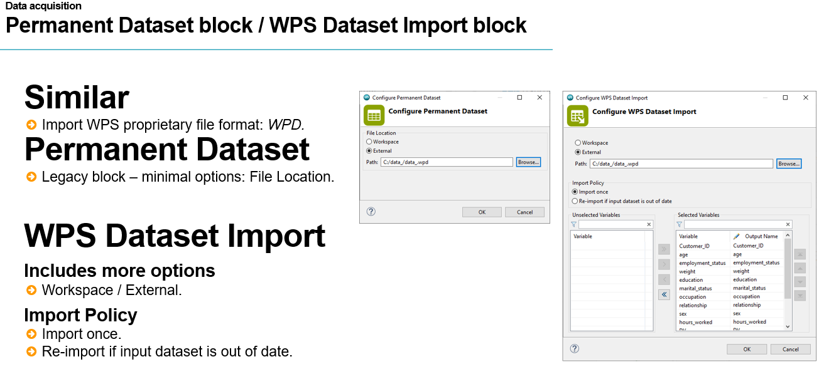

The Permanent Dataset block is a legacy block and has been superseded by the ALTAIR Dataset Import block which provides more options.

Both blocks provide the facility to import from either a Workspace or an External location. In addition to this the ALTAIR Dataset Import block provides the facility to specify the Import Policy as either import once or re-import if input dataset is out of date.

This option relates to a file that has already been imported to a Workflow, if the data in the file has changed setting this option ensures that the file is re-imported automatically when the Workflow is opened.

## Interactive Questions

Q1.

Drag the file onto the block that can be used to import it

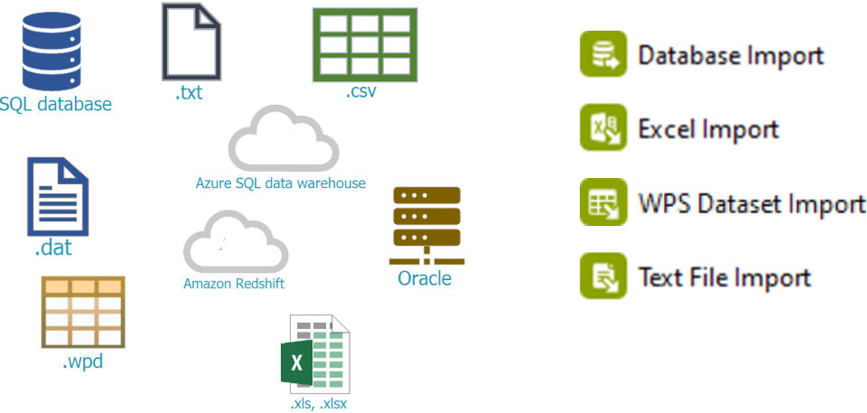

Q2.

When using the Excel Import, Permanent Dataset or Text File Import blocks, data can be imported from a Workspace or from an external location. **t**/f

A:  
When using the Excel Import, Permanent Dataset or Text File Import blocks, data can be imported from a Workspace or from an external location.

Q3:

Drag the words to complete the sentence correctly.

Files, if saved to a _______, regardless of whether they are *.txt*,.*xls*/*.xlsx* or *.wpd* files, can be imported only if using the _________.

**Workspace Local Engine** Workflow desktop installation database import block

A:

Files, if saved to a Workspace, regardless of whether they are .txt, .xls/.xslx or .wpd files, can be imported only if using the Local Engine.

Q4:

When importing a Microsoft Excel file, sheets or named ranges can be imported, but variable names will have to be applied manually. t/**f**

A:

When importing a Microsoft Excel file, sheets or named ranges can be imported. The option: Use first row as headers, will take the first row of data and use its contents as variable names.

Q5.

When importing text files, the delimiter must be one of comma, semicolon, tab or space. If the delimiter is something other that these, the file cannot be imported. t/**f**

A:

Any text file can be imported regardless of delimiter. If the delimiter is anything other than comma, semicolon, tab or space, selecting the option Other, from the Delimiter dropdown, allows specification of the delimiter.

Q6:

What is the ALTAIR proprietary file format extension?

***.wpd***

*.Altair*

*.wfd*

*.wpf*

A:

*The ALTAIR proprietary file format extension is .wpd.*

### Database Import block

The database import block enables the use of already existing database references via a dropdown but also enables the creation of new database references by clicking the icon of the same name.

Once clicked, the Add Database wizard opens. The database type is selected from the dropdown and then it is necessary to proceed through additional pages to configure the connection with particulars such as the data source name and authentication details.

Figure 5: Database import

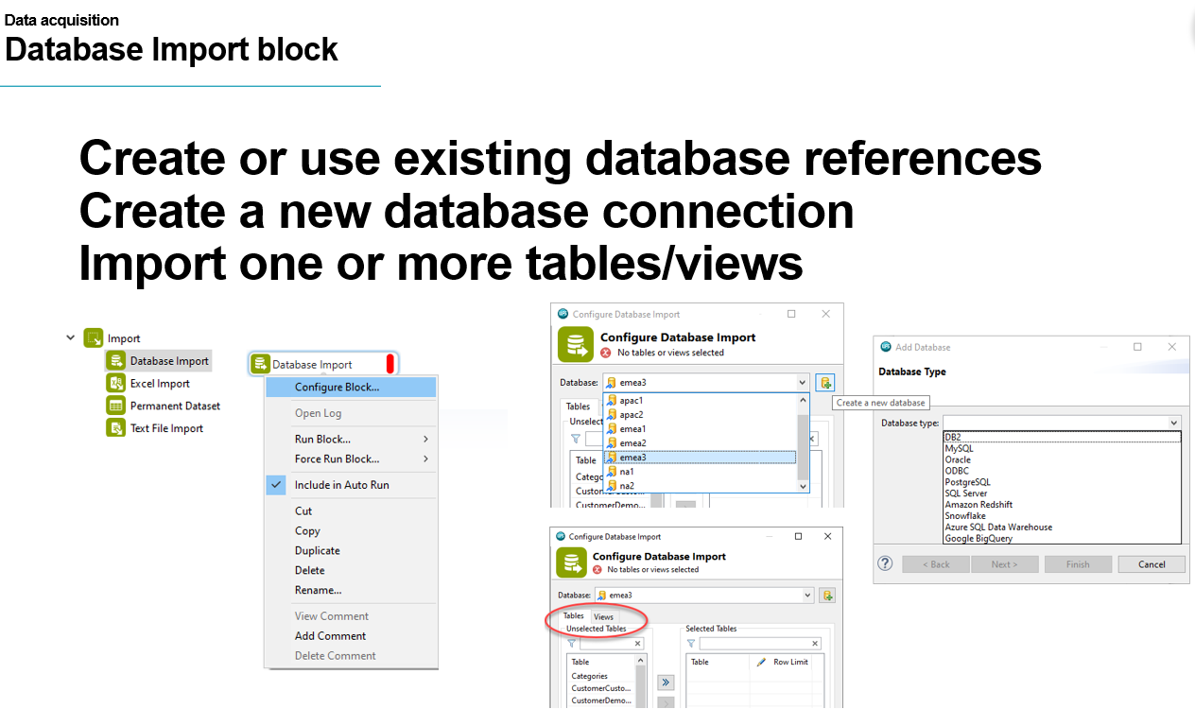

Once the connection has been created, all tables and views are accessible by clicking the appropriate tab and one or more tables and/or views can then be selected.

Rather than use the Database Import block to create a database reference, the Database Explorer view can be used to define a new database reference and also import and export references.

Figure 6: Database Explorer

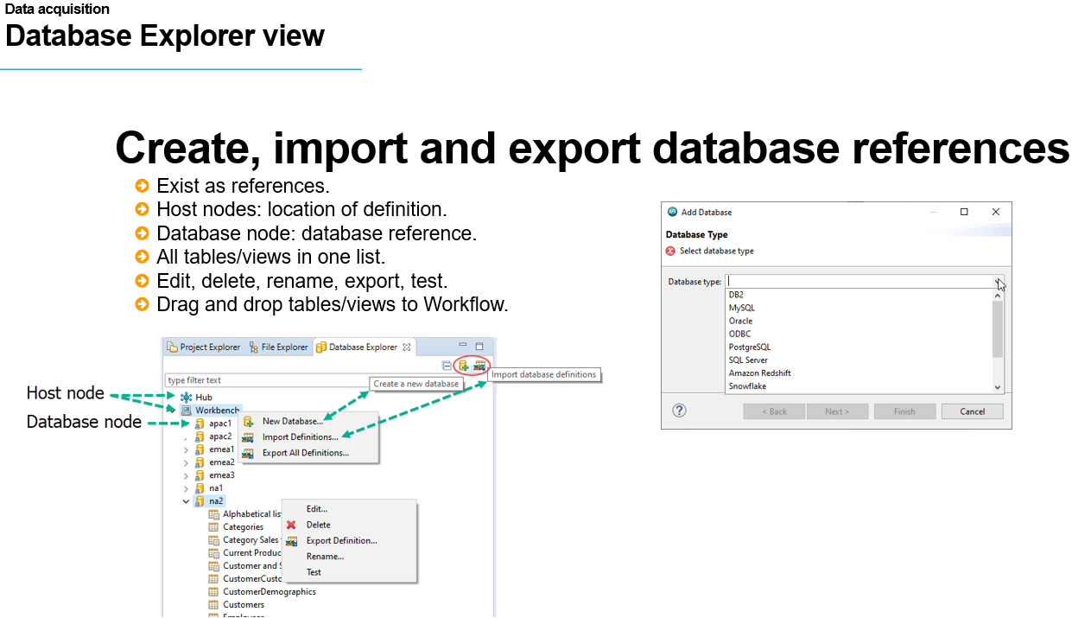

The host nodes define the location of the database reference and there are two: Altair SmartWorks Hub and Workbench. Altair SmartWorks Analytics Hub is a cloud-based solution enabling governance of users and data sources and deployment of programs as APIs.

Users can log into the Hub from the Workbench. Once logged in all references defined and stored there are pushed to the Workbench and appear in an expandable list below the Hub node.

Options to create, import or export references are available using the icons or by right-clicking the Workbench node. Clicking the option New Database opens the same wizard that appears when creating a database reference using the Database Import block.

Additionally, right clicking any database node in the Database Explorer view provides access to options to edit, delete, export the definition, rename, and test the connection.

### Database references

Databases defined using the Database Import block or from the Database Explorer view are references.

Figure 7: Database references

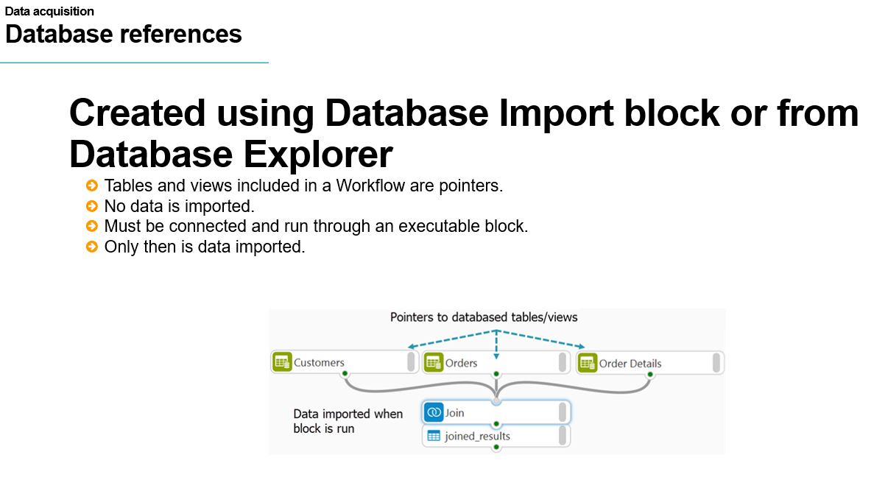

A database reference is a connection to a database listing all tables and views contained therein. Any table or view dragged into the Workflow canvas exist as pointers. A pointer can be thought of as a signpost to the data, it points to it and provides information about it but the data is not imported.

Data is only imported when the tables and views are connected to an executable block and run. As databases tables can be large and when accessing information from them, there is generally a need to get information from more than one table.

Importing all tables individually and then applying, for example a join operation can be quite inefficient, having pointers means that tables can be used in a Workflow, a join operation set-up, and only at the point of the join being run, is the data imported.

Database references and pointers ensure efficiency and time saving when accessing data contained in databases.

One question then arises is what is the difference between creating a database reference using the Database import block in comparison to the using the Database Explorer view?

Figure 8: Database references

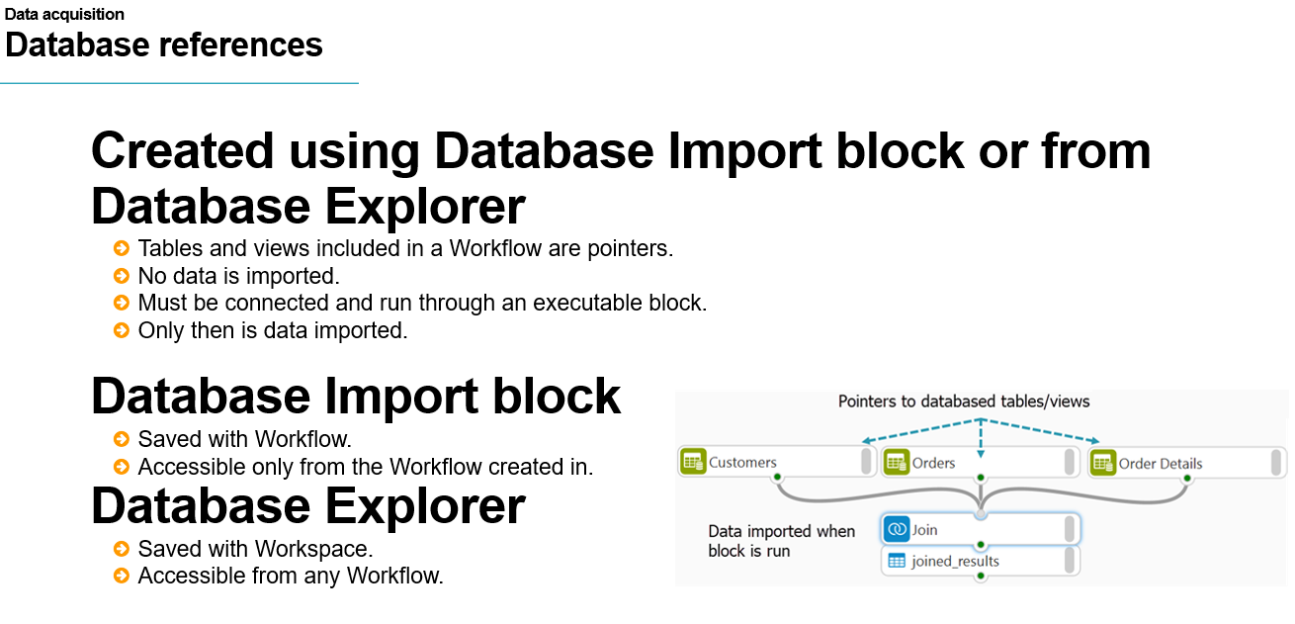

Database references defined using the Database Import block are saved with the Workflow they are defined from and are only accessible to it, whereas database references defined from the Database Explorer view are saved with the Workspace and are available and accessible from any Workflow.

### Settings tab

The settings tab lists all database references and options are available to add, edit, rename, remove, and test any connection and all databases defined using the Database import block are automatically added to this view.

Database references defined using the Database Explorer appear when a view or a table is used in a Workflow. Note that all connections evident here appear in the Database Import block database connections drop-down.

Figure 9: Settings tab

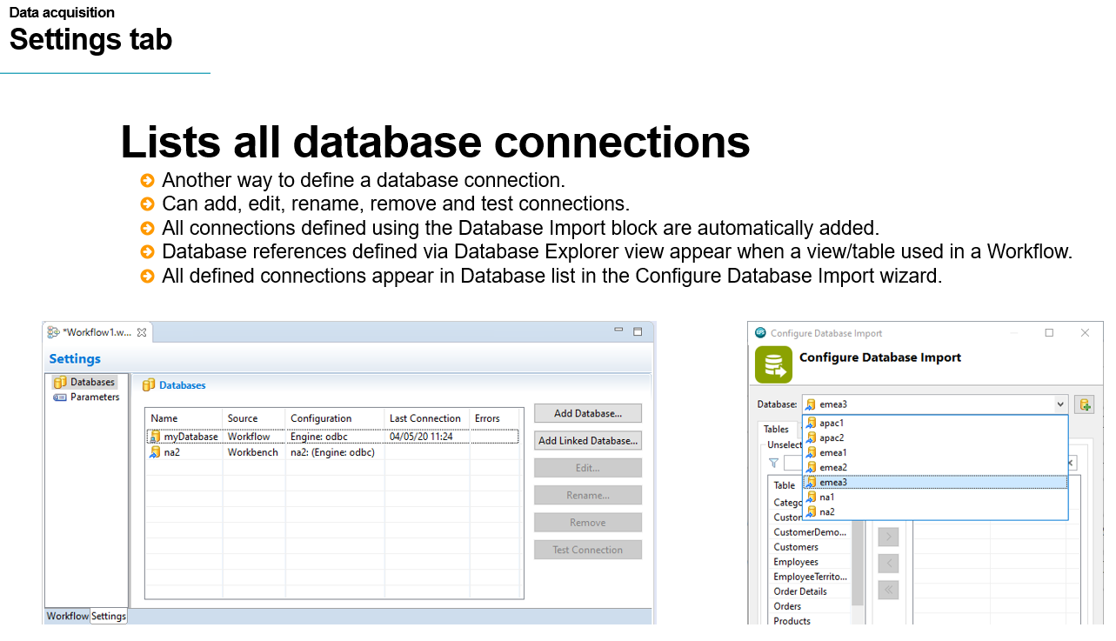

## Interactive Questions

Q1:

The Add Database wizard pages are the same regardless of what database connection is being created? t/**f**

A:  
The Add Database wizard pages may vary depending on the database being connected to.

Q2:

Drag the words to complete the sentence correctly.

The _________ can be used to define a new ________ by either right clicking the Workbench host node and selecting New Database or by clicking the shortcut icon: Create a new database.

**Database Explorer view database reference** Data source Database Import block

Add Database wizard

A:  
The Database Explorer view can be used to define a new database reference by either right clicking the Workbench host node and selecting New Database or by clicking the shortcut icon: Create a new database.

Q3:

Database references defined from the Database Explorer view can only be created by right-clicking the Workbench host node. Database references cannot be created using the Hub host node because:

The Hub host node is not active.

**Hub database references are defined in the cloud and pushed to the Workbench only when a user logs into the Hub from the Workbench.**

This location can only be accessed if connecting using a remote engine.

Hub database references can only be imported. This is accomplished by right-clicking.

A:  
Database references defined from the Database Explorer view can only be created by right clicking the Workbench host node. Database references cannot be created using the Hub host node because they are defined in the cloud and pushed to Altair Analytics Workbench only when a user logs into Altair SmartWorks Analytics Hub from Altair Analytics Workbench.

Q4.

Database tables and views are pointers. Data is only imported when the table or view is used in a Workflow and connected to an executable block. **t**/f

A:

Database tables and views listed in the Database Explorer are pointers. Data is only imported when the table or view is used in a Workflow and connected to an executable block.

Q5:

The Settings tab lists all database connections:

Created using the Add Database wizard.

Created using the Add Database wizard from the Database Explorer view.

Created using the Add Database wizard from the Database Import block.

**Used in a Workflow, created using the Add Database wizard from the Database Import or added from the Settings tab.**

A:

The Settings tab lists all database connections that are used in a Workflow or added from the Settings tab. References defined using the Database Explorer view only appear here when a table or view is used in a workflow. Databases defined using the Database Import wizard appear in the settings tab immediately.

## Demonstration

So onto a demonstration. This demonstration uses the Workflow created in the previous lesson with the Workflow canvas cleared.

### Excel Import

Expanding the import group reveals the six import blocks. Dragging an Excel Import to the canvas outputs an empty dataset and the block configuration status is red, hovering displays a message: Import not yet configured.

Either double-clicking provides access to its configuration dialog. With the Excel Import block, data can be import from files in a current Workspace when using Local engine. As this is the case here, this option is selected and Browse clicked.

Note that the dialog is blank and the message: No files found is evident. To illustrate this option more clearly, a new empty project called temp_ is created in the Project Explorer and a Microsoft Excel file copied to it.

Returning to the **Excel Import block configuration** dialog and **choosing the same option** it can be seen that the new project is listed and when **expanded** the Microsoft Excel file copied previously is available. This option works in the same way for the Permanent Dataset, ALTAIR Dataset and Text File import blocks in that If Workspace is chosen, only projects containing files of that format are listed, and only if Local Engine is in use.

The **created project is deleted** and the Excel Import block configuration dialog accessed. **Selecting External** allows browsing of the file system the engine is installed on. The current engine is local, meaning a desktop/laptop installation and therefore its files system is visible and navigable.

Here, the data folder in the ALTAIR eLearning **directory is expanded** and all Microsoft Excel files are listed. The **file *data_.xlsx* is selected** and **Finish clicked.**

From the data format area sheets is selected by default and the **dropdown lists the first sheet**: data_. Clicking the dropdown it can be seen that this is the only sheet available, but if there were others they would be listed here. Note if there is interest in importing data from multiple sheets, multiple import blocks must be used.

The Locale is left blank and adopted from the operating system. As a result of Use first row as headers being selected by default, variable names are visible in the Preview area.

From the **Column Selection page** it can be seen that all variables are by defaulted selected and evident in the **Selected Columns list**. If there is interest in not importing variables they should be moved from the Selected Columns list to the **Unselected Columns** list.

The **Column Properties page** provides the capability to specify variable properties. Note the first column contains the original variable names. To change either the name or the Label is a matter of **clicking the appropriate column** for any variable and typing a new name or label.

Other variable properties can be modified by selecting an appropriate option from a dropdown, for example, to change the variable type, the Type column drop-down is clicked and the type to apply to the variable can be easily selected.

Note also that on this page is a %Errors column. This relays the number of observations with errors for that particular variable. As can be seen, all variables have a value of 0, meaning there are no observations with errors.

From the Errors page, there is only one option: Remove rows with errors. This is not selected here as there are no observations with errors.

Clicking the Help icon provides additional detail for all available options and also lists related content, clicking the Help icon again, closes the help page and clicking OK, runs the process and imports the data.

Notice that the execution status of the block is green and hovering displays the message Completed successfully and up to date.

The data can be viewed by double-clicking, this opens the Dataset File Viewer with data visible. Returning to the Workflow, right-clicking the imported dataset and selecting the option Open With provides two options: Dataset File Viewer and Data Profiler. Double-clicking the block has the same effect as selecting the option Dataset File Viewer in that both open the data with the Dataset File Viewer.

Right-clicking the Excel Import block and selecting the option: Configure Outputs opens the Excel Import block Outputs dialog.

Note that the Selected Output columns lists the created dataset and the Unselected Output list contains an entry named Errors. Moving this to the Selected Output list and clicking OK, an additional dataset is evident on the canvas named Errors.

Opening this dataset reveals that it contains variable names but is empty, this is not surprising because as was evident from the Column Properties page, there were no observations with errors as denoted by the 0 for all variables in the %Errors column.

If there were, these observations would be evident in the Errors dataset.

### Text File Import

To import a text file, a Text File Import block is used - again dragging onto the canvas and accessing configuration settings reveals a lot of similarity with the Excel Import block. Here, again, the option External is selected and the data folder in the ALTAIR eLearning directory navigated to.

Considerably more files are evident, including Microsoft Excel files. However, the Text File Import block cannot be used to read this format. Here, the file: *data_.csv* is selected. The delimiter is automatically detected and set as Comma.

Other delimiters can be selected and if the required delimiter is not listed, selecting Other provides the facility to specify any. Note that it may sometimes be necessary to open the file in a text reader to gain this information.

The Locale is left blank and the option: Use first row as headers is automatically selected and as a result variable names are evident in the Preview along with the data.

Options available from the Column Selection, Column Properties and Errors pages are identical to those available from the Excel Import block and are not modified here.

Clicking Help, again provides access to help for the Text File Import block and related content and clicking OK imports the data.

Right clicking the block and choosing Open With again provides options to open the data with the Dataset File Viewer or the Data Profiler, here the Dataset File Viewer is chosen and the data is revealed.

### Permanent Dataset / ALTAIR Dataset Import

The Dataset Import block is used to import ALTAIR’ proprietary file format: *.wpd*.

Accessing configuration settings reveals one page with options to read from a Workspace or an External location.

Here External is chosen, the same folder is accessed via the browse button and the file *data_.wpd* selected. This has the effect of moving all variables into the Selected Variables list. Clicking the Output Name for any variable provides the facility to change it if desired.

The order of variables can also be modified by selecting one or more variables and using the options to the right-hand side to move as required.

The Import Policy enables an already imported *.wpd* dataset to be re-read if the data has changed. This happens automatically when the Workflow is opened if this option is selected.

Once complete, OK is clicked and the file imported and double-clicking opens with the Dataset File Viewer.

### Interactive Questions

Q1:

When using the Text File Import, Excel Import or Permanent Database blocks, if Workspace is chosen as the File Location, only projects that contain files of the format being imported are listed. **t**/f

A:

When using the Text File Import, Excel Import or Permanent Database blocks, if Workspace is chosen as the File Location, only projects that contain files of the format being imported are listed.

Q2:

When using the Text File Import, Excel Import or Permanent Database blocks, if External is chosen

as the File Location, this allows browsing of the file system the engine is installed on. For example,

if the engine is remote, all accessible locations on the server ALTAIR is installed on can be browsed to locate the file to import. **t**/f

A:

When using the Text File Import, Excel Import or Permanent Database blocks, if External is chosen as the File Location, this allows browsing of the file system the engine is installed on. For example, if the engine is remote, all accessible locations on the server that ALTAIR is installed on can be browsed to locate the file to import.

Q3:

If multiple sheets exist in a Microsoft Excel file, they can all be imported with one Excel Import block. t/**f**

A:

If multiple sheets exist in a Microsoft Excel file, they must be imported individually and a separate Excel Import block must be used for each.

Q4:

Help for any import block is available only from the Help menu. t/**f**

A:

Help for any import block is available from the Help menu and also from within the block. This can be accessed by clicking the Help icon.

Q5:

.csv files can be imported using the:

**Text File Import block**

Database Import block

Permanent Dataset block

Excel Import block

A:

You chose the correct responses, .csv files can be imported with the Text File Import block.

Q6:

The Permanent Dataset and ALTAIR Dataset Import blocks are used to import .wpd files, ALTAIR proprietary file format. In comparison to other import block there are very few configuration options because:

The data format is not complex and can therefore be easily imported.

**The format of the file is known as it is proprietary.**

Headers do not need to be read.

Options to set the structure and format are applied once the file is imported.

A:

The Permanent Dataset and ALTAIR Dataset Import blocks are used to import .wpd files, ALTAIR proprietary file format. In comparison to other import block there are very few configuration options because the file is proprietary and its format is known.

### Database Import block

The Database Import block enables database references to be created in a Workflow. Dragging the block onto the canvas and accessing its configuration dialog automatically opens the add database wizard.

Closing this momentarily reveals why: currently no databases are available for selection and must be added. Clicking the Create a new database icon opens the Add Database wizard as before. From the drop-down the database type must be selected, here, ODBC is chosen and clicking next navigates to the ODBC Settings page.

Figure 10:ODBC Settings

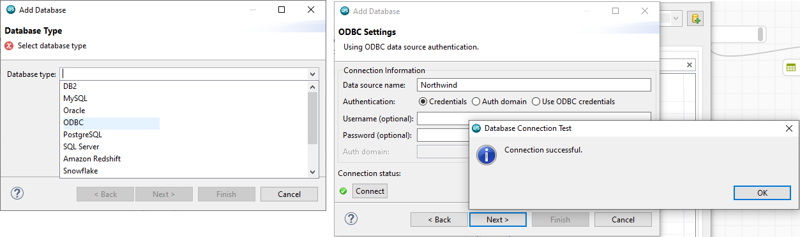

The path through the wizard is slightly different depending on the database type selected. Here the database to connect to must be supplied via Data source name and the method of authentication selected.

Depending on the authentication selected, a username and password may be necessary. Here, credentials are selected and a username and password supplied. The connection must be tested and successful prior to being able to proceed.

The next page allows the selection of the schema, if this is not known, it can be left blank and the database default will be used. Clicking Next> displays options to provide a name to reference the database.

Here databaseA is entered and once Finish is clicked all database tables are listed by default, selecting the Views tab lists all available views.

One or more tables and/or views can be selected and moved from the unselected list to the selected list by either using the chevrons or double-clicking.

Figure 11: Database tables

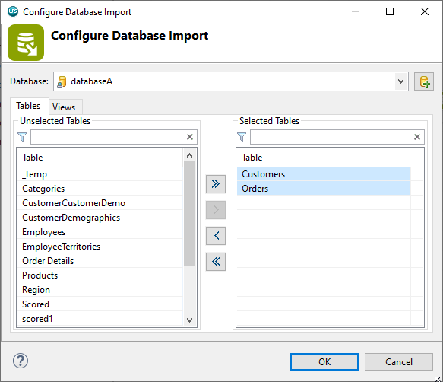

Clicking OK results in the database and table references being evident on the Workflow canvas. Note that the variable and observation count are visible as a result of the option Show/hide observation count being selected. Notice there is a question mark for the number of observations.

Figure 12: Database tables in Workflow

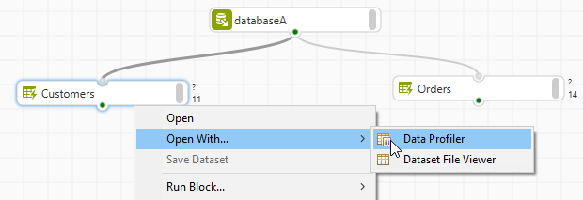

One thing to bear in mind here is that these are currently references or pointers to the database tables. The data is not imported to the Workflow until the table references are connected to and run through an executable block.

This is further illustrated when viewing results with the Data Profiler. From the Summary View tab it can be seen that the number of variables is evident but the Number of observations is as yet unknown.

A Select block is added from the Data Preparation group and connected to the Customers table reference. All variables are retained and the resulting dataset is again opened with the Data Profiler.

As can be seen both the number of variables and observations are now evident. As a result of running the table through an executable block, the table has been imported and its data read.

## Settings tab

Clicking the settings tab provides access to all database references used in the Workflow and notice the recently added database appears here.

Figure 13: Settings tab

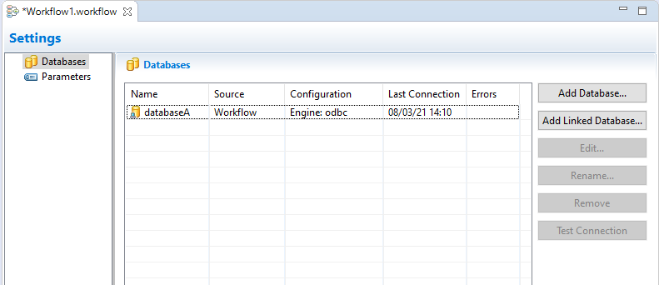

Selecting any database provides options to edit, rename, remove and test the connection. Databases can also be added via Add Database.

This opens the Add Database wizard as before. Note the help option, again, clicking this provides access to help. This includes links to additional Help pages to assist when adding a specific database type.

The Database Explorer view provides an additional mechanism to add databases by either using the Create a new database icon or by right-clicking the Workbench node and selecting the option New Database.

This opens the same Add database wizard to that accessed from the Database Import block. Here, the the same database is configured and named databaseB.

Figure 14: New Database...

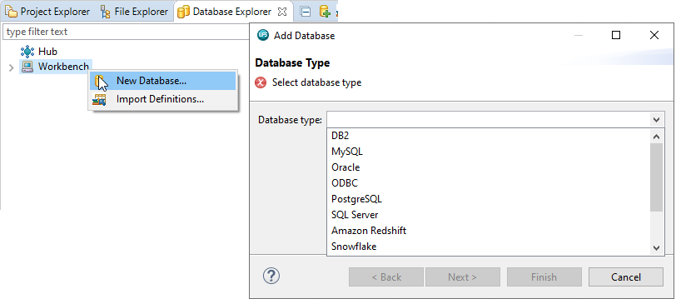

The Workbench node is now expandable and lists all added databases - here there is only one: DatabaseB. Expanding it reveals all tables and views in one list.

Figure 15: Database in Workbench

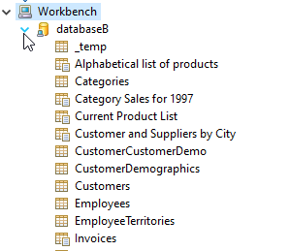

Notice that the settings tab does not list this database currently, this is because only databases used in a workflow are listed here.

All the tables and views in databaseB are, again, pointers. These can be dragged onto the Workflow

Canvas. As a result of this databaseB now appears in settings.

Right clicking any added database node from the Database Explorer view provides options to edit, delete, rename, export definition, and test the connection.

Right clicking the host node, provides options to create a new database, import definitions and export all definitions. The Export All Definitions option saves all defined databases to a *.dsx* file. This can be shared for easy configuration. Here the option Export All Definitions is selected, the name All_ applied and the *.dsx* file saved to the data folder used previously.

Right clicking the Workbench host node and choosing the option Import Definitions and navigating to and selecting the file previously exported automatically creates new databases. Notice that the previously exported definition is replicated with an additional character.

Bear in mind this duplicates the already existing database reference databaseB but serves to illustrate the export and import of database definitions.

One final point to note is that there is a difference between defining a database reference using a Database Import block in comparison to using the Database Explorer view to do the same.

Database references defined from the Database Explorer ensures that the database reference is available to any Workflow – this is illustrated by creating a new Workflow, notice that the databases defined and imported using the Database Explorer are available to it.

The database defined using the Database Import block in the previous Workflow – databaseA is not, this is because database references defined using the Database Import block are saved with the Workflow they are created from and are only available to it.

## Interactive Questions

Q1:

Multiple database tables and/or views can be accessed and included in a Workflow as pointers using one Database Import block. **t**/f

A:

Multiple database tables and/or views can be imported in one step with the Database Import block.

Q2:

When using the Database Import block for the first time and when configuring the block, the Add Database wizard will open. Why?

Because a database connection must be defined.

This is standard functionality and the wizard always opens when the block configuration settings are accessed.

This does not happen automatically.

**Because no database connections are currently defined or available.**

A:

When using the Database Import block for the first time. The Add Database wizard will open because no database connections are currently defined or available.

Q3:

Drag the words to complete the sentence correctly.

Regardless of the _______ being connected to, a data source name and ________ are always required.

**database** **authentication details** URL file

You chose the correct responses. Regardless of the database being connected to, a data source name and authentication details are always required.

Q4:

A database connection must be tested and the database successfully connected to, to define the connection. **t**/f

A:

A database connection must be tested and the database successfully connected to, to define the connection.

Q5:

If a database definition already exists under the Workbench host node and also exists in a *.dsx* file along with other database definitions. Importing the *.dsx* will import all database definitions but will ignore any that are already present. t/**f**

A:

All definitions are imported, even if a definition already exists.

## Summary

This lesson focused on the Altair Analytics Workbench Import group and blocks available to read from various data sources.

Each block was introduced and settings highlighted, additionally the creation and management of database connections was focused on prior to a demonstration of capabilities.

# Chapter 4: Data exploration and profiling

## Introduction

Contents for this lesson include an introduction and focus on the functionality available in Altair Analytics Workbench to explore and profile data.

The Dataset File Viewer and Data Profiler are introduced as well as the Chart Builder block. The use of

the SAS Language perspective for data exploration and profiling is also covered. A demonstration follows prior to outlining additional methods to explore data prior to a summary.

Figure 1: Contents

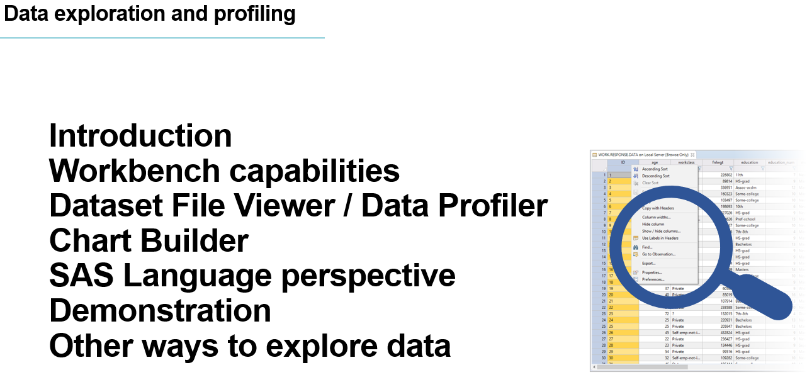

Profiling and exploring data is of primary importance in any analytics endeavour and leads to better data understanding, what data to use, what techniques can be applied and in general will make processing the data more efficient.

There are many ways to investigate data, the first step is to simply view contents: columns and rows and then generate statistics, tables, charts and graphs to generate insight. Modelling techniques can also be applied.

Figure 2: Introduction

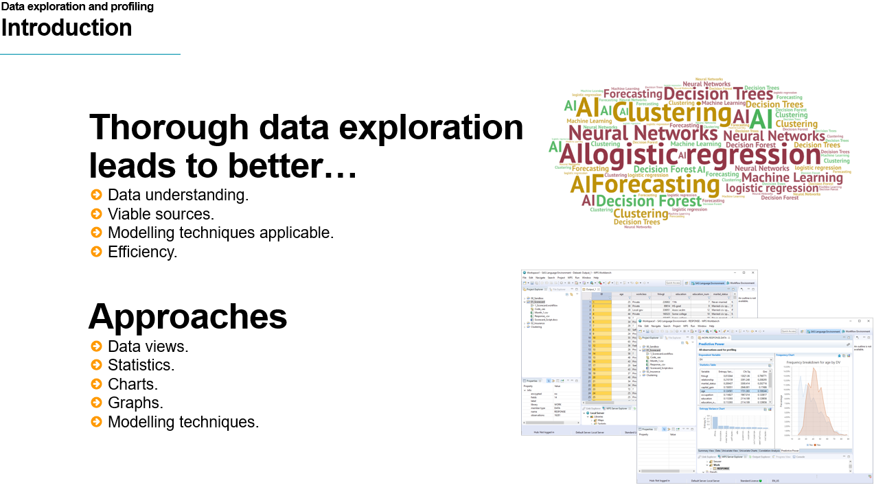

Altair Analytics Workbench provides many capabilities to explorer and profile data including the Dataset File Viewer and Data Profiler, the Chart Builder and the SAS Language perspective.

Figure 3: Altair Analytics Workbench capabilities

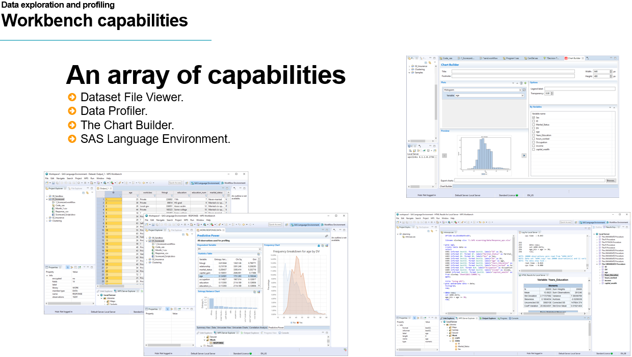

The Dataset File Viewer and the Data Profiler provide a means to view and profile data and are available

across both the SAS Language and the Workflow perspectives.

Even though both views are accessible via right click, double- clicking a dataset in either of these views

opens the Dataset File Viewer. This is a spreadsheet style display with variables in columns and observations in rows. Right-clicking any variable provides options and filtering capabilities are also included.

The Data Profiler is accessed via right-click only and includes the spreadsheet style display with additional profiling tabs containing statistics and charts to better understand and profile data.

Figure 4: Dataset File Viewer / Data Profiler

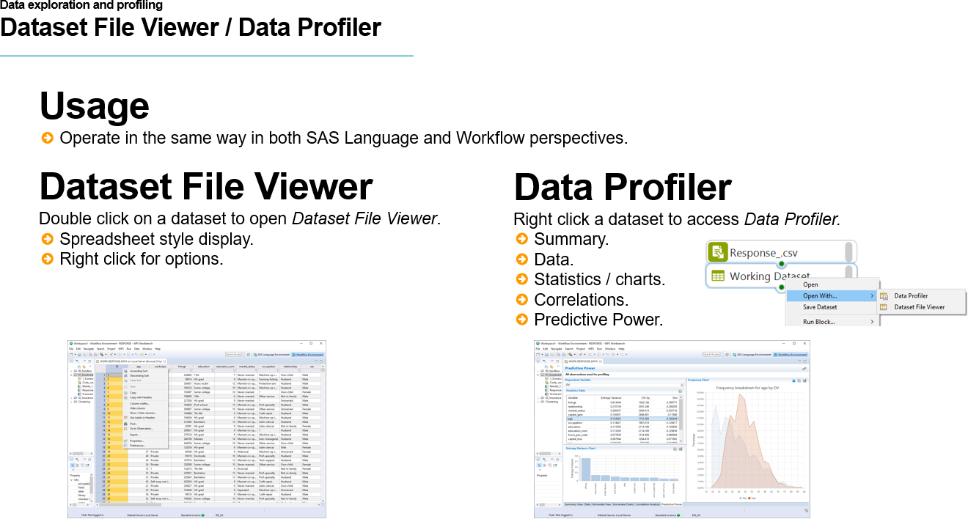

The Chart Builder is a Workflow block found in the Export group. This provides an easy mechanism to generate charts. Overlays and by variables can also be included for additional insight.

Figure 5: Chart Builder

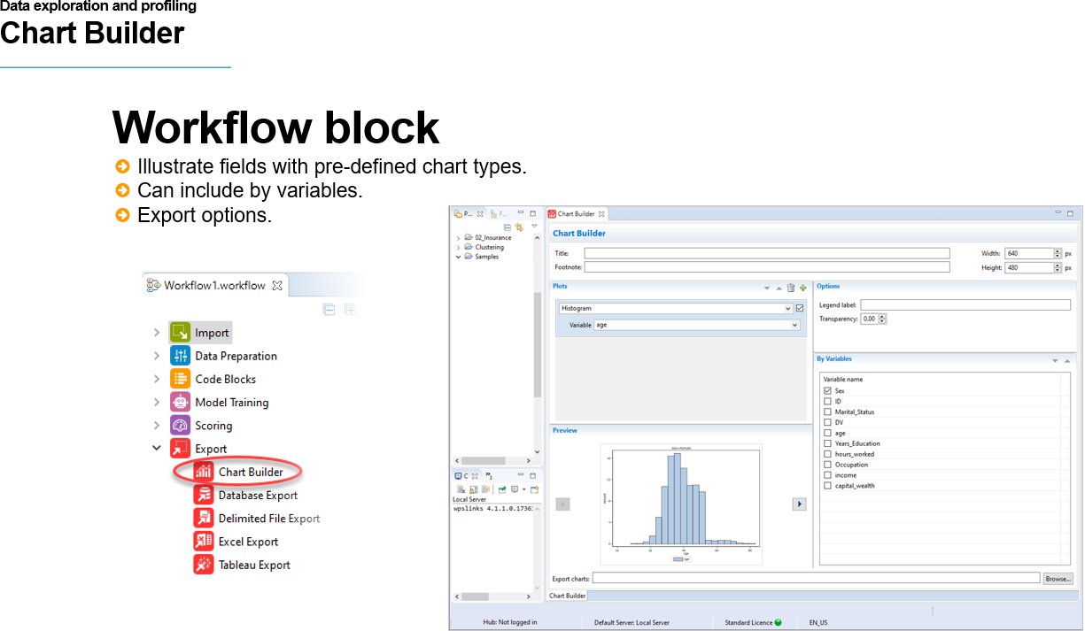

The SAS Language perspective provides a wealth of capability to profile data but requires knowledge of the language of SAS to use effectively. Some simple commands can be used to generate insights

and create tables, but the data must be opened in the SAS Language perspective.

Extracting a dataset from the Workflow can be easily achieved by using a SAS code block containing a simple *libname* statement. Once complete, the data can then be easily accessed and used in the SAS Language perspective.

Figure 6: SAS Language perspective

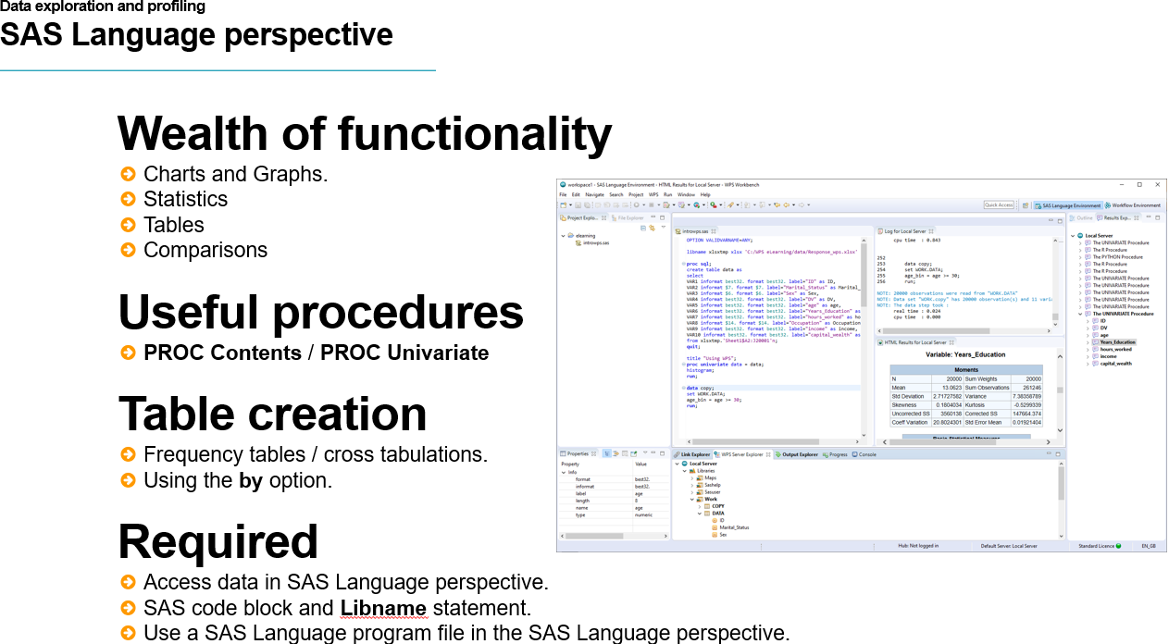

## Interactive Questions

Q1:

Select all correct statements. Thorough data exploration leads to:

**A better understanding of the data being worked on.**

A better understanding of where to process the data.

**A better understanding of what data sources to include for a given project.**

A better understanding of what modelling techniques to apply.

A:

Thorough data exploration leads to a better understanding of the data being worked on, what data source should be included for a given project and a better understanding of the modelling techniques that can be applied.

Q2:

Click on the image of the view which opens when a dataset is double-clicked.

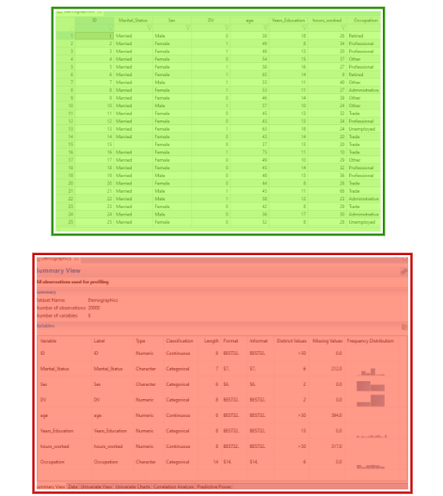

A:

Double-clicking any dataset opens the Dataset File Viewer, which is a spreadsheet display of the data.

Q3:

Which of the following Altair Analytics Workbench elements is not used for data profiling:

The Data Profiler

The Dataset File Viewer

**The Properties View**

The Chart Builder

A:

The Properties view is not used for data profiling. It relays information for selected Workbench entities.

Q4:

The Dataset File Viewer does not provide an option to:

Sort

Filter

Export

**Add new variables**

A:

The Dataset File Viewer includes useful features such as filtering, sorting and the functionality to export, but does not include the capability to add new variables.

Q5:

Select all correct statements:

The Data Profiler is available from the SAS Language perspective only.

**The Data Profiler includes the Dataset File Viewer and additional profiling tabs.**

The Chart Builder block is accessible via the SAS Language perspective and the Workflow perspective.

**Workflow data can be made available in the SAS Language perspective via a SAS Code Block.**

A:

The Data Profiler includes the Dataset File Viewer and additional profiling tabs. Workflow data can be made available in the SAS Language perspective via a SAS Code block and also by exporting the data. The Data Profiler is available across both the SAS Language and Workflow perspectives. The Chart Builder block is accessible from the Workflow perspective only.

## Demonstration

So let's get on to a demonstration. This demonstration starts from the Altair Analytics Workbench Workflow perspective with a clean slate.

A project folder is added **by right-clicking the Project Explorer view selecting New and then Project**. From here, General is expanded and Project selected. Clicking Next provides the option to specify the project name, here, First_Project. The project default location is accepted, which is the Workspace root directory but can be changed if desired.

Figure 7: New project creation

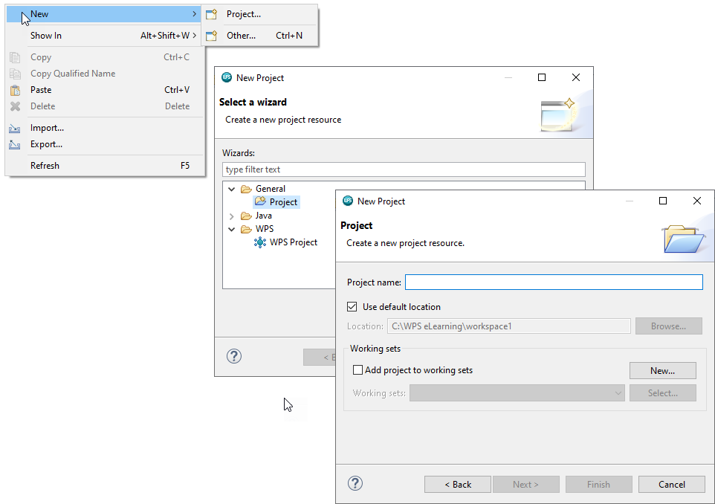

Once complete, clicking Finish creates the project and the project folder is visible and appears in the Project Explorer view.

A Workflow is added to the project by **right-clicking the project folde**r **and selecting New > Workflow.**

Here the name First_Workflow is assigned and clicking Finish adds the new Workflow to the project folder and this is automatically opened in the Workflow perspective.

The file used here is a *.csv* file called *Model_View* and can be found in the data folder. This can be located using the File Explorer view. Double-clicking opens the file in Microsoft Excel.

As can be seen there is an id variable, some demographics and financial details as well as a variable called *DV* with two values: *0* and *1*.

This file can be imported to the Workflow using a number of methods. The first is by using an appropriate block from the import group - as this is a *.csv* file, the Text File Import block is used.

The block can be dragged from the group, or by double-clicking the Workflow canvas with the left mouse button - all blocks can be accessed.

A quick method, given this is a known file type, is to drag the file directly from the File Explorer onto the

Workflow canvas. Hovering over the block indicator shows that additional configuration is required.

Figure 8: Import not yet configured

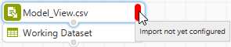

Double-clicking the block opens its configuration dialog.

Figure 9: Text File Import block

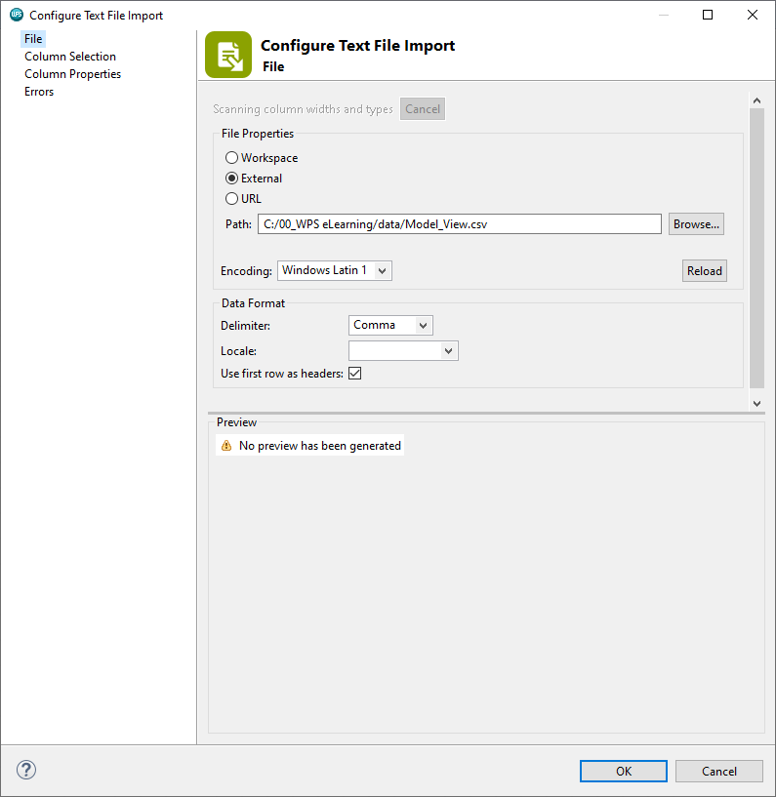

The configuration dialog opens on the File page and as can be seen the Preview displays No preview has been generated. It can be seen from the File page that the file particulars are set correctly, and other pages also list the dataset variables and properties.

Clicking OK it can be seen that the block indicator status is now grey, meaning the block is configured correctly, but the block execution status is red and hovering displays the message: Execution failed with errors.

Figure 10: Execution failed with errors

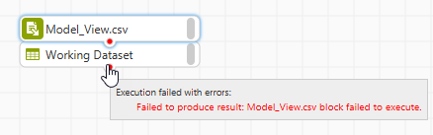

The message does not provide any insight in terms of why there is an error so further investigation is necessary. Right-clicking the block and selecting Open Log provides more detail.

Figure 11: Block log

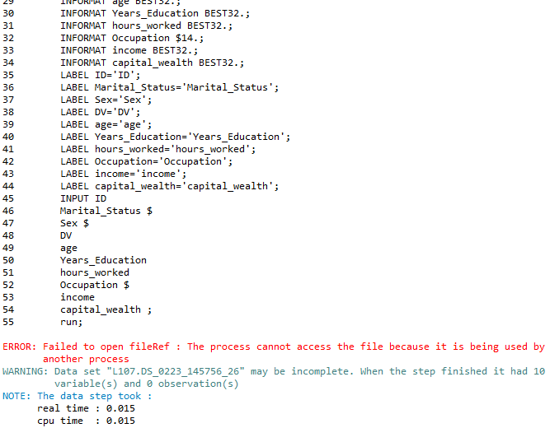

From the log, its easy to see why the block is not executing, the file is being used by another process. This is due to the file being currently open in Microsoft Excel.

The file is closed and the block right-clicked. From here Run block > Run To Block is selected and now the block execution status is green meaning the data has been imported successfully. At this point the file is renamed to *Model_View*.

The dataset can be opened by either double-clicking the dataset or by right-clicking and selecting Open or Open With and choosing either Data Profiler or Dataset File Viewer.

Choosing Open, or Open With > Dataset file Viewer or simply double-clicking the dataset opens the Dataset File Viewer.

Figure 12: Dataset File Viewer

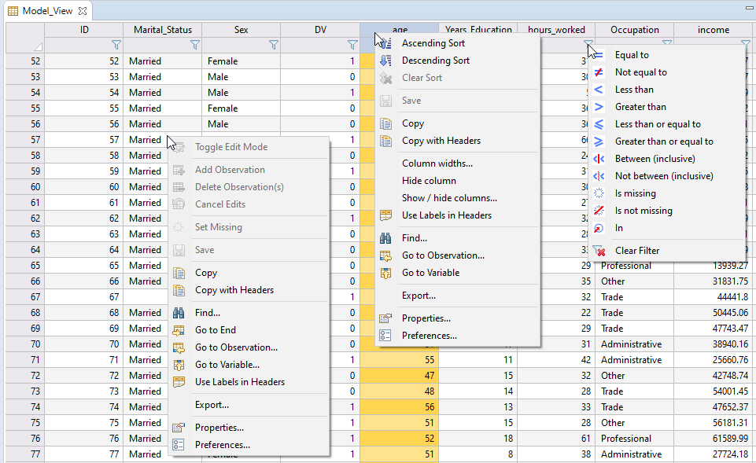

This is a spreadsheet style display with variables in columns and observations in rows. Right-clicking provides access to sort, copy, search, and export options. Note that sort options are only available when a variable header is selected and right-clicked.

Properties provides access to variable and dataset information. The Columns page lists all dataset variables and their properties.

Figure 13: Columns

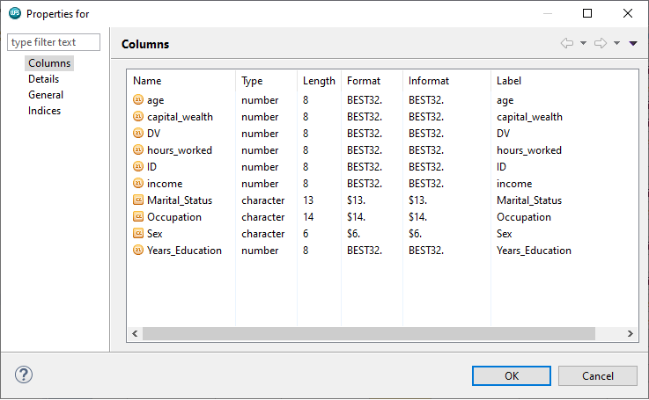

Other pages provide additional dataset details.

Each variable can be filtered by accessing the filtering icon and selecting an option, the filter applied is displayed as a label below the variable name, and multiple filters can be applied, and here a filter is applied to the variable age: Age ge 79.

As can be seen, only three observations meet the filter criteria of being greater than or equal to 79.

The dataset can be exported by right-clicking and selecting Export. Three options are available: Delimited, Fixed width and Excel. Note that selecting either Delimited or Fixed width provide a preview of the data and this includes the filter applied previously.

Figure 14: Export

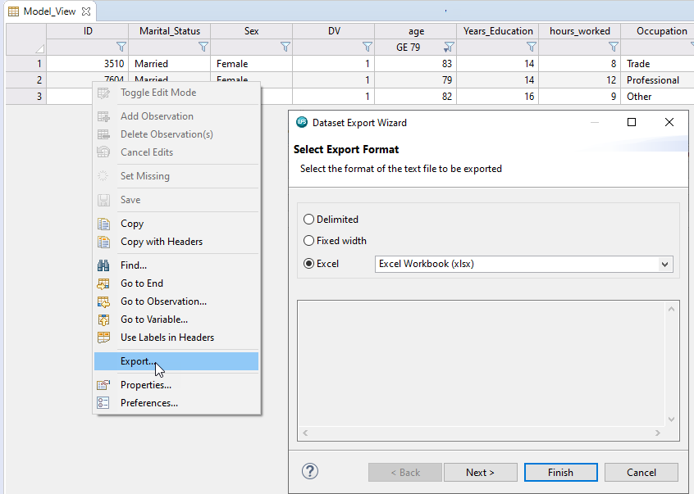

Here Excel is chosen and clicking Next provides options to specify the export location. Additional options to open the file once the export is complete and overwrite an existing file are also present.

The option Open when complete is selected and clicking Next reveals the SAS language code for the export. Clicking Finish runs the export and opens the file in Microsoft Excel.

Note that the filter applied previously has still applies

## Interactive Questions

Q1:

Data cannot be imported to a Workflow by:

**Double clicking the file from the File Explorer view**

Using a block from the Import Group.

Dragging from the Project Explorer.

Dragging from the File Explorer.

A:

Data can be imported to a Workflow by using an Import group block or by dragging and dropping from the Project Explorer or File Explorer views. Data cannot be imported by double-clicking a file from the File Explorer view, this will open the file for viewing but not import it!

Q2:

A red execution status indicator means the block has not yet been configured.t/**f**

A:  
A red execution status means there were errors running the import. A red configuration status means the block has not yet been configured.

Q3.

Select all incorrect statements.

Any filter applied to a variable in the Dataset File Viewer appears as a label below the variable name.

**When exporting data from the Dataset File Viewer filters used are applied.**

**The Data Profiler is accessed by right-clicking a dataset and selecting the option: Open.**

The log can be used to determine the cause of execution status error messages.

A:

Any filter applied to a variable in the Dataset File Viewer appears as a label below the variable name. The log can be used to determine the cause of execution status error message. The Data Profiler is accessed by right-clicking a dataset and selecting Open With > Data Profiler. When exporting data from the Dataset File Viewer, filters are not applied.

## The Data Profiler

The Data Profiler is accessible from either the SAS Language or Workflow perspective by right-clicking any dataset and selecting the option: Open With > Data Profiler.

Figure 15: The Data Profiler

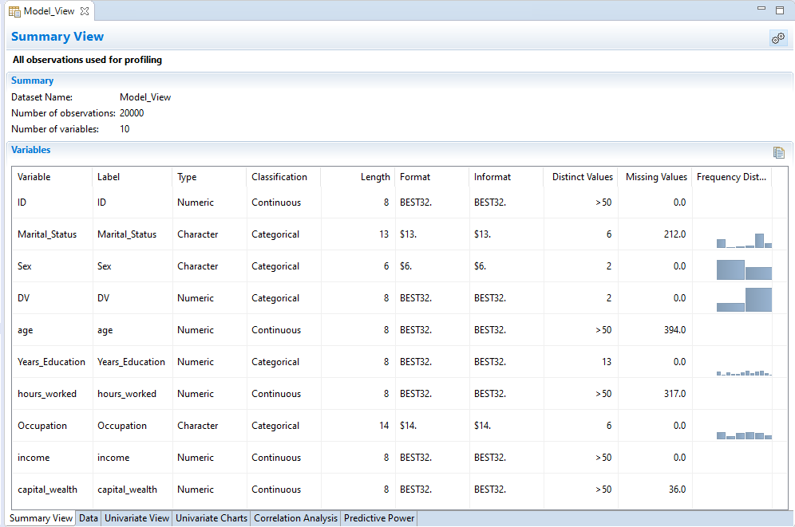

The Data Profiler opens in a new panel and contains a number of profiling views accessible by selecting an appropriate tab, one of which, the Data tab, contains the Dataset File Viewer with options and filtering capabilities as previously described.

The Summary View tab provides an overview of the dataset and its contents including its name, number of observations and number of variables, here 20000 and 10 respectively.

Dataset variables are visible with characteristics in columns including name, label, type, classification, length, format, informat, cardinality as Distinct values, the number of missing values and a frequency distribution.

The Configure data profiler icon is a shortcut to Data Profiler options available from the Windows > Preferences menu.

Figure 16: Configure data profiler

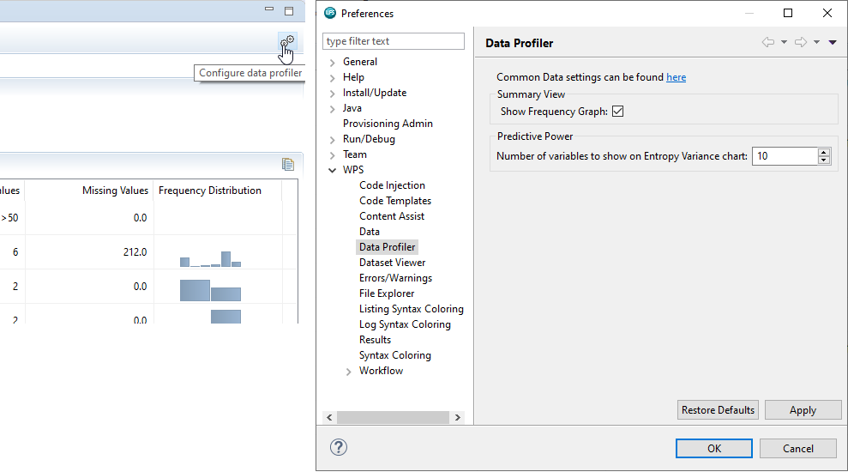

As can be seen there is an option to exclude the frequency distribution graphs from the Summary view and specify the Number of variables to show on the Entropy Variance chart, more on this shortly.

If we Navigate to the Data page, which is the item directly above the Data Profiler entry. This provides more insight into the default number of rows to sample on import, which informs how variables are classified.

As can be seen, the first 50 rows are read for each variable and this is used to determine the variable classification and to derive the number of distinct values in each variable.

When importing data, variable Type is determined by assessing the first 50 values for each variable. If a variable is determined to be numeric and there is less than 50 distinct values the variable Classification is Categorical and for numeric variables with more than 50 distinct values, the Classification is Continuous.

For Character variables, if there are less than 50 distinct values the variable Classification is Categorical and if there are more than 50 distinct the variable Classification is Discrete.

Bear in mind that the Classification threshold of 50 is a default value and can be changed as desired.

From the Summary View tab, clicking any column header sorts the variables. Here, Type is clicked and as can be seen all numeric variables are listed first followed by all character variables.

As can be seen, of the seven numeric variables *ID*, *age*, *hours_worked*, *income,* and *capital_wealth* most 9have greater than 50 distinct values and as a result are all determined to be continuous. The variable *Years_Education* has been assigned the Classification Categorical as it has only 13 distinct values.

There are only 3 Character variables and all are classified as Categorical as a result of the number of distinct values in each not reaching the Classification threshold of 50 to be assigned the classification of Discrete.

The Summary View, among others, can be copied to the clipboard using the Copy data to clipboard icon, here contents are pasted into Microsoft Excel to illustrate.

Figure 17: Copy data to clipboard

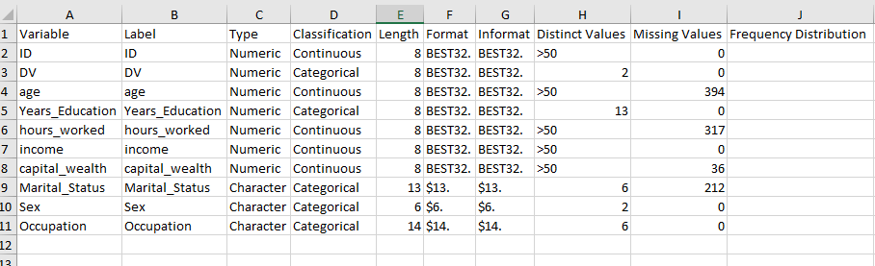

The Univariate View generates univariate statistics for all numeric variables. Default statistics include the number of valid values, the number and percentage of missing values and common measures of central tendency and dispersion.

For this dataset, the variable *ID* can be ignored. As can be seen, no variable has a large number of missing values and there appears to be adequate ranges for all variables

The average age at 46 seems reasonable as do the averages for *Years_Education*, *income* and *capital_ wealth*. The average for *hours_worked* looks a little low at 30.5, although there may be reasons for this.

The display can be toggled to show formatted values, and the view can be copied to the clipboard.

The configure statistics icon provides access to additional Univariate statistics. Statistics are grouped as Quantiles, Variable Structure, Measures of Central Tendency, Measures of Dispersion and Others.

Figure 18: Configure statistics

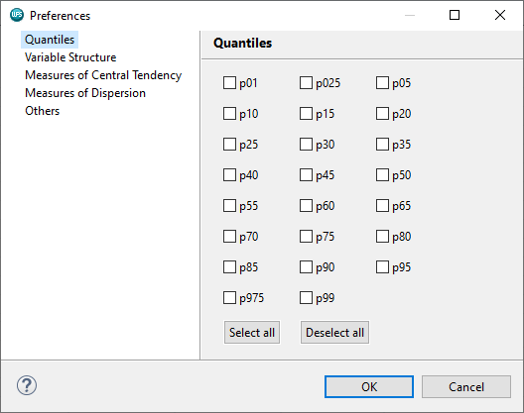

Some options are displayed by default as denoted by that statistic being visible in the Univariate View. From Measures of Central Tendency, the Median is selected and clicking OK shows that a new column has been added to the right showing the median for each variable.

Figure 19: Univariate View

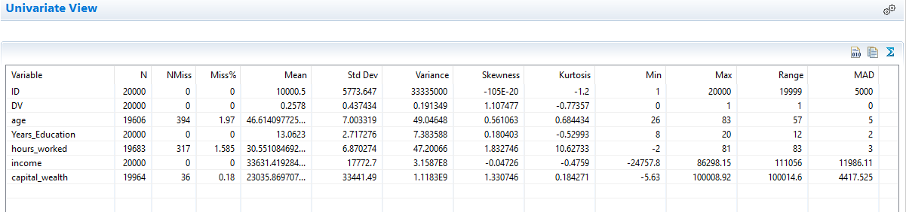

The low median *capital_wealth* of approximately 4400 in comparison to an average of 23035 supports the low average and median *hours_worked* in that a household or individual with low average *hours_worked* may not have the capacity to save to the same extent as those working longer hours.

The Univariate Charts view is simple to use. Select a variable from the Variable selection dropdown and a frequency table and chart are generated.

The frequency table can be copied to the clipboard and the chart type can be changed by selecting an appropriate icon. Clicking Edit chart opens the Chart Editor, from here the chart can be copied to the clipboard as a jpeg.

Figure 20: Chart Editor

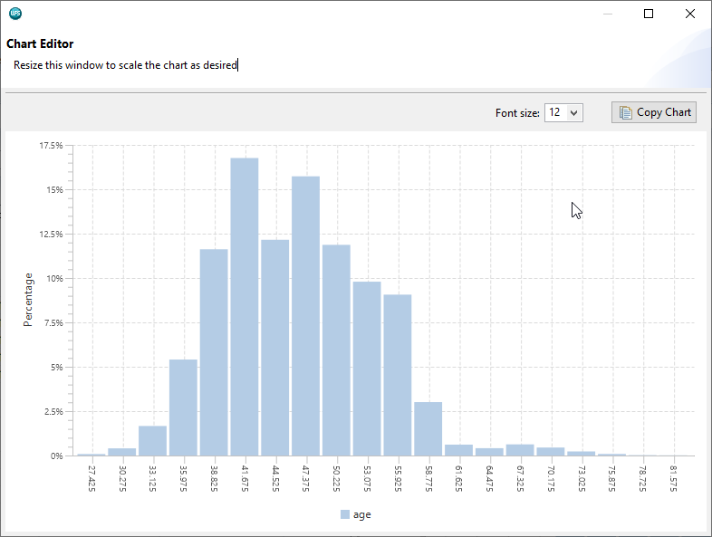

The selected chart type is sticky and so changing the variable may require modifying the chart type applied. Here a categorical variable, *occupation* is selected and the frequency chart displays a histogram, the chart type can be changed to a pie chart by clicking the show as pie chart icon.

Viewing *Age* as a histogram it can be seen that it looks approximately normally distributed with a good spread. Viewing the variable *sex*, it can be seen the data comprises in excess of 60% females.

The variable *DV* contains two values *0* and *1*. Notice that there are predominantly more *0*'s than *1*'s.

Correlations can be generated from the Correlation Analysis tab, variables are moved from the Unselected Variables list to the Selected Variables list by either double-clicking or using the chevrons.

Figure 21: Correlation Analysis

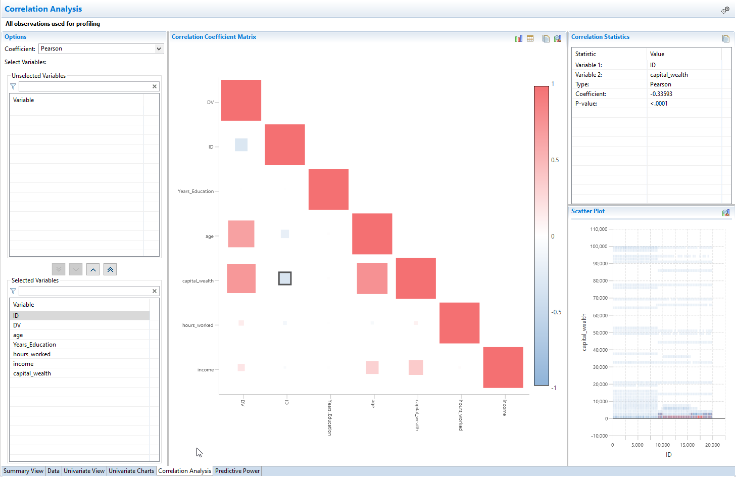

The Pearson correlation coefficient is generated for each pair of variables. This can be changed to either. Spearman Rho or Kendalls Tau from the coefficient dropdown.

The results are presented in a matrix view and squares, colours and colour depth are used to convey the magnitude of the association.

The diagonal squares represent the association between a variable and itself, clicking any off-diagonal square, for example the square representing the correlation between the variables *DV* and *age*, generates statistics and a scatterplot to the right-hand side.

The correlation statistics shows the variables used, the coefficient type and magnitude and a significance value. Here the association between the variables of approximately 0.65 is significant.

The view can be changed to a table by selecting the table icon and can be sorted if necessary. Again, the option to copy to the clipboard and edit the chart are also available.

 In general, there are variables that are associated with *DV*, this is good if the focus is to use *DV* as a dependent variable to model.

There are also other pairs of variables exhibiting strong associations. For example, *age* and *income* and *income* and *capital_wealth*. These are easy associations to understand as older people would have had time to increase income and accumulate capital wealth.

Assessment of the usefulness of each variable to model an outcome or dependent variable is available from the Predictive Power tab.

Here, *DV* is selected as the dependent variable from the dependent variable dropdown, four statistics are generated for each variable. The entropy Variance statistic is illustrated in descending order in a chart below the statistics table.

Figure 22: Predictive Power

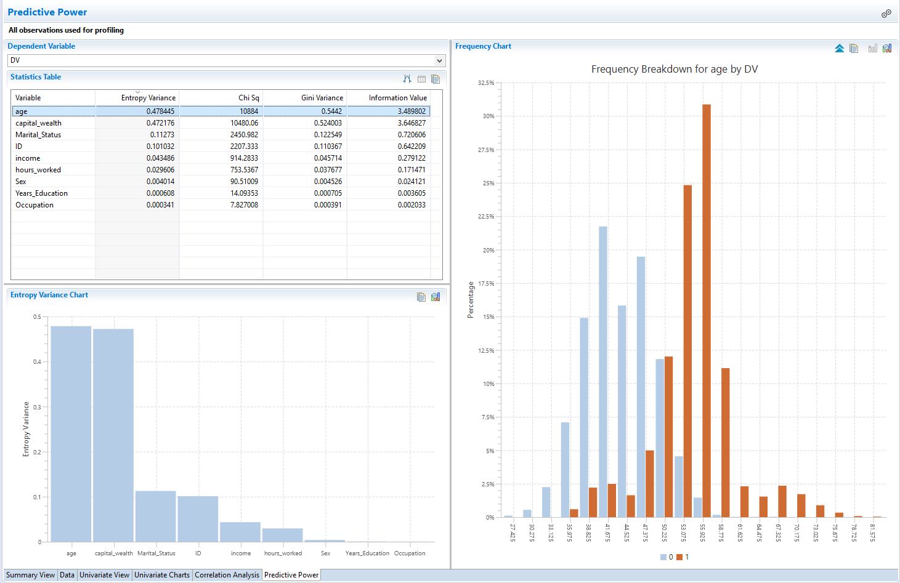

Selecting any variable illustrates its distribution across the categories of the dependent variable. Here, *age* is selected. Notice that different colours are used for each category of the dependent variable.

The *age* distribution for those in the *1* category is notably higher than those in the *0* category and as a result *age* may prove to be a good predictor of the variable *DV*. The overall distribution of *age* can be toggled by clicking the chevrons.

Figure 23: Viewing all data

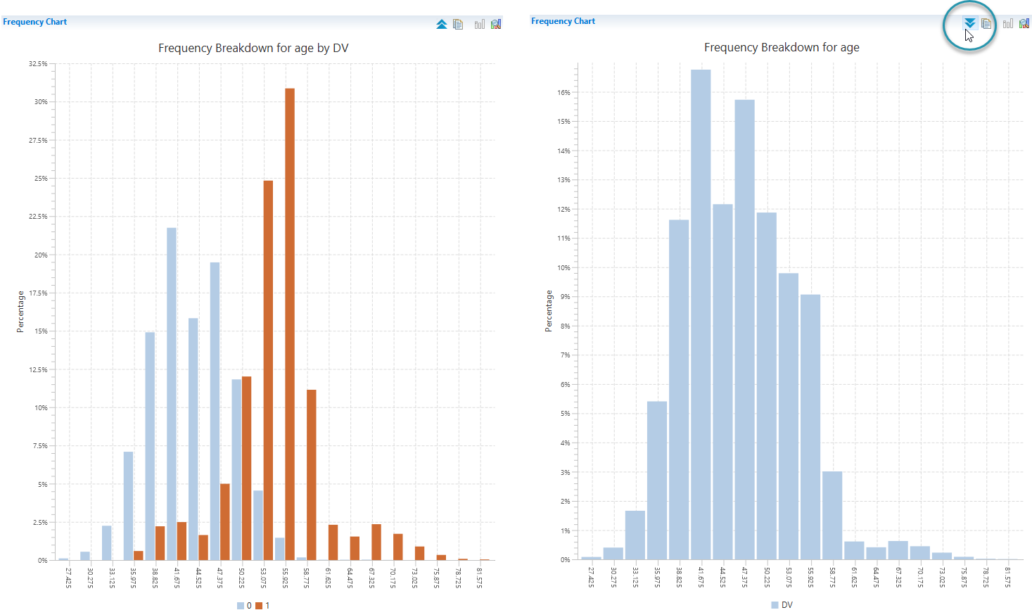

Other variables can be assessed similarly, and all output generated can be copied to the clipboard.

## Interactive Questions

Q1: Drag and drop correct image onto the Summary view:

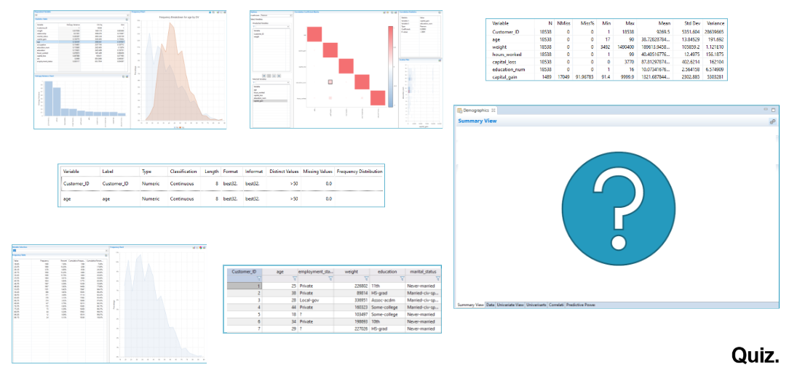

A:

The Summary view relays information about the dataset and its contents including: dataset name, number of observations, number of variables and variable characteristics.

Q2:

The Distinct Values column in the Summary view displays the number of unique values in a variable. The number of observations to read from each variable to determine the number of Distinct Values can be set via:

Window > Preferences > ALTAIR > Data Profiler.

**Window > Preferences > ALTAIR > Data.**

Window > Preferences > ALTAIR > Dataset Viewer.

Window > Preferences > ALTAIR > Results.

A:

The Number of observations to read from each variable to determine the number of Distinct Values can be set via: Window > Preferences > ALTAIR > Data.

Q3:

The Univariate Statistics tab displays univariate statistics for all variables.t/**f**

A:

The Univariate View tab displays univariate statistics for numeric variables only.

Q4:

Select all incorrect statements.

The correlation matrix available from the Correlation Analysis tab cannot be viewed as a sortable table.

**The Predictive Power tab assesses each variable in terms of how well it is associated with a selected Dependent Variable.**

The predictive power of each variable is relayed via a table in the Predictive Power tab with one statistic only: Gini.

Selecting any variable from the Predictive Power tab view displays how it is distributed across the categories of the selected Dependent Variable.

Only the Data tab view can be copied to the clipboard.

A:

The Predictive Power tab assesses each variable in terms of how well it is associated with a selected Dependent Variable. Selecting any variable from the Predictive Power tab view displays how it is distributed across the categories of the dependent variable. The correlation matrix available from the Correlation Analysis tab can be viewed as a sortable table. Predictive power is created as a table with

three statistics: Entropy Variance, Chi-Sq and Gini. Additionally, all profiling views can be copied to the clipboard.

## The Chart Builder

Additional profiling capabilities are available by using charts to visualize data. The Chart Builder block can be dragged onto the Workflow canvas from the Export group or by double-clicking the Workflow canvas and typing ‘c‘ to locate it.

The block is then double-clicked to place it on the Workflow canvas and then dragged and dropped onto the **Model_View** dataset.

Figure 24: Chart Builder block

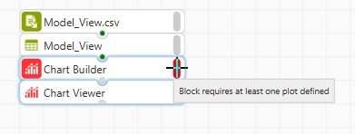

The status indicator message: Block requires at least one plot defined, is warranted at this stage as the block has not yet been configured. Double-clicking the block or right-clicking and selecting Configure Block opens the chart builder.

Figure 25: The Chart Builder

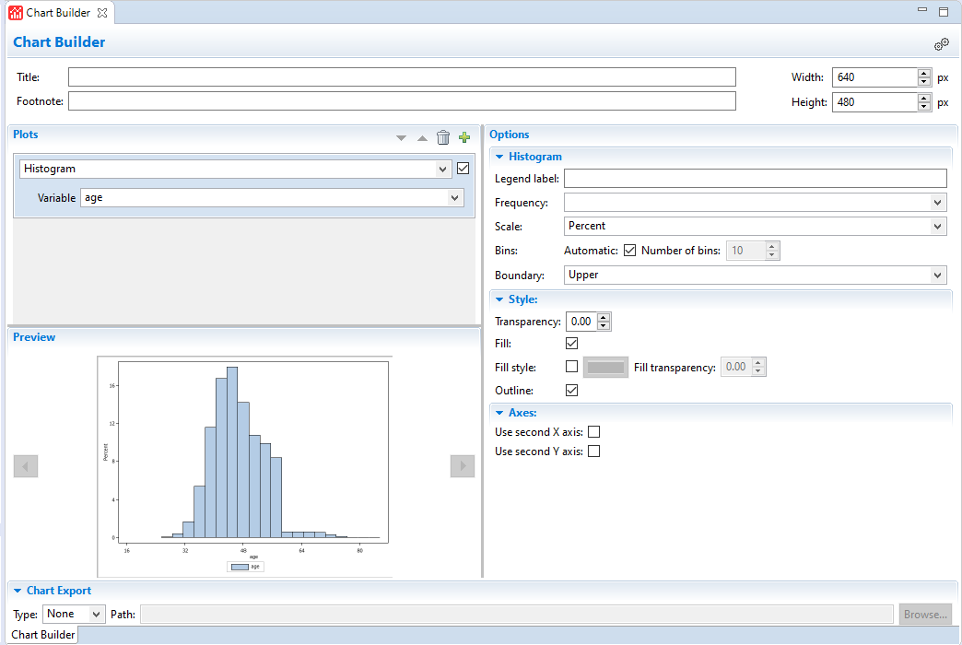

There are a number of areas, first Plots, a chat type can be selected from the plots dropdown. Here, Histogram is chosen. Once selected, variables can be chosen and here *age* is selected. As can be seen from the Preview area, changes must be saved to update it and display a chart, clicking CTRL+S performs this and results are displayed.

A title and footnote can be added via title and footnote and the chart size can be set from this area also.

Depending on the chart type selected, additional options become available in the options area. For the histogram, a legend can be assigned - here distribution of *age*, CTRL+S is used to update the preview.

Figure 26: Legend label

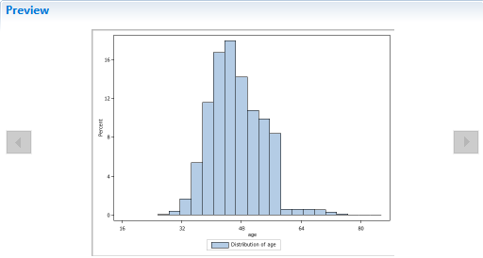

A frequency variable can be selected as well as the y-axis scale chosen, currently this is set to percent. Bins are automatically determined but deselecting allows users defined values to be input, here 50 is used as an upper boundary limit and provides an additional level of granularity.

Figure 27: Number of bins increased to 50.

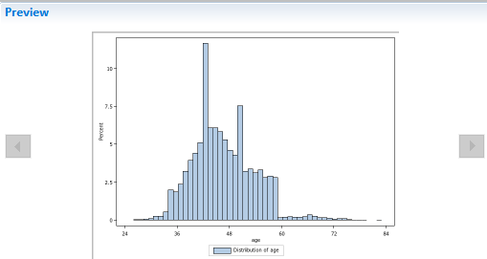

Additional style options are provided, and the chart axis position can be changed by selecting an option from axes. Charts can be added or deleted using the appropriate icon, here a chart is added, and this time Horizontal Bar is chosen.

Figure 28: Horizontal Bar chart

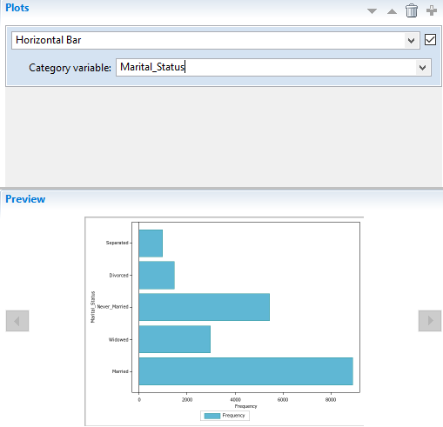

Only categorical variables are available for selection and here *Marital_Status* is selected. Once saved, the preview shows the number of observations in each category with *Married* being the largest.

Additional options are available to the right-hand side including Group. Adding a Group variable colour codes each bar based on the categories of another variable, here *DV* is chosen. Each *Marital_Status* category is colour coded to reflect the number of *0*s and *1*s in each.

Figure 29: Adding a Group variable

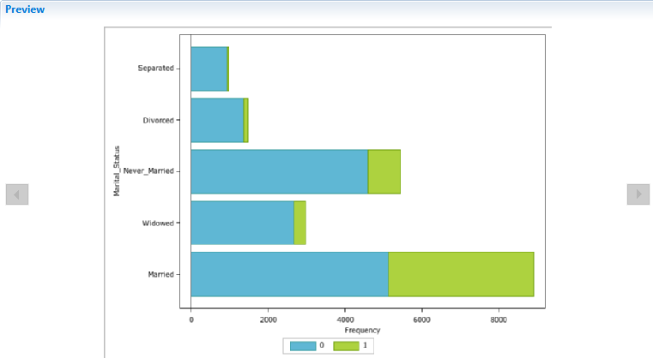

A statistic can also be chosen. Options are Mean, Sum or Frequency with frequency being the default. The option Response variable only becomes available if either Mean or Sum is selected from the Statistic drop-down.

Here, *DV* is removed as a Group variable and Mean selected from the Statistic drop-down with ­*capital_wealth* selected as the Response variable. Saving updates the preview.

Figure 30: Adding a Response Variable

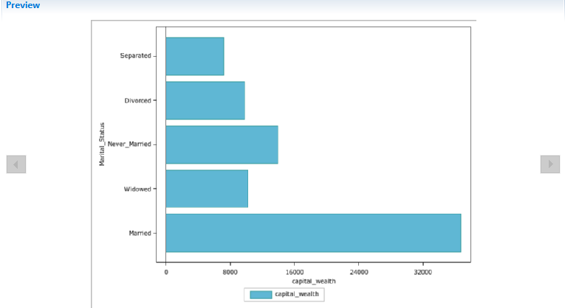

The chart now shows the mean *capital_wealth* for each *Marital_Status* category.

A by variable can be added from the chart Preferences dialog which is accessed by clicking the Configure Chart icon. The first option By Variable allows selection of one or more by variables.

Here *DV* is chosen, additional options in this menu relate to style options for both the x and y and the second x and y axes. Clicking OK and then saving using the keyboard shortcut CTRL+S updates the preview.

Figure 31: Adding a by variable

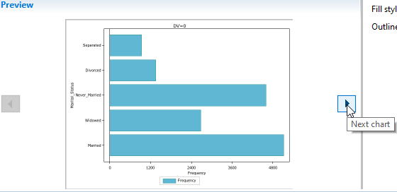

Given that there are two *DV* values, two charts are generated showing the mean *capital_wealth* across *marital_status* categories for both categories of the variable *DV* and these can be navigated by clicking Next chart or previous chart.

As can be seen there is a distinct difference between *capital_wealth* for those in the *1* category of *DV* in comparison to the *0* category of *DV*.

For those *Married*, *capital_wealth* is steady across the *DV* categories*.* For all other *marital_status* categories *capital_wealth* is higher for the *DV 1* category in comparison to the 0 category.

Charts can be exported as PDF, HTML and as images which is SVG format. A location and name can be specified. Here PDF is selected, the file named: charts, and the output location are selected as the project folder.

Using CTRL+S updates settings and outputs the PDF file. Refreshing the project shows the PDF output, which can be double-clicked to view.

Figure 32: PDF output

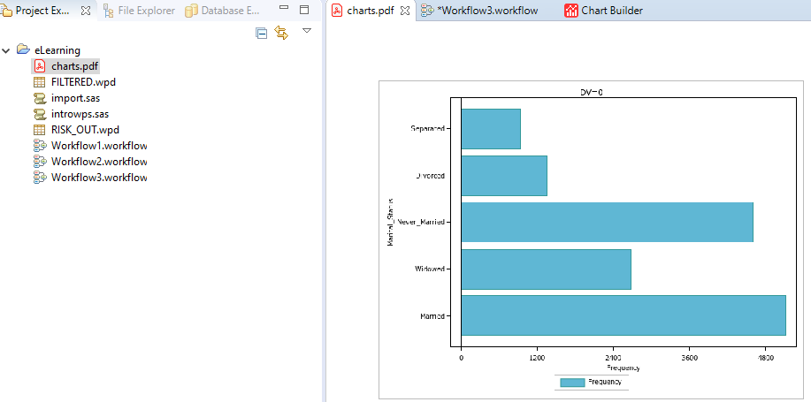

## Interactive Questions

Q1:

Select the group that houses the Chart Builder block.

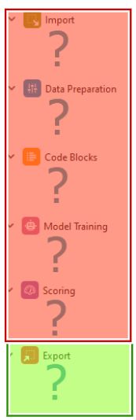

A:

The Chart Builder block is located in the Export group.

Q2:

Histogram chart options do not include:

Automatic or user specified number of bins.

Add a legend.

Style options.

Filter options.

A:

Histogram chart options include the ability to apply bins automatically, these can also be user defined. A legend can be added and style options set. Filtering is not available.

Q3:

A response variable is used to calculate a statistic to display for a selected Category variable? **t**/f

A:

A Response variable can be selected and used to calculate a statistic to display for a selected Category variable on a Horizontal Bar chart.

Q4:

Separate charts can be created for each value of a selected Category variable for a Horizontal Bar chart by:

Adding a Group variable.

**Adding a By variable.**

Adding a Response variable.

Selecting the statistic to display for a selected Response variable.

A:

Separate charts can be created for each value of a selected Category variable for a Horizontal Bar chart by adding a By variable.

Q5:

Select all correct statements. When using the Chart Builder block:

**A chart must be saved before it can be previewed.**

Regardless of chart type selected, options are identical.

Charts can be exported as .png.

**Only a numeric variable can be selected as a Response variable.**

A:

A chart must be saved before it can be previewed and only a numeric variable can be selected as a Response variable. Charts can be exported as HTML, PDF or as images, but cannot be exported to *.png*. Also, available options change depending on the chart type selected.

## Using the SAS Language perspective to profile data

 Additional Altair Analytics Workbench functionality to profile data is available through coding using the SAS Language perspective. Data must be made persistent to be accessible from the SAS Language perspective.

To do this, a SAS Code block is dragged from the Code Blocks group and connected to the Model_View dataset and once complete, the SAS code block is double-clicked and opened.

Figure 33: SAS code block

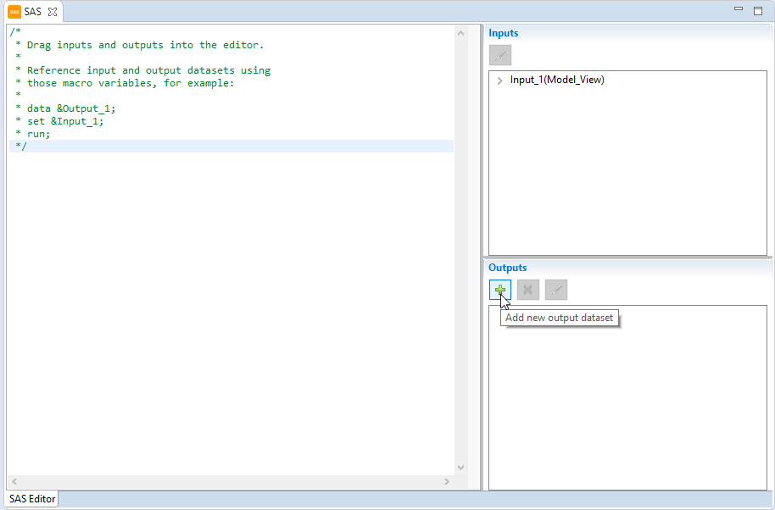

The block can be used to apply the language of SAS in a Workflow. 0, 1 or many datasets can be connected and output. A quick reference example of how to pass data in and out is provided.

To duplicate the connected dataset, a new output is added by clicking the Add new output dataset icon from the Outputs panel. The dataset name can be changed and it can be easily dragged into code for easy reference. The input dataset can be set to the output using the same mechanism.

Figure 34: Adding SAS Language code

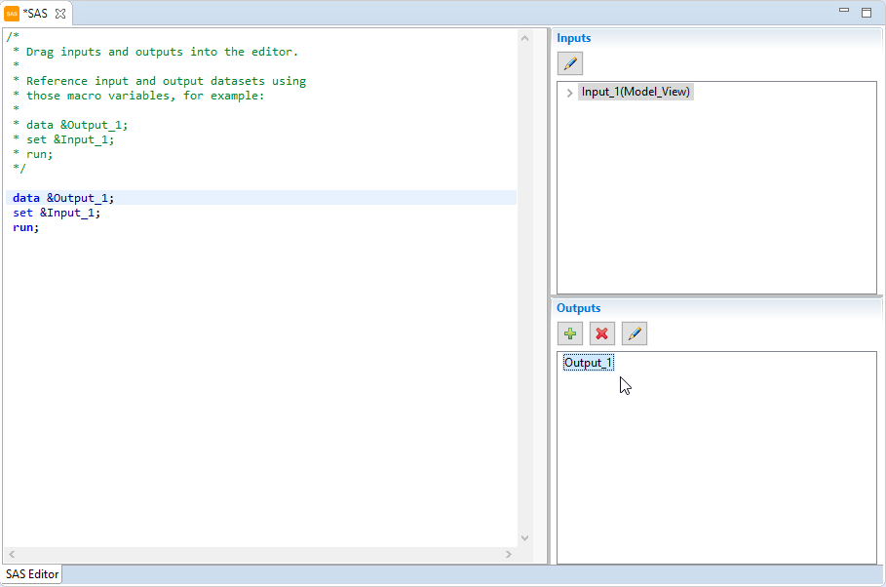

Once complete clicking CTRL+S updates settings and applies the code. Returning to the Workflow a new dataset has been output to the Workflow canvas.

Figure 35: New dataset

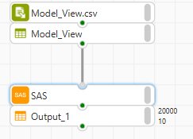

Here there is a need to export the data so that it can be accessed via the SAS Language perspective and profiled further.

The code is cleared and a LIBNAME statement added. This will create a library called outfile at the location specified, note this is the location of the project folder, and any file sent there will be stored as a WPD file, ALTAIR’ proprietary file format.

The project folder location is easily obtained by right-clicking the project folder and selecting Show in System Explorer, the address can be copied and pasted into the SAS Code block.

A code statement is added to take the input and save it to the library as *model_view_copy*. No output is necessary as the file is being exported and not output to the Workflow.

Figure 36:Using LIBNAME

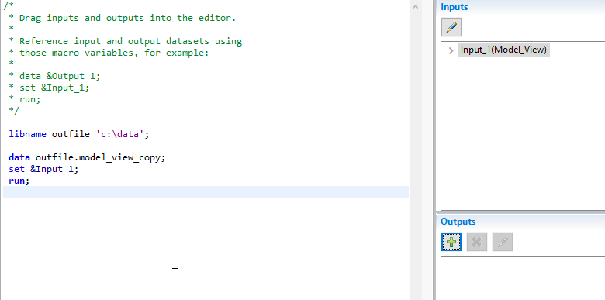

At this point, the code line beginning with libname is copied as this will come in useful shortly. CTRL+S is used to update settings and returning to the Workflow it can be seen that the process has run successfully as reflected by the green execution status indicator and the message: Completed successfully and up to date.

Figure 37: Successful execution

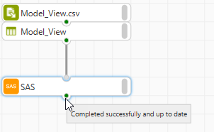

Refreshing the project, notice the file has been output to the project folder. At this point, a new code file is added from File > New > Program and named *profiling.sas*.

At the point of creating the file and as a result of being in the Workflow perspective a Change Perspective notice pops up informing that program files are best viewed with the SAS Language perspective. Would you like to switch?

There is an option to remember the decision also, this is selected here and Yes clicked.

Figure 38: Change Perspective notification

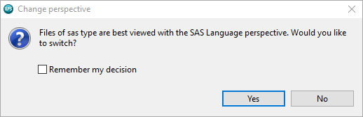

Note that a similar notification appears if creating or accessing a Workflow from the SAS Language perspective.

At this point, the code file is open in the SAS Language perspective. To access the *Model_View_Copy* dataaset the copied libname statement is pasted and run.

A new library is created: outfile and this contains the file *Model_View_Copy* and can be referenced in code.

Figure 39: Accessing the dataset

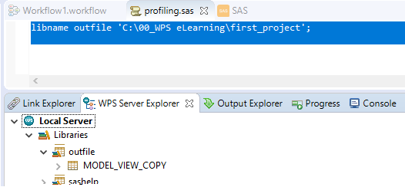

Here some simple commands can be applied to further profile the data. First PROC CONTENTS.

The code statement is simply proc contents data and an equals sign to the data, as well as the dataset name which can be dragged from its library and dropped into the code pane. A semi-colon is added and the statement completed with a run statement and a final semicolon.

Figure 40: PROC CONTENTS

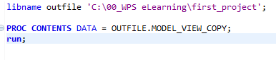

Once complete, the code is selected and run. The output generated can be accessed from the Output Explorer view via the HTML node. The screen can be split to show the code side by side with the output.

Figure 41: Code and output

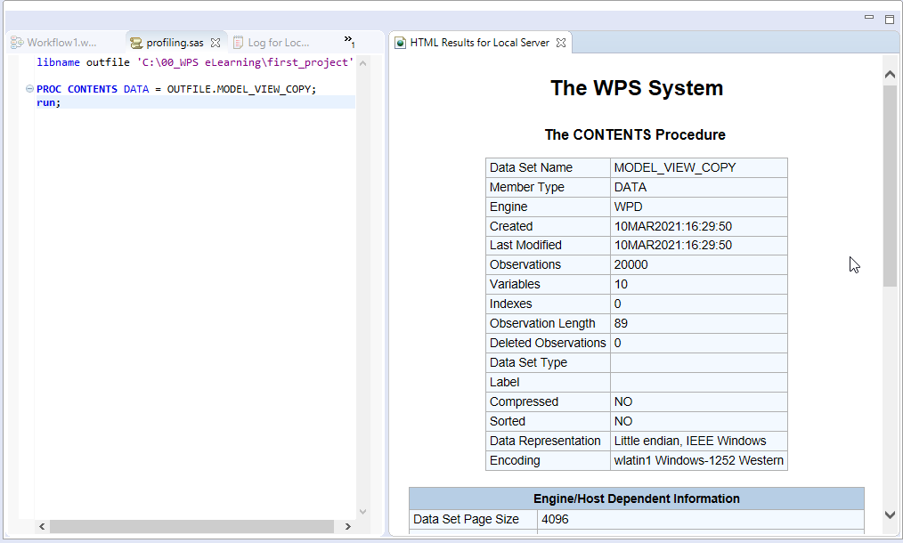

As can be seen proc contents outputs dataset information, including name, size and number of variables. Three tables are generated including an alphabetic list of variables and their attributes.

Another useful procedure is PROC UNIVARIATE, it takes the same form as proc contents and outputs statistics and charts for all numeric variables. The Results Explorer to the right-hand side can be used to navigate.

Figure 42: PROC UNIVARIATE

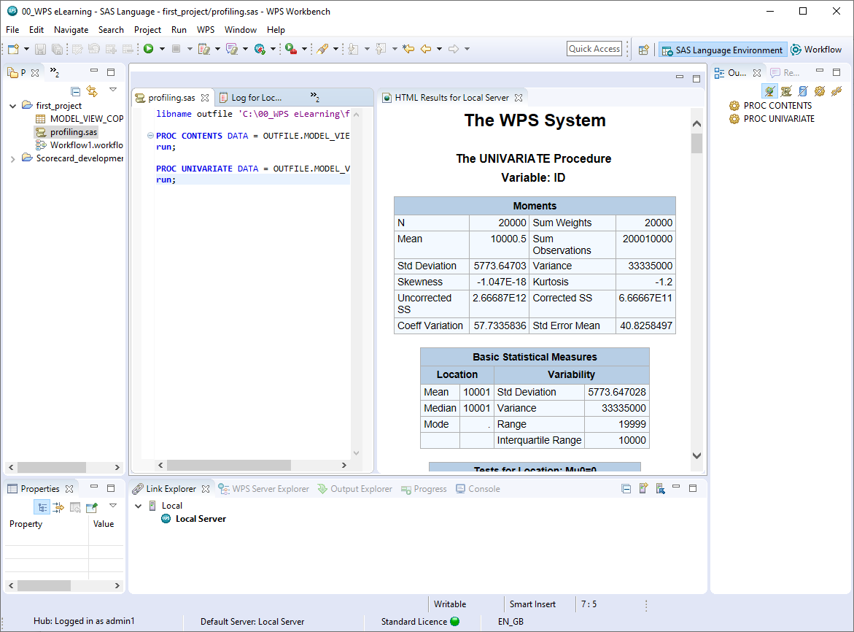

Frequency tables and cross tabulations can be generated using the procedure PROC FREQ. The variables to tabulate are listed singularly. To generate cross-tabulations an asterisk is used between variables and additional options are used to declutter the output.

Figure 43: PROC FREQ

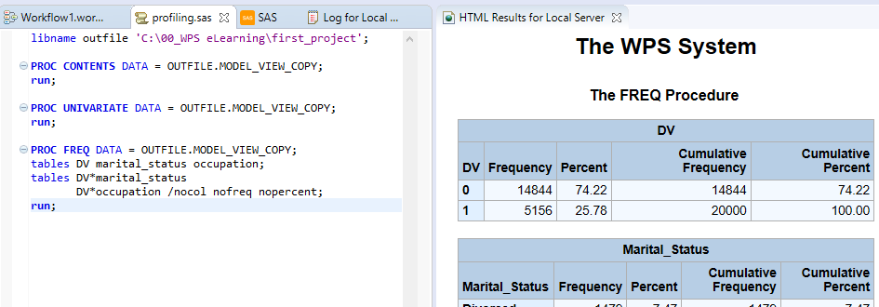

Here tables are created for the variables *DV, marital_status* and *occupation* and cross-tabulations are created for *DV* with *marital_status* and *DV* with *occupation* showing row percentages.

From the results generated, it can be seen that 45% are married and that occupations are well spread.

From the cross-tabulations it can be seen that the bulk of those in the *1* category of *DV* are *Married*, the distribution for *occupation* does not show any difference across the *DV* categories.

## Interactive Questions

Q1:

To access a Workflow dataset in the SAS Language perspective…

**The dataset must be made persistent and saved to an accessible location.**

switch from the Workflow perspective to the SAS Language perspective.

Open the SAS Language perspective and drag the file from the Project folder.

None of these options are correct.

To access a Workflow dataset in the SAS Language perspective, the dataset must be made persistent and saved to an accessible location.

Q2:

Drag the words to complete the sentence correctly.

The SAS cod block can be used to apply SAS Language in a Workflow, _______ datasets can be connected and ________ output.

**0,1 or many 0, 1 or many datasets** 2 datasets only 1 dataset no datasets

A:

The SAS code block can be used to apply SAS language in a Workflow, 0,1 or many datasets can be connected and 0, 1 or many datasets can be output.

Q3:

In any Workflow, a SAS code block and a LIBNAME statement can be used to export data to a known location. **t**/f

A

In any Workflow, a SAS code block and a LIBNAME statement can be used to export data to a known location.

Q4:

Drag the words to complete the sentence correctly.

Some simple SAS language commands that can be used for ________ a dataset include PROC CONTENTS and ________.

**profiling and exploring PROC UNIVARIATE** PROC EXPORT PROC LOGISTIC modelling exporting

A

Some simple SAS language commands that can be used for profiling and exploring a dataset include PROC CONTENTS and PROC UNIVARIATE.

Q5:

The SAS language command PROC FREQ can be used to create frequency tables and cross tabulations. **t**/f

A:  
The SAS language command PROC FREQ can be used to create frequency tables and cross tabulations.

## Accessing Workflow code

The code for any Workflow can be accessed by right-clicking any blank area of the Workflow canvas and selecting the option Export to SAS Language Program.

A temporary directory must be set, this can be anywhere, and once complete clicking Next provides access to the code, the code can be exported to a program file or copied to the clipboard by clicking the Copy Code icon.

Figure 44: Export to SAS Language Program

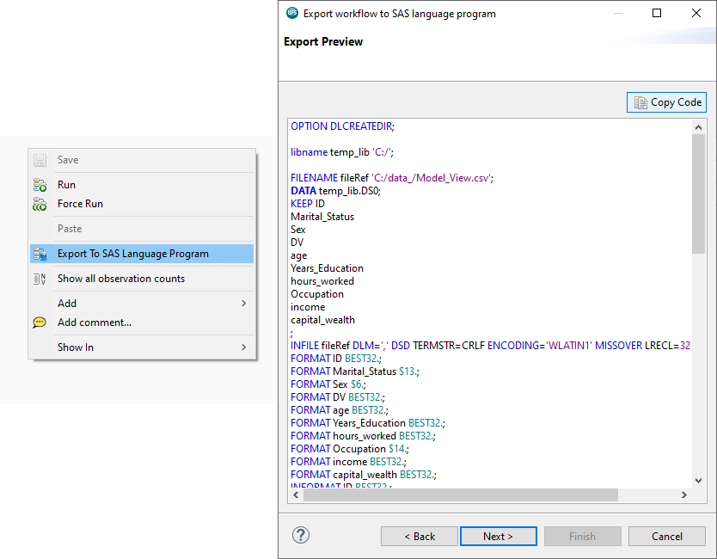

Here, Copy Code is clicked and the code pasted to the file created in the SAS Language perspective previously and run.

The code simply imports the data to the temporary library selected when exporting the code and is evident from the ALTAIR Server Explorer view as *Model_View_Copy* and can be accessed as normal.

Figure 45: Running the code

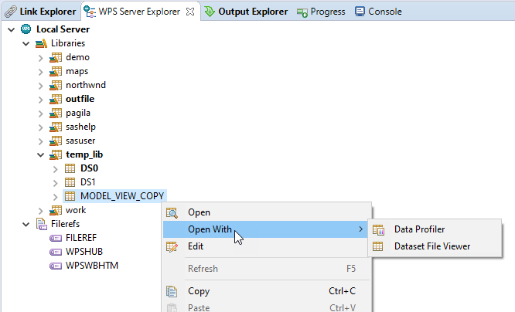

This has been an introduction to data exploration and profiling with Altair Analytics Workbench. Other mechanisms and methods can be used to profile data including modelling techniques such as decision trees to illustrate associations and regression to determine the strength of the association between variables.

Segmentation methods such as clustering can be used to identify groups with distinct characteristics and variable reduction methods can be further used to assess variable associations. Other capabilities such as the WoE Transform block can be used to assessing associations and applying appropriate binning to variables.

Figure 46: Other ways to explore data

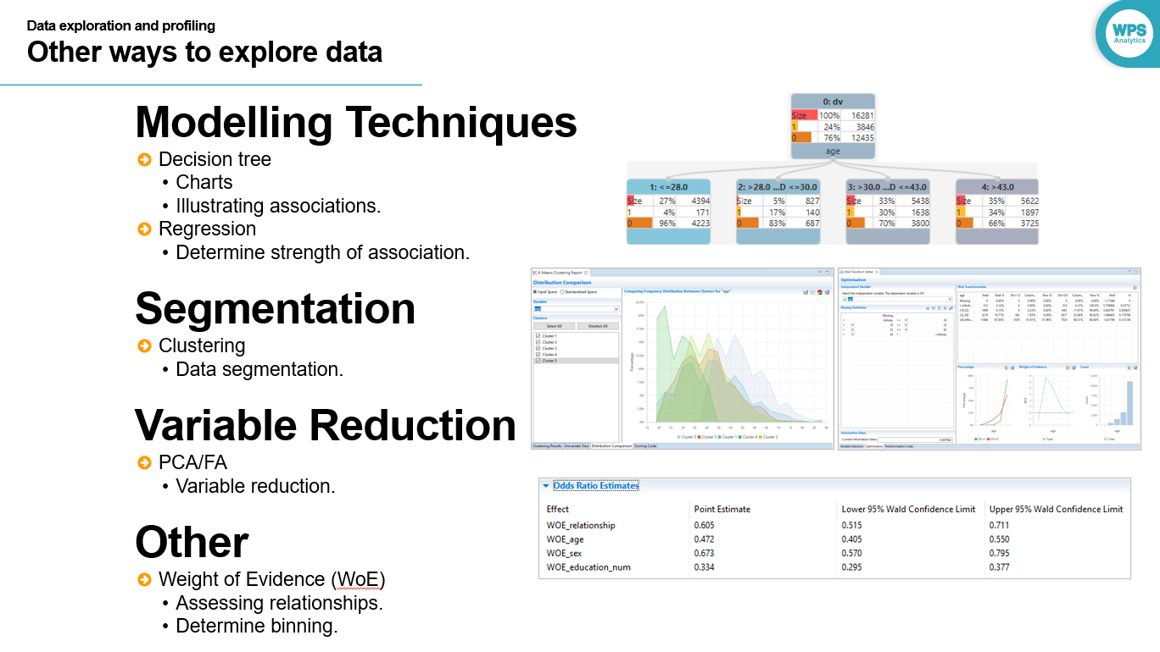

## Summary

Figure 47: Summary

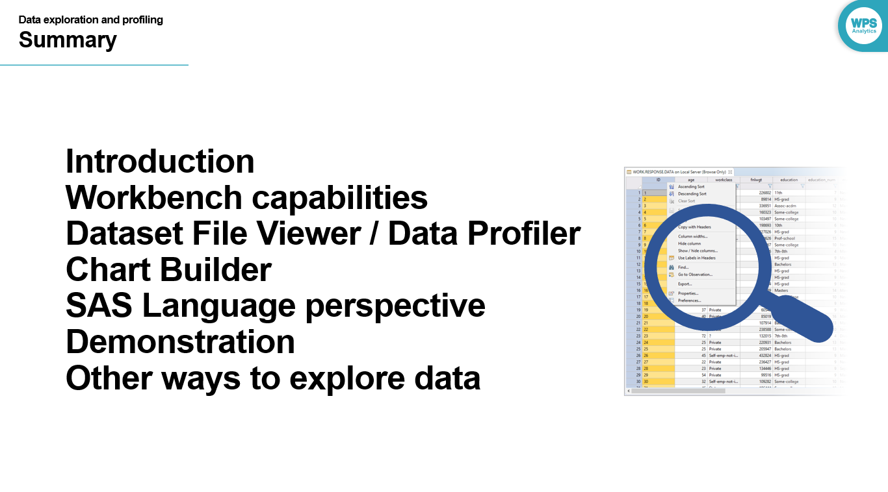

Altair Analytics Workbench capabilities for exploring and profiling data are deep and provide myriad ways to investigate any data and some methods have been demonstrated here.

This lesson introduced the Dataset File Viewer, the Data Profiler, the Chart Builder and the use of the SAS Language perspective to profile and explore data as well as introducing other ways to profile data including modelling techniques and segmentation methods.

# Exercises



Q1:

Using the Workflow created in the previous exercise, import the file *data_.xlsx*. Open the data with the Dataset File Viewer. Add a filter: AGE GE 40. NOTE: GE means Greater than or Equal to

Question: How many observations are greater than or equal to 40?

1181

931

4660

**8141**

A:

The file data_xlsx is located in the training data folder and is navigated to via the file explorer and dragged onto the Workflow canvas. The block is correctly configured and the resulting dataset double clicked - this opens the data in the Dataset File Viewer.

The filter can be added by clicking the filter icon for the age variable, selecting the option greater than or equal to And entering the value 40, pressing return applies the filter, sorting by age illustrates this.

Scrolling to the end of the dataset it can be seen there are 8141 observations greater than or equal to 40.

Q2:

From the Dataset File Viewer and with the filter still in place, export the dataset as a delimited file named *dlm_export*, including headers, to the project folder. HINT: right-click any variable name and choose the option: Export. Drag the resulting file onto the Workflow canvas.

Question: Is the number of observations equal to that in the file: *data_* with the filter on? What does this mean?

**No. Filters applied in the Dataset File Viewer are not included when exporting from the Dataset File Viewer.**

Yes. Filters applied in the Dataset File Viewer are included when exporting from the Dataset File Viewer.

A:

The dataset can be exported by right click any variable and selecting the option export, select the export type, here delimited, and the export location is set to the project folder. Finish is clicked and the project refreshed with the exported data evident.

The file is dragged into the Workflow canvas, configured and opened, as can be seen there are 18538 observations in the file, this means that Filters applied in the Dataset File Viewer are not included when exporting from the Dataset File Viewer.

Q3:

Remove the file dlm_export from the Workflow. Open *data_* with the Data Profiler. The number of variables and observations in the dataset can be ascertained from the Summary View tab.

Question: What is the average age, minimum education_num? Do any variables have missing values?

48.72, 1.Yes, capital_gain.

**38.72, 1. Yes, capital_gain.**

17, 1, No.

48.72, 1. No.

A

Opening *data_* with the data profile and selecting the univariate view, it can be seen that the average *age* is 38.72, the minimum *education_num* is 1 and *capital_gain* has in excess of 90% missing values.

Q4:  
From the Summary View take note of the Type and Classification columns. Type is determined by whether the variable contains numbers or strings. Variables with numbers are Numeric and variables with strings are Character. Classification for both is determined by the number of Distinct Values reaching a threshold. For categorical variables, classification is Discrete if the number of distinct values if >=50 and Categorical otherwise. For Numeric variables, Classification is Continuous f the number of distinct values if >=50 and Categorical otherwise.

Question: Can this threshold be changed and what effect will it have? HINT: Window ... Preferences ... ALTAIR ... ?

Yes, little to no effect.

No, no effect.

Yes, it may change the Classification of some Numeric variables only.

Yes, it may change the Classification of some variables.

A

Variable Classification is determined by Type and the number of Distinct Values. Modifying the classification threshold can affect a variables classification.

Notice the variable *education_num* it is of type numeric but its classification is categorical.

viewing the variable values from the data tab it can be seen that the variable should be classified as continuous. From Windows > Preferences > ALTAIR > Data, the classification threshold is lowered to 15, and apply clicked, notice now that as *education_num* has more than 15 values, its classification has changed to continuous.

Q5:

View the distribution of the variable D*V.* As can be seen there are approximately 76% *No* and 24% *Yes*.

Question: Excluding the variables *weight* and *customer_id*, what are the top two useful variables that could be used to predict *DV*?

*Customer_ID* and *relationship*

***Relationship* and *marital_status***

*marital status* and *capital_gain*

*Customer_ID* and *capital_gain*

A:

From the Predictive Power tab, *DV* is selected from the Dependent Variable dropdown. From the statistics table is can be seen that the top 2 useful variables on the face of it excluding *customer_id* and *weight* are *relationship* and *marital_status.* As these two variables observation the same thing, *relationship* and *capital_gain* are most associated with *DV*, and this is the case across all measures.

Q6:

Question: Are there any variables that are highly correlated. i.e. where: r >= 0.6?

Yes

**No**

A:

From the correlations tab, all available variables are moved into the selected variables area, there are no correlations in excess of 0.6. The highest correlation is between the variables *education_num* and *capital_gain* at 0.289.

Q7:

Use the Chart Builder block to create charts for each category of the variable: *sex*. Modify the chart such that it displays the distribution of the variable: *employment_status*, across the categories of the variable: *DV*. Multiple charts should result and resemble the following illustration:

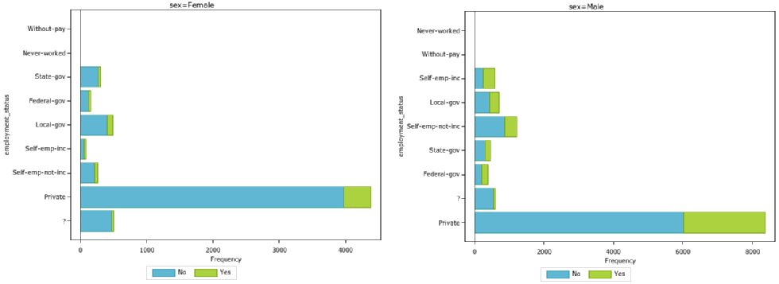

Question: Approximately how many females in the *Private employment_status* category are *Yes*?

500

**4000**

6000

2200

 A:

To build the chart, a Chart Builder block is dragged from the Export group and docked onto *data_*. From the plots dropdown, *Horizontal bar* is selected and *employment_status* chosen as the category variable. CTRL+S generates the graph.From the Group dropdown *DV* is selected and again, click CTRL+S used to generate the chart.

Each bar is colour coded to highlight the number of *No* and *Yes* in each *employment_status* category.

From the configure chart dialog, *sex* is selected as the By variable OK is clicked and CTRL+S used to generate results. The breakdown of *DV* across *employment_Status* is now generated for both categories of *sex*: *Female* and *Male*. Focusing on the chart for Female, there are approximately 4000 in the *Private employment_Status* category are in the *Yes* category of *DV*.

Q7:

For the brave!

Use the SAS Language perspective to write a SAS program to access the file *data_.xlsx*.

HINT: Create a folder called temp in the c:\ directory. Write code to export the file using the SAS code block. From the SAS Language perspective, import the data and analyse it. The following code snippets may come in useful!

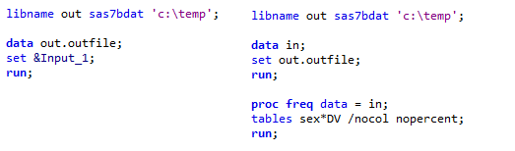

Question: What is the proportion of females in comparison to males in the *Yes* category of *DV*?

A:

To answer this question, a code block and some code are used to export the file as outfile to a known location.

Once complete, a new program file is created and the same libname statement along with a datastep is used to read the file into The work directory.

A PROC FREQ command is used to output a cross-tablulation with row percentages and as can be seen there are 10.68% of females In the yes category of dv in comparison to 20.07% of males.

# Chapter 5: Data preparation and manipulation

## Introduction

This lesson includes an introduction and focus on data preparation capabilities available from the Altair Analytics Workbench Workflow perspective.

A data preparation scenario will be introduced which will be demonstrated using blocks available from the data preparation group. Other data preparation blocks will also be demonstrated prior to a summary.

Figure 1: Contents

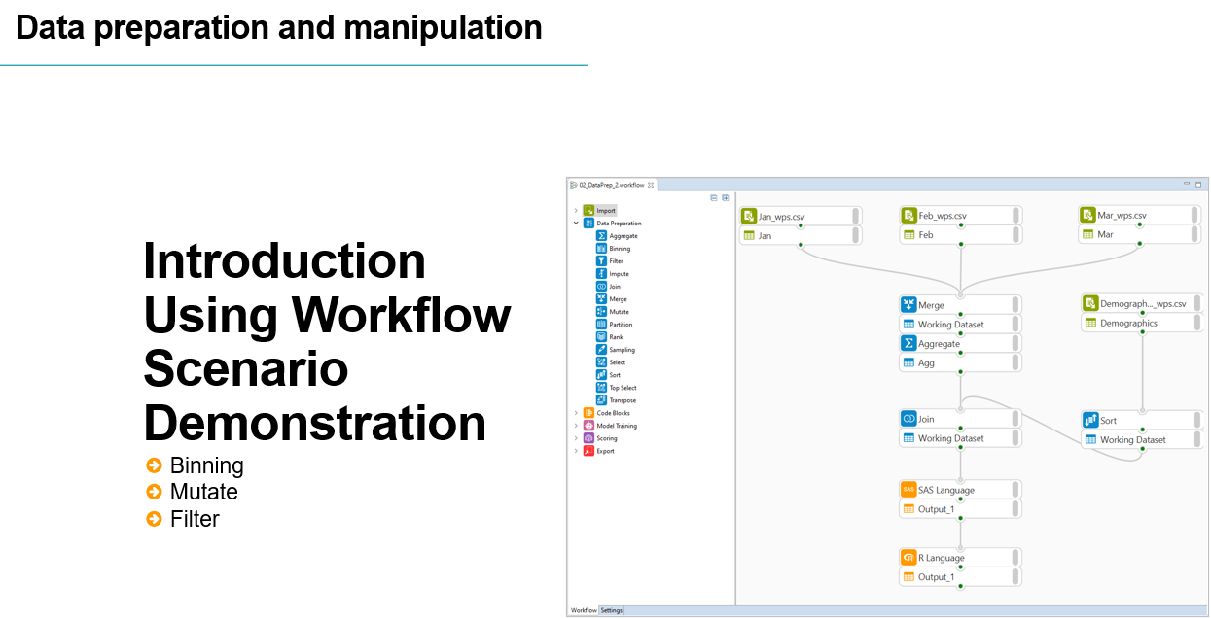

Data preparation is involved and can take a considerable amount of time whether for etl, modelling, deployment or other data processing operations. There are many things to consider and may be many iterations before things are acceptable.

Figure 2: Introduction

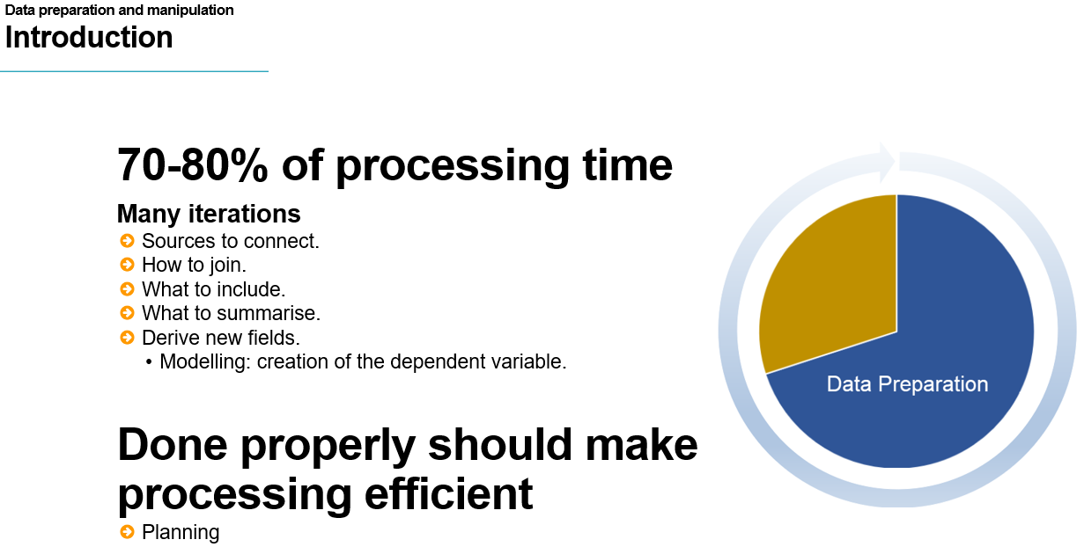

When preparing data questions such as what sources to include, how to join, what to include, what to summarise and what variables to derive are all considerations that require adequate time to assess and implement correctly.

When modelling, the added need to develop a dependent variable requires considerable data preparation time but done properly should make further processing run smoothly.

Figure 3: Workflow blocks

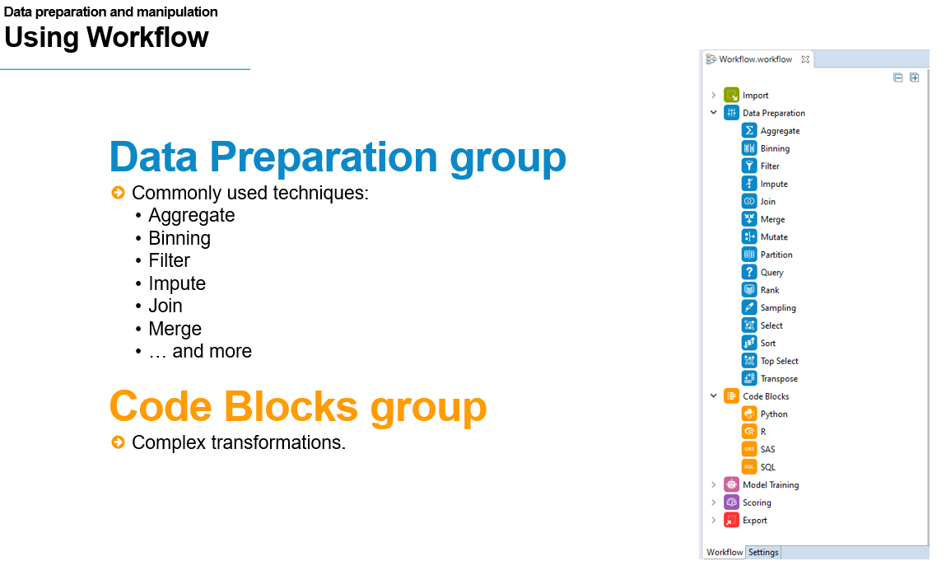

Altair Analytics Workbench provides an array of easy to configure data preparation blocks. These are located in the Data Preparation group and include the most commonly used techniques such as aggregate, binning, filter, impute merge, join and more.

For more complex data preparation transformations, code blocks can be used to augment any Workflow with the language of SAS, R, Python or SQL and add additional processing functionality.

To highlight Altair Analytics Workbench Workflow perspective capabilities for data preparation consider the following scenario.

Figure 4: Scenario

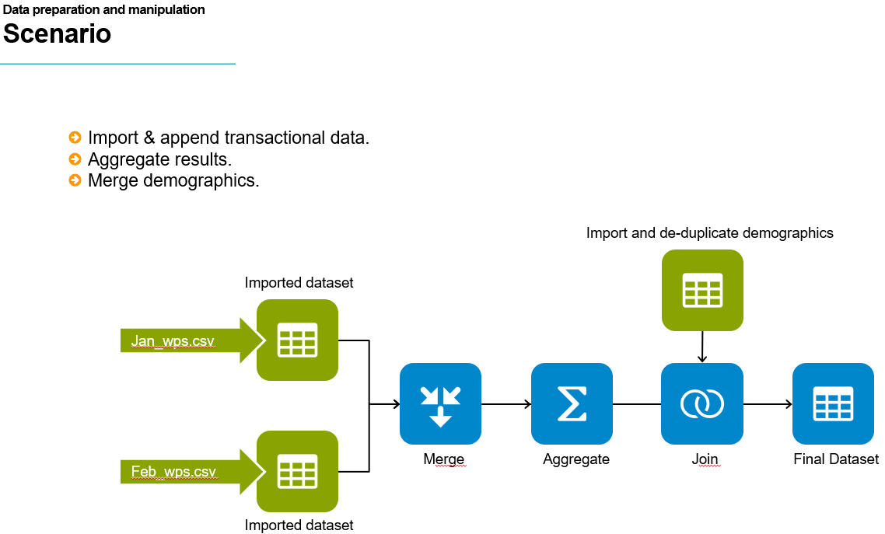

Transactional information for January and February are joined into one large file and the results

aggregated and summaries created. The results are enriched with demographic details to generate the final file, which will be used to illustrate additional data preparation blocks.

## Interactive Questions

Q1:

Select all correct statements. Data preparation is an involved process that typically includes questions such as:

**What data sources to include?**

**What variables should be included and what new variables should be derived?**

**What data should be summarised?**

**How should data be joined?**

A:

Data preparation is an involved process that typically includes questions such as: What data sources to include and how they should be joined? What data should be summarised and what variables should be included and derived?

Q2:

Select and move all blocks that may be used in any analytics endeavour to prepare data into the

Altair Analytics Workbench data preparation funnel:

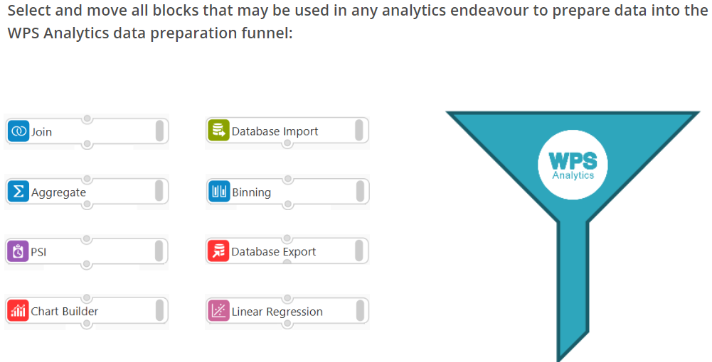

A:

The Database Import, Aggregate, Binning and Join blocks are typical data preparation processes that may be used in any analytics endeavour.

Q3:

The Data Preparation Group blocks are the only way to prepare data in the Workflow perspective.t/**f**

A:

Code blocks can be used to augment any workflow and include additional processing.

Q4:

A SAS Code block can be added to any Workflow. **t**/f

A:

A SAS code block can be added to any Workflow.

Q5:

SQL, R and Python cannot be used in a Workflow. t/**f**

A:

SQL, R and Python can be used in a Workflow.

## Demonstration

So on to a demonstration. To begin, a new Workflow is added to the project folder created in a previous lesson. The project is right-clicked and New > Workflow selected. The Workflow is named *data_prep*. Finish is clicked and the Workflow is created in the project and opened.

The data used in this demonstration is located in the eLearning data folder and can be navigated to using the File Explorer. The goal here is to prepare some transactional data contained in two CSV files:

* Jan_Altair.csv
* Feb_Altair.csv

Double-clicking open the files and here both are opened and shown side by side.

Figure 5: Data to use

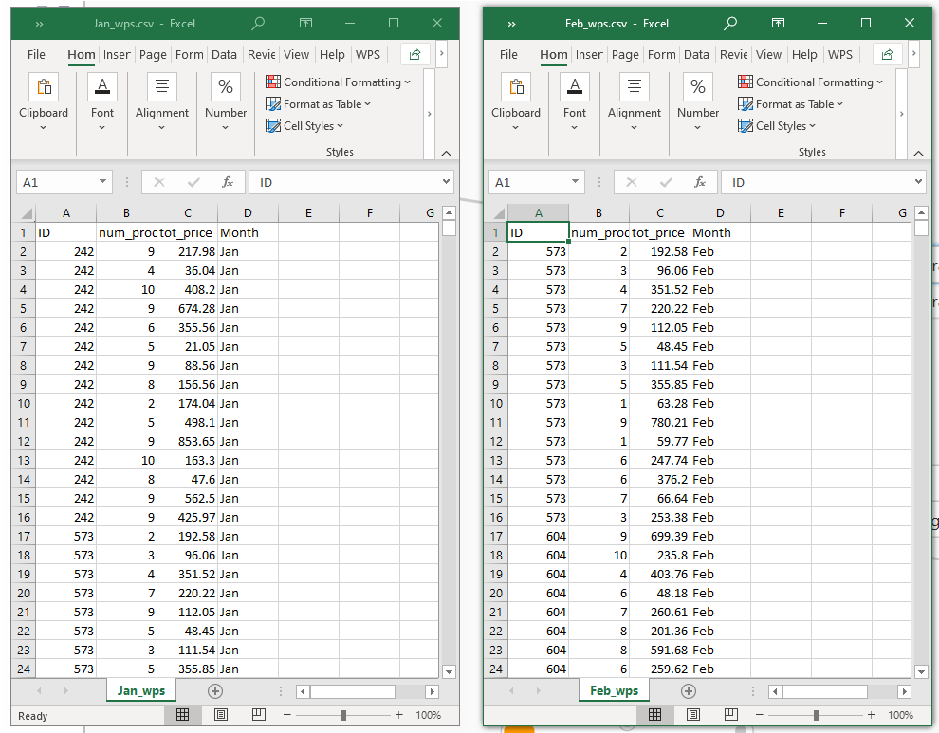

As can be seen both files contain transactional data and the same four variables, an id variable, and other variables observing the number of products purchased, the total price paid and the month the transaction was conducted.

There are multiple transactions for some ids and there are 1215 observations in *Jan_Altair* and 2520 in *Feb_Altair*, giving 3735 observations in total.

The goal is to gather these observations into one file, group by id, create summaries for number of products and price and enrich the results with demographic detail from the file *demographics_Altair.csv*.

Opening this file from the File Explorer it can be seen it contains variables such as martial status, sex, hours worked and occupation. Notice that id values seem to be unique and there are 20000 observations in total.

The variable id will be used to link data across files and attach demographics to the summarised transactional information.

Closing all files and returning to the Workflow, the first thing to do is import the transactional data, this can be done by dragging and dropping both files from the File Explorer onto the Workflow canvas.

Both blocks have a red configuration status indicator with the message: Import not yet configured. Opening and running both blocks addresses this issue as denoted now by the green execution status indicator.

Both files are opened with the Data Profiler and split screen is used to place them side by side.

Figure 6: Files open with the Data Profiler

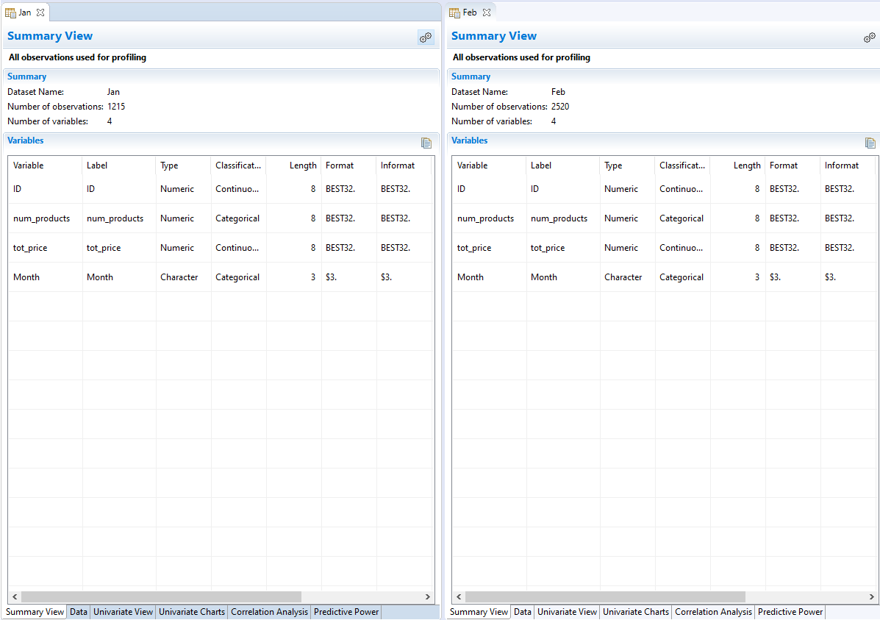

From the summary view it can be seen that there are 1215 and 2520 observations across files and both have the same 4 variables. From the Data tab variables and observations can be viewed for both files.

Figure 7: Viewing data with the Data tab

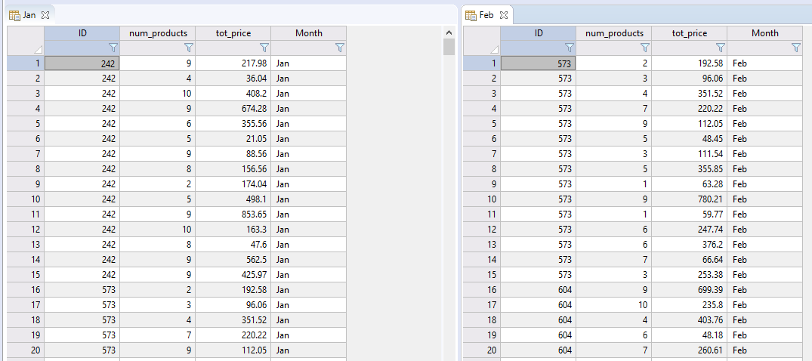

Again, notice that across both files there are multiple transactions associated with the same id and some id's have transactions across both months.

The Data Preparation group contains a series of point and click blocks to assist in data preparation tasks. There are blocks for aggregating, binning, filtering, imputing missing values, calculating new columns and more.

Figure 8: Data Preparation group

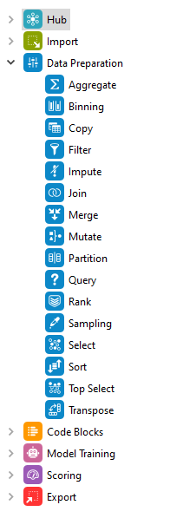

## Merge block

The Merge block can be used to merge all observations from both transactional files. This is dragged onto the Workflow canvas. Notice the configuration status messages: Block requires at least two dataset inputs and: No merge operation selected.

Figure 9: Merge block

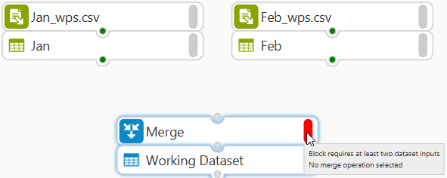

The imported files are renamed to Jan and Feb respectively and then connected to the merge block and as a result, there is now only one configuration status message: No merge operation selected.

The Merge block is double-clicked to access its configuration dialog. Options are included to select the merge operation and a By Variable.

Figure 10: Merge block dialog

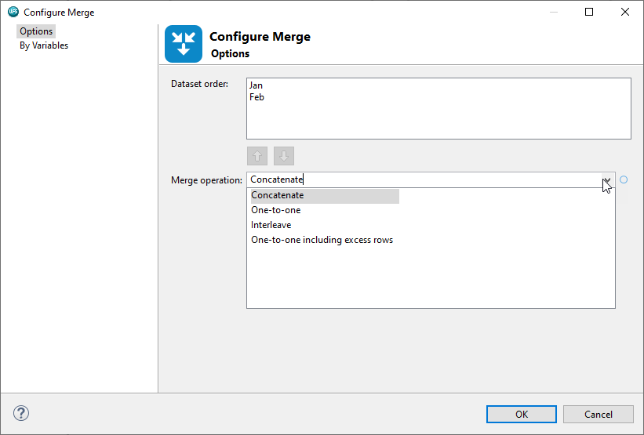

Both connected datasets are listed and the available merge operations are: concatenate, interleave, and one to one.

Concatenate stacks observations from one file on top of the other. Missing values may result if some variables are present in only one file.

Interleave works on a observation index and requires a by variable as indicated by the error message. One or more by variables can be included and will result in an output dataset ordered by the by variable, in this instance id.

The *one-to-one* option is based on observation row index and does not use a by variable. The first file is used as a base, if there are additional variables in other file(s), they will be added. Values used are taken by matching row index number. The number of observations in the final file is equal to the number of observations in the smallest input dataset, here 1215, choosing to include excess rows will results in a file size equal to the largest connected dataset and some observations will have missing values.

The appropriate option to use here is concatenate, which does not require a by variable. OK is clicked and the process runs. Opening the resulting dataset with the Data Profiler, it can be seen there are 3735 observations and four variables, as expected.

Viewing the data, 1215 January observations appear first, followed by 2520 February observations.

## Interactive Questions

Q1:

Two files have the same four variables and 100 and 200 observations respectively. What block from the Data Preparation group can be used to create a new file that combines these two such that the new file has four variables and 300 observations?

Aggregate.

Filter.

Join.

**Merge.**

A:

The Merge block is used to concatenate the files.

Q2:

Drag and drop words to complete the sentence correctly.

**­­­­­­­­__________** datasets can be connected to the Merge block

At least three

Only two

**Two or more**

A:

**­­**Two or more datasets can be connected to the Merge block.

Q3:

Fill in the blank variable to complete the sentence correctly:

The Merge block provides options to Automatically sort using ___ variable(s), only if Interleave is selected as the Merge operation.

A: by

The Merge block provides options to Automatically sort By variables, only if Interleave is selected as the Merge operation.

Q4:

When using a Merge block and a By variable is included, the By variable:

**Must exist in all connected datasets.**

Must exist in only one connected datasets.

Must exist in at least one connected dataset.

Must be sorted.

A

When using a Merge block and a By variable is included., the By variable must exist in all connected datasets.

Q5:

Select all correct answers. When using the Merge block, which option(s) will output 200 observations and

4 variables, if the input datasets have 150 observations and 4 variables and 50 observations and 4 variables respectively?

**Interleave**

**Concatenate.**

One-to-one.

One-to-one including excess rows.

A:

Interleave or Concatenate will output 200 observations and 4 variables.

## Aggregate block

The next step is to group observations by id and generate some summaries such as average and total for number of products and total price.

The Aggregate block can be used for this purpose, the block is dragged from the Data Preparation group to the Workflow canvas and connected to the merged dataset.

Figure 11: Aggregate block

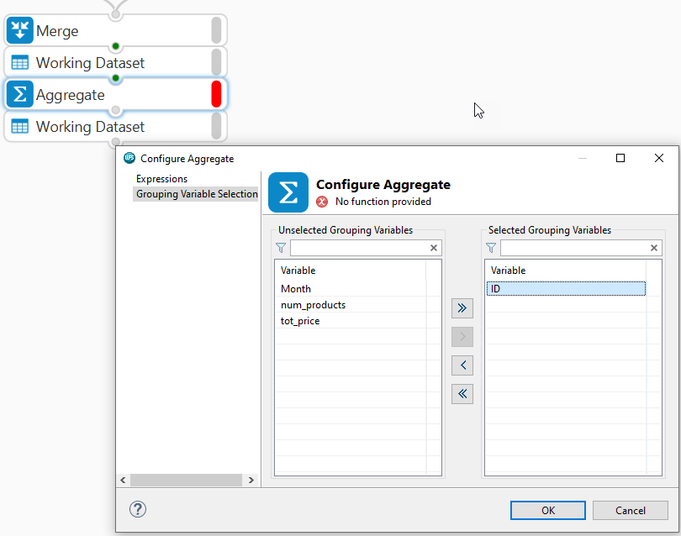

As with all newly connected blocks the configuration has not been set and the status indicator message: No function provided reflects this.

Double-clicking opens the block configuration dialog. The dialog has two pages. Grouping Variable Selection allows selection of one or more grouping variable, here *ID* is double clicked and automatically moved to the Selected Grouping Variables list. Observations will now be grouped by *ID*.

From the expressions page, new variables can be created based on aggregate functions. Options to specify the variable to base the calculation on, the function to apply and the name to assign to the calculated variable are available.

Figure 12: Expression’s page

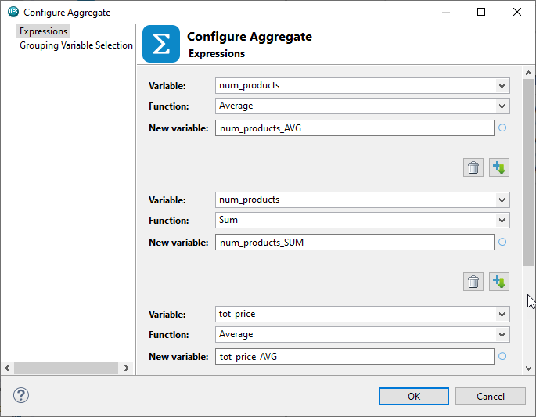

Here there is interest in creating new variables that calculate the sum and average number of products purchased and total price.

To create average number of products ,The function dropdown provides a long list of possibilities, here average is selected, *num_products* is selected from the variable selection pop up window., notice the new variable name is added automatically but can be changed if desired.by default an the suffix _AVG is added.

Expressions can be added or deleted by selecting the appropriate icon. Clicking the Add expression below icon adds a new expression entry. This time sum selected and the same variable is chosen and the same two calculations are repeated for the variable *tot_price*.

OK is clicked to complete the process and the resulting dataset is opened with the Data Profiler.

Figure 13: Summary View

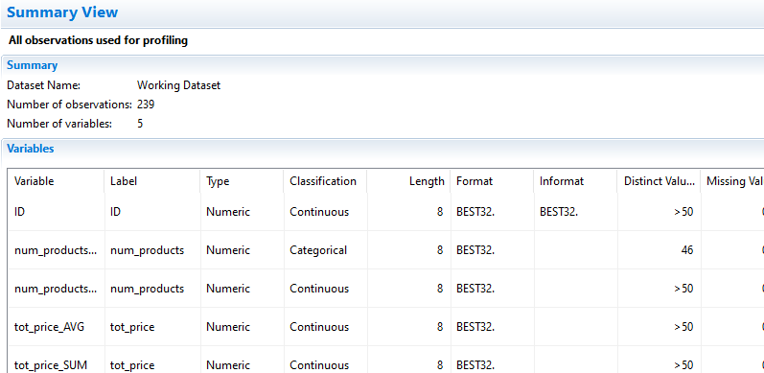

As can be seen there are 239 observations and 5 variables. From the Data View it can be seen that

All transactional information has been summarised and there is now one row for each unique id.

Figure 14: Data View

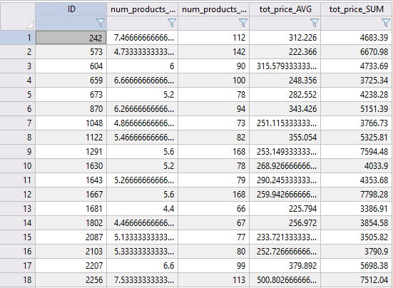

The next step is to enrich the transactional data with demographic detail contained in the file *demographics_Altair.csv*.

First, the file is dragged onto the Workflow canvas from the File Explorer, configured and imported. Opening the file with the Data Profiler, there are 20000 observations and 8 variables. Viewing the data, it can be seen it contains an id variable and this will be used to join demographic details to the transactional data.

The join block will be used for this but prior to proceeding it is wise to ensure there are no duplicates contained in the demographics file. To do this a Sort block is added and docked with the demographic’s dataset. The sort block can be used to sort data based on one or more variables, here, *ID* is selected and the option: Remove duplicate keys chosen.

Figure 15: Sort block

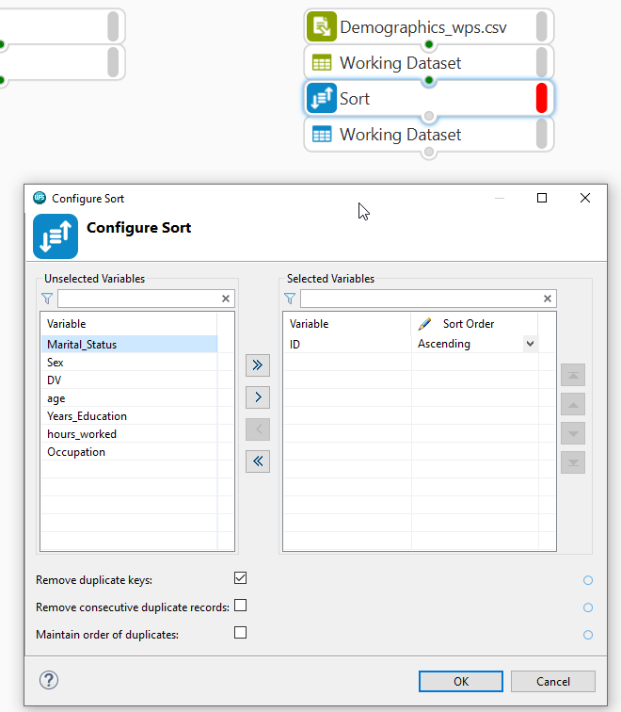

Opening the results with the Data Profiler and from the Summary View tab it can be seen there are 20000 observations, no change from the previous file, regardless, this is good practice and something to bear in mind.

## Join block

The final step is to enrich the transactional data with demographics. At this point the file names are changed to *transactions* and *demographics* as this will make further processing easier.

To complete the process, a Join block is dragged from the Data Preparation group to the Workflow canvas. As always, the configuration settings indicator is red and displays two messages: At least two connections being required and At least one join must be defined.

Both datasets are connected to the Join block and its configuration dialog accessed, where both files are illustrated listing variables in both.

Figure 16: Join configuration

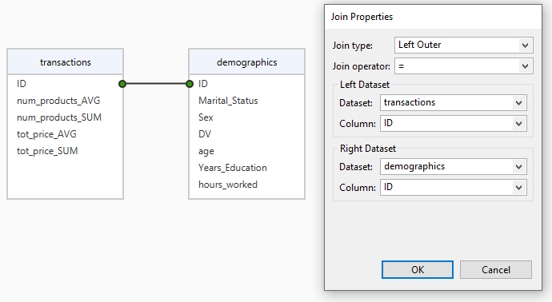

Here there is interest in retaining all observations in the transactions file and enriching with demographics based on the variable id.

The join variable, *ID*, is dragged from transactions to *ID* in demographics. A join is created and can be defined by either right-clicking the line joining the variables and selecting the option: Configure Join or simply by double-clicking. Either will open the Join Properties dialog.

The left dataset is demographics and the right dataset is transactions with *ID* as the column for both.

There are six join types to choose from and also six join operators. To retain all observations from transactions and matching observations from demographics the Join Type is right Outer and the Join operator selected as equals.

There are also two additional tabs in the Join block: SQL and Preview. The SQL tab outputs the code for the join and Preview illustrates what results will look like.

Clicking CTRL+S updates settings and applies the join. Returning to the Workflow and opening the resulting dataset with the Data Profiler, it can be seen that there are 239 observations, and summarised transactional information has been enriched with demographics, the data can be viewed in greater detail from the Data tab.

## Interactive Questions

Q1:

Drag and drop the Data Preparation group block that can be used to group observations and calculate summaries for numeric and character variable onto the question mark.

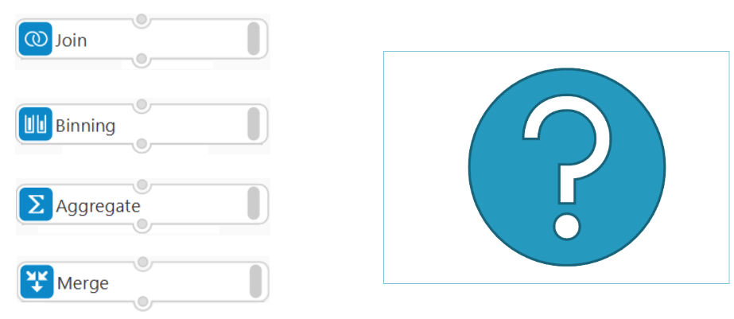

A:

The Aggregate block from the Data Preparation group can be used to group observations and calculate summaries for numeric and character variables.

Q2:

Drag and drop the words to complete the sentence correctly.

The _____ block outputs unique observations based on one or more ____ variables.

**Aggregate** join Merge **grouping** id

A:

The **Aggregate** block outputs unique observations based on one or more **grouping** variables.

Q3:

Drag and drop the words to complete the sentence correctly.

The ___________ function in the Expressions page of the Aggregate block calculates _________.

**Count** Minimum Count(*) Average **number of observations**

A:

The **Count** function in the Expressions page of the Aggregate block calculates **number of observations**.

Q4:

The Sort block, found in the Data Preparation group, can be used to sort data based on one or more variables and includes options to remove duplicate rows and variables. **t**/f

 A:

The Sort block can be used to sort data based on one or more variables and includes options to remove duplicate rows and variables.

Q5:

Select all incorrect statements:

To join two datasets, the Join Column must exist in both files.

**Join’s, once configured cannot be modified.**

To join three datasets, the join column must exist across all three.

A:

Join’s, once configured can be modified.

Q6:

If the Left Dataset contains 100 observations of customer transactional information, and the Right Dataset contains 12000 observations of customer demographic information, and both datasets contain an id variable. How many observations will be in the resulting dataset if a Right Outer Join Type is used with the Join operator: '='?

100.

**12000.**

12100.

None of the options are correct.

A:

The answer is 12000 as all observations in the Right Dataset will be retained and enriched with matching observations from the Left Dataset.

Q7:

Choose the correct answer from the drop-down list:

If the Left Dataset contains 100 observations and 5 variables observationing transactions and the Right Dataset contains 12000 observations and 16 variables observationing demographics, and both contain an id variable. If a Right Outer Join type is used with the Join operator: '='. The resulting dataset will have ___ variables.

5.

16.

21.

**20.**

A:

If the Left Dataset contains 100 observations and 5 variables observationing transactions, and the Right Dataset contains 12000 observations and 16 variables observationing demographics, and both contain an id variable. If a Right Outer Join type is used with the Join operator: '='. The resulting dataset will have 20 variables.

## Binning variables with the Binning block

At this stage all transactions have been merged, summarised and enriched with demographic detail but there may be a need to process the data further.

The data preparation group contains blocks that can assist, for example the Binning block. The block is dragged onto the resulting dataset, connected, and double-clicked to access its configuration dialog.

Figure 17: Binning block

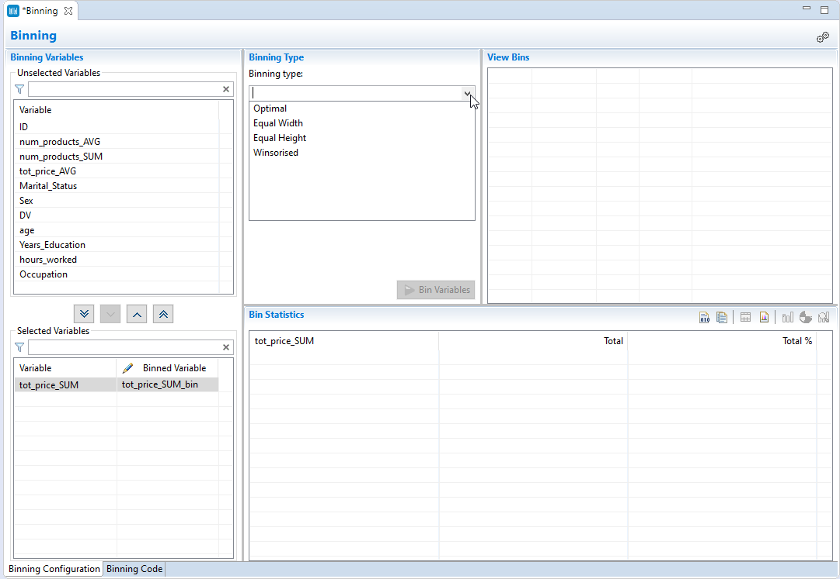

The binning block can be used to create categories or bins for any variable. The dialog has a number of areas, first a variable to bin must be selected by moving it from the Unselected Variables list to the Selected Variables list, here *tot_price_sum* is chosen.

The binned variable is the variable that will be created and can be renamed, more on this shortly.

Once selected there are four binning types to choose from: Optimal, Equal Width, Equal Height and Winsorised. Options for each can be set from Binning Preferences accessible by clicking the gears icons.

Figure 18: Binning Preferences

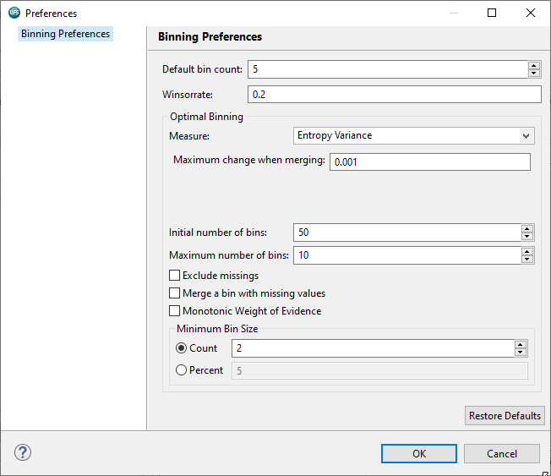

The Default bin count and Winsorrate values apply to Equal Height, Equal Width and Winsorised binning and the optimal Binning settings apply to the option Optimal.

Equal height binning attempts to create *n* equally populated bins, whereas equal width creates bins with the same width, Winsorised binning removes a proportion of the largest and smallest values, here 20%, equal width bins are calculated and the removed observations are returned to the first and last bins respectively. This ensures that the first and last bins are adequately populated.

Optimal binning settings include the ability to choose the measure, specify the starting and maximum number of bins to create, how to deal with missing values and whether to force monotonicity.

There are also options to ensure resulting bins are adequate in terms of size. The binning type: Optimal requires selection of a Dependent variable and its treatment.

Here, there is interest in creating a new variable that records whether total price sum is either *low* or *high*. A good place to start is to choose Equal Height as the Binning type. From Binning Preferences, the default bin count is set to 2.

The Bin Variables button is clicked and this generates bins for the selected variable with bin cut points visible.

Figure 19: Equal Height binning applied

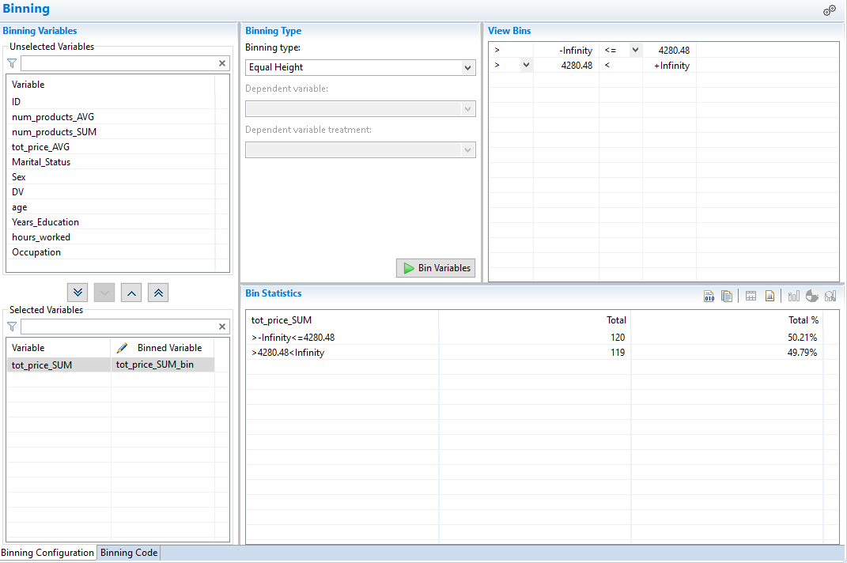

The Bin Statistics area relays the size and % of each bin in a frequency table. The view can be changed by hovering and selecting an appropriate icon.

Here, the icon Show as frequency chart is selected, this view shows how the created bins are distributed across the variable *tot_price_sum*, bear in mind this is the variable that binning is based on. The option to Show as pie chart is also available and bins can be isolated and compared by selecting them from the bins area.

Figure 20: Show as frequency chart

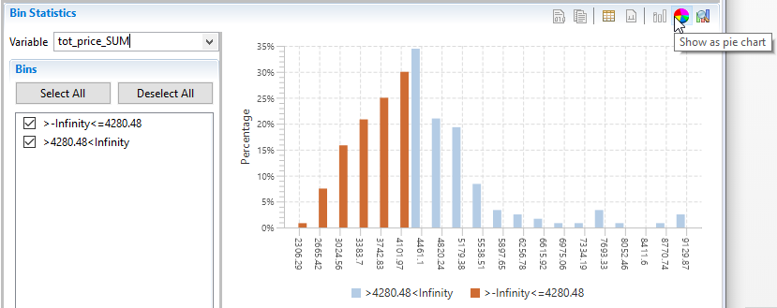

From the Variable drop-down, *DV* is selected. Now the chart illustrates how the bins are distributed across the categories of *DV.* Changing the chart to a pie illustrates things more clearly.

Figure 21: Selecting DV as Variable

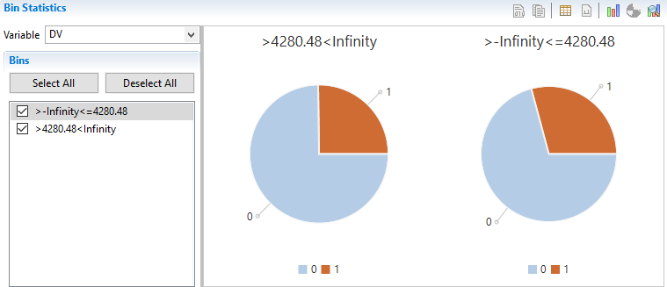

As can be seen there is little difference across the *DV* categories in terms of the bin distributions.

The new variable is given the name: *value_bins* and num_products_SUM selected. The new variable to create is named to *loyalty_bins* and the Binning type selected as Equal Height, previous settings are retained and 2 bins are created.

The binning code for the transformations applied is available from the Binning Code tab in either SAS or SQL format.

Figure 22: Binning Code

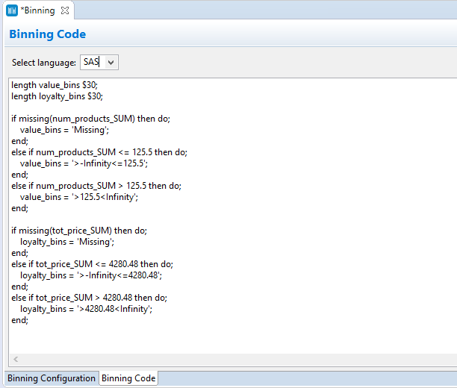

The keyboard shortcut CTRL+S is used to apply binning settings and the asterisk disappears reflecting this.

Returning to the Workflow and opening the created dataset with the Data Profiler, the variables *loyalty_bins* and *value_bins* have been added. Viewing bins for each variable using charts, it can be seen two bins are evident for each with an approximately equal number of observations in each bin.

Figure 23: Chart of value_bins

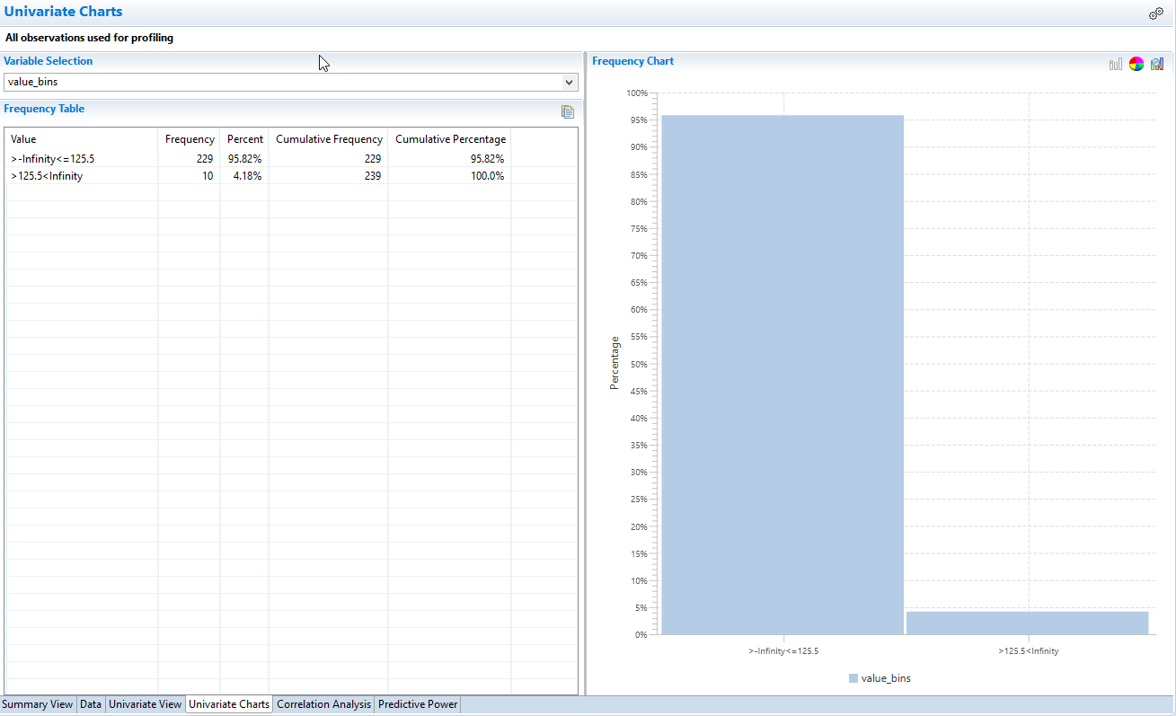

Viewing the data it can be seen that the bins have cutpoints that are not appealing. To address the binning code can be copied and used in a SAS Code block and applied to the data directly. This way the bin labels can be changed to something more readily identifiable.

The binning code is copied by selecting and using the keyboard shortcut CTRL+C. A SAS code block is dragged onto the canvas and the dataset prior to the binning block attached.

Double clicking opens the SAS Code block. First an output data set is needed, and this is added by clicking the Add a new output dataset button In the Outputs area.

The binning code copied previously is pasted using CTRL+V. Now, the bin labels can be easily changed and here are updated to low and high for each variable.

The code must be wrapped in a DATA STEP. This requires the use of the command DATA, this creates a dataset, and the dataset to create is the one generated previously, this is dragged into the code and a semi-colon added.

Next, the data to process must be specified, this is done using a SET statement and the input dataset is dragged into the code and the code line completed with a semi-colon.

Finally, a RUN Statement is required and this is added at the very end with a semi-colon.

Figure 24: Completed code

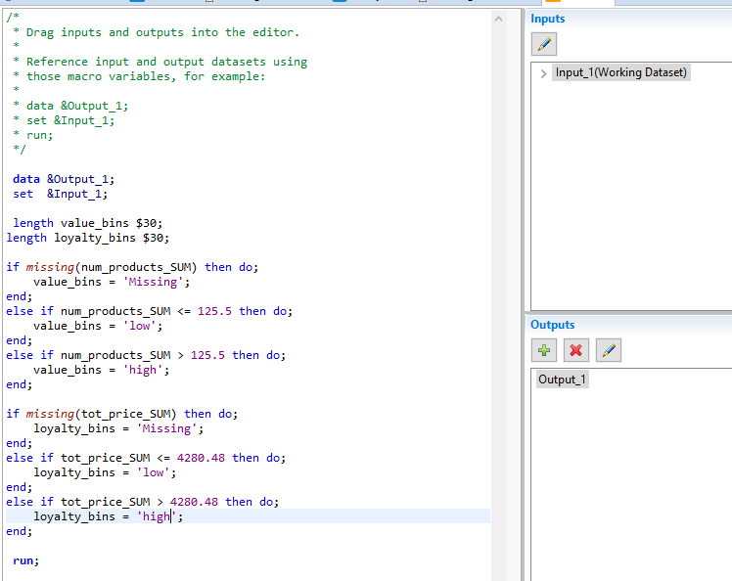

Using CTRL+S applies the binning and the output dataset is created. Accessing the new dataset via the Data Profiler and viewing charts for the created variables shows labels have been applied and make the variable categories much easier to understand.

Figure 25: Labels applied

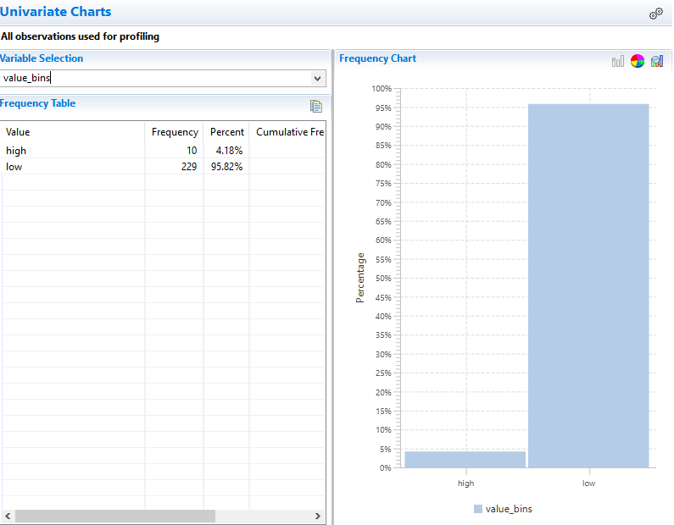

The binning can also be applied to other data by generating a binning model - this is accessed by right clicking the binning block.

Clicking the option configure outputs opens the binning block outputs dialog. By default a new dataset is generated but this can be suppressed by moving it to the Unselected Output list.

Moving the binning model from the Unselected Output list to the Selected Output list and clicking OK, generates the binning model block.

Figure 26: Outputting a binning model

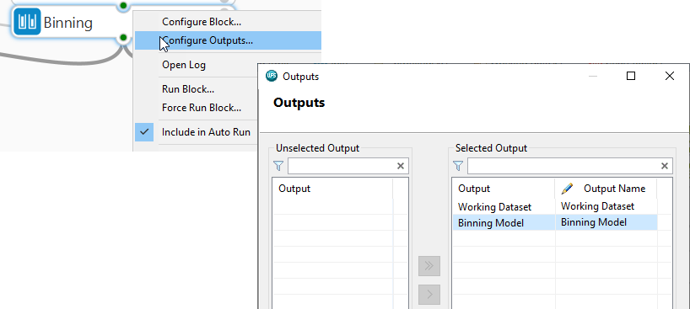

The block cannot be viewed but now the binning can be applied to any appropriate dataset by connecting both the binning model and the dataset to bin to a Score block. To illustrate, the same dataset is connected and the output is automatically generated.

Figure 27: Scoring data with the binning model

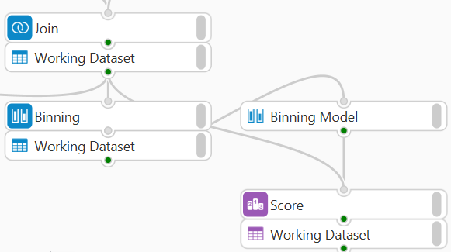

Viewing the data it can be seen that the new variables have been added.

## The Mutate block

The Mutate block can be used to apply the language of SAS or SQL statements to generate new variables. The Mutate block is dragged onto the canvas and the dataset created previously connected, and subsequently the Mutate block configuration dialog accessed.

Here there is interest in creating a new variable using those created earlier to distinguish valuable and loyal customers.

A new variable can be added by clicking the Add new variable icon, once added the variable name is changed to *value_loyalty.*

Figure 28: Mutate block

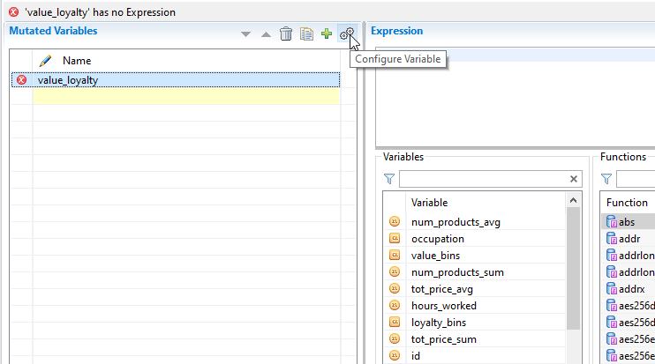

Options to define the variable are available from the Configure Variable dialog, which is accessed by clicking the gears icons.

Figure 29: Configure Variable dialog

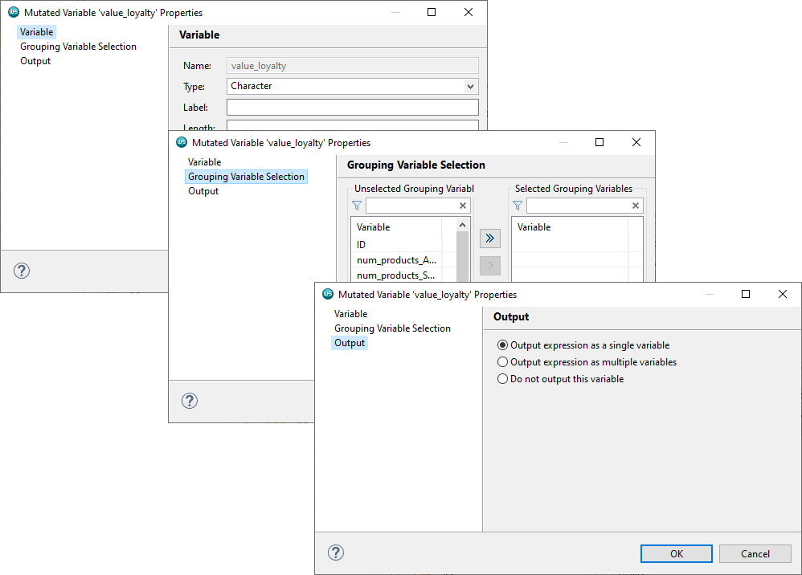

Three pages are available. The first, Variable, enables the properties of the variable to be specified.

As the variable being created here will contain character values, the Type Character is appropriately set. Other options such as label, length, format and informat can be set but if not, defaults are applied.

The Grouping Variable Selection page allows selection of one or more grouping variables and the Output page provides options to determine how to output results including the option to Do not output this variable.

Expression can be applied in the Expression area. A list of dataset variables and functions with help are available to assist with building expressions. These can be clicked to automatically add them to an expression.

Here case statements are used to assign a value of gold, silver, bronze based on the values of the variable’s *loyalty_bins* and *value_bins*.

Figure 30: Applying an expression

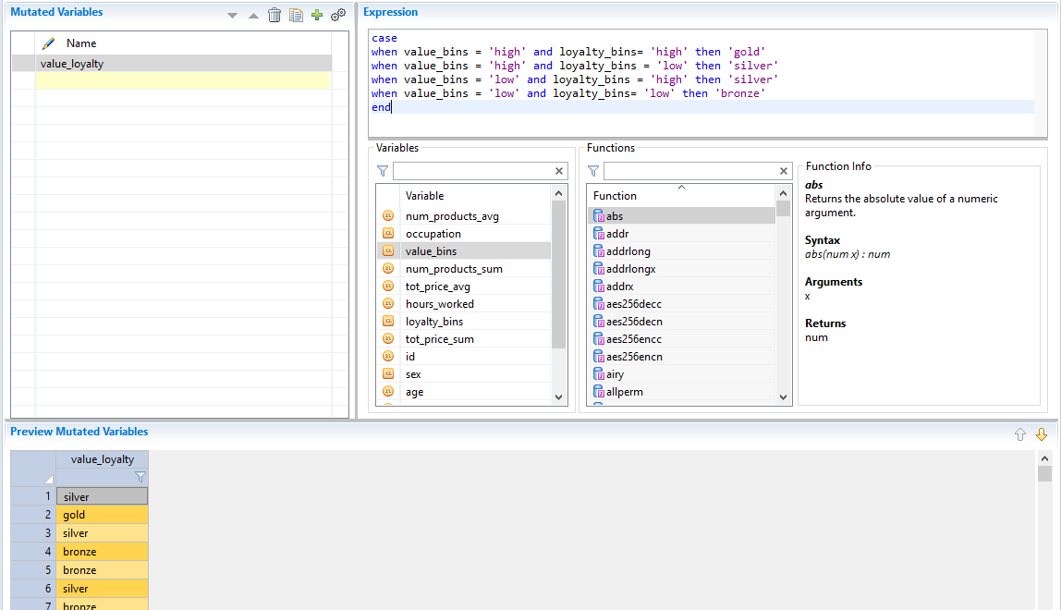

The preview provides insight as to not only the results but whether the expression has been specified correctly and here, it had.

CTRL+S applies the expression and a new dataset is output. Viewing results with the Data Profiler it can be seen that the variable has been added and from Univariate Charts its distribution can be viewed.

Figure 31: Viewing value_loyalty

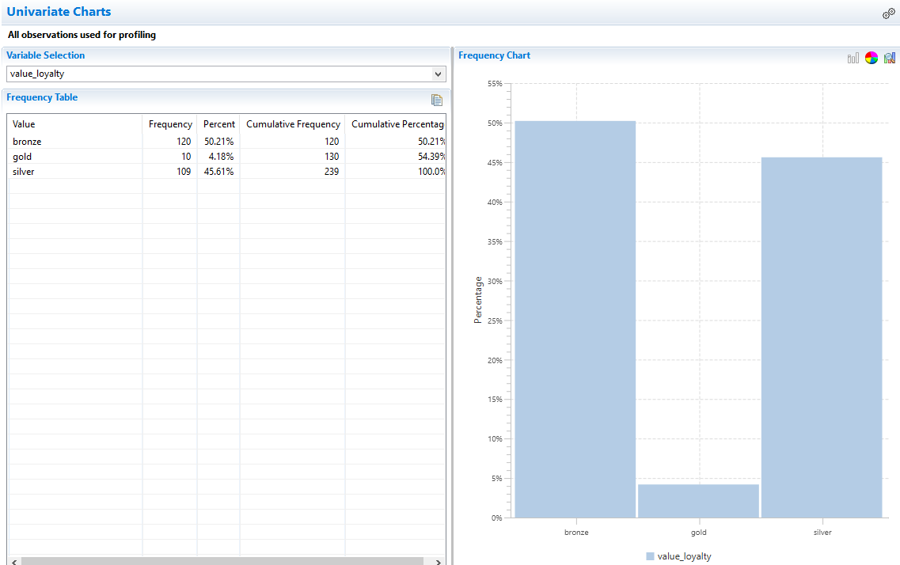

The resulting Workflow can be augmented with additional detail, for example if there is interest in adding transactional information for March, simply add the March dataset to the Workflow, connect to the merge node and the Workflow automatically updates and includes the new data in processing. Notice the resulting File now has 355 observations, whereas previously there were 239.

Bear in mind that the new data should correspond in format and nature to that used to build the processing chain initially to ensure the Workflow runs error free.

The SAS language code for the entire Workflow can be generated and exported to a SAS language program via canvas right-click. The code can be copied and used directly in the SAS Language or Workflow perspectives or exported and accessed as necessary.

Here the code is output to the Project folder as *data_prep.sas*, refreshing the project shows the file and it can be accessed by double-clicking.

## Interactive Questions

Q1:

When using the Binning block, the number of observations in resulting bins can be ascertained from the Bin Statistics area. **t**/f

A:

When using the Binning block, the number of observations in resulting bins can be ascertained from the Bin Statistics area.

Q2:

The Bin Statistics area of the Binning block does not provide the facility to view charts of the distribution of the resulting variable across the categories/values of another variable? t/**f**

A:

The Bin Statistics area of the Binning block provides the facility to view charts of the distribution of the resulting variable across the categories/values of another variable.

Q3:

Select the incorrect statement:

**When using the Binning block, the block settings must be saved using CTRL+C to ensure binning is applied.**

The SAS code generated for any block can be viewed from the block log. Some block code can be accessed from the configuration window, including the Binning block.

The SAS language output from a block can be used in the workflow by copying and pasting into a SAS language block.

A:

When using the Binning block, the block settings must be saved using CTRL+S to ensure binning is applied, not CTRL+C!

Q4:

The SAS language code for any Workflow can be generated and either exported to a SAS language program or copied to the clipboard. **t**/f.

A:

The SAS language code for any Workflow can be generated and either exported to a SAS language program or copied to the clipboard.

Q5:

The Mutate block can be used to apply either SAS language or SQL expressions to create new variables. **t**/f

A:

The Mutate block can be used to apply either SAS language or SQL expressions to create new variables.

## Summary

 This lesson focused on data preparation and manipulation and Altair Analytics Workbench Workflow perspective capabilities.

A scenario was introduced followed by a demonstration using blocks from the data preparation group to

illustrate steps in the scenario. Once complete additional data preparation blocks were demonstrated using the results.

# Exercises



Q1:

Create a new Workflow or use an already existing one but delete all blocks. Using the files: *mar_Altair.csv* & *demographics_csv.* Profile the datasets and use them to generate the dataset depicted. Note: *ID* should be unique. Retain all observations from *mar_Altair.csv* and matching observations from *demographics_csv*.



Question: How many observations and variables are in the resulting dataset?

**131 and 14.**

140 and 14.

A:

Here, an already existing Workflow is used. A blank area of the Workflow canvas is moved to by holding the left mouse button and dragging. Bothe files are located using the File Explorer, dragged onto the canvas configured and opened. Both can be opened simultaneously using the Data Profiler and viewed side-by-side.

*mar_Altair* has 1965 observations and 4 variables. Demographics has 20018 observations and 8 variables. Both contain an id variable so can be joined.

Looking at the data tab for the *mar_Altair* dataset it can be seen it is transactional, to get to the final file, it will need to be aggregated. Using *ID* as a grouping variable, summaries are generated for *num_products*, *tot_price* and *month*.

To do this, an Aggregate block is added to the Workflow and connected to the *mar_Altair* dataset and opened it. From the Grouping variable selection page, *ID* is moved into the selected grouping variables area.

From the expressions page expressions are added for the average and sum for *tot_price* and *num_products*. Minimum is selected for *month* and a count of the number of observations in each *ID* group is created using the variable *ID* and the function count.

Clicking OK, the dataset is created. Note this dataset has 131 observations. To join observations from the *demographics_* data, it is best to first de-duplicate on the variable id. Recall that this dataset had 20018 observations. To de-duplicate, a Sort block is added and ID is moved into the Selected variables area and the option remove duplicate keys is chosen. This will remove any duplicate ids found.

Running the process and opening the resulting dataset with the Data Profiler, it can be seen that there are 20000 observations, so some duplicates were found and removed.

To retain all observations in the aggregated *mar_Altair* dataset and only matching observations from demographics a join block is added to the Workflow and both datasets connected.

*ID* is dragged from the aggregated dataset to *ID* in the demographics file. To retain all observations in the aggregated dataset left outer is selected as the Join type and equals as the join operator. Once completed OK is clicked and results are opened with the Data Profiler where it can be seen there are 131 observations and 14 variables.

Q2:

Add data from the files: *Jan_Altair.csv* and *Feb_Altair.csv* to the process. The resulting dataset should have 355 observations and 14 variables.

NOTE: If this did not succeed the file: *dp_.xlsx* can be used from this point.

Using an appropriate block from the Data Preparation group: create a new variable: *age_3* using the variable: *age*. Create 3 equal height bins. Make sure the variable age is Numeric and Continuous!

Question: Comment on the distribution of *age_3* across the categories of the variable: DV.

**Older people are generally in the 1 category of DV.**

Older people are generally in the 0 category of DV.

Younger people are generally in the 1 category of DV.

Missing observations are generally in the 1 category of DV.

A

As equal height binning, in this instance, created 3 bins. Subsequent categories should contain those in a progressively older age group, therefore it can be said that older people are generally in the 1 category of DV.

Demo

The datasets *jan_Altair* and *feb_Altair* are added to the Workflow and configured correctly, opening both files it can be seen they contain the same variables as in the file *mar_Altair* so can be easily piped through the same blocks.

First the data must be joined, to do this, a Merge block is added to the Workflow all files connected.

The option Concatenate is selected and OK clicked to run the process.

The current connection to the Aggregate block is removed and the merged dataset connected. The process updates automatically, this is as a result of the blocks being included include in Auto Run and the Workflow also being set to Auto Run, this is found in Windows > Preferences > ALTAIR > Workflow.

The resulting dataset now has 355 observations. To bin the variable *age*, add a Binning block is added and connected to the resulting dataset. The block is opened and *age* moved into the Selected Variables

list, the binning type provides only the option Optimal.

This is due to the variable Classification: it is Numeric but Categorical. It has 36 unique values, lower than the current thrreshold of 50 to be classified as continuous.

To rectify this, from Window > Preferences > ALTAIR > Data, the Classification threshold is set to 35 and applied. The classification for *age* is now continuous,, Returning to the binning block, it is closed and re-opened for changes to take effect.

*age* is moved into the Selected Variables list and now Equal Height is available from the drop-down. Clicking Bin Variables creates 5 bins. To create 3, the Default bin count is set to 3 from the Binning Preferences dialog

Bin Variables is clicked again and now three bins, four including missing, are evident. The bin ranges are <= 43, greater than 43 to less than or equal to 50, and greater than 50.

From the bin statistics area any variable can be selected and the binning variable distribution for each category or value of the selected variable is depicted as either a graph or a table.

Here DV is selected and the chart type changed to a pie chart, its easy to see that Older people are generally in the 1 category of DV. Clicking CTRL+S applies binning settings, notice the asterisk is now gone.

Opening the resulting dataset, it can be seen the new variable, *age_3*, has been added.

Q3:

Question: Can the bins created previously be applied to new data? Select all correct answers.

No.

**Yes, by coping the code and using it in a SAS code block.**

**Yes, using the binning code in the SAS Language perspective.**

**Yes, by generating a Binning Model and using the Score block.**

A:

binning can be applied to new data in three ways. By coping the code and using it in a SAS code block or using the binning code in the SAS Language perspective or generating a Binning Model and using the Score block.

The binning code can be applied to new data in three ways: via a SAS Language Code block or using the binning code in the SAS Language perspective or by outputting a Binning Model and using a score block.

The third way is illustrated first. Right-clicking the Binning block provides the option to Configure Outputs. The Binning Model is moved to the Selected Output list and OK clicked. This outputs a Binning Model block.

To apply the binning model to new data, a Score block must be used. This is dragged onto the Workflow canvas and for illustrative purposes the demographics dataset and the Binning Model are connected. The dataset is generated automatically. Opening results, it can be seen that the binning has been applied and the new variable is added.

Another method is to access the code for the binning from the Binning Code tab, this can be pasted into a SAS code block. Here, again for Illustrative purposes, the demographics dataset is used.

Some slight modifications are made to the code to score the data and then ok clicked, the new variable is added to the dataset and can be accessed by double clicking

The code can also be used in the SAS Language perspective in a similar way.

# Chapter 6: Modelling with Altair Analytics Workbench

## Introduction

This lesson consists of an introduction and progresses to a classification of modelling techniques before introducing those most commonly used and also discusses questions around which and when to use.

Modelling capabilities available from Altair Analytics Workbench will also be introduced prior to speaking about partitioning before a summary.

Figure 1: Contents

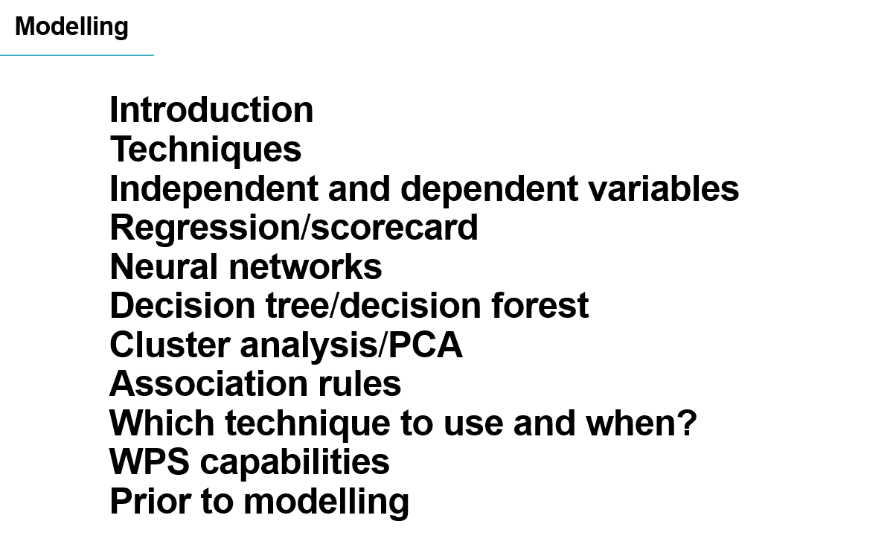

Any modelling endeavour needs a focus or business problem to solve. For example, we need to attract more customers, or we're not offering the right products or we're overstocked for the season or any one of a number of issues experienced across and within industries and verticals.

Figure 2: Introduction

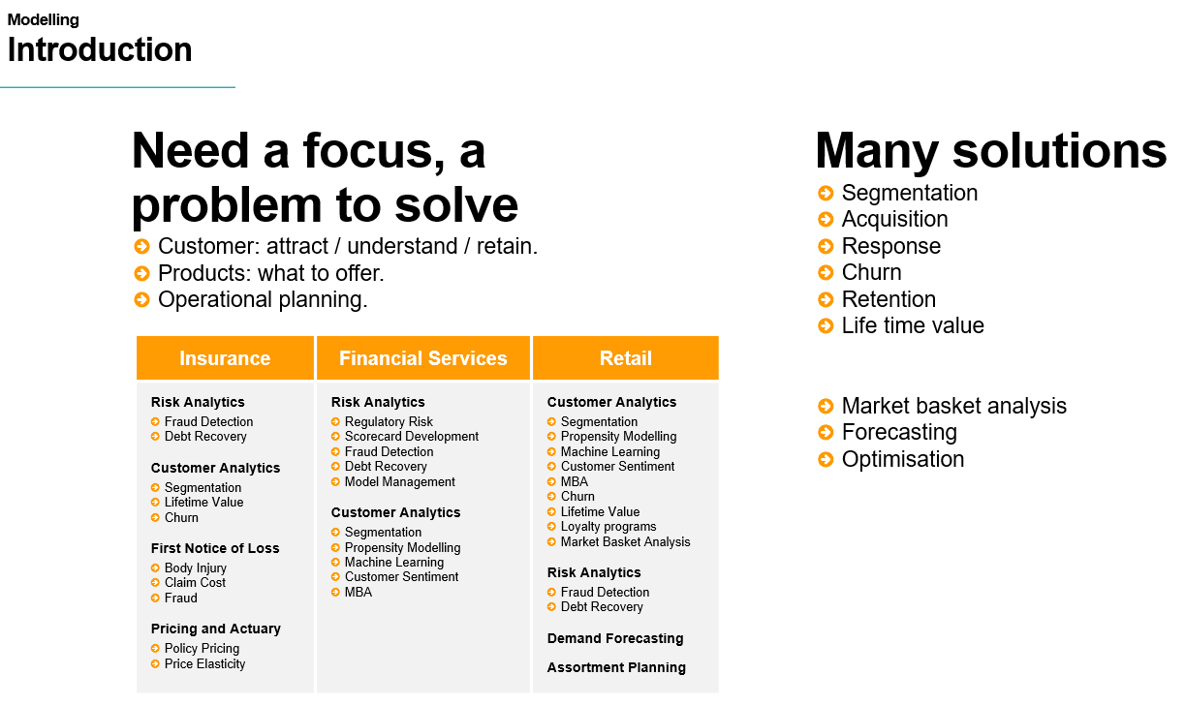

Once an issue has been identified it can be possibly be solved by modelling and there are many solution

available if that is the chosen route for example response modelling to increase customers, market basket analysis to offer the right products and forecasting for stock control, among others.

There are many modelling techniques and sometimes the wealth of capabilities can be overwhelming and regardless of the technique used all will predict something and output either a propensity, a category a group an offer a value or something of that nature.

Figure 3: Classifying techniques

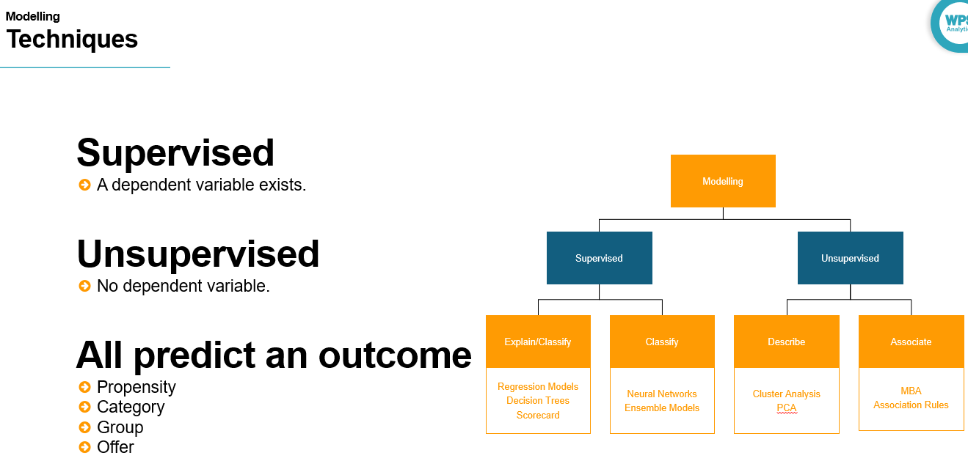

In general modelling techniques can firstly be classified as supervised or unsupervised. Supervised techniques require a dependent variable, a target, whereas unsupervised techniques require no target variable.

Supervised techniques can be further classified in relation to whether they provide insight into the model workings such as the reasoning behind the predictions or the impact of each variable in the model and generate output or whether they simply generate an output.

Modelling techniques that provide some insight into how the model arrived at its decision or output include regressions, decision trees and scorecard. Modelling techniques outputting simply a result include neural networks and ensemble modelling techniques.

Unsupervised techniques can be further sub divided also as those that describe or group data and that find associations between elements in that data.

Modelling techniques that describe data include cluster analysis, segmentation and data reduction techniques such as principal component analysis and factor analysis. Those that can be classified as finding associations including Market basket analysis and association rules.

Figure 4: The dependent and independent variables

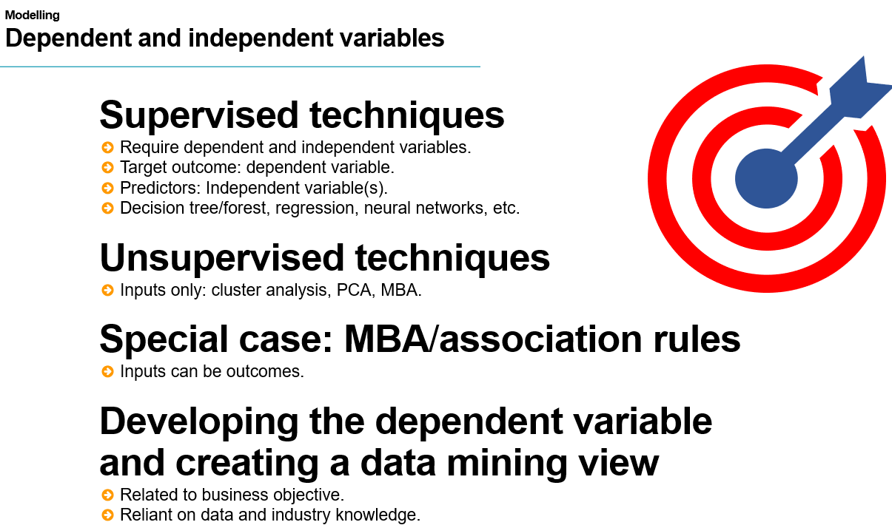

All supervised modelling techniques require an outcome, or dependent variable and predictors also called independent variables. For example, a logistic model will predict the propensity to default using demographic, financial and bureau details.

Unsupervised modelling techniques require inputs only, for example demographic details are used to identify groups of customers to promote products to in retail.

A special case of an unsupervised technique is market basket analysis and association rules where model inputs can act as predictors of an outcome or can be the outcome.

Regardless of the modelling technique a great deal of time is invested in data preparation and developing the dependent variable. This can be time consuming and requires consideration and should be related to a business objective with stakeholder approval

## Interactive Questions

Q1.

Select the correct statement:

Supervised modelling techniques do not require a dependent variable.

Unsupervised modelling techniques require a dependent variable.

**Supervised modelling techniques require dependent variable and independent variable(s).**

Unsupervised modelling techniques require dependent variable and independent variable(s).

A.

Supervised modelling techniques require a dependent variable and independent variable(s).

Q2.

Which technique classifies only:

Regression

Decision Tree

Scorecard

**Neural Network**

A

A neural network, generally referred to as a black-box technique, provides no insight into why the model predicts the way it does and classifies only.

Q3.

Which technique can be used to find associations in data?

Cluster Analysis

PCA

Factor Analysis

**MBA**

A

MBA, Market Basket Analysis, finds associations in data.

## Regression / Scorecards

Regression and scorecards are prime examples of supervised techniques that can both explain a model and classify data. They require both independent variables and a dependent variable. Linear regression is used to model a continuous dependent variable and logistic regression is used to model a categorical dependent variable.

These techniques can assess independent variables for inclusion and output an equation or a scorecard

providing the ability to quantify changes and understand the impact of each independent variable on the outcome.

 Figure 5: Regression/scorecards

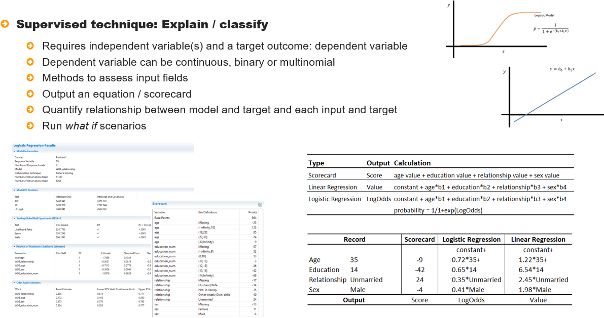

Regression outputs an estimate of impact of each independent variable on the dependent variable as an

Equation and by supplying input values, what if scenarios can be evaluated. Scorecards output scores for characteristics, these can be summed, and if a threshold is reached a decision can be made. Given this it is easy to see how scores are arrived at and how they can be changed.

## Decision tree

Decision trees also fall under the heading of being a supervised technique that can explain and classify data. Decision trees can be used to model a continuous or categorical dependent variable and independent variables can be of any type.

Figure 6: Decision tree

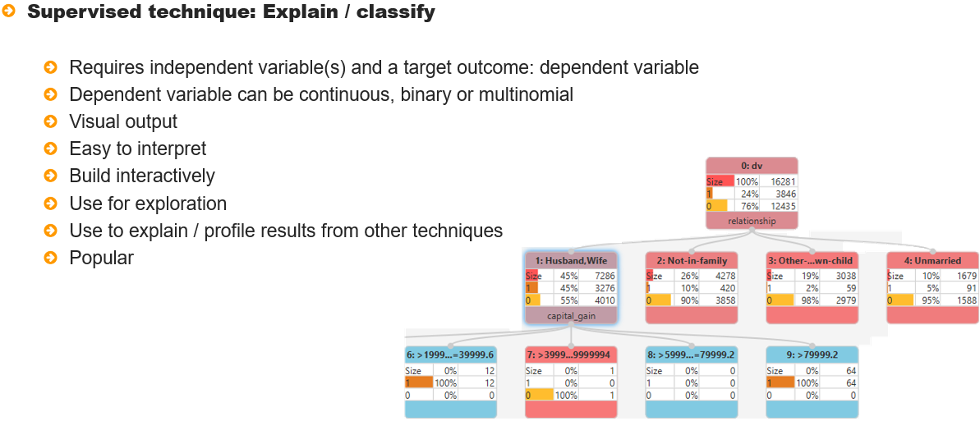

They output a propensity score, as logistic regression does, and so can be and is used in similar circumstances or in tandem. Decision Trees are popular as they are easy to use and interpret and have applications beyond modelling such as exploring a dataset and complementing other techniques

## Neural networks

Neural networks required independent variables and a dependent variable, which can be either

continuous or categorical, but they do not provide any insight into model predictions and only generate an outcome. For this reason neural networks are commonly referred to as a *black box* technique. They may outperform other modelling techniques but will not provide any reasoning behind its predictions

Figure 7: Neural network

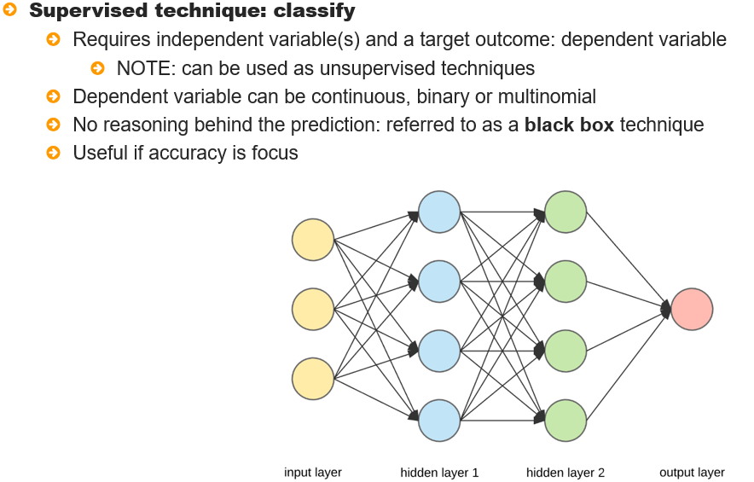

## Ensemble methods

Ensemble methods can also be considered as *black box* as a result of combining results from lots of models. The most commonly used ensemble methods derive from decision tree methodologies and

include boosting, bagging and random forests in some form or other.

Figure 8: Ensemble methods

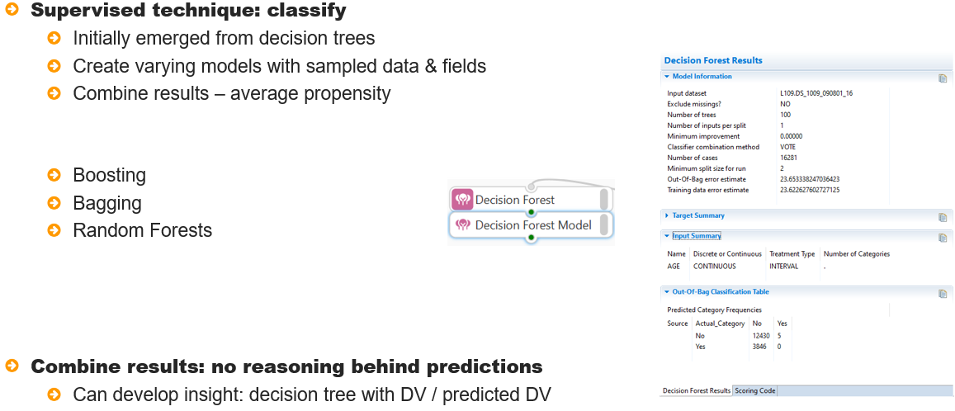

These methods build lots of models, usually in the 100s or 1000s. The prediction from each model is used to calculate the final outcome and this entanglement means that predictions, and therefore the model workings cannot be well understood.

## Interactive Questions

Q1:

Regression and scorecards can both explain a model and classify data. **t**/f

A:

Regression and scorecards can both explain a model and classify data. Each of these methods generates a model equation which can be used to assess what-if scenarios. Additionally, models generated with these techniques also classify data.

Q2:

Logistic regression can be used to model a categorical dependent variable with 2 or more categories. **t**/f

A:

Logistic regression can be used to model a categorical dependent variable with 2 or more categories. If there are only 2 categories in the dependent variable, the technique is referred to as binary logistic regression. If there are more than 2 categories, the technique is called multinomial logistic regression.

Q3:

Select the incorrect statement

Regression and scorecards output model equations.

Regression assesses the impact of each predictor on the target.

Scorecards assign points based on characteristics.

**What-if scenarios cannot be evaluated with regression and scorecards.**

A:

What-if scenarios can be evaluated with regression and scorecards.

Q4:

Decision trees fall under the heading of being a supervised technique that can explain the reasoning behind the prediction and also classify data. **t**/f

A:

A decision tree generates a tree model which can be used to understand why an observation is predicted in the way it is. Additionally, a propensity score is generated which is used to classify each observation.

Q5:

Select the incorrect statement

**Decision trees accept categorical independent variables only.**

Decision trees output a graphic representation of the model.

Decision trees are easy to interpret.

Decision trees can be used for modelling, exploration and complimenting other techniques.

Decision trees generate a tree-based diagram of the model, are easy to interpret and can be used to modelling, exploration and complimenting other techniques. Additionally, decision trees accept both categorical and continuous independent variables.

Q6:

Not all supervised models are transparent in the decision-making process, for example: Ensemble Models. **t**/f

A:

Ensemble models generate many models and combine results from each to generate predictions. As a result of this, the reasoning behind the prediction is opaque and cannot be easily ascertained, if at all.

## Clustering / PCA

Unsupervised methods such as cluster analysis and principal component analysis require inputs only and

describe data by either grouping observations or variables into identifiable segments or factors. Their use is widespread across industries and verticals to create marketable groups and segments.

Figure 9: Clustering/PCA

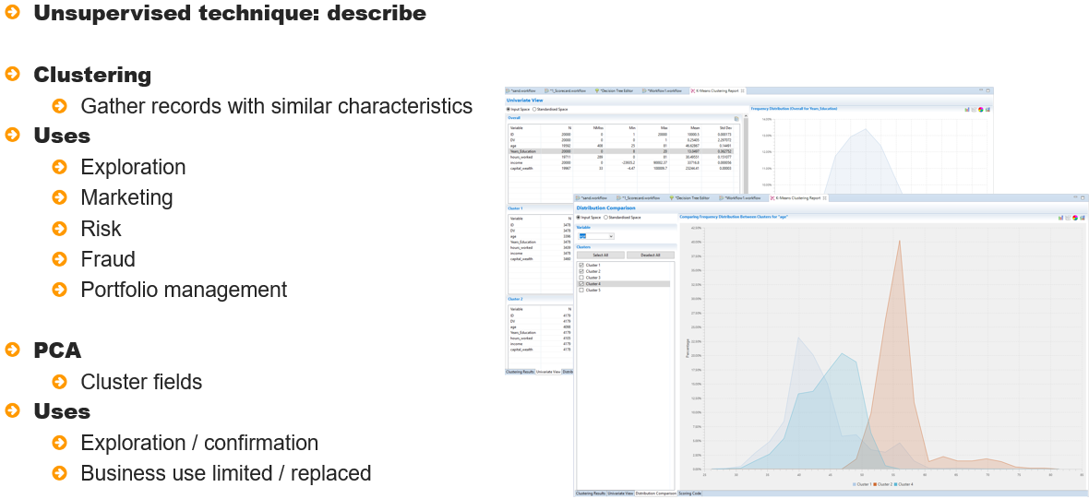

## Association rules

Another unsupervised technique that is commonly used is Market Basket Analysis and association rules.

These techniques look for associations in data whether between products, services, or progress through

pages on a website.

Figure 10: Association rules

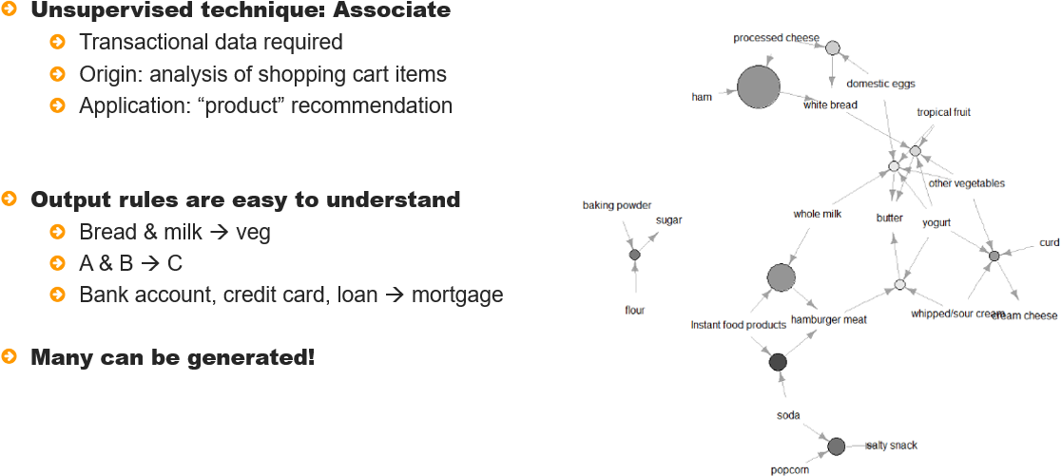

Market basket analysis originated from the analysis of the contents of shoppers’ trollies and outputs

rules with antecedents and consequents; the left hand and the right hand of the rule.

For example, those purchasing bread and milk also purchase veg. Inputs can act as outputs So another finding may be that those purchasing veg and frozen foods also purchased milk. The output is easy to understand as it is in the form of rules but may can be generated.

## Technology and data

 New methods are constantly being presented to address and deal with a progress environment and the impact of technology and the explosion of data cannot be ignored.

Figure 11: Technology and data

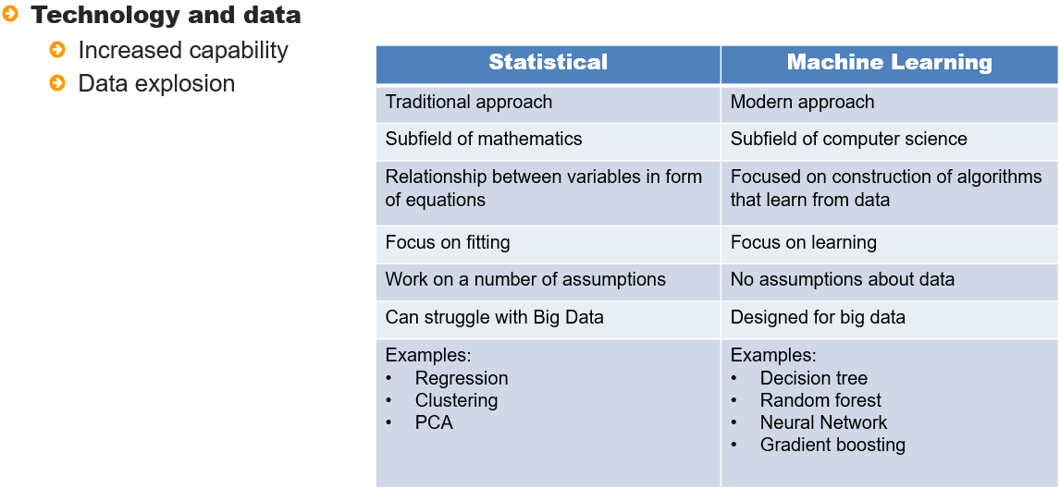

Statistical methods have been joined by machine learning methods designed for large data that focus on outcomes whereas traditional statistical methods may struggle with large volumes of data but do provide a level of insight absent to some degree from machine learning methods.

Which technique to use and when?

The technique to use and the method to apply are all dependent on goals.

Whether there is a need to be very accurate or whether there is a need to understand and explain results may impact the technique chosen but bear in mind that techniques do not have to be used in isolation and one technique may be used to compliment another.

For example, a decision tree might be used to illustrate logistic regression odds ratio or to give some clarify behind the predictions of a neural network

Figure 12: Which technique to use and when

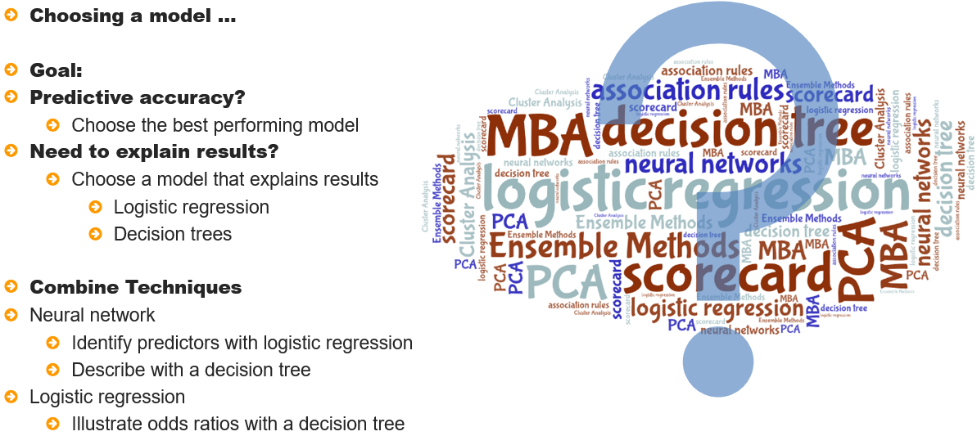

Altair Analytics Workbench modelling blocks

Altair Analytics Workbench provides an array of modelling techniques available from the Workflow via the

Model training group blocks or via code. Modelling blocks are drag drop with point and click

functionality and automatic scoring code generation.

Figure 13: Altair Analytics Workbench modelling blocks

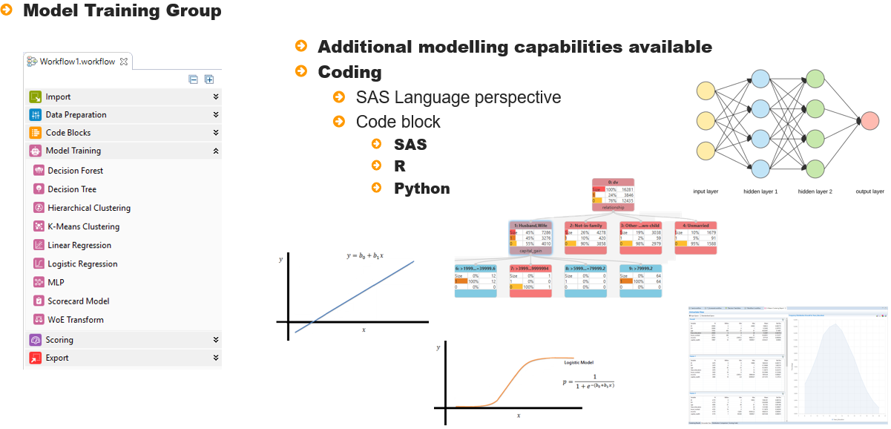

Other modelling functionality can be accessed through the SAS, SQL, Python and R code blocks.

Prior to modelling

Prior to any modelling the data should be partitioned. This is a mechanism to ensure that models

are accurate and can be used in production. A dataset is split, generally into two partitions a development and a training partition, but more can be created if desired.

Figure 14: Prior to modelling

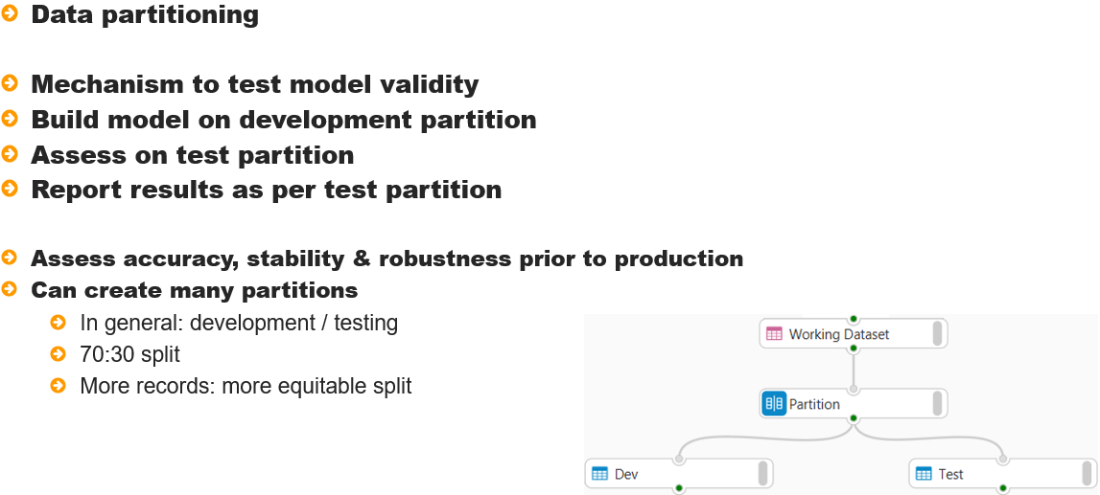

The testing partition is isolated and a model is built using the development partition. The model is then

applied to the testing partition to ensure consistency prior to production.

## Interactive Questions

Q1:

Select the incorrect statement:

PCA and cluster analysis are both grouping techniques that describe data.

PCA and cluster analysis are both unsupervised techniques.

**PCA and cluster analysis require a dependent variable.**

PCA and cluster analysis require inputs only.

A:

PCA and cluster analysis are classification techniques and as such, do not require a dependent variable.

Q2:

Cluster Analysis clusters:

**Observations**

Datasets

Files

Variables

A:

Cluster analysis clusters observations and attempts to find homogeneous groups.

Q3:

MBA finds associations and generates rules. **t**/f

A:

MBA or market basket analysis finds associations between items and generates rules that can be used to apply to new observations. Rules can be used to make offers or recommendations whether for products, services, processes and more.

Q4:

In MBA inputs can also be outputs, for example bread + milk = diary, milk + eggs = bread. **t**/f

A:

When using MBA, inputs can be outputs. To be more precise, inputs are called antecedents and the output or result is called a consequent. As multiple rules are generated an antecedent in one may be a consequent in another.

Q5:

To predict whether an applicant will be accepted or rejected, use:

Linear regression.

**Logistic regression.**

PCA.

Cluster Analysis.

A:

Logistic regression is widely used to model a binary outcome, for example: whether to reject or accept an applicant.

Q6:

If there is a need to explain the results of neural network, logistic regression may be used to assess variable impact and a decision tree can be used to provide some additional visual insight. **t**/f

A:

It is more than appropriate to use complimentary modelling techniques to provide additional insight.

Q7:

Altair Analytics Workbench modelling functionality can only be accessed using the Model Training group

blocks in the Workflow perspective only. t/**f**

A:

Altair Analytics Workbench has considerable modelling functionality which is available via the Workflow perspective Model Training group blocks. Additional modelling functionality can be accessed via code using either the SAS Language perspective or using code blocks from the Code Blocks group in the Workflow perspective.

Q8:

Python and R code cannot be used in Altair Analytics Workbench.t/**f**

A:

Python and R code can be used in Altair Analytics Workbench. The Workflow perspective includes Python and R code blocks that can be used to augment any Workflow with open source code. Additionally, Python and R code can be applied from the SAS Language perspective.

## Summary

This lesson discussed modelling techniques and presented a simple classification to easily distinguish

varying approaches.

Common modelling techniques and their characteristics were illustrated as well as introducing questions

relating to which technique to use when.

Altair Analytics Workbench Modelling capabilities were presented as well as discussing the need to partition

Data prior to modelling.

# Chapter 7: Introduction to decision trees

## Introduction

This lesson will include an introduction prior to speaking about decision tree algorithms and their common ground.

The mechanism by which decision trees work will be introduced before speaking about Altair Analytics Workbench decision tree capabilities prior to a demonstration followed by a summary.

Figure 1: Contents

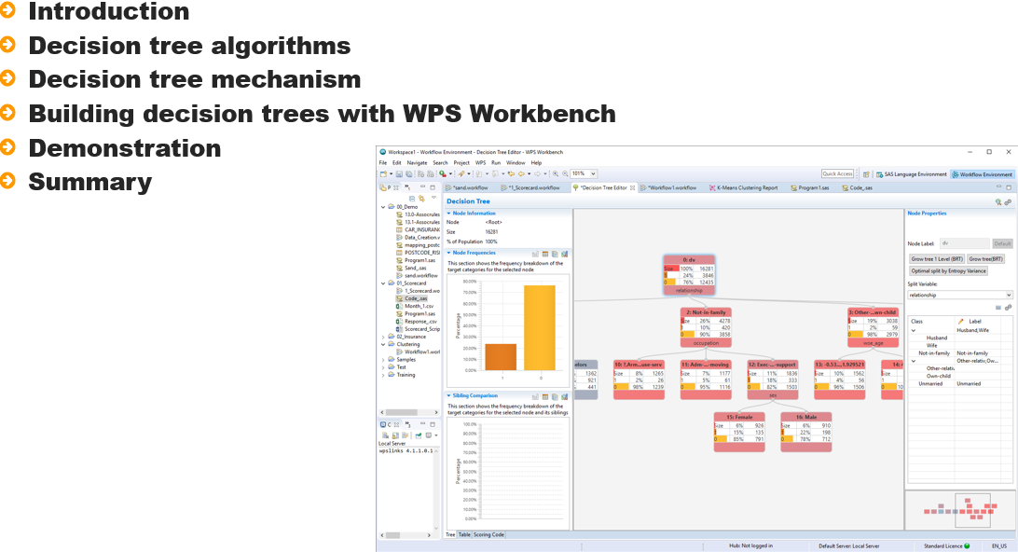

Decision Trees are a popular technique that represent results visually a tree diagram. The dependent variable can be either categorical or continuous and Independent variables can be of any type.

Figure 2: Introduction

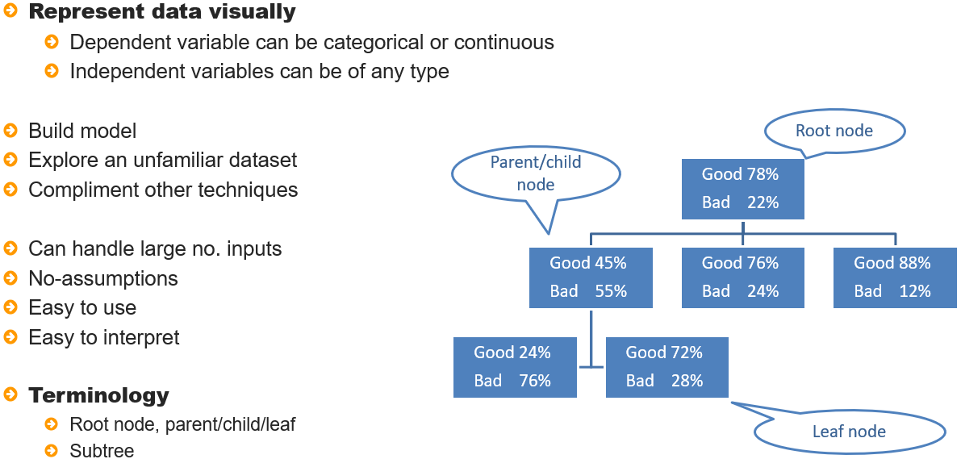

Decision Trees can be used for modelling, exploring an unfamiliar dataset and complimenting other

techniques to provide some insight and clarity on their operation.

Their popularity is not only due to the visual representation but also as a result of being able to supply independent variables of any types and volume. There are no assumptions associated with model building and output is easy to interpret.

Decision Trees operate by successively splitting data into subgroups to better identify and distinguish membership of the dependent variable. There will be Segments that have a high concentration of one category or the other and these lead to being able to create rules to better predict category membership.

Segments in the tree diagram are referred to as nodes. The root node is the entire dataset with the dependent variable distribution. Nodes can be parents or child and terminal nodes are nodes that do not undergo further spitting and the point at which a prediction takes places. Branches are the splits from one variable and subtrees are a subset of the overall tree.

## Decision tree algorithms

Decision Tree modelling evolved from cross-tabulations into techniques such as CHAID, CaRT and C4.5.

More variants of decision tree algorithms exist and all have varying operating mechanisms, however

they are all designed for the same purpose and common ground exists regardless of the algorithm

selected in that they all segment data by applying algorithms to determine splits and have options

to specify the tree depth along with other stopping rules or pruning.

Figure 3: Decision tree algorithms

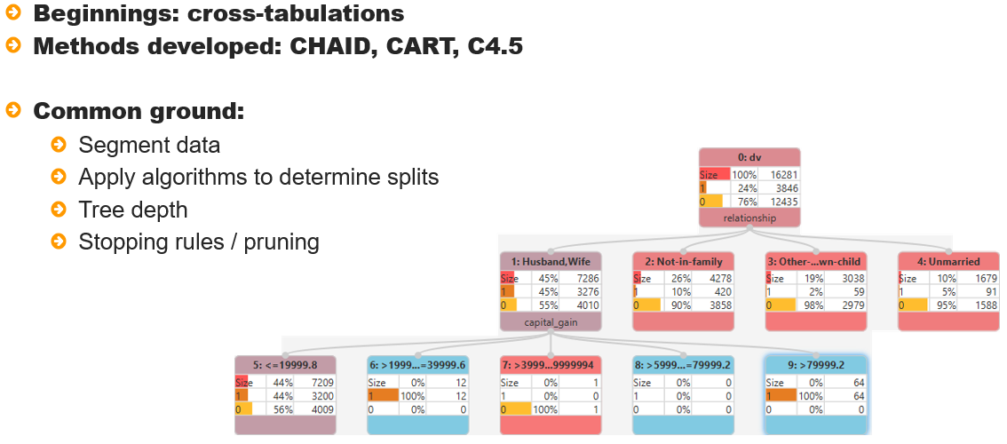

## Decision tree mechanism

Decision trees, regardless of algorithm follow the same steps of categorising variables, them minimising

the number of categories, selecting the best predictor as a split and repeating the process until a stopping rule is encountered.

Figure 4: Decision tree mechanism

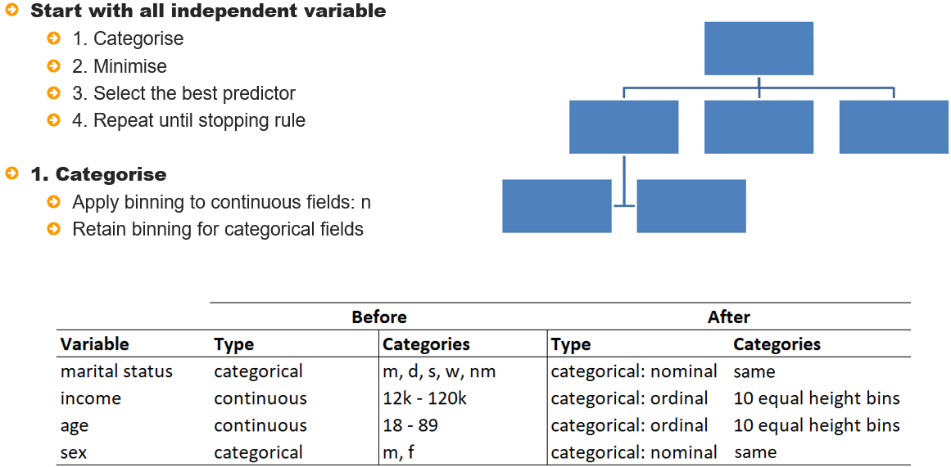

As Decision trees uses cross tabulations in some form or other, all variables must be categorical. Continuous variables are converted to categorical equivalents and categorical variables are retained as

they are.

Many binning methods can be applied and varying bins created. For illustrative purposes, here, as can

be seen the variables *income* and *age* are continuous. These are converted to categorical equivalents by using 10 equal height bins as a starting point.

The variables *martial status* and *sex* are retained as they are as they are already categorical. The next step is to minimize the number of categories. This is achieved by using the dependent variable and pairs of bins.

Figure 5: Minimise

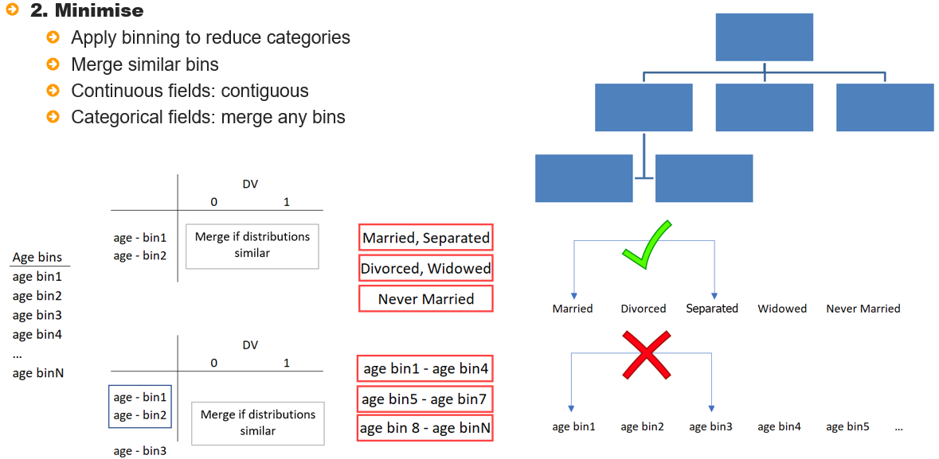

For example, to reduce the number of bins in the variable *age*, the first two bins are cross-tabulated with the dependent variable and their distributions compared. If they are determined to be similar, they

are merged.

The process continues by cross-tabulating the dependent variable with the combination of the first two bins and the third bin. Again, if they are determined to be similar regarding their dependent variable distribution then they are merged, otherwise, they are left separate. This process continues until a minimal set of bins has been arrived at.

Note that the minimization process for nominal variables is different compared to continuous variables in that, for nominal variables, for example *marital status*, as there is no order to the categories, any categories can be merge.

For continuous or ordinal variables, when converted to categorical, are ordered, for example, age bins might be less than or equal to 30, 31 to 41 and 42+, to main the order, bins that are non-contiguous can only be merged if the intervening bin can also be grouped with them.

At this point, the best splitter variable is selected and its bins are used as the first split in the tree. For

Illustrative purposes, *age* with three splits is selected.

Figure 6: Select the best predictor

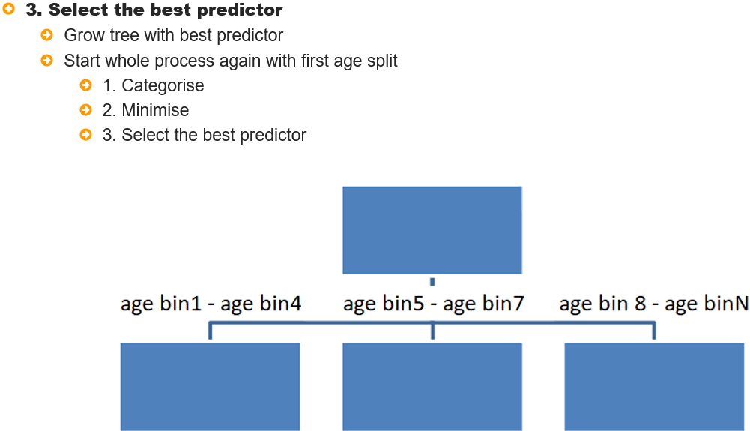

At this point the entire process begins again with the left most split - this can be seen as a separate dataset. It has a root node and now must assess independent variables: categorising, minimising and selecting the best split.

This continues until a stopping rule has been met, which can be that no independent variables meet the criteria for inclusion, another way to say this is that no potential predictor meets the algorithm entry requirement whether that be by way of significance or a threshold value being reached.

Figure 7: Stopping rule

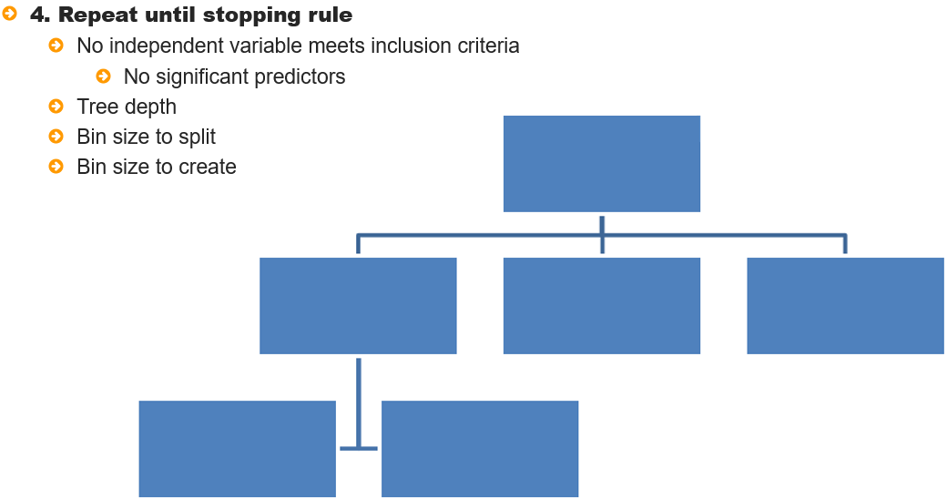

A second criteria is tree depth, this can be preset, for example, 5. If the tree reaches a depth of 5 levels, it will grow no further.

Bins size to split means that there must be at least a minimum number or percentage of observations in a node for It to be split further.

Bins size to create means that there must be at least a minimum number or percentage of observations in a node for It to be created

All of these options and more can be set via the Decision Tree block from the Model Training group and three decision tree methods are available: CART, c4.5 and BRT.

Figure 8: Methods available in ALTAIR

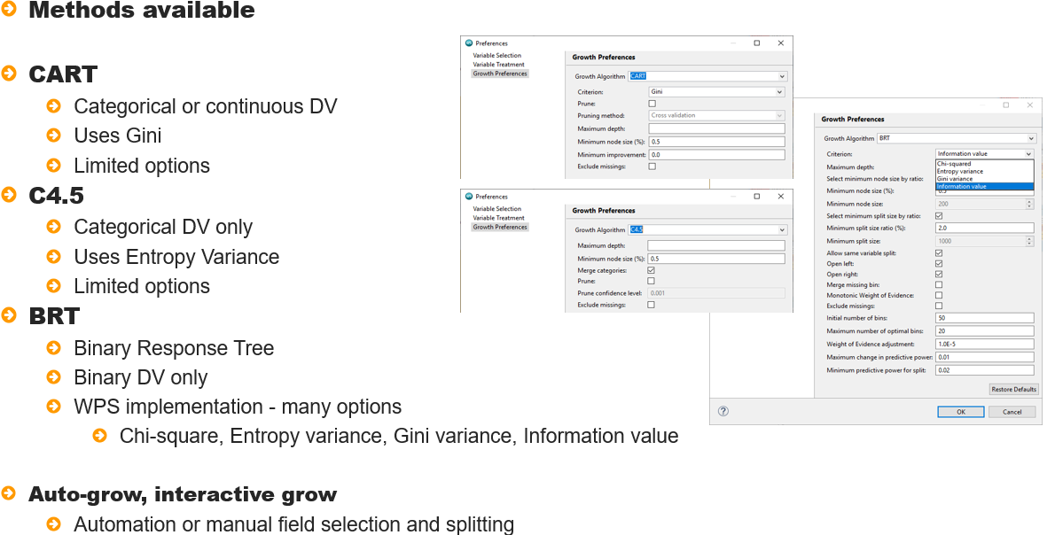

CART and C4.5 are well known industry decision tree algorithms. CART can handle any categorical or continuous Dependent variable and uses a *Gini* statistic for tree growth. C4.5 allows categorical dependent variables only and uses entropy variance for tree growth. Options for both are limited but do Include tree depth and minimum node size.

BRT - Binary Response Tree is ALTAIR implementation of a decision tree with options to choose from one of four growing algorithms: *Chi-square*, *Entropy Variance*, *Gini Variance* and *Information Value*.

Options are available to control tree depth, and minimum node creation size as well minimum size to split and a host of additional options that make it the go to choice when building decision trees.

Regardless of the method chosen, all avail of auto-grow and interactive growing methods to either automatically Select variable and find splits or manually select variables and split points.

## Interactive Questions

Q1:

Select the incorrect statement:

Decision trees represent data visually.

For a decision tree, the dependent variable can be categorical or continuous.

Decision trees can handle a large number of inputs and results are easy to interpret.

**Decision trees make a lot of assumptions about the data.**

A:

Decision trees are a popular modelling technique as they represent data visually, can model a dependent variable that is either categorical or continuous and can handle a large number of inputs. An additional advantage to using this method to model an outcome is that, in contrast to traditional modelling techniques such as linear and logistic regression, decision trees do not make assumptions about the data.

Q2

Drag and drop all correct characteristics onto the decision tree:

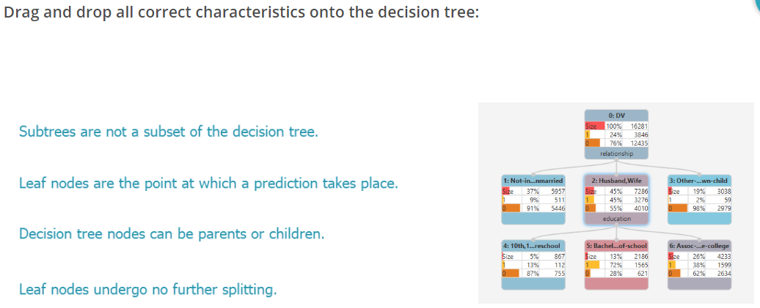

A:

Decision tree nodes can be parents or children. Leaf nodes undergo no further splitting and are the point at which a prediction takes place. Subtrees are a subset of the decision tree.

Q3:

Drag and drop the words to complete the sentence correctly:

Regardless of the ______ chosen, all share common ground in that data is segmented using algorithms to determine splits, with options to limit the _________, along with other stopping rules and pruning.

**Decision tree algorithm** model **tree depth** dependent variable

A:

Regardless of the decision tree algorithm chosen, all share common ground in that data is segmented using algorithms to determine splits, with options to limit the tree depth, along with other stopping rules and pruning.

Q4:

Arrange the following decision tree mechanism items in the correct order:

Categorise

Minimise

Select best predictor as a split variable.

Repeat

A:

When building a decision tree, the algorithm categorises all independent variables, then minimizes the number of categories. The best predictor is selected and used as a split variable. The process is then repeated for the next node selected.

Q5:

Select ALL correct statements:

**Decision trees used cross-tabulations in some form or other.**

**For nominal variables, any categories can be merged.**

**For continuous or ordinal variables, only contiguous categories can be merged.**

Decision trees cannot be automatically grown.

A:

Decision trees use cross-tabulations in some form or other. If a split variable is nominal, any categories can be merged, whereas for continuous or ordinal variables, only contiguous categories can be merged. Additionally, decision trees can be automatically grown.

Q6: Which of the following is not a decision tree stopping rule in the Altair Analytics Workbench Decision Tree

block:

Tree depth.

Bin size to split.

Bin size to create.

**Number of splits to create for a selected variable.**

A:

When growing a decision tree with Altair Analytics Workbench, the tree depth, bin size to split and bin size to create are options that will limit the tree growth. These can be referred to as stopping rules, as they stop tree growth. The number of splits to create for a selected variable is not a stopping rule.

Q7:

BRT, Binary Response Tree, is ALTAIR' decision tree implementation. **t**/f

A:  
BRT is ALTAIR' algorithmic implementation of a decision tree.

## Demonstration

So let’s get onto a demonstration.

This demonstration uses the project created in a previous lesson and adds a new Workflow named *Decision_Tree*. The data used in this lesson are contained in the file *Risk_Def.csv*, this file is contained in the eLearning data folder and is dragged onto the Workflow canvas from the File Explorer view.

Figure 9: Risk_def.csv

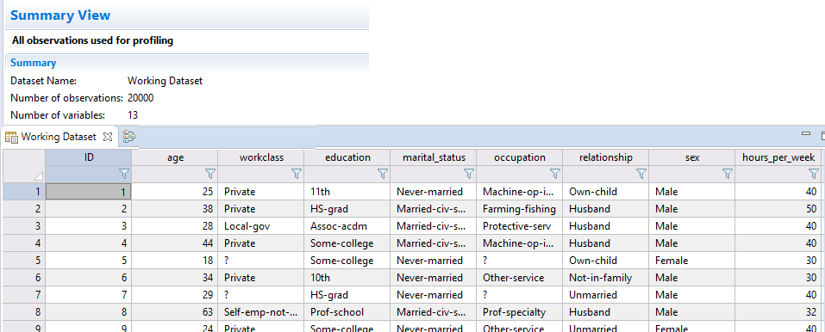

Opening the file with the data profiler it can be seen there are 20000 observations and 13 variables.

Viewing the data it can be seen there is an *ID* variable, some demographic and financial variables aswell as a variable named *DV*. This will be the focus of the model and used as the dependent variable.

Viewing its distribution from univariate charts it can be seen that it contains two values: *bad* and *good*, a

breakdown of approximately *24*% and *76%* respectively.

Figure 10: Chart of DV

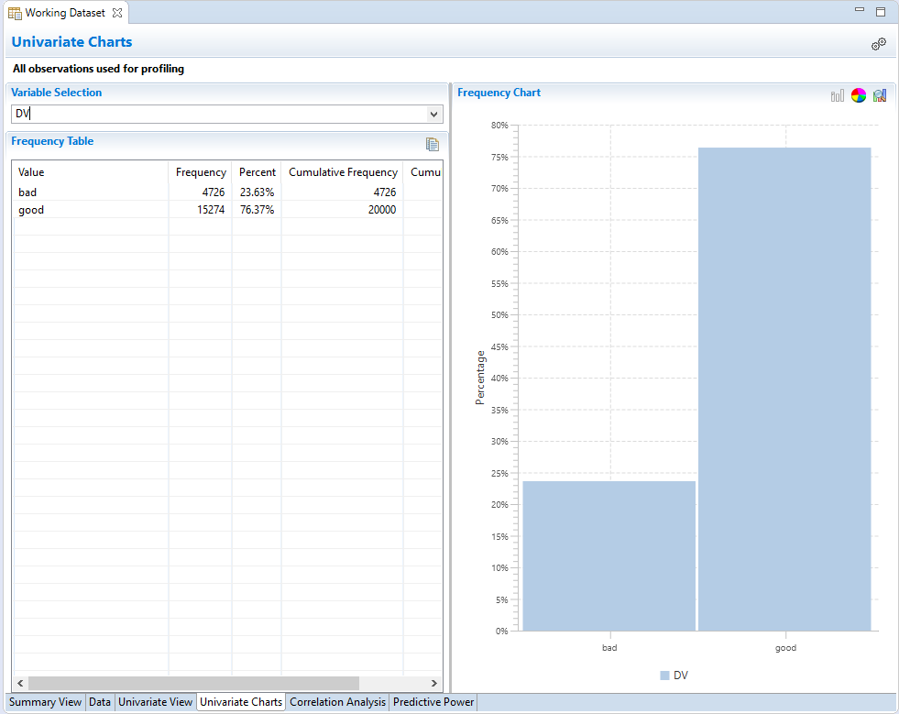

The data come from a financial institution and the dependent variable records whether an account has been deemed to be good / bad. There is interest in building a model to identify bads.

Prior to getting on to any modelling it is a good idea to partition the data first. Here the partition block is dragged from the data preparation group to the *risk_def* dataset and docked. Notice that two datasets are created immediately, this is due to the block being included in *Auto Run*.

Opening its configuration dialog, two partitions are created by default with 50% of observations randomly assigned to each.

More partitions can be added by clicking the add partition button, here, partition names are changed to development and testing with a 70:30 split and the random seed of 1000 is also used. The model will be created with the development partition and tested on the testing partition.

Clicking OK creates the partitions. Opening both with the Data Profiler it can be seen the development partition contains 14000 observations and the testing partition contains 6000 observations.

From the model training group, a Decision Tree block is dragged onto the *development* partition, docked and opened.

Figure 11: Adding and opening a Decision tree block

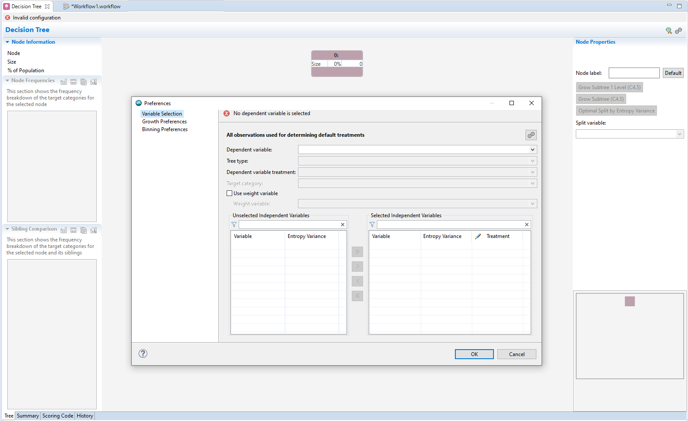

The first time the block is opened the preferences dialog pop ups automatically. There are three dialog pages: Variable selection, Growth Preferences and Binning Preferences.

From Variable selection, model variables are set. The dependent variable is selected as *DV*, the tree type automatically changes to classification. Altair Analytics Workbench decision trees can be applied to a dependent variable that is either categorical or continuous, if a continuous dependent variable is selected, the tree type would change to regression.

From the Target Category drop-down *bad* is selected. The model results will be identical regardless of the target category selected, the selection simply impacts the way tree results are presented.

A weight variable can be included, this can be any continuous dataset variable, and one is not included here. All variables bar *ID* are moved from the Unselected Independent Variables list to the Selected Independent Variables list.

All variables appear with an Entropy Variance statistic to guide variable inclusion. Notice the treatment dropdown. Variable type can be set as Nominal, Ordinal or Interval for numeric variables and nominal or ordinal for string variables.

Here, the variable *education_num* is changed from nominal to interval as it contains the number of years of education complete.

Figure 12: Variable Selection

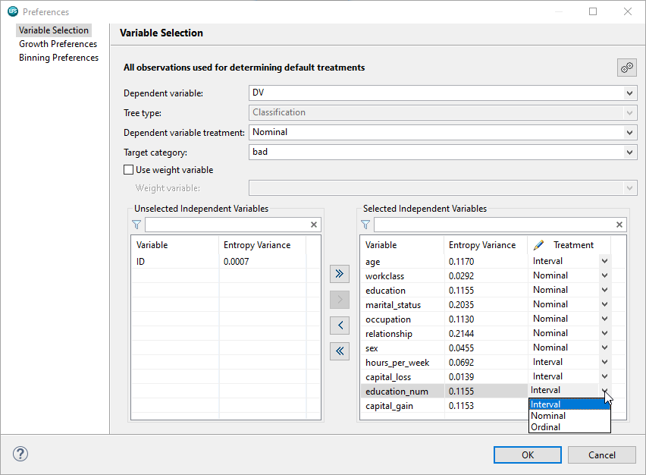

It is wise to ensure that variable type is set correctly and this facility provides the ability to adjust if necessary.

From Growth Preferences the algorithm can be chosen. Clicking the Growth algorithm drop-down it can be seen there are three to choose from C4.5, CART and BRT.

C4.5 provides options to set the maximum tree depth and minimum node size as well as providing options to merge categories and exclude missing values.

Pruning removes terminal nodes and subtrees that do not significantly improve predictive accuracy.

CART, similarly, has options to set the maximum tree depth, the minimum node size, exclude missings and apply pruning. It also provides a dropdown to select the citerion to determine splits, the default being Gini but Twoing is also available.

Options for c4.5 and cart are limited, selecting BRT - Binary regression tree, ALTAIR decision implementation, provides a range of options that make it the clear choice when building a decision tree.

Figure 13: BRT

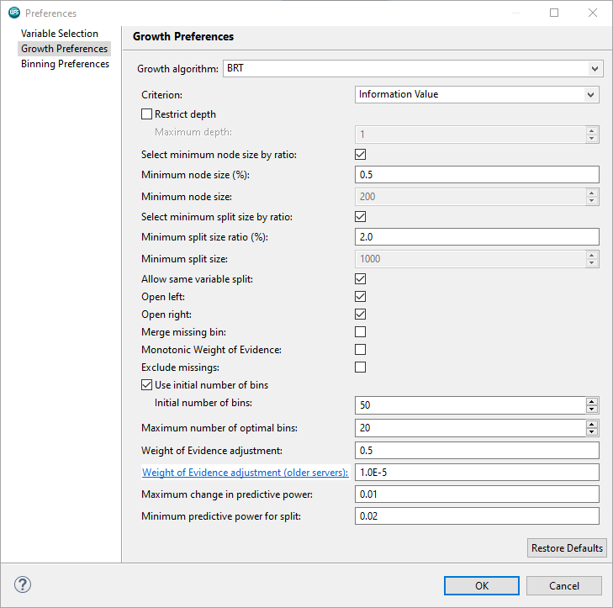

For the most part, options available via C4.5 and CART are also present here, bar pruning methods.

Notice the criterion dropdown provides four options: Chi-squared, Entropy Variance, Gini Variance and Information Value, with the default being Information Value. The maximum depth can be set, if not selected, there is no maximum depth.

The options: Select minimum node size by ratio, Minimum node size (%) and Minimum node size relate

To the minimum node creation size, this can be set as a % of the overall dataset size or as a value.

Tree nodes will only be created if they reach a default threshold size, here .5% of the overall dataset size – with the dataset here contains 14000 observations, 700, a half a percent, is the minimum size a node must be, to be created.

The next three options are similar but relate to the size a tree node must be to be considered to be split further, currently this is set at 2% but can be changed.

Options selected by default and not present in C4.5 or CART are:

* Allow same variable split
* Open left and open right

The same variable split means that a variable may be split further, for example if a split was created with the variable and two nodes created *age*: <=30 and greater than 30, selecting this option means that either category may undergo further splitting, For example, the greater than 30 category might be split in two categories: 30 - 41 and 42+ in a subsequent split.

Open left and Open right ensure that values below a dataset minimum or above a dataset maximum for any variable will be accommodated. For example, If a model uses the variable *age* and its range is 20 - 89. Lets say the first bin for this variable is 20 - 30. This excludes all values below 20, using open left, the bin range changes to <=30, this is a useful option to include and here, selected by default.

Missing values are included by default in the tree but will always appear as a separate category, they can be excluded by selecting Exclude missings or can be forced to be a valid category by selecting merge missing bin and will therefore be considered for merging with other bins.

Monotonicity can be forced using weight of evidence and the number of bins can be set including the maximum number of optimal bins. Other options relate to the criterion chosen and thresholds for selecting and splitting variables.

At this point all options are accepted at their defaults. Bear in mind that *Help* is available from within the dialog by clicking the help icon. Selecting *Decision Tree Preferences* opens the help pages for all growth preference options.

Figure 14: Decision tree help

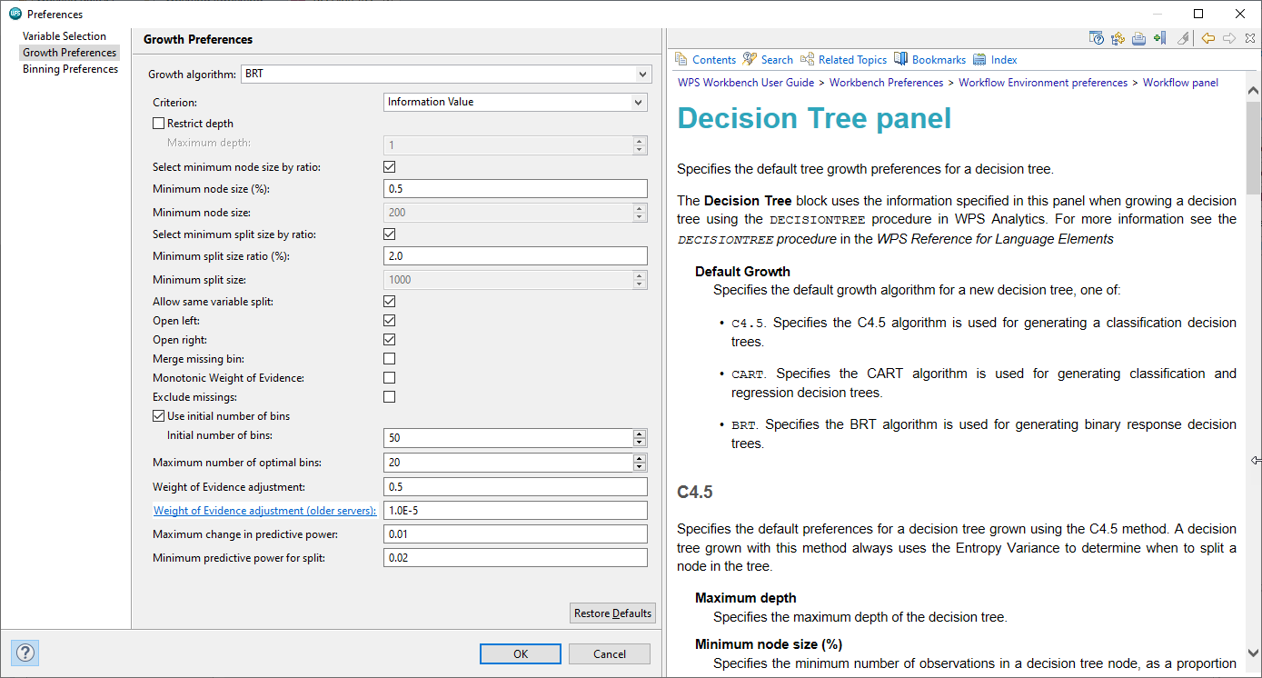

The third page relates to binning. ALTAIR decision trees provides automatic and interactive growing methods with the ability to force variables into a model. Given this, the selected algorithm can be used to choose variables and decide splits or, variables can be forced into the model and splits applied by way of ALTAIR binning.

Figure 15: Binning Preferences

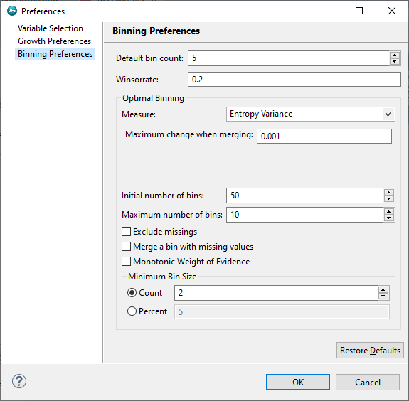

This page contains two areas: Default bin count and Winsorrate and Optimal Binning. The Default bin count and Winsorrate relate to Equal Height, Equal Width and Winsorized binning, and the Optimal Binning area relates to optimal binning settings.

Setting can be changed, for example the default bin count can be increased to give greater granularity across splits. This page will be revisited when forcing variables into the model.

## Interactive Questions

Q1: Drag and drop the words to complete the sentence correctly:

When building a model, ______ is recommended. The **_______** from the data preparation group can be used to accomplish this.

**Partitioning Partition block** sorting data filtering Filter block Sort block sampling

A:

When building any model it is recommended to partition data to ensure models can be properly validated. The Altair Analytics Workbench Partition block can be used to accomplish this.

Q2:

When building a decision tree with the Altair Analytics Workbench Decision Tree block, options are available to select the dependent variable, tree type and target category. If the dependent variable has two categories, different models will be created depending on the target category selected.

True.

**False, the tree will be the same. This selection only affects the way results are presented.**

True, but it can be forced to output the same model.

It depends on the algorithm chosen.

A:

When building a decision tree with the Altair Analytics Workbench Decision Tree block, the dependent variable, tree type and target category can be selected. If the dependent variable has two categories. Regardless of the target category selected, the tree generated is the same.

Q3:

If a numeric variable has been incorrectly classified as nominal, its treatment cannot be changed when configuring a decision tree model with the ALTAIR Decision Tree block. t/**f**

A:

If a numeric variable has been incorrectly classified as nominal, its Treatment can be changed to interval from the Variable Selection page of the Altair Analytics Workbench Decision Tree block.

Q4:

Drag all BRT options onto the Growth Preferences page:

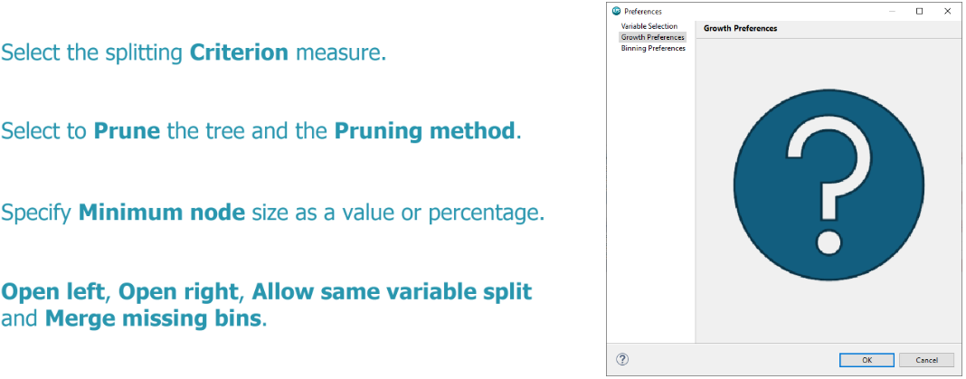

A:

BRT provides all options listed.

Q5:

Help in relation to decision tree options, and most blocks for that matter, is available from:

The help menu only.

Help is not available.

**Help is available from the Help menu and also from within most each block by clicking the help icon.**

None of these options are correct!

A:

Help in relation to the Altair Analytics Workbench Decision Tree block options is available from the Help menu. Help is also available from within the Decision Tree block by clicking the help icon.

Q6:

The binning preferences page of the Decision Tree block provides alternative binning options to apply to variables in the model. **t**/f

A:

The Binning Preferences page of the Altair Analytics Workbench Decision Tree block provides alternative binning options to apply to independent variables in the model.

At this point OK is clicked and the Decision Tree Editor view appears. This contains a number of tabs: Tree, which is the default, displays the decision tree and associated information.

Figure 16: Decision tree editor view

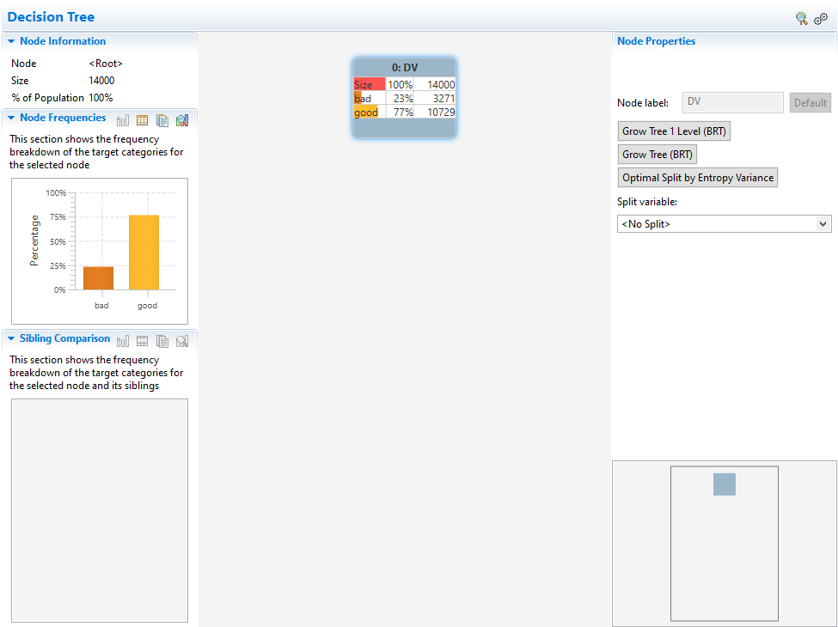

In this view there are a number of panel and the main tree view which displays the dependent variable distribution and overall dataset size. As can be seen there are 14000 observations in total, 3271 *bad* and 10729 *good*. Which results in a breakdown of 23% and 77% respectively.

Options to grow the tree are available from the Node Properties panel. Options here relate to the selected method, in this case BRT.

The tree can be grown in full using the option: Grow Tree (BRT). The map panel shows the scope of the results. The map panel can be used to navigate the tree which can also be accomplished by clicking and dragging the mouse from the tree view.

Auto grow can be useful to explore an unfamiliar dataset but the tree may need a lot of assessing once complete. For example, there are nodes that have mostly all observations in the same category. The tree is also unwieldly as it is very wide with lots of terminal nodes.

It may be more productive and useful to build the tree level by level. This can be done by clicking Grow Tree 1 Level (BRT). The variable *capital_gain* has been selected with 9 bins including a missing bin. The bins may be acceptable but can be easily modified by joining bins together or manually changing cut-points to something a little more appealing.

Here, bins 2,3, 4, and 5 are joined by holding down the CTRL key on the keyboard, selecting all bins and then right-clicking and choosing the option: Join. The same process is applied to the bins with a very high percentage of bad and the cut points are manually modified to 700. There are now three bins: missing, <=700 and >700.

Figure 17:Three bins

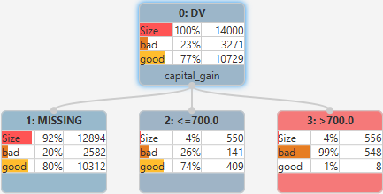

Selecting the missing bin and the option: Grow Subtree 1 level (BRT), selects the variable *relationship* and four bins are generated. Alternatively, the option: Optimal Split by Entropy Variance can also be used for tree growth, here, clicking this results in the same variable with the same splits being selected.

From the node properties panel, it can be seen that categories: *Husband* and *Wife* have been merged as have *Other-relativ* and *Unmarried*.

More binning is applied here and all bins bar *Husband,* Wife are joined by selecting all bins, right-clicking and selecting the option: Combine. This is the join equivalent for string variables.

The resulting node names can also be changed, here the marital status splits are changed to *married* and *other*.

Figure 18: Change node labels

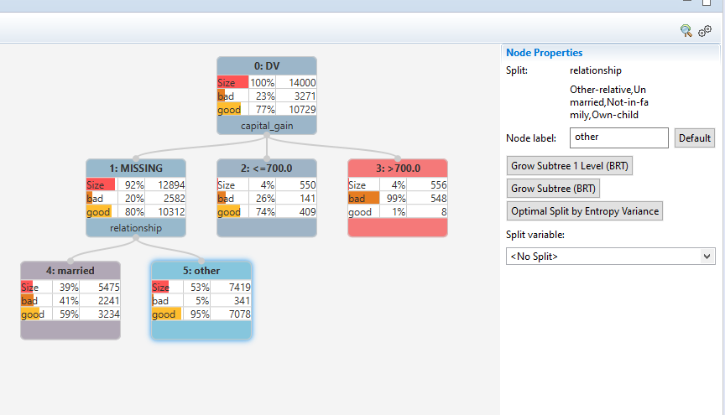

The options illustrated to this point relate to the technique chosen from Growth preferences, in this instance, BRT. This selects variables and decided splits which can be further modified.

Variables can also be forced into the model at any point by selecting a variable from the Split variable dropdown and choosing a Binning option.

Here the *married* split is selected and the variable *eduction_num* chosen from the Split variable dropdown. Notice the output that is generated is a single node will the same observations and distribution, binning must be applied via binning options directly below the selected variable in the Node Properties panel.

Figure 19: Selecting education_num

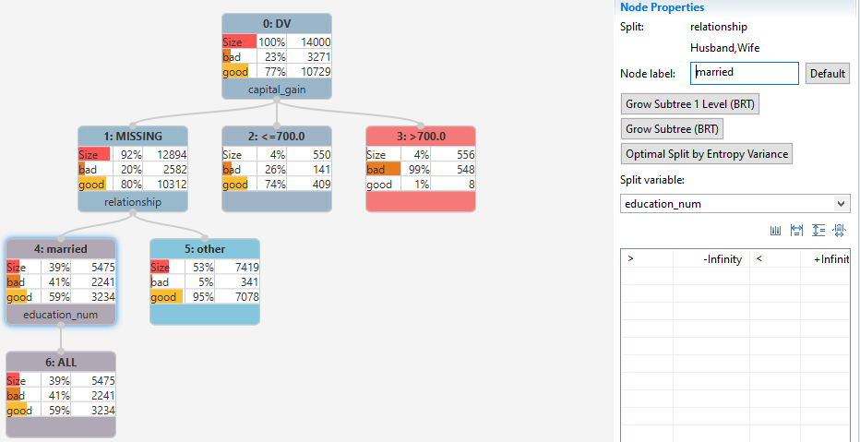

Available binning options are: Calculate winsorised binning, Calculate equal height binning, Calculate equal width binning and Calculate optimal binning.

Note that these options are controlled via the binning preferences page. The options: equal height, equal width and Winsorised are controlled by the Default bin count and Winsorrate settings and the optimal binning option is controlled via Optimal Binning settings.

Here, equal height is selected, and four bins are generated. Bear in mind that the maximum is five. Selecting Calculate Optimal binning outputs 5 bins, notice that as the number of years of education increases so does the % of *bad*.

Figure 20:Optimal binning

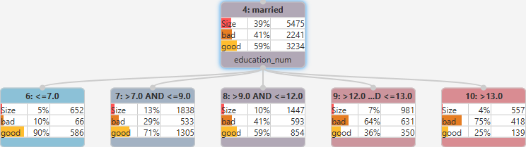

## Interactive Questions

Q1:

Options to grow the tree are available for the Node Properties panel. These include Grow Tree 1 Level, Grow tree and Optimal Split by Entropy Variance. What do these options relate to?

**The tree growing algorithm selected, for example: BRT.**

Binning Preferences.

A:  
Options to grow the tree are available for the Node Properties panel including Grow Tree 1 Level, Grow tree and Optimal Split by Entropy Variance. These options relate to the Growth algorithm selected from the Growth Preferences page.

Q2:

A tree can be grown in full by:

Selecting **Grow Tree.**

Selecting Grow Tree 1 Level.

Selecting the root node and the option: Grow Tree.

Selecting the root node and the option: Optimal Split by Entropy Variance.

A:

A decision tree can be grown in full by selecting the root node and the option: Grow Tree.

Q3:

A decision tree can be navigated using the Map panel only. t/**f**

A:

The tree can also be navigated by clicking the left mouse button and dragging to a specific area of the tree.

Q4:

Select all incorrect statements. Once a split variable has been selected and bins created:

**Cut points and bins cannot be modified.**

Cut points can be changed and bins merged.

**Cut points can be modified but bins cannot be merged.**

**Cut points cannot be modified but bins can be merged.**

A:

Once a split variable has been selected and bins created, cut points can be changed and bins merged.

Q5:

Choose the correct answer from the drop-down list:

Nodes names ______ be changed.

**Can.**

Cannot.

Are set by default and cannot.

Are determined by the algorithm and cannot.

A:

Node names can be changed.

Q6:

Independent variables can be chosen by the algorithm or forced into the model. **t**/f

A:

Variables can be chosen by the algorithm if any growing option is selected from the Node Properties panel. Alternatively, variables can be manually selected and forced into the model.

Q7:

The Default bin count and Winsorrate from the Binning Preferences page of the Decision Tree block control binning options for:

Calculate winsorised binning and Calculate equal height binning.

**Calculate winsorised binning, Calculate equal height binning and Calculate equal width binning.**

Calculate equal height binning and Calculate equal width binning.

Calculate optimal binning.

A:

The Default bin count and Winsorrate from the Binning Preferences page of the Decision Tree block control binning options for: Calculate winsorised binning, Calculate equal height binning and Calculate equal width binning.

To the left-hand side are additional panels providing information for selected nodes. The Node Information panel displays the size of the node and the node frequencies panel shows the dependent variable distribution.

Figure 21: Node Information

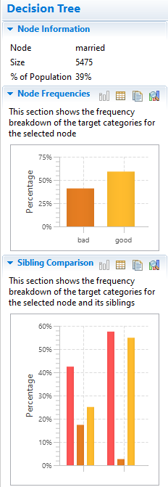

By default, this is displayed as a graph or a table with export and edit capabilities, hovering over the chart highlights each bar with details. The sibling comparison chart compares all nodes in the same split and also shows node size.

The summary tab provides a decision tree summary including model information, as can be seen there are 11 nodes in total in the tree with 8 leaf nodes, the tree is 5 nodes wide and 4 levels deep.

Returning to the tree tab it can be seen that each node is numbered and there are 10 plus the root node which gives 11. There are 8 leaf or terminal nodes, the maximum width is 5 and the tree is 4 levels deep.

Information for the dependent and independent variables is also listed along with a confusion matrix to give an idea of how well the model classifies observations.

The node table is a tabular representation of the leaf nodes in the decision tree. There are 8 leaf nodes in the tree and therefore there are 8 rows in this table that correspond with each leaf node. Clicking any column sorts the table, here, the *Node % DV = bad* column is selected until nodes are listed in descending order

of percentage of *bad*.

Figure 22: Sorted Node Table

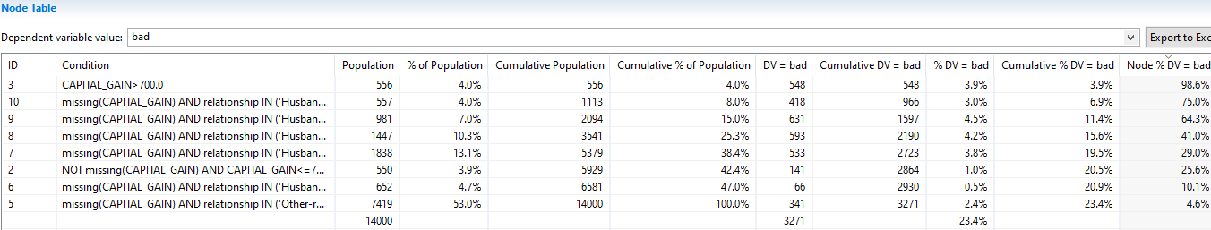

The first column lists the node id. The Condition column displays the rule that determines membership of this node. For example, for node ID =3, this is *capital_gain >700*. The size of this node is 556 observations which is 4% of the overall dataset size

The number of *DV = bad* in this node is 548 ,this is 3.9% of the total number of *bad* in the dataset and also 98% of the number of observations in the node.

The lift value compares the node concentration of bad to the overall bad rate with the values weighted by the node percentage size.

For example, the selected node bad rate is 98.6%, the overall bad rate is 23%, dividing these gives a value of approximately 4.28, when this is multiplied by the node percentage size of 3.9%, this returns the lift value of 16.8%.

Leaf nodes are also the point at which a prediction takes places – for example, for those in node number 8 their propensity to be *bad* Is 41% and propensity to be good is 59%, other nodes can be interpreted similarly.

The node table can be listed for any category of the dependent variable by selecting it from the dependent variable Value dropdown and the table can also be exported to excel via the Export to Excel button.

The scoring code tab contains the scoring code for the tree. This can be output in either the languages of SAS or SQL. The code generates two variables *P_bad* and *P_good* which hold model propensities for each scored observation.

Figure 23: Scoring Code tab

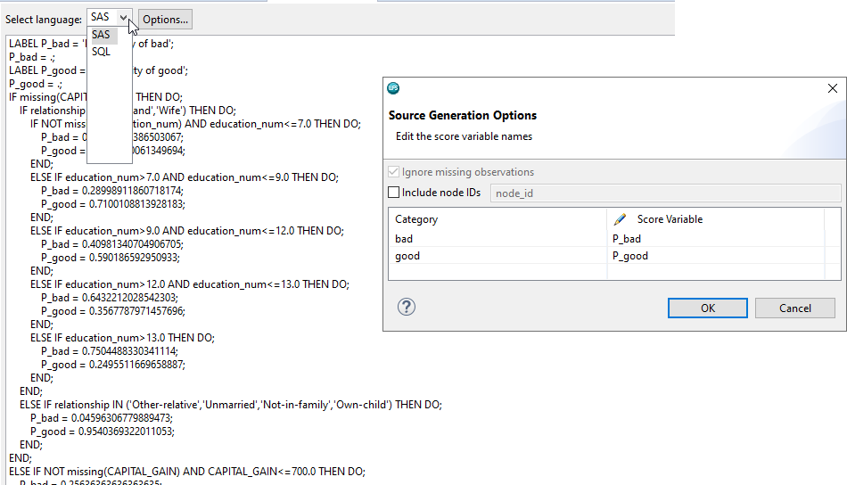

Names can be changed from the options dialog and notice also the option to Include node IDs.

The History tab records all changes to the tree and is divided into a number of areas. Events lists all actions taken and Dataset Variables lists the properties of all dataset variables.

Selecting any event cause panes to be populated to show Growth Settings, Decision Tree Settings and Binning Settings for the selected event. All output can be copied to the clipboard by selecting copy data to clipboard.

Returning to the tree view, this tree could be grown a little more however at its current state it will suffice and is accepted at this point. This model will be used in later lessons. Clicking CTRL+S saves the tree and the asterisk disappears from the Decision Tree Editor, confirming the same.

Figure 24: Final model

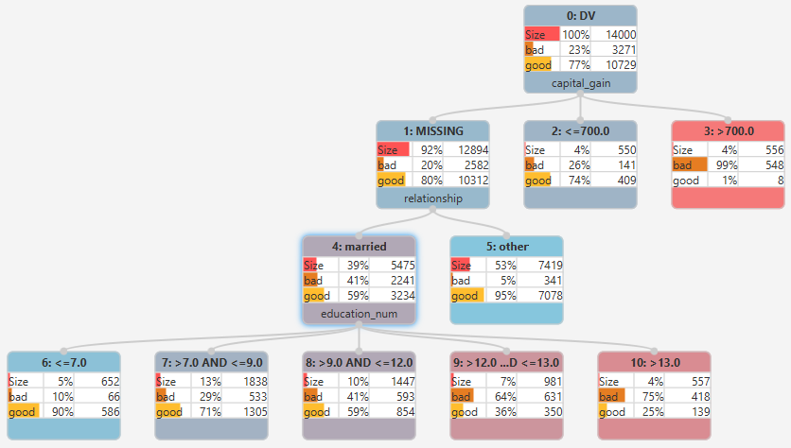

## Interactive Questions

Q1:

For any selected node, its dependent variable distribution is illustrated by default as a chart in the

Node Frequencies panel. This can be also be changed to a table. **t**/f

A:

For any selected node, its dependent variable distribution is illustrated by default as a chart in the Node Frequencies panel and can be changed to a table.

Q2:

The Sibling Comparison panel displays:

**The dependent variable distribution for all nodes in a split.**

The dependent variable distribution for the selected node.

The dependent variable distribution for leaf nodes in the split.

The distribution of the dependent variable in the dataset.

A:

The Sibling Comparison panel displays the dependent variable distribution for all nodes in a split.

Q3:

Select all correct statements. The Node Table includes:

**Node Condition and size.**

Dependent variable distribution.

**The percentage of the total number of the target category contained in the node.**

**Lift.**

A:

The Node Table is a tabular representation of the leaf nodes in the tree and includes information such as node Condition and size, the percentage of the total number of the target category contained in the node and Lift. The dependent variable distribution is not present in this table.

Q4:

The node table can be displayed for any category of the dependent variable. **t**/f

A:

The Node Table, available from the Summary tab, can be displayed for any category of the dependent variable.

Q5:

Decision trees assigns probability scores based on the dependent variable distribution

In leaf nodes. **t**/f

A:

Decision trees calculate probability scores based on the dependent variable distribution in leaf nodes.

Q6:

Select all correct statements.

Scoring code for a decision tree model is available from the Scoring Code tab. Scoring code is available in SQL format only.

Scoring code for a decision tree model is available from the Scoring Code tab. Scoring code is available in the language of SAS only.

**Scoring code for a decision tree model is available from the Scoring Code tab. Scoring code is available in either the language of SAS or SQL.**

The History tab observations all changes for a selected split.

**For any selected event in the History tab, Decision Tree Settings are available.**

A:

Scoring code for a decision tree model is available from the Scoring Code tab in either the languages of SAS or SQL. For any selected event in the History tab, Decision Tree settings are available. The History tab observations all changes to the tree and not for a selected Event.

## Summary

This lesson included an introduction prior to speaking about decision tree algorithms and their common ground.

The mechanism by which decision trees operate was introduced before speaking about Altair Analytics Workbench decision tree capabilities which was followed by a demonstration

## Exercises - Interactive



Q1:

Create a new Workflow or use an already existing one but delete all blocks. Import and profile the dataset *data_.xlsx*. Create two partitions with a 70/30 split using the random seed 1000.

Name the partitions *dev* and *test* respectively.

Question: How many observations and variables are in there in each partition?

* 12920 and 5618
* **12977 and 5561**

A:

An existing Workflow is used and all blocks deleted. *data_xlsx* is located using the File Explorer, dragged onto the workflow canvas and configured. A partition block is added, two partitions are created called dev and test with 70/30 split. The seed is set at 1000, clicking OK and opening both partitions with the data profiler it can be seen that there are 12977 observations in the *dev* partition and 5561 observations in the *test* partition.

Q2:

* Create a decision tree model using the Dev partition. Use the following settings:
* Select *DV* as the Dependent variable with *Yes* as the Target category.
* Use all other variables as independent variables.
* Set the Treatment for *education_num* to Interval, and *education* to Ordinal.
* Use the Grow Tree option with BRT selected as the Growing algorithm.
* Set Minimum node size(%) to 1%.
* Select the option to Merge missing bin.

Question: How many leaf nodes in the tree and what is the minimum leaf node size?

* 67 and 131 respectively.
* 65 and 131 respectively.
* 60 and 130 respectively.
* 97 and 37 respectively.

A:

A Decision Tree block is added and docked onto the *Dev* partition. DV is selected as the Dependent variable and the target category set to *Yes.* All variables are moved into the Selected Independent Variables list.

*education_num* is changed from Nominal to Interval and *education* is changed from Nominal to Ordinal.

From Growth Preferences BRT is selected as the Growth algorithm. The minimum node size is set to 1% and merge missing bin is also selected. To auto-grow the tree, Grow tree (BRT) is clicked. From the summary tab it can be seen there are 67 leaf nodes and 131 is the smallest leaf node size.

 Q3

 Is the tree acceptable and why?

* Yes, it captures the *Yes* categories very well.
* Yes, it predicts the *Yes* category ok.
* No, it does not predict the dependent variable very well.
* **No, many reasons including questionable leaf nodes and variables.**

A:

From the Confusion Matrix it can be seen that 1770 observations that are *Yes* are predicted to be *Yes*, this gives an accuracy of approximately 58% for the *Yes* category. This is reasonable, however there are a lot of small leaf nodes with all observations in the same category and even more alarmingly, the variables

*Weight* and *customer_id* are included in the model. Given this the current model is not acceptable.

 Q4:  
Is there any way to use automated methods to grow an acceptable tree?

* Yes, but settings must be set very carefully and some manual pruning may be required.
* No, the target category will not be predicted well.
* Yes, just select the correct algorithm for the data.
* No, leaf node sizes will always be too small.

A:

This is a reflection of what can happen when an auto-grow method is used. Care must be taken when configuring a model and using auto-grow to build a decision tree. At this point the model is not acceptable and the variables *customer_id* and *weight* are removed.

Q5:

Ensure the following setting are applied:

* Set the Default bin count to 5 from Binning Preferences.
* Set the Minimum node size(%): 1% from Growth Preferences.
* Grow the tree 1 level using Grow tree 1 Level (BRT).

Question: Is the split acceptable, why?

* Yes. It captures the Yes category very well.
* Yes. The split variable selected has 6 nodes so can be grown further.
* No. A different variable is needed.
* No. For the selected split variable, created nodes have decimal cut-points and there are nodes where all observations are in the same category.

A:

From the option dialog, the default bin count can be set from binning preferences and here 5 is already evident. The minimum nodes size can be set from growth preferences and has already been set to 1%.

Selecting the root node and clicking Grow Tree 1 Level (BRT) results in the variable *capital_gain* being selected with 6 nodes generated. The split is unacceptable, the node cut points are decimals and some concentrate all observations into the same DV category.

Q6:

Regrow the tree from the root node using Optimal Split by Entropy Variance.

Question: Is the split acceptable, why?

* **Yes**
* No

A:

Selecting the root node and clicking Optimal Split by Entropy Variance results in the Variable *relationship* being selected with 4 splits. This is an adequate split with good distributions and is acceptable.

Q7:

Merge appropriate categories of the variable: *relationship*, such that there are two nodes: *married* & *other*. Grow the tree further using available methods and reproduce the tree illustrated.

NOTE: This is also available from the Workflow: *tree_*, which is located in the eLearning data folder.

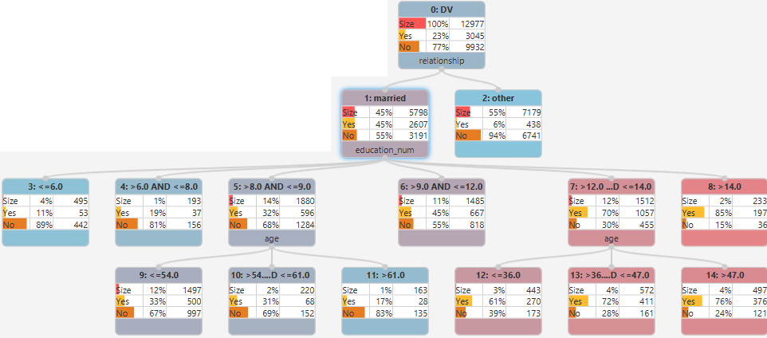

Question: What is the approximate classification rate for the *Yes* category?

* 95%
* 82%
* **41%**

A:

The *husband* and *wife* node is renamed to *married* and all other nodes are merged and renamed to *other*. For the *married* node, the variable *education_num* is selected from the split variable dropdown

and calculate optimal binning applied. The same process, calculate optimal binning with the variable *age* is used with the two *education_num* nodes. Bins are manually joined to ensure that the concentration of observations in the yes category is either monotonically increasing or decreasing.

From the summary tab it can see from the Confusion Matrix that the accuracy for the yes category is approximately 41%.

# Chapter 8: Improving the model

## Introduction

Contents for this chapter include an introduction and a focus on aspects that improve model acceptability: accuracy, robustness, simplicity and explainability, followed by a summary.

Figure 1: Contents



Model development can be a very time-consuming process, varying techniques can be applied and parameters modified. Regardless of the technique used all most should be accurate, robust, simple and

Explainable.

Figure 2: Introduction

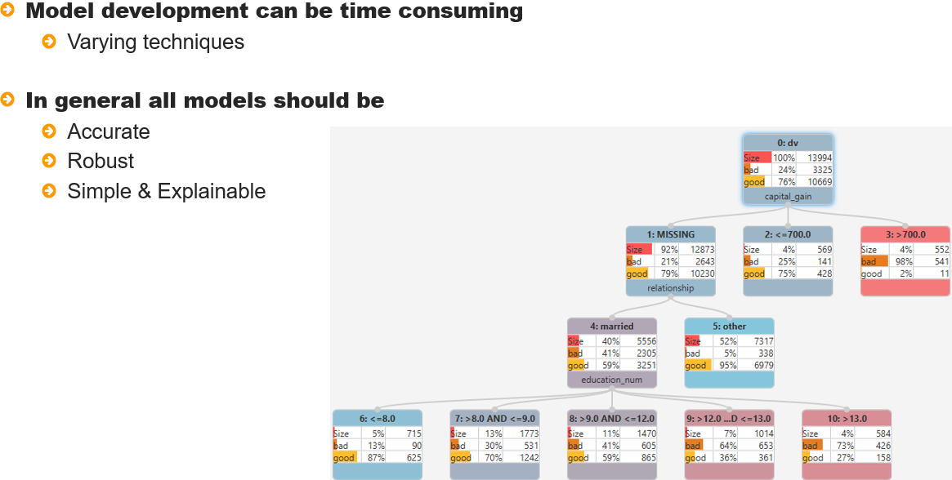

What do these things mean in practice? Accuracy relates to model predictions and models should predict new data well.

A decision tree is no exception and the thrust to concentrate observations into the dependent variable categories can lead to some leaf node with all observations concentrated into one of the dependent variable categories.

This is in most cases questionable and should be viewed with caution as to inclusion. Auto-grow with relatively small node size and or lots of variables may suffer this.

Figure 3: Accuracy

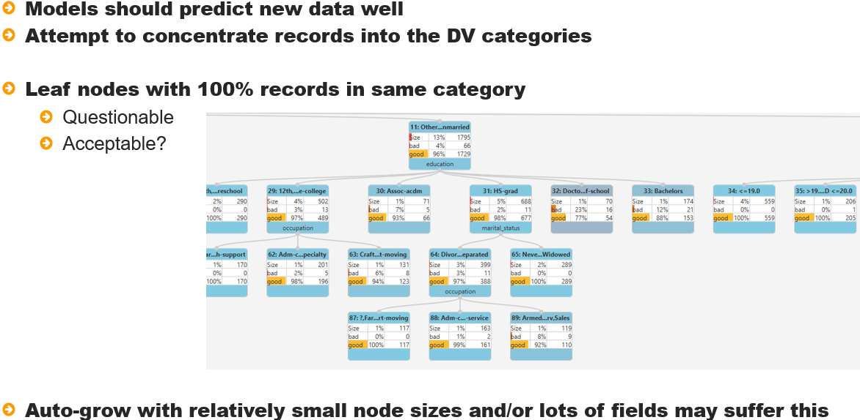

Robustness relates to the existence of model segments in the population. For example, a variable that has many splits may not replicate in the population making some of them redundant. To ensure segments are robust they should be of adequate size, a guide being between 1 - 2% of the dataset size but smaller sizes may be considered if they can be justified.

An additional support to ensure robustness is to limit the nodes resulting from any split to be between

4-6, this should ensure segments generalize.

Figure 4: Robustness

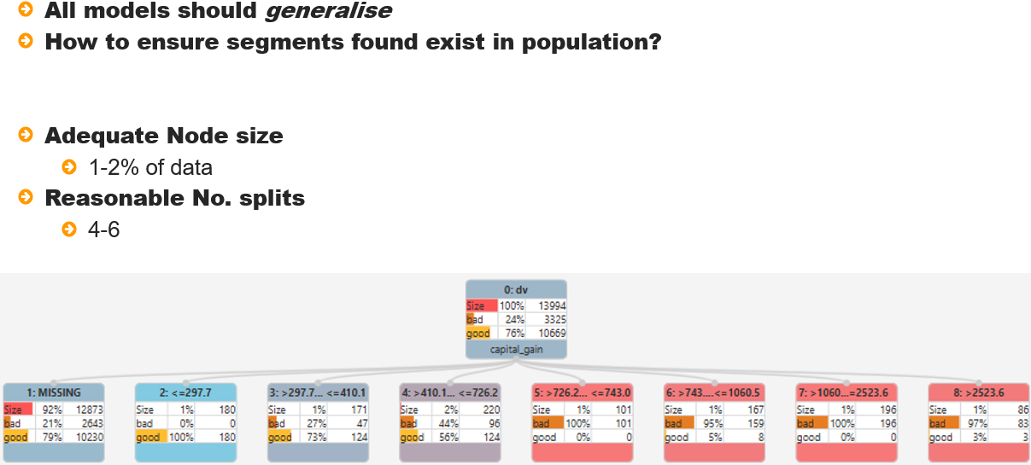

A good model should also be simple and explainable. Removing insignificant predictors and

splits that do not further improve predictive accuracy should be top of the list.

The illustration to the right illustrates that additional splits do not improve the model and only

increases complexity.

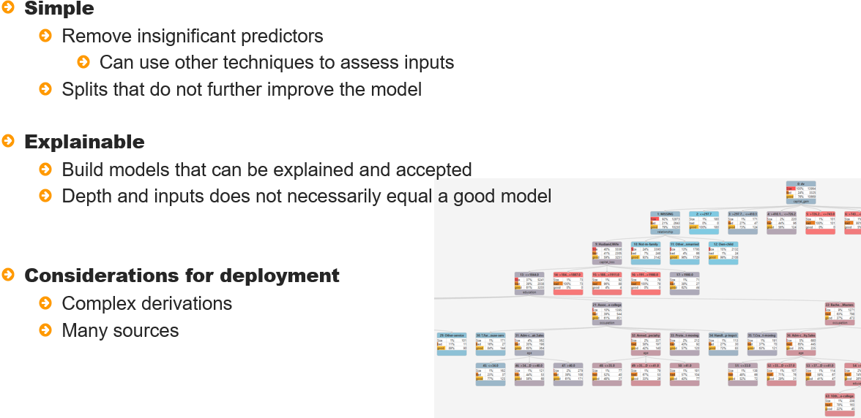

Model should also be explainable. Results should be relatable and segment characteristics acceptable.

 A complex model will have implications for deployment and may impede getting a model into production unnecessarily.

The elements of accuracy, robustness, simplicity and explainability can be taken into acccount when

building the model and can be further refined during model evaluation and validation.

## Interactive Questions

Q1:

Desirable characteristics that any model should possess are:

Accuracy, relatedness, simplicity, explainability.

Robustness, simplicity, explainability, significance.

**Accuracy, robustness, simplicity, explainability.**

Accuracy, robustness, simplicity, durability.

A:

Models should be accurate, robust, simple and explainable.

Q2:

What does accuracy relate to?

Model segments.

**Model predictions.**

Significance.

Model variables.

A:

Accuracy relates to the model's ability to predict correctly.

Q3:

What quality should a robust decision tree exhibit?

All model predictions are accurate.

All model variables are significant.

**The ability to replicate model segments in the population.**

Many observations and variables are included in the model.

A:

A robust decision tree should exhibit the ability to replicate model segments in the population. This means that the segments created using the model are evident in the population.

Q4:

A good rule of thumb for decision tree leaf nodes is that they are:

Approximately 1% of the dataset size.

Approximately 2% of the dataset size.

**Between 1-2% of the dataset size.**

At least 1% of the dataset size.

A:

Although arbitrary, a good rule of thumb to follow when developing a decision tree is that leaf nodes are between 1-2% of the dataset size. This ensures that segments are more evident in the population as opposed to being a characteristic of the data used to develop the model.

Q5: Select the correct option from the drop-down to complete the sentence correctly.

To be more confident of the robustness of a decision tree, a good rule of thumb to follow, if possible, is to create between _____ node splits for each variable in the model.

>5

3-4

<20

**4-6**

A:To be more confident of the robustness of a decision tree, a good rule of thumb to follow is to create between 4 and 6 node splits for each variable in the model. This is of course based on the ability to apply numerous splits to a variable. Bear in mind that some variables may not tolerate many splits and some variable may have limiting factors, such as binary variables, which contain only two categories.

Q6:

To ensure a decision tree model is simple and explainable, what precautionary measures should be taken?

**Ensure all model variables are significant and that all leaf nodes can be explained.**

Remove insignificant predictors and increase the development partition size.

Confirm the model using a different decision tree technique.

Make sure models are not more than 4 levels deep.

A:  
To ensure a decision tree model is simple and explainable, all model variables should be significant and all leaf nodes should be easy to explain.

Q7:

What additional aspects should be taken in account when developing models:

What data sources are used and are they accessible.

Whether derivations need to applied.

What code the model needs to be transformed into.

**All options deserve consideration.**

When developing any model, a number of aspects deserve consideration, including what data will be used and its accessibility, what new variables need to be derived and the code the model will be transformed into when the model will be deployed.

## Summary

## This lesson focused on model improvement, included an introduction and highlighted aspects that

focus on improving model acceptability: accuracy, Robust, simplicity and explainability

# Chapter 9: Evaluating and validating a decision tree model

## Introduction

Contents for this lesson include an introduction and a focus on aspects associated with evaluating and

validating a decision tree model including set up using Workflow blocks.

Model evaluation using statistics and charts will be introduced followed by a discussion of model validation: Statistical validation, structural validation and business validation.

This will be followed by a demonstration and then a summary.

Figure 1: Contents

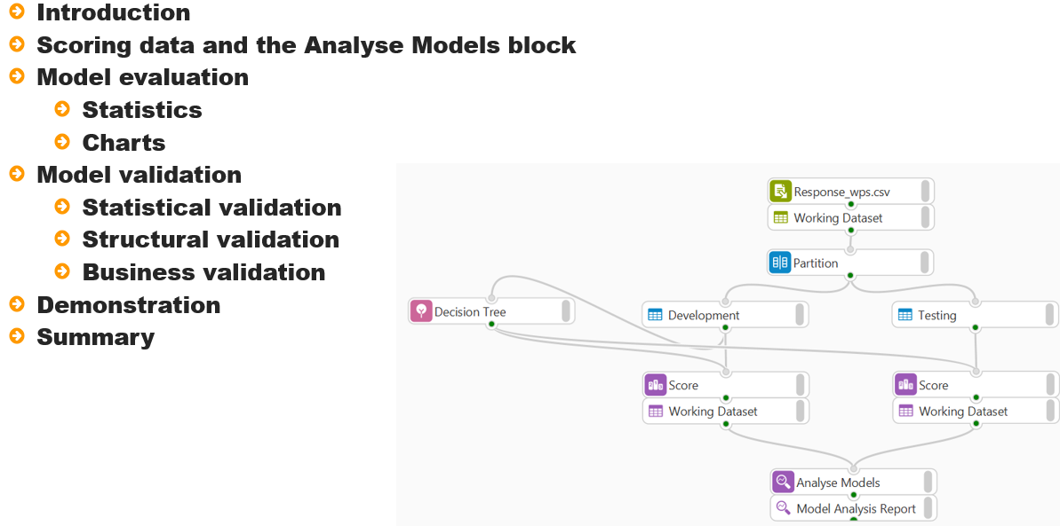

Taking a structured approach to model assessment untangles the complexities associated with evaluating and validating a decision tree model.

Figure 2: Introduction

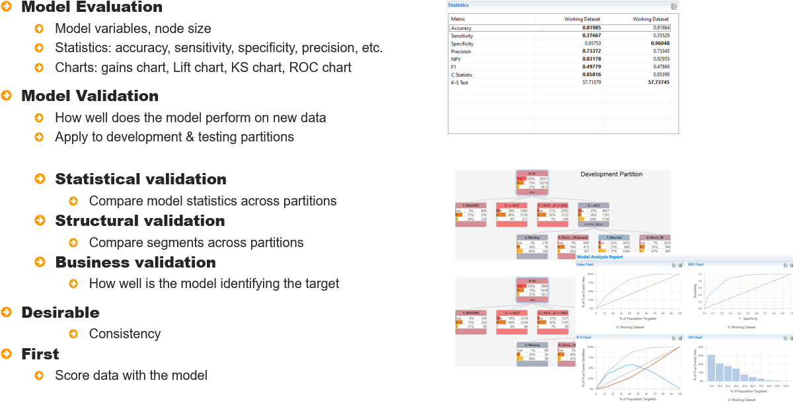

The first step is model evaluation. For a decision tree, ensuring only significant predictors are included,

the tree depth is adequate, node sizes are acceptable, and the tree is explainable and simple are complemented by statistics and charts to further determine model capability.

Once this is complete, the model should be validated. Model Validation applies the model to both

Partitions, generates statistics and charts and compares the model performance across partitions.

Model validation shares a lot of ground with model evaluation in that the same statistics and charts are used and takes three approaches:

Statistical validation, which compares model statistics across partitions, structural validation compares the tree structure and nodes sizes across partitions and business validation focuses on charts.

The focus of model validation is to ensure that the model performs consistently across partitions.

Figure 3: Scoring data and the Analyse Models bock

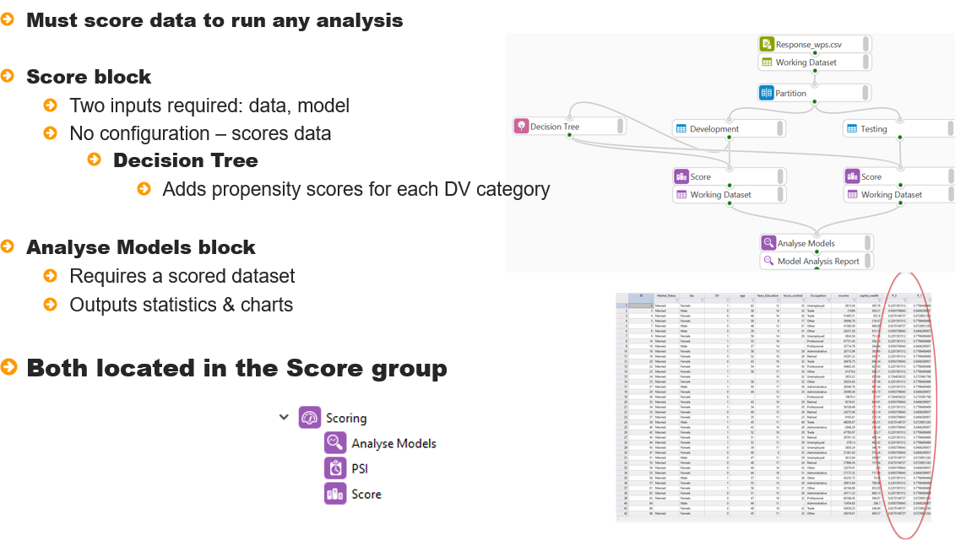

Two blocks are needed when evaluating and validating models. The Score block and the Analyse Models block. These are both located in the scoring group.

The score block is used to score a dataset and requires two inputs, the data to score and the model to score it with.

A decision tree model outputs propensity scores for each dependent variable category and these are used when generating statistics and charts with the Analyse Models block.

Figure 4: Model evaluation

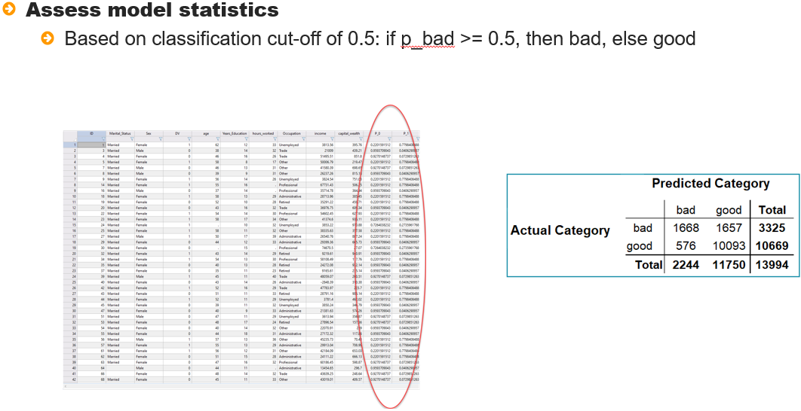

Model evaluation focuses on the scored development partition. When a dataset is scored with a decision tree, two new variables are added containing model propensities for each dependent variable category.

These are used to determine which category of the dependent variable a observation Is predicted to fall into. A classification cut-off of 0.5 is used such that if the propensity of *bad* is equal to or in excess of 0.5, then the observation is classified as bad, otherwise it Is classified as *good*.

As a result of this a classification matrix and statistics can be generated to assess given insight into model performance.

Figure 5: Statistics

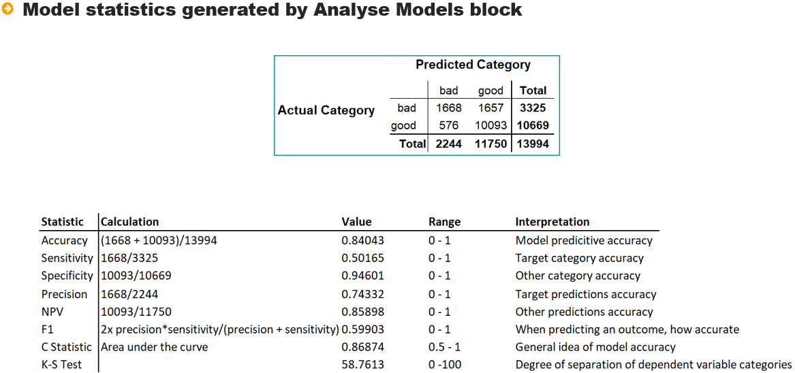

The Analyse Models block generates 8 statistic: Accuracy, Sensitivity, Specificity, Precision, NPV, F1, the C-Statistic and K-S test.

Accuracy relates to overall model accuracy, this sums the correctly predicted bads and goods and expresses the result as a proportion of the overall dataset size, here approximately .84, this means that 84% of observations are correctly predicted.

This statistic can be misleading as one category may be better precited that the other leading so other statistics are provided to give a more holistic approach.

Sensitivity focuses on the target category accuracy, here *bad*, this is simply as assessment of what proportion of the bads have been predicted as *bad*, here, at just over .5, or 50%.

Specificity focused on the other category accuracy, here *good*, with a value of approx. 95%. The overall accuracy of .84 is weighted by 95% accuracy of the good category and 50% accuracy of the bad category.

Precision focuses on the target category predicted outcome. For example, 2224 observations are predicted as *bad*, of that 1668 are *bad*. This gives a figure of .74332. This statistic can be interpreted as when *bad* is predicted, is it right approx. 75% of the time, meaning that when *bad* is predicted, It's generally correct.

NPV, is the same statistic for the other category and at approx. .85 means that when a observation is predicted as *good*, the model Is correct 85% of the time.

The F1 statistic can be used in conjunction with the Accuracy value - the Accuracy value may be high due to one category accuracy weighting the results. The F1 statistic can be interpreted as an overall average accuracy and here is .6 in comparison to the overall accuracy of .84.

The C-Statistic, also known as AUC or area under the curve is an industry standard statistic that is used when assessing models. The threshold varies across industries, but in general a value in excess of .75 indicates a model fit to deploy.

The K-S Test statistic measures the models’ ability to separate observations into the dependent variable categories and the higher the value the better, again, an industry standard is for a value in or around .6.

Most of the statistics have a range from 0 - 1 with the exception of the C-Statistic and K-S Test value which vary from 0.5 - 1 and 0 - 100 respectively.

Across all statistics, and in general, higher values are more desirable.

## Interactive Questions

Q1:

Model evaluation focuses on the model applied to the development partition? **t**/f

A:

Model evaluation focuses on the model applied to the development partition.

Q2:

Model validation compares statistics and charts applied to, in general, both partitions. **t**/f

A:  
Model validation compares statistics and charts applied to, in general, both partitions.

Q3:

When validating a model what is desirable when the model is applied across partitions and statistics and charts generated?

Statistics should be very similar.

Charts should be identical.

**Consistency: statistics and charts should be comparable across partitions.**

Statistics should be identical and charts similar.

A:

When validating a model, what is desirable is consistency: statistics and charts should be comparable across partitions.

Q4:

Statistical validation compares model statistics across partitions, business validation focuses on charts,

structural validation:

Compares parent node sizes across partitions.

**Compares the tree structure across partitions.**

Compares root node size across partitions.

Compares tree depth and maximum split width across partitions.

A:

Structural validation compares the tree structure across partitions.

Q5:

Drag and drop the words to complete the sentence correctly.

When a dataset is scored with a decision tree that has a binary dependent variable with two categories,

_________ containing __________ for each dependent variable category.

**two variables are added propensity scores** category predictions one variable is added

A:

When a dataset is scored with a decision tree that has a binary dependent variable with two categories, two variables are added containing propensity scores for each dependent variable category.

Q6:

Drag and drop the words to complete the sentence correctly.

The **______** value is used to determine the degree of accuracy of the target category when the target category is predicted.

Sensitivity.

Specificity.

**Precision.**

NPV.

A:

The Precision value is used to determine the degree of accuracy of the target category when the target category is predicted.

Q7:  
Which of the following statements is false:

The F1 statistic can be used in conjunction with the Accuracy figure to better determine model performance.

**In general, the F1 statistic can be interpreted as the ability of the model to separate observations into categories of the dependent variable.**

The C-Statistic is also known as areas under the curve.

The K-S Test statistic reflects the ability of the model to separate observations into categories of the dependent variable.

A:

In general, the F1 statistic is not interpreted as the ability of the model to accurately predict the target category of the dependent variable, rather it can be interpreted as an overall average accuracy.

Q8:

Model statistics generated using the Analyse Models block, are based on a classification matrix of the predicted dependent variable categories and the actual dependent variable categories.

If the dependent variable categories are *good* and *bad*, and the target category is *good*, then a observation is assigned the category *good* if *P_good >= 0.5* and assigned *bad* otherwise. **t**/f

A:

An observation is assigned the category good if *P_good >= 0.5* and assigned *bad* otherwise.

Q9:

The C-Statistic and K-S test values should exhibit values in excess of what thresholds to be

confident of an acceptable model?

.7 & .6 respectively.

**.75 & .6 respectively.**

.7 & .6 respectively.

.6 & .75 respectively.

A:

The C-Statistic and K-S test should exhibit values in excess of .75 & .6 respectively to be confident of an acceptable model. Bear in mind that these thresholds can fluctuate across industries and therefore the values of .75 & .6 should be viewed as a rule of thumb.

Charts are also used to assess model performance and four are available from Altair Analytics Workbench including the Cumulative Gains chart, the Lift chart and K-S and ROC charts.

Figure 6: Charts

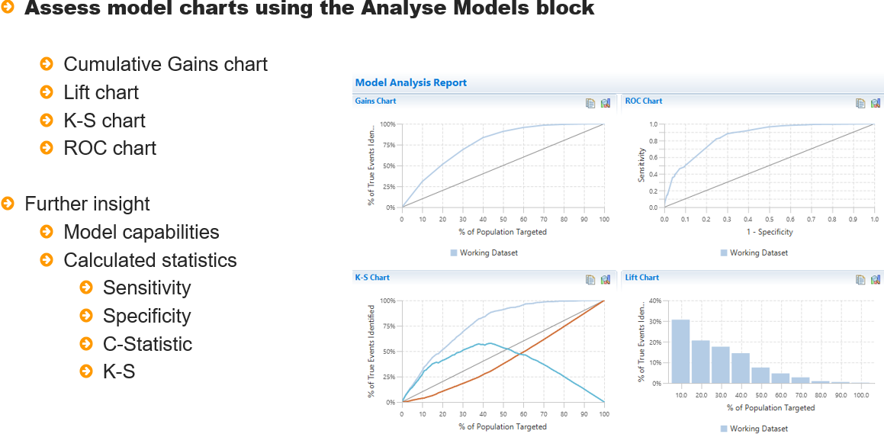

These charts can be used to further assess model Capabilities and can provide insight into calculated statistics such as Sensitivity, Specificity, C-Statistic and K-S statistic.

Figure 7: Cumulative Gains chart

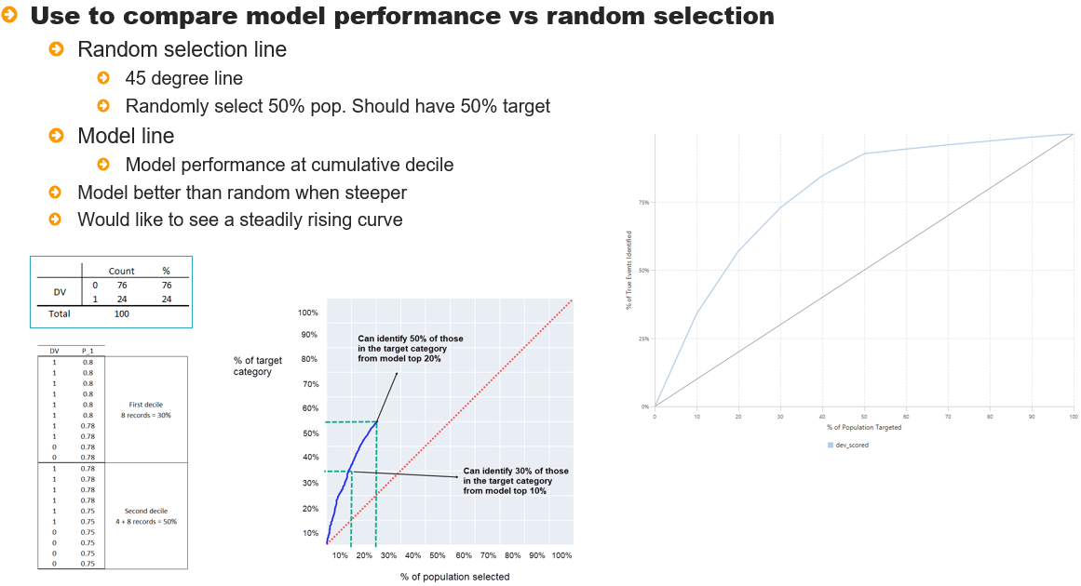

The Cumulative Gains chart or simply Gains chart is used to compare model performance to random selection. The diagonal line is the random selection line and the other(s) are the model applied to partitions.

The horizonal axis, % of Population Targeted, is the percentage of observations selected and the vertical line,

% of True Events Identified is the concentration of the dependent variable target category contained in that selection.

For example, a random selection of 10% of the data should contain 10% of the target category. In the same way, a random selection of 50% of the data should contain 50% of the target category.

The model performance line is interpreted similarly but relates to the selection of observations based on model scores. For example, the top 10% of observations predicted by the model contains approx. 30% of the target category. In the same way, the top 20% of observations predicted by the model contains approx. 50% of the target category.

The model line construction can be easily understood by referring to a simple example. A dataset has 100 observations of which 76, 76% are zeros and 24,24% are 1's. A model is created to predict 1's.

To construct the model line:

Firstly, dataset observations are scored with the model, then listed in descending order of propensity to be in the target category. The graph is created using deciles. Here there is 100 observations so 10 observations is a decile. The first 10 observations are assessed and the number of *DV=1* identified in the decile is expressed as a percentage of the overall number in the target category and graphed.

For example, here there are 24 observations in the 1 category. The top decile by way of model scores, correctly identifies 8 observations in the 1 category, which is 30% of 24. This value is graphed as can be seen and other points are plotted similarly to build a complete picture.

Returning to the graph and drawing a vertical line from 30% on the % of population targeted gives a value of 30% for the randomly line, expectedly, and a value of approximately 65. Dividing these two values: 65/30 will give a value in excess of 2, lets approximate and say 2.

It can then be said that at the 3rd decile, the model is twice as good at identifying the target category

in comparison to random selection.

There is a point where the model is worse than random selection, this is inevitable and can be identified from the graph by identifying the point at which the slope of the random line is steeper than the model line, here, this occurs at the 4th decile. At this point, random selection will outperform the model as the bulk of the target category, in excess Of 80%, have been identified at this point.

Figure 8: Lift chart

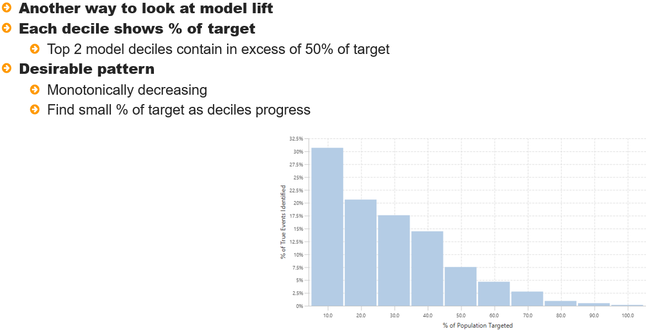

The Lift chart is another way to look at model lift and shows the concentration of the target category in each decile. For example, in excess of 30% of the target category is contained in the first decile, a little over 20% in the second category - cumulatively, the top 2 model deciles contain in excess of 50% of the target category.

Desirable characteristics here are a monotonically decreasing charts, something that looks like a staircase. This is desirable as smaller and smaller numbers of the target category should be identified with each decile.

Figure 9: K-S chart

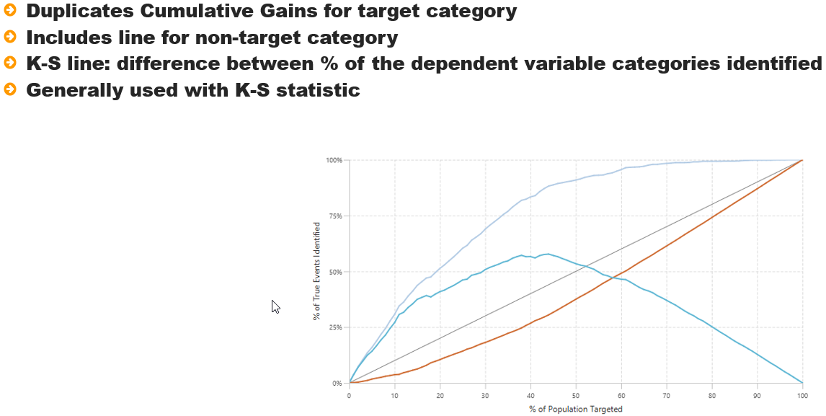

The K-S chart replicates the cumulative gains line for the target category and also includes a line for the

non-target category.

 There is an additional line that represents the difference between the % of true events identified for both the target and non-target category and this is the K-S line, which is generally used with the K-S statistic.

The line simply shows the ability of the model to separate observations in the target category for a select % of

Population Targeted, Desirable characteristics are to see a curve that peaks in the 60s and then trails off.

Figure 10: ROC chart

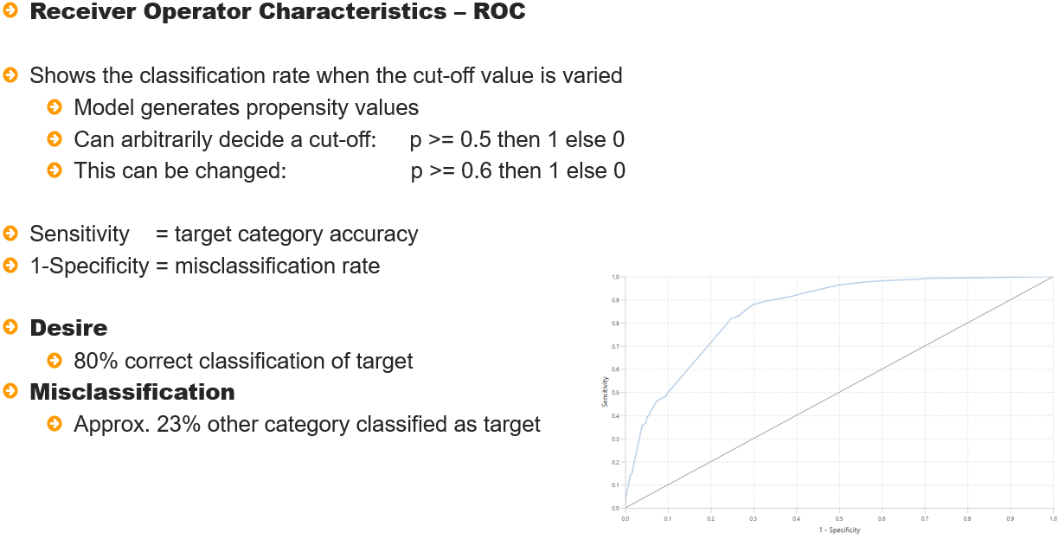

The ROC chart - Receiver Operator Characteristics shows the model classification rate as the cut-off varies.

As the model outputs propensities, any value can be chosen as the point at which to make a decision, for example, a simple approach would be to say that in predicting a dependent variable with two categories 0 and 1, if the probabilities of 1 is greater than or equal to 0.5, then the observation is classified as a 1 and 0 otherwise.

The classifications as a result of the model can then be compared with the actual dependent variable classification and a hit rate or percentage correct can be ascertained.

Bear in mind that as there are two categories of the dependent variable, increasing the correct classification of one category will increase the misclassification of the other and the ROC chart conveys the degree to which this will occur.

The vertical axis, Sensitivity, represents the target category classification rate and the horizontal axis, 1-Specificity represents the misclassification rate. Selecting a sensitivity level provides insight into the degree of misclassification at that rate - for example to correctly classify 80% of the target category, approx. 23 % of the non-target category will be misclassified as a result.

Once the model has been evaluated, it can be validated and here there are three approaches:

* Statistical validation
* Structural validation
* Business validation

Figure 11: Model validation

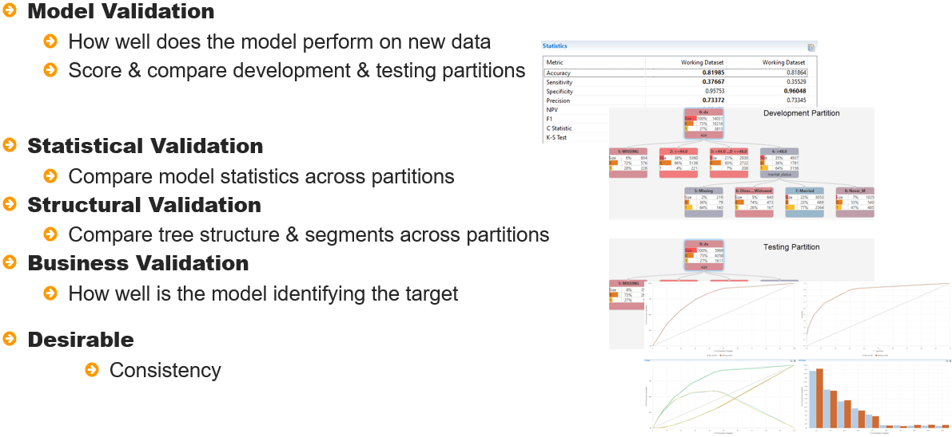

Statistical validation focuses on statistics to compare model performance across partitions. Structural validation compares the tree structure across partitions and Business validation focuses on charts.

Regardless of the approaches, what is desirable is that statistics, the tree structure and charts are comparable, and ideally, indistinguishable across partitions to ensure model acceptability.

Additionally, model evaluation and validation can be conducted in parallel as statistics and charts can be generated for all scored partitions.

## Interactive Questions

Q1:

A Gains Chart is used to compare model performance to random selection. **t**/f

A:

A Gains Chart is used to compare model performance to random selection.

Q2:

For the Gains Chart illustrated. Click on the axis that represents the proportion of the population selected.

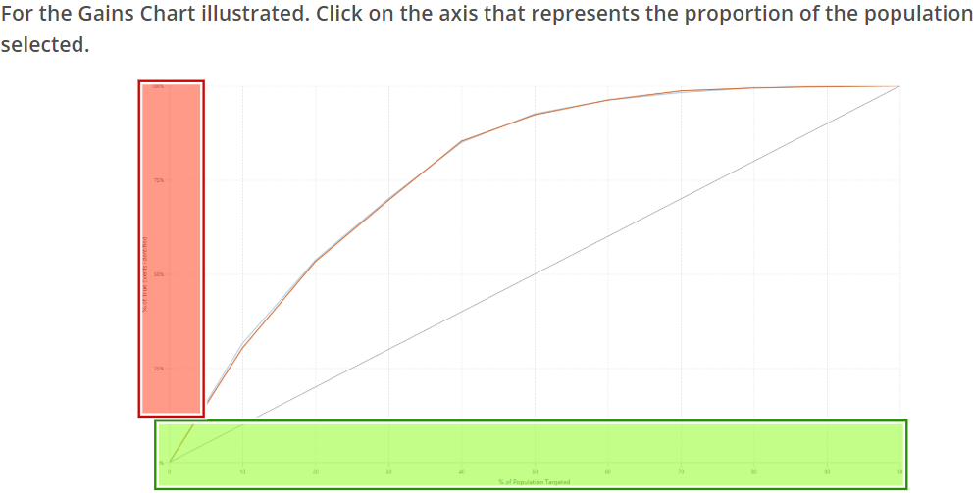

A: x-axis – green

The horizontal axis represents the proportion of the population selected. The vertical axis is the proportion of the target category contained in that selection.

Q3:

Drag and drop the words to complete the sentence correctly.

Consider a Gains Chart and the random selection line, randomly selecting 40% of the population should contain approximately _____ of the target category.

80%.

**40%.**

20%.

10%.

A:

Randomly selecting 40% of the population should contain approximately 40% of the target category.

Q4:

Click on the chart that illustrates the concentration of the target category in each model decile.

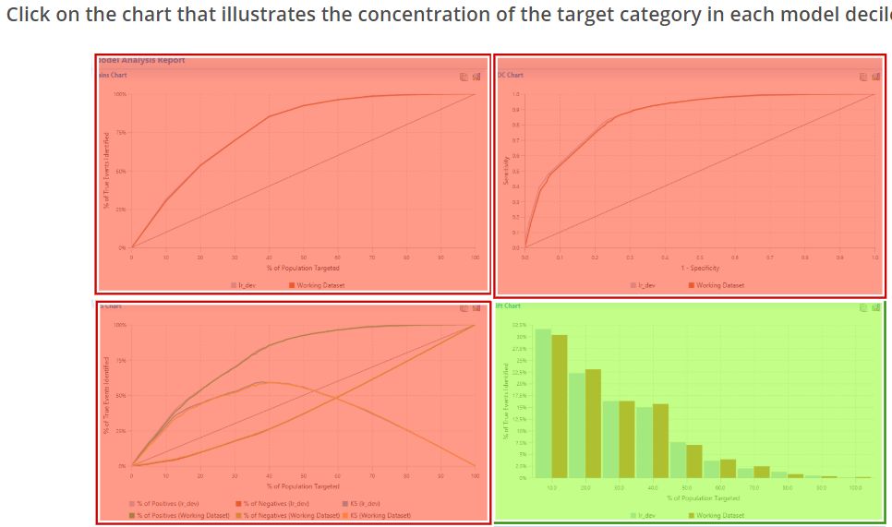

A:

That's right! You chose the correct chart. The Lift Chart illustrates the concentration of the target category in each model decile.

Q5:

Drag and drop the words to complete the sentence correctly.

A desirable characteristic for a Lift chart is that it is __________________.

Uniform Monotonically increasing **Monotonically decreasing** Exponentially increasing

A:

A Desirable characteristic for a Lift Chart is that it is monotonically decreasing.

Q6:

The K-S line on the K-S chart shows the separation between the classification rate of the dependent variable categories. **t**/f

A:

The K-S line on the K-S Chart shows the separation between the classification rate of the dependent variable categories for any selected percentile.

Q7:

The ROC chart can be used to assess the degree of misclassification at any target category classification rate. **t**/f

A:

The ROC Chart can be used to assess the degree of mis-classification for any target category classification rate.

## Demonstration

So lets get on to a demonstration.

This demonstration uses a model developed in a previous lesson. There are three variables in the model. *capital_gain*, *relationship* and *education_num*.

Figure 12: Tree model

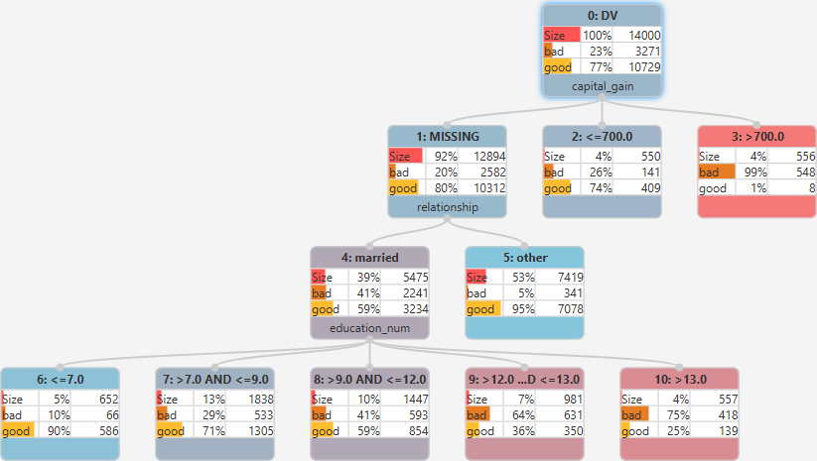

All leaf nodes, the point at which a prediction takes places, are of adequate size. All being at least 4% of the dataset size and the widest split has 5 nodes. There is the possibility to grow some segments further but as to whether there will be better isolation of the *bad w*ith an acceptable distribution is questionable, for example, consider leaf node number 7.

The node size is 13% of the overall dataset size with 1838 observations, characteristics for membership of this node are missing *capital_gain*, *relationship* = *married* and *eduction_num* greater than 7 and less than or = 9.

There are 533 *bads*, accounting for 29% of the node. Selecting this node and choosing Optimal Split by Entropy Variance splits on the variable *occupation* with 5 splits. As can be seen, most observations, 7% are concentrated in one node.

The generated split looks acceptable but with a variable such as *occupation*, which may have lots of categories, category merging may not be common sensical.

Validation will highlight whether this split is acceptable or not but for the time being it is retained.

Figure 13: Adding more splits

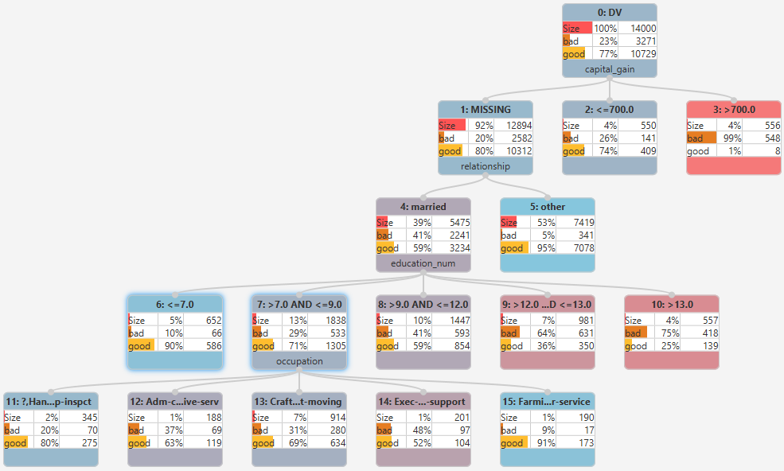

There is a questionable segment, node number 3, as can be seen almost all observations in this node are *bad*, again, validation will lead to understanding whether it can be retained or must be merged with another node.

One final node to focus on is node number 5, this has 53% of observations and only 5% of these, 341 are in the *bad* category. It would be great to split this further but given the small % of *bad*, additional splitting may provide no further benefit. To investigate, the node is selected and Optimal Split by Entropy Variance clicked.

The variable selected is *education* with 8 splits. The splits are further refined such that three are created that reflect an order. The resulting splits are acceptable with adequate distributions.

Figure 14: Final tree

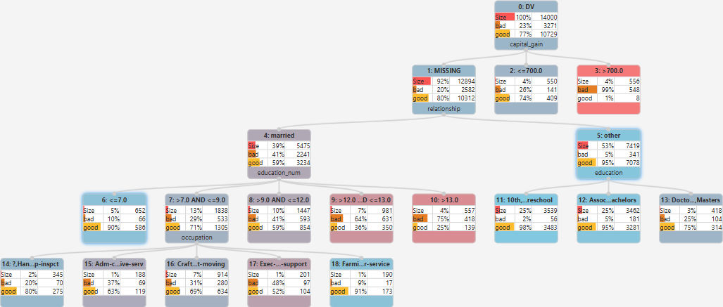

An attempt could be made to grow the tree further as some of the *education_num* splits are adequately sized with adequate distributions but here model building will stop at this point.

Onto validation. Notice the asterisk on the Decision Tree, clicking CTRL+S saves tree settings and the asterisk disappears.

Statistical and business validation can be assessed using the Analyse Models block, this is found in the Scoring group. This block requires a scored dataset, so the first thing to do is score the development partition with the decision tree model using the Score block, also found in the Scoring group.

Figure 15: Adding a Score block

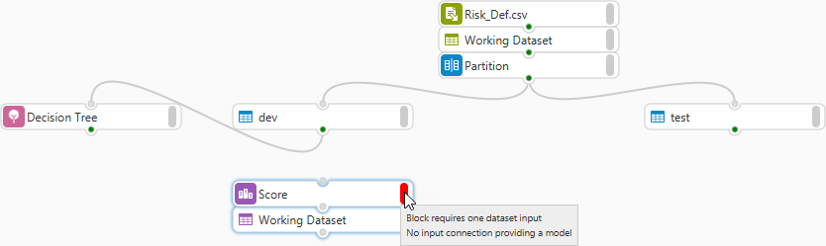

Notice the configuration status messages when the block is dragged onto the canvas: Block requires one dataset input and No input connection providing a model.

The development partition and model are both connected to the Score block and as a result of the block

being included in Auto-Run, a scored dataset is automatically output. Here, its name is changed to *dev_scored*.

Opening the scored dataset with the Data Profiler, it can be seen that two new columns have been added *P_bad* and *P_good*, these variables contain the probability of *bad* and *good* for each scored observation*.*

Clicking the data tab and splitting the screen with the decision tree, it is easy to understand how scores

Were arrived at.

Figure 16: Understanding scores

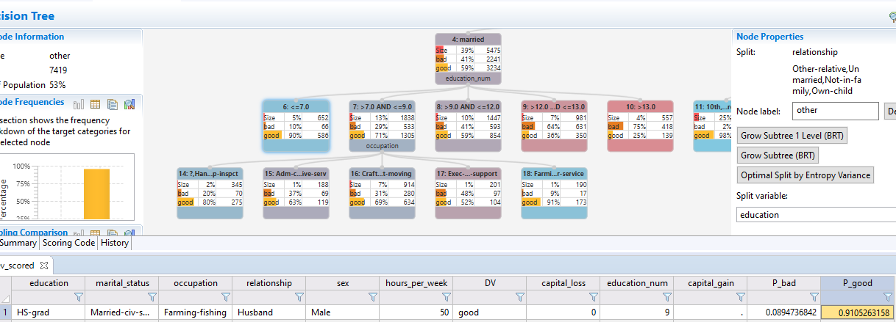

For example, the values for the first observation were generated as a result of it being a member of node 23.

This node contains 190 observations, so there will be another 189 observations with the same values as they are also contained in the same leaf node.

Notice that the tree has 19 leaf nodes, therefore there are 19 distinct *P_Bad* values and 19 distinct *P_good* values.

Now that the development partition is scored, the Analyze models block can be added to the Workflow and the scored development partition connected. The block configuration dialog contains two pages: Analysis Type and Variable Selection.

The Type of analysis drop-down provides two options: Classification and Regression. As the dependent variable in this instance is categorical, classification is appropriately selected.

The variable selection page allows selection of the variables to analyse in the connected dataset. Presently there is only one dataset connected. From the True class dropdown, the dependent variable is selected, here *DV*.

From the Truth category drop-down. The category of interest is selected, here, *bad* and from the Predicted probability drop-down the corresponding variable that contains the probability scores for the selected category chosen, here *P_bad.* Once complete, OK is clicked and the Analyse Models report accessed.

Figure 17: Model Analysis Report

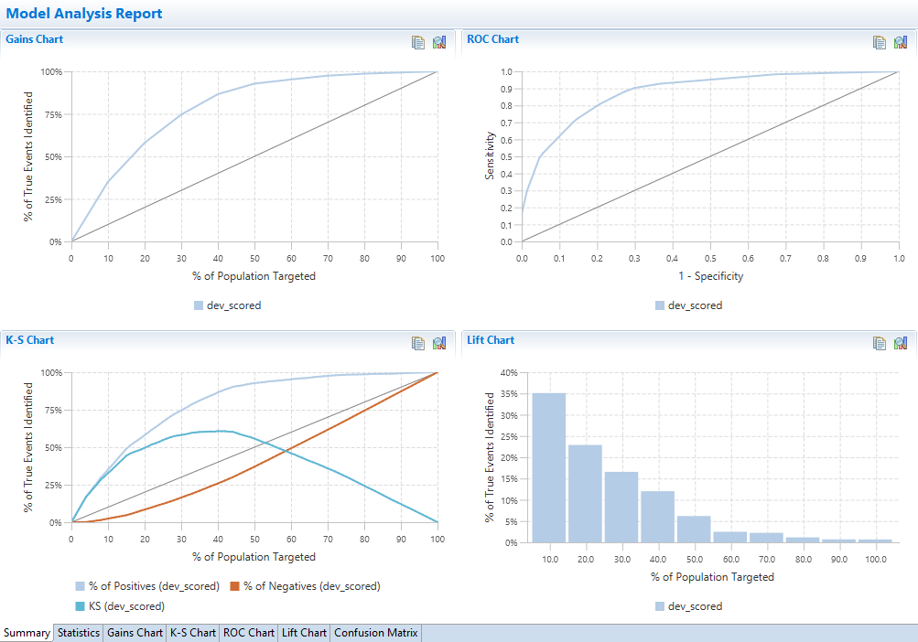

## Interactive Questions

Q1:

What Altair Analytics Workbench block is used to generate statistics and charts to evaluate and validate models?

The PSI block.

**The Analyse Models block.**

The Logistic Regression block.

The Database Export block.

A:

The Analyse Models block is used to generate statistics and charts to evaluate and validate models.

Q2:

What prerequisite must be in place so that the Analyse Models block can be used.

**The connected dataset(s) must be scored with a model.**

Ensure that the data has been imported and read correctly.

The model must be saved.

All datasets must be saved.

A:

All connected dataset(s) must be scored with a model when using the Analyse Models block.

Q3:

Drag and drop the words to complete the sentence correctly.

To apply model scores to a dataset using the Score block, ____________ must be connected.

a dataset a model **a dataset and a model** a development and a testing partition.

A:

To apply model scores to a dataset using the Score block, a dataset and a model must be connected.

Q4:

The Analyse Models block can only be used to assess models with a categorical dependent variable. t/**f**

A:

The Analyse Models block can be used to assess models with a categorical or a continuous dependent variable.

Q5:

For a decision tree, can the number of distinct propensities generated by the model be determined?

**Yes, by counting the number of leaf nodes**

No, the number of propensity values cannot be known.

Yes, by counting the number of nodes in the tree.

Yes, but an additional chart or statistics are required to determine.

A:

The number of distinct propensities generated by the model can be known by counting the number of leaf nodes.

As can be seen there are 6 tabs in the Model Analysis Report: Summary, Statistics, Gains Chart, K-S Chart, ROC Chart and Lift chart.

The summary tab provides a view of the charts available from their respective tabs and the statistics tab provides an array of statistics for each connected scored dataset.

Figure 18: Statistics

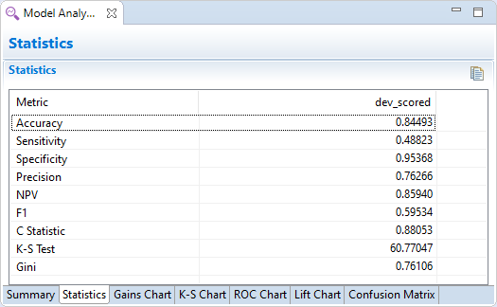

The overall predictive accuracy of the model is high at approximately .84, but this is due to the high classification rate of the other category, good, at approximately .95, as the target category classification rate is low at approximately .48.

Precision is good at approximately .76, meaning that when an observation is predicted as *bad,* the model is correct 76% of the time.

The F1 statistic is another measure of model accuracy and at approximately .59 puts the weighted accuracy figure into perspective; that on average the model predictions are approximately 60% accurate.  The C-Statistic and K-S Test values exceed requirements for model acceptability.

To statistically validate the model, it is better to compare statistics across scored partitions. To do this another Score block is added to the Workflow and the testing partition and model connected. The scored output dataset is renamed to *test_scored,* connected to the Analyse Models block and configured as before.

Clicking OK runs the report, opening and returning to the statistics page, as can be seen statistics are generated for both connected datasets.

Figure 19: Adding a second scored dataset

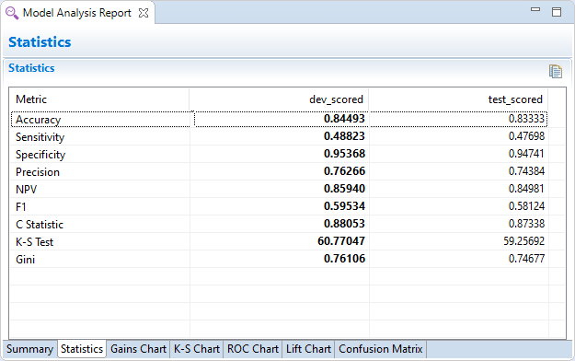

The statistic in bold highlights the connected dataset with the higher score for that statistic. In general, there is little difference in statistics across scored partitions. The C-Statistic is in excess of .75 which is generally the accepted cutoff for a good model, and values are comparable across partitions.

This suffices to statistically validate the decision tree model. The next step is to structurally validate the tree. This compares the tree structure across partitions.

The way to accomplish this is to duplicate the Decision Tree block on the canvas, connect the testing partition and open. A message: do you wish to recalculate node frequencies? appears. Clicking OK, updates node frequencies with the testing partition data.

To view and compare the tree structure, the screen is split to view both trees.

Figure 20: Structural validation

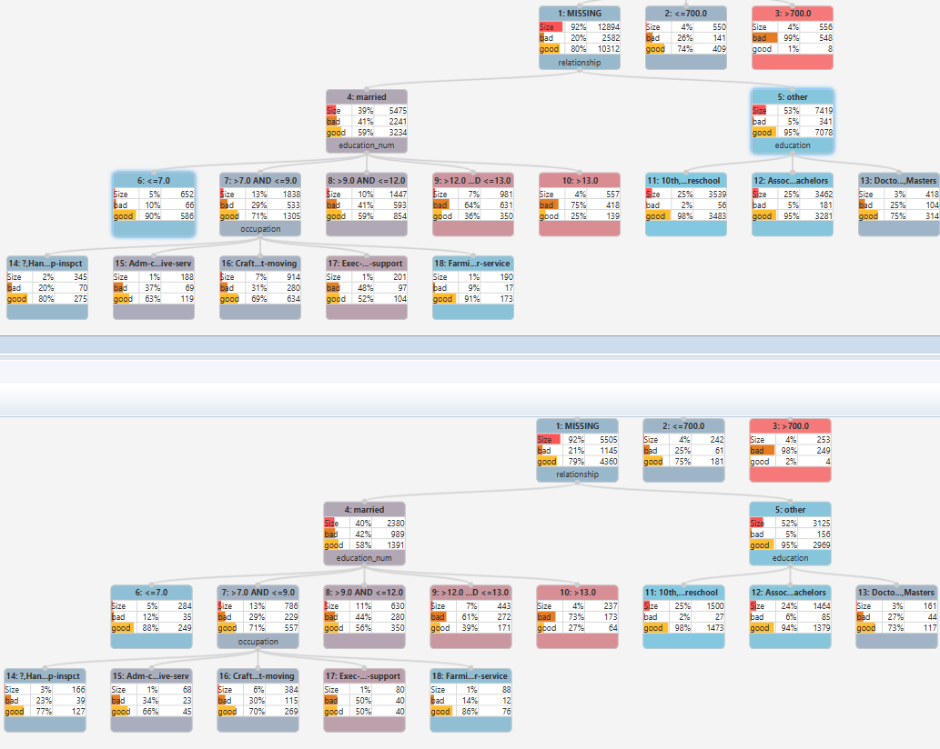

Structural validation is a simple comparison of the nodes across the model applied to both partitions. It is desirable to see consistency in the distribution of the dependent variable across nodes.

For this model, there is a little bit of a discrepancy in terms of the *DV* distribution for the *occupation* split. The values vary slightly with the largest deviation evident for node 23 where there is a 5% difference.

To address this, node 23 is merged with node 22 for both partitions. The largest deviation for the variable *occupation* is now 3% for node 19 and also node 20. This is accepted here but further merging could be performed to attempt to more closely match the dependent variable distributions.

Figure 21: Modified structure

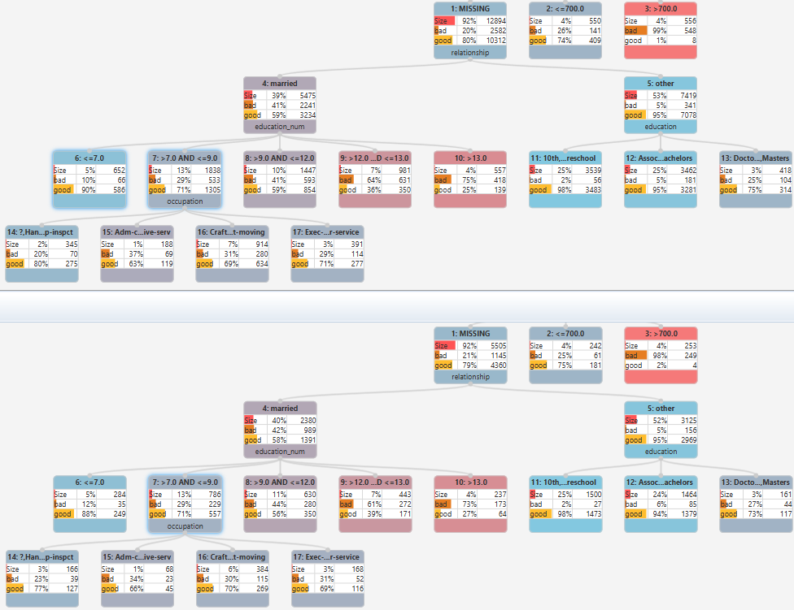

The *capital_loss* split validates well as do all other node distributions, at this point the statistics generated previously must be updated as a result of changing the tree.

This is easy to accomplish, first the tree created using the development partition is saved using the keyboard shortcut CTRL+S, notice the asterisk has disappeared. Auto-run takes care of re-scoring and it’s simply a matter of opening the Model Analysis Report to access updated results.

Figure 22: Updated statistics

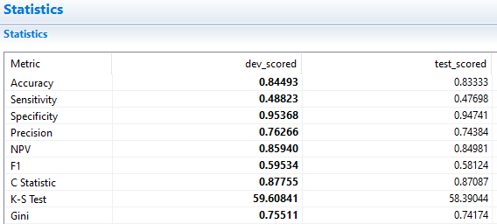

Statistics have changed minimally and they are comparable across partitions. Notice that most values are well matched. The C-Statistic and K-S Test value have dropped slightly but are still acceptable and the model validates.

Business validation can be assessed by viewing charts. Selecting the Gains Chart tab, two lines are present, one for the model applied to each partition and both are tracking well.

Figure 23: Gains Chart

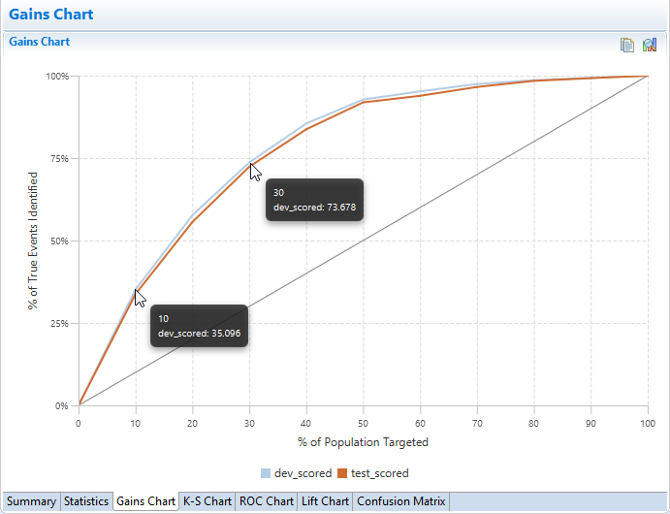

Exclude(not working in my version)

Hovering over any plotted point reveals additional detail. For example, for the development partition, the top 30% predicted by the model contains approximately 73% of the target category. This is similar across partitions and slightly lower for the testing partition at approximately 72%.

Notice the jaggedness of the lines. This is due to groups of observations being assigned the same value as a result of being members of the same decision tree node.

The model performs well but there is a slight dip toward the latter deciles. Clicking the K-S chart tab, this replicates the gains chart but adds a line for the non-target category and the K-S values for both partitions.

Figure 24: K-S Chart

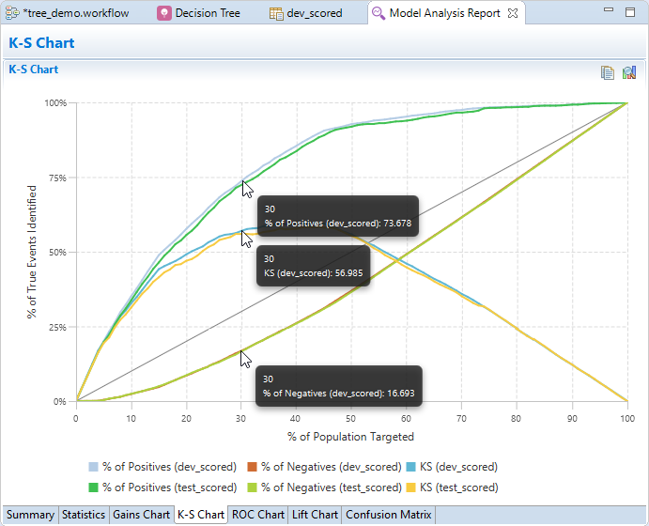

This plots the difference between the % of True Events Identified for both the target and non-target category. For example, for the development partition the % of true events for the target and non-target categories at the 3rd decile are 73.678 and 16.693 respectively. The difference between these two values is 56.985 and this is the K-S Test value at this decile.

The K-S Test plot should ideally have a smooth curved increase to a maximum and then a smooth curved decrease. Here, the curve is not smooth but does increase, somewhat haphazardly, and then decreases linearly.

The ROC chart reflects other charts in that the lines are comparable. This chart can also provide insight into the degree of misclassification of the model.

Figure 25: ROC Chart

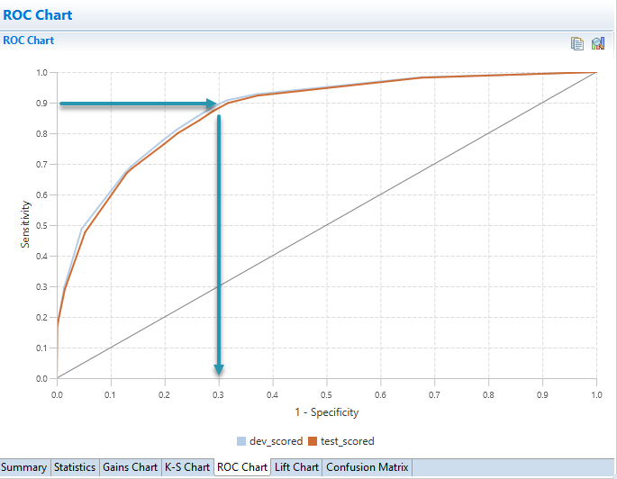

For example, focusing on the development partition line, to correctly classify 90% of the target category, approximately 30% of the non-target category will be misclassified. In plain terms this means that to ensure high classification of *bad*, about 1/3 of *good* will be misclassified as *bad* as a result.

From the lift chart, it can be seen there is good classification and the target category concentration in each decile across partitions is comparable.

Figure 26: Lift Chart

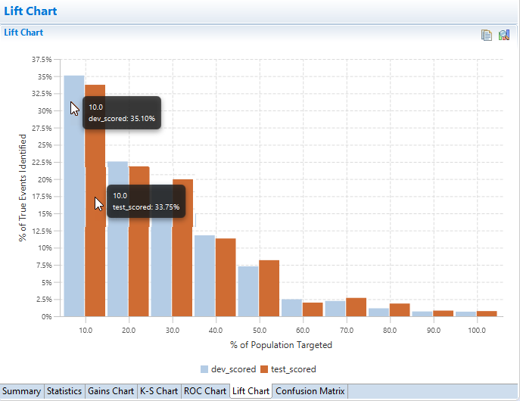

For example, in the first decile, the model applied to the development partition identifies approx. 35% of the target and the testing partition is slightly lower at approximately 33%.

There is a little instability in the upper deciles for the model applied to the deciles of the testing partition. This slightly distorts the monotonically decreasing representation that is desirable, however, given these are the latter deciles and there is not an extreme distortion, this is acceptable.

At this point, the model has been evaluated and validated. The model code can be access from the scoring code tab of the decision tree and deployed as necessary.

## Interactive Questions

Q1:

A high Accuracy value can be misleading as one category may be predicted far better than the other. **t**/f

A:  
A high Accuracy value can be misleading as one category may be predicted far better than the other.

Q2:

The Sensitivity and Specificity values reveal how well each dependent variable category is predicted. **t**/f

A:  
The Sensitivity and Specificity values reveal how well each dependent variable category is predicted.

Q3:

Precision is calculated by determining the proportion of those predicted as the target category, for example: bad, who are actually in the target category. **t**/f

A:

Precision is calculated by determining the proportion of those predicted as the target category, for example: bad, who are actually in the target category.

Q4:

The F1 statistic is better used with the _________ to better understand model performance.

**Accuracy value** Precision value Sensitivity value Specificity value

A:

The F1 statistic is better used with the Accuracy value to better understand model performance.

Q5:

Structural validation is a comparison of the model structure when applied to all partitions and can be used to determine whether a generated leaf node should be retained. **t**/f

A:

Structural validation is a comparison of the model structure when applied to all partitions and can be used to determine whether a generated leaf node should be retained.

## Summary

This lesson focused on using statistics and charts to evaluate and validate a decision tree model.

The model was first evaluated using statistics and charts. Model validation looked at applying the model to both partitions and assessing the consistency and stability across results and three approaches were presented:

Statistical validation which focused on comparing statistics across partitions, structural validation, which looked at comparing the tree structure across partitions and business validation focusing on charts.

This was then followed by a demonstration using Altair Analytics Workbench capabilities.

## Exercises – Interactive



Q1:

Use the Workflow and decision tree created in the previous exercise or, open the workflow: tree_. This is included with course data. Note that the import block used will need to be configured correctly. Score the *Dev* partition with the decision tree model and add an Analyze Models block to evaluate the *Yes* category of *DV*. Once complete, open the Model Analysis Report to access results.

Question: What do results look like?

**Good. Statistics and charts are acceptable.**

Not acceptable. Overall accuracy is misleading, F1 gives a more rounded picture at approx. 52%.

Good. The Gains Chart shows that the target category is captured well.

The model is not acceptable, as the Lift Chart is not monotonically decreasing.

A:

The decision tree is saved and a Score node is used to score the *Dev* partition with the decision tree model, the scored partition is renamed to *dt_dev*.

An Analyse Models block is added and *dt_dev* connected and configured to assess the *Yes* category of DV. Accessing the report generated it can see that statistics are acceptable with overall accuracy of

Approximately 82%,

The *Yes* category is predicted with approximately 40% accuracy, but when a observation is predicted as yes the model is correct in excess of 70% of the time as indicated by the Precision value. The C-Statistic is high and meets acceptable criteria. The K-S Test value is a little low but still acceptable.

From the Summary tab, model curves are acceptable, monotonicity is violated in the upper deciles but again, this is acceptable. In summary, statistics are acceptable, and chart are encouraging.

Q2:

Duplicate the decision tree block and connect the Test partition.

Compare the structure of the tree across partitions.

Question: Does the tree validate structurally?

No, there is not much replication of leaf nodes with comparable DV distributions.

**Yes, for the most part, however there is a little instability in one or two leaf nodes.**

A:

To structurally validate the model, the Decision Tree model block is duplicated, and the test partition connected. On Opening the decision tree, a message appears: Do you wish to recalculate node frequencies? Clicking yes will retain the tree structure and populate with the connected data. The screen can be split to show both models.

In general, the model validates structurally, although there are some nodes where the *DV* distribution is different by more than 5%. A variant of the model can be created and nodes such as this merged with

others and compared with the original tree, however here the model is accepted.

Q3:

Score the Test partition. Connect it to the Analyse Models block, configure it appropriately and once complete, access results from the Model Analysis Report.

Question: Does the model validate well?

No. The model charts and statistics do not compare across partitions.

No. The Yes category Accuracy and F1 values are too low.

**Yes. The model charts track well and models statistics are comparable across partitions.**

Yes, as Accuracy and the C-Statistic are high on the Test partition.

A:

To validate the model from a statistical and business perspective, the model is applied to the test partition using a Score node. The scored dataset is renamed to *dt_test*, connected to the Analyse

Models block, configured and results accessed.

As can be seen from the summary tab, model curves are tracking well and statistics are comparable across partitions, given this and results from structural validation, it can be said the model validates well.

# Chapter 10: Challenging the model

## Introduction

This lesson includes an introduction and focuses on using Altair Analytics Workbench Workflow modelling

capabilities to challenge a model prior to demonstration followed by a summary.

Figure 1: Contents

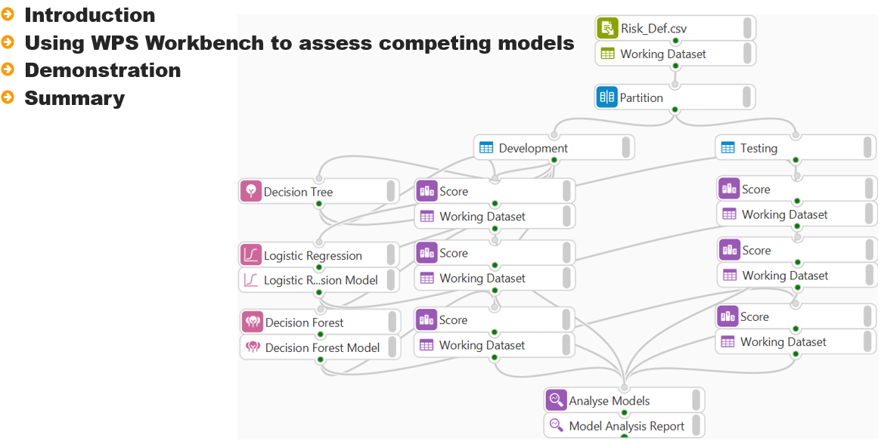

There are many ways to model a dependent variable, whether it is continuous or categorical. Once a model has been developed, other models can be assessed to determine whether they outperform the current model and can takes its places as the model of choice.

Figure 2: Introduction

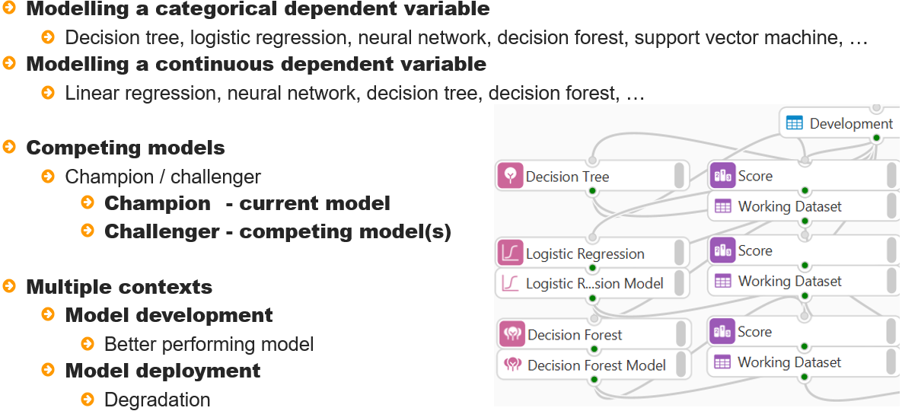

This process is referred to as champion/challenger. The champion is the currently accepted model and the challenger is the competing model or models. The context of where champion / challenger can be applied is twofold.

Firstly, model development - multiple models can be developed and the best performing model selected

Champion challenger can also happen when models have been deployed and are in production.

The current production model is the champion, at the point it degrades such that it no longer predicts well, a model rebuild may be necessary and one or more challenger models can be assessed.

Figure 3: Champion/challenger process

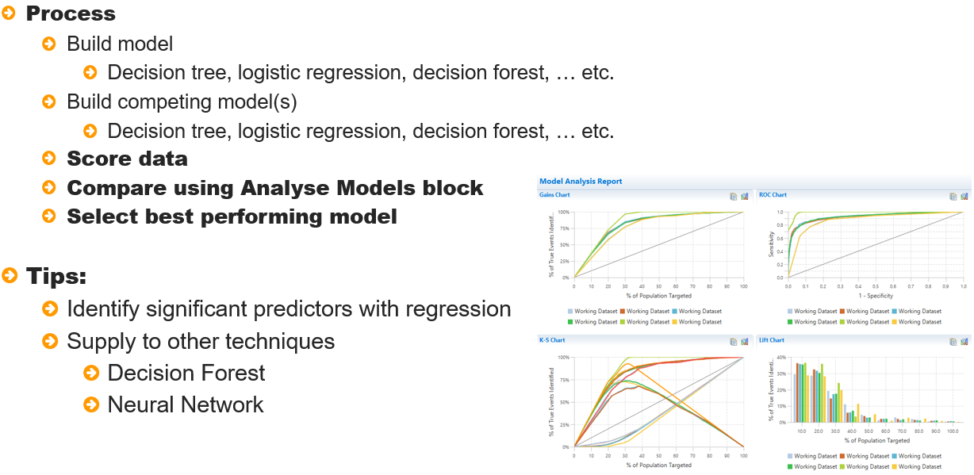

The process to challenge a model is straightforward and regardless of whether an established model

Is being challenged or multiple models to predict the same dependent variable are being assessed, the

Steps are identical.

Assuming there is interest in modelling a binary dependent - the first step is to build a model, once complete other models are built, data is scored, and results can be compared using the Analyse Models block. Simply select the best performing model.

Some tips in relation to developing other model types - as a decision forest and neural network may take considerable time to run, the process can be made more efficient by using regression to identify significant predictors to supply to these techniques.

The demonstration for this lesson will focus on a decision tree model previously developed and challenge it with two competing models, a logistic regression that uses a stepwise procedure to identify significant predictors and a decision forest, this will use the significant predictors identified with logistic regression to build a model.

## Interactive Questions

Q1:

The phrase champion / challenger refers to:

Assessing the type of models type that are applicable, given a specific scenario.

**Developing additional models to compete with the currently accepted model.**

Developing additional models to run concurrently with the currently accepted model.

Developing additional models to replace the currently accepted model.

A:  
The phrase champion / challenger refers to developing additional models to compete with the currently accepted model.

Q2:

The champion is not the currently accepted model. t/**f**

A:  
The champion model is the currently accepted model.

Q3:

A challenger model becomes a champion if it acceptably outperforms the current champion model. **t**/f

A:

A challenger model becomes a champion if it acceptably outperforms the current champion model.

Q4:

Arrange the following items in the correct order by dragging and dropping. The correct order should reflect the process steps involved when challenging a champion model

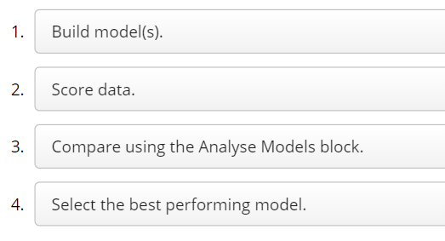

A:

When challenging a champion model the steps to follow are: build model(s), score data, compare using the Analyse Models block and then select the best performing model.

Q5:

When developing additional models that may take considerably longer to run, are there any mechanisms that can be used to make the process more efficient?

No, the time taken may be due to some variables having lots of categories.

Yes, ensure the model configuration is as simple as possible.

**Yes, supply only significant predictors to the model.**

No, the best approach is to supply all variables to the model being developed.

A:

When developing additional models that may take considerably longer to run. Supplying only significant predictors to the model can make the process more efficient.

## Demonstration

So onto a demonstration.

This demonstration uses a decision tree model developed in a previous lesson. The model contains five variables *capital_gain*, *relationship*, *education,* *education_num* and *occupation.*

This is the current champion model. Two additional models will be developed to compete with this model, a logistic regression and a decision forest. Logistic regression will be used to assess all variables and a stepwise method will be used to select and include only significant predictors.

Variables identified here will be used to model the same dependent variable using a decision forest and all models will be assessed using the Analyse Models block.

Viewing the data prior to proceeding shows that there are 13 variables. The variable *DV* will be used as the dependent variable and a selection of remaining variables used as independent variables.

As *capital_gain* has a high proportion of missing values it will not be included as a possible predictor. Another variable that will not be included are *ID*. *education_num* and *education* record education, as *education_num* is a numeric continuous variable, it is preferred.

The variables *relationship* and *marital_status* record similar characteristics and here *relationship* will be used.

To begin, a logistic regression block is dragged from the Model Training group to the Workflow canvas and the development partition connected.

Figure 4: Adding a Logistic Regression modelling block

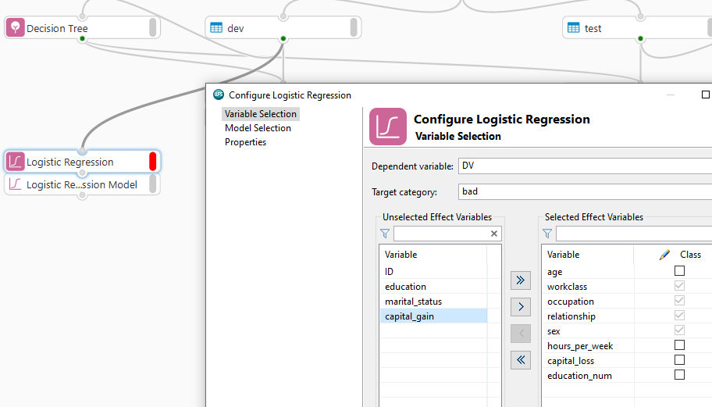

The block has three pages, Variable selection, Model Selection and Properties. The Variable Selection page allows selection of the dependent and independent variables.

From the dependent variable dropdown *DV* is chosen and *bad* selected from the event dropdown. All variables are moved into the selected effect variables area and *capital_gain*, *education*, *ID* and *marital_status* are removed.

Note that some variables have been correctly identified as class variables, however *education_num* has also been selected as a class variable, as it contains integer values, deselecting ensures it will be used as a continuous predictor.

There is interest in only including significant predictors in the model. An option to ensure all variables are assessed and only significant predictors retained is available from the model selection page.

The method drop down provides five options, the option none, will build a model with all independent variables supplied. The other four methods include and retain variables only if they meet specific significance thresholds, these are available and can be modified once an appropriate method has been selected.

The option selected here is Stepwise, this allows only significant predictors into the model. Once a new variable is added to the model, variables already present are re-assessed to ensure their continued significance.

Clicking OK runs the model and once complete double-clicking the resulting Logistic Regression Model block reveals that output is presented across two tabs: Logistic Regression Results and Scoring Code.

The logistic regression results provide six expandable sections including Model Information, Model Fit Statistics, Testing Global Null Hypothesis: BETA = 0, Analysis of Maximum Likelihood Estimates, Odds Ratio Estimates and Association of Predicted Probabilities and Observed Responses.

A discussion of the specifics of these areas is not warranted here, however from either the Analysis of Maximum Likelihood Estimates or the Odds Ratio Estimates tables, the variables included in the model are visible.

Figure 5: Analysis of Maximum Likelihood Estimates

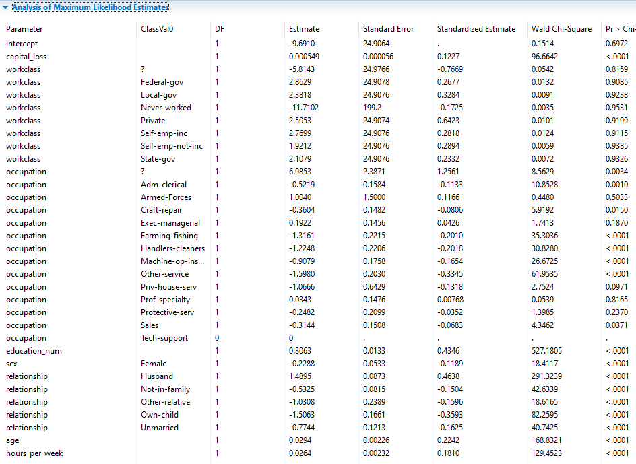

Eight variables were included: *capital_loss*, *workclass*, *occupation*, *education_num*, *sex*, *relationship*, *age* and *hours_per_week*.

These variables are all significant predictors in the model and will be used when developing a decision forest. The next step is to score the development and testing partitions, here score blocks are added, connections made and data scored.

Prior to connecting to the Analyse Models block, the scored datasets are renamed to *lr_dev* and *lr_test* respectively so that they can be easily identified. The partitions scored with the decision tree are also renamed appropriately.

Once complete, the scored partitions are connected to the Analyse models block and configured. Here the same True class, Truth category and corresponding Predicted probability variable for both partitions are selected and OK clicked.

Opening the Model Analysis Report, it can be seen there are lines for both the decision tree and logistic regression applied to both partitions.

Figure 6: Summary

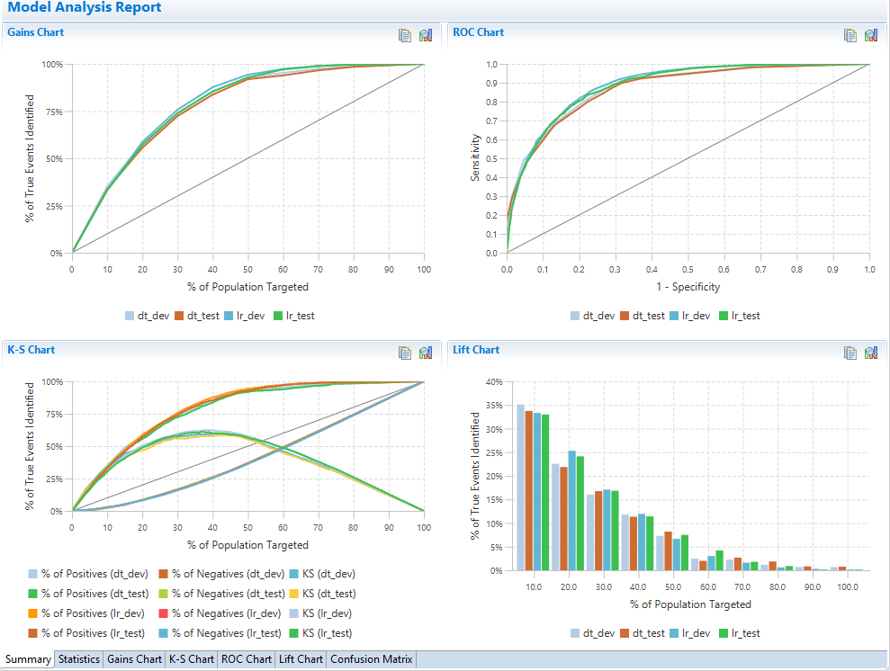

From the Summary its clear to see that the logistic regression is outperforming the decision tree. This is not surprising given that more variables were used to build the logistic regression model.

Notice that the curves are smooth for the logistic regression model in comparison to the decision tree, this is because an equation is used to generate scores for each observation based on the independent variable characteristics as opposed to grouping observations and assigning them the same score.

From the graphs the logistic regression is outperforming the decision tree. This is reflected in the statistics.

Figure 7: Statistics

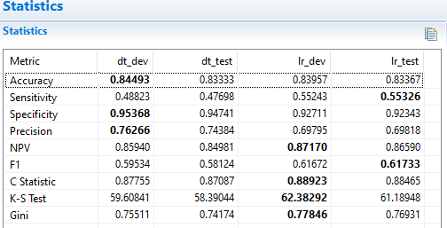

Focusing on the development partition. The accuracy is slightly higher for the decision tree but the target category is not predicted as well as the logistic regression.

Also, the logistic regression gives a better average predictive accuracy as relayed by the F1 statistic. Other values such as the C-Statistic and K-S Test value also favour the logistic regression.

Both models perform consistently across partitions but at this point the logistic regression with eight variables would be the model of choice.

## Interactive Questions

Q1:

Does the Altair Analytics Workbench Logistic Regression block contain options to change how a variable is used in the model?

No, all variable types are preset.

**Yes. String or character variables are automatically selected as Class. Numeric variables can be**

**manually selected as Class.**

A:

The Altair Analytics Workbench Logistic Regression block contains options to modify numeric variable types. String or character variables are automatically selected as Class. Numeric variables can be manually selected as Class.

Q2:

Logistic regression does not provide options to assess and include only significant predictors in the model. t/**f**

A:

Logistic regression includes options to assess and include only significant predictors in the model.

Q3:

Model chart plots for a logistic regression model are, in general, more jagged that those of a

decision tree. t/**f**

A:  
Model chart curves for a logistic regression model are, in general, smoother that those of a decision tree.

Q4:

When comparing models, the criteria for choosing a champion is:

Select the model that scores highest across all statistics for all partitions.

Select the model that scores highest across most statistics for one of its partitions.

Select the model that scores highest for the C-Statistic.

**Select the model that scores highest across most statistics and those statistics are comparable across partitions.**

A:

When comparing models, the criteria for choosing a champion is to select the model that scores highest across most statistics which should also be comparable across partitions.

Q5:

Logistic regression output can be used to assess the impact of each variable in the model, thereby providing a means to rank the importance of each predictor, whereas this is not possible for a decision tree when viewing the Tree diagram. **t**/f

A:

Logistic regression output can be used to assess the impact of each variable in the model thereby providing a means to rank the importance of each predictor, whereas this is not possible for a decision tree when viewing the tree diagram.

Let’s see what impact a decision forest may have. A Decision Forest block is dragged onto the Workflow canvas and the development partition connected. Accessing configuration options reveals two pages: Variable Selection and Preferences. The Variable Selection page provides the ability to specify the model.

From the Dependent variable drop-down *DV* is selected and its treatment is automatically set as Nominal.

The eight variables identified previously with the logistic regression model are moved into the Selected Independent Variables list. Variable treatment can be modified by selecting from the treatment dropdown and here *education_num* is changed to Interval.

Figure 8: Variable Selection

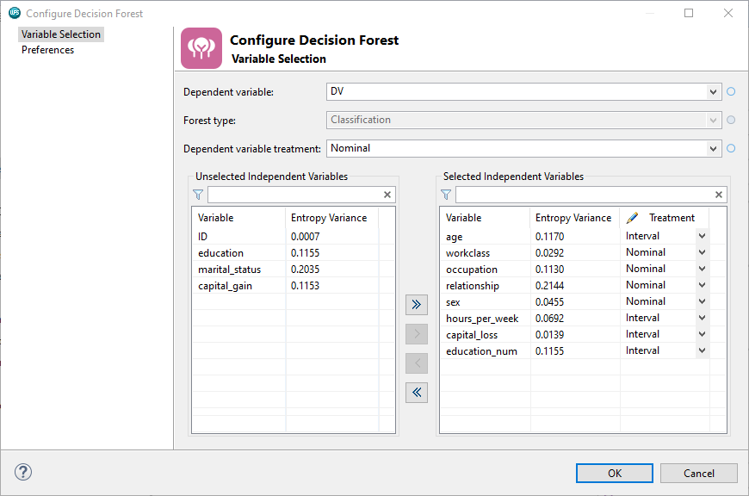

From the Preferences page, model particulars can be set. A decision forest is an ensemble method that builds many decision tree models and combines results.

The number of trees in the decision forest is set to 100 by default but can be modified. Decision forests

score data and add a propensity for each of the dependent variable categories. The resulting propensities are arrived at by summing all the scores from each model and outputting an average.

A decision forest will also create a new variable that classifies observations into one of the dependent variable categories, here either *bad* or *good*. Options available to determine how to classify observations are based on Mean Probability or voting, the default being Vote.

Here, the only option that is change is to set the Classifier combination to Mean Probability. Clicking OK runs the model. Note that as the decision forest is building 100 models the process may take a little longer than normal to run.

Once complete, results are accessed. Again, there are two tabs Decision Forest Results and Scoring code.

The decision forest results are presented in five tables: Model Information, Target Summary, Input Summary, confusion Matrix and Out-Of-Bag Confusion Matrix. Given that 100 models were developed and results from each of these combined, there is little insight into the model predictions beyond the confusion matrices.

Figure 9: Out-Of-Bag Confusion Matrix

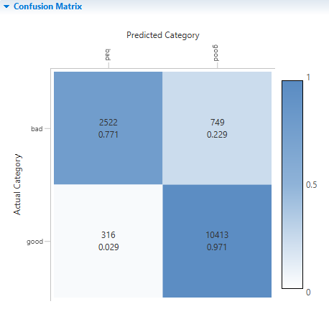

From here it can be seen that the *good* category is predicted much better than the *bad* category. The *bad c*ategory classification rate is slightly in excess of 77%, which on the face of is very good.

The development and testing partitions are scored with the model and opening the development partition it can be seen there are three new variables: *p_bad*, *p_good* and *_PredValue_*, this is the classification of each observation into one of the dependent variable categories, based on propensity scores and is created as a result of the Classifier Combination. this was set to Mean Probability.

Notice that if an observation has a propensity for *bad >= 0.5,* then it will be classified as *bad*, otherwise the observation is classified as *good*.

Both scored datasets are renamed to ensure they can be easily identified and once complete the scored partitions are connected to the Analyse Models block, configured as before and OK clicked.

Figure 10: Summary

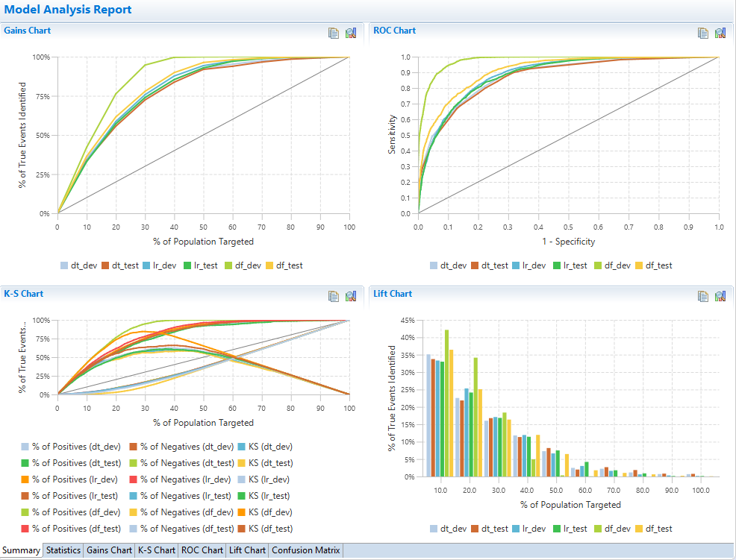

Opening results, it can be clearly seen from the Summary that the decision forest is outperforming both

the logistic regression and the decision tree.

Bear in mind that a better comparison between the decision forest and the decision tree would be to build the decision tree with the variables identified using the logistic regression and then compare.

From the statistics tab, notice that statistics are highest for the decision forest.

Figure 11: Statistics

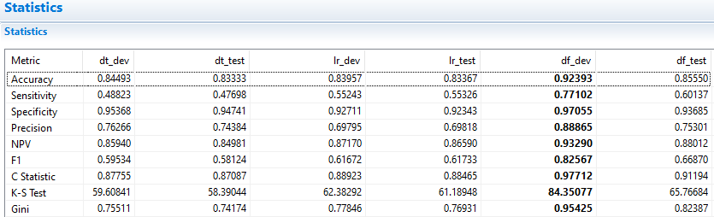

Comparing the decision forest applied to the development and testing partitions, it can be seen that there is a lot of variability across values. Notice the large differences in the C-Statistic for the decision forest applied to the development partition at approx. .97 vs approx. .92 for the same model applied to the testing partition.

The statistics are much more stable for the other models and given this, the preference in this instance would be for the logistic regression as it outperforms the decision tree and is consistent across partitions.

The decision tree could be further developed to include additional independent variables to better compare with the logistic regression but for now, the logistic regression model is the champion.

## Interactive Questions

Q1:

Drag and drop the words to complete the sentence correctly.

Independent variable treatment can be set as ______ for ______ and Nominal or Ordinal for _____ when building a model using the Altair Analytics Workbench Decision Forest block.

Nominal or Ordinal **Interval, Nominal or Ordinal** Interval or Ordinal Interval or Nominal

character variables numeric variables

A:

Independent variable treatment can be set as **Interval, Nominal or Ordinal** for **numeric variables** and **Nominal or Ordinal** for **character** when building a model using the Altair Analytics Workbench Decision Forest block.

Q2:

A decision forest is an ensemble modelling method that:

**Builds many models and combines results.**

Builds one model with supplied variables.

Builds one model with significant predictors only.

Outputs a tree model created with a random selection of observations and variables.

A:

A decision forest is an ensemble modelling method that builds many models and combines results.

Q3:

A Decision Forest model outputs a summary tree diagram. t/**f**

A:A decision forest model does not output a summary tree diagram.

Q4:

For a binary dependent variable, how many variables does the Altair Analytics Workbench Decision Forest block add to any scored dataset?

Only one, containing the target category propensities for each observation.

Two, containing the propensities for each dependent variable category for each observation.

**Three. Two containing propensities for each dependent variable category for each observation and a third classifying each observation into one of the dependent variable categories.**

Three, propensities for each dependent variable category and a classification into one of the dependent variable categories for each observation based on a user defined cut-off value.

A:

For a binary dependent variable, the Altair Analytics Workbench Decision Forest block adds three variables to any scored dataset. Two containing propensities for each dependent variable category for each observation and a third classifying each observation into one of the dependent variable categories.

Q5:

A logistic regression can be used to identify significant predictors to pass to a Decision Forest model. **t**/f

A:

A logistic regression model can be used to identify significant predictors to pass to a decision forest model.

## Summary

This lesson introduced the concept of champion challenger, whereby competing models are assessed.

This was followed by a demonstration challenging a decision tree model with a logistic regression and a decision forest and the Analyse Models block was used to assess models and select a champion.

## Exercises - Interactive



Q1:

Use the Workflow and decision tree created in the previous exercise or open the Workflow: tree_2. This is included with course data. Note that the import block may need to be configured correctly.

Using the *dev* partition; model the *Yes* category of *DV* using logistic regression. Include all variables except *Customer_ID*, *weight*, *capital_gain*, *marital_status*, *education* and *occupation*. Make sure variables are selected as Class appropriately. Use the Stepwise method to ensure only significant predictors are included in the final model.

Question: How many variables are included in the final model?

6

**7**

There are 7 variables included in the final model.

A:

A logistic regression block is added to the Workflow and the *dev* partition connected. *DV* is selected as the dependent variable and *Yes* selected from the event dropdown.

All variables bar *Customer_ID*, *weight*, *capital_gain*, *marital_status*, *education* and *occupation* are moved to the selected effect variables area and the class option is deselected for the variable *education_num* as it contains Numeric values and is for all intents and purposes continuous.

From the model selection page Stepwise is selected from the method dropdown and OK clicked. The model results are opened and as can be seen, 7 variables have been included in the model, none were excluded, therefore all significantly predict *DV*.

Q2:

Score the *dev* and *test* partitions with the logistic regression model. Add a separate Analyse Models block and connect both scored partitions. Ensure the block is configured appropriately. Once complete, open the Model Analysis Report.

Question: Does the logistic regression model validate?

No, there is not much stability across statistics or charts.

**Yes, statistics and charts are comparable across scored partitions.**

The logistic regression model validates well as statistics and charts are comparable across scored partitions.

A:  
Both the *dev* and *test* partitions are scored with the logistic regression model and renamed to *lr_dev* and *lr_test* respectively. An Analyse Models block is added to the Workflow and both scored datasets

connected, configured and results opened.

As can be seen from the summary tab the model validates and all charts illustrate acceptable curves. The logistic regression model generates a smoother curve, additionally, the Lift Chart is monotonically decreasing. From the statistics tab, statistics are comparable across partitions and the model validates very well.

Q3:

Ensure scored partitions are renamed for ease of identification. Connect all partitions scored with the decision tree and logistic regression models to the same Analyse Models block. Ensure the block is configured appropriately. Once complete, open the Model Analysis Report.

Question: Is the logistic regression model a better choice that the decision tree?

**From statistics and charts, yes.**

From statistics and charts, no.

The logistic regression model is a better choice that the decision tree.

A:

Adding all scored datasets to the same Analyse Models block is a matter of making connections,

configuring and clicking ok. Opening results, it can be seen the logistic regression model is outperforming the decision tree. Across all charts, the curves are more defined and encouraging.

From the statistics tab almost all statistics are higher for the logistic regression model bar precision, so from statistics and charts the logistic regression model is a better choice than the decision tree.

Q4:

Why is the logistic regression a better model for this data than the decision tree?

**The logistic regression model is better because there are smoother curves and in general, higher values across statistics including Accuracy, Sensitivity, F1 and the C-Statistic.**

The decision tree model is better because Precision is higher.

The logistic regression model is better because there are smoother curves and in general, higher values across statistics including Accuracy, Sensitivity, F1 and the C-Statistic.

A:

Charts are smoother for the logistic regression and the lift chart is monotonically decreasing. The logistic regression has a much greater accuracy of the *Yes* category in the 50's as compared to the decision tree in the 40's. The overall average accuracy, F1 is close to 60% for the logistic regression in comparison

To the decision tree with values closer to 50%.

The C-Statistic is also much larger for the logistic regression model and therefore from statistics and charts, the logistic regression model would be a better choice than the decision tree.

# Chapter 11: Model deployment

## Introduction

This lesson includes an introduction to model deployment and highlights Altair SmartWorks Analytics Hub as a means to easily deploy program code for on-demand, scheduled and real time applications.

Figure 1: Contents

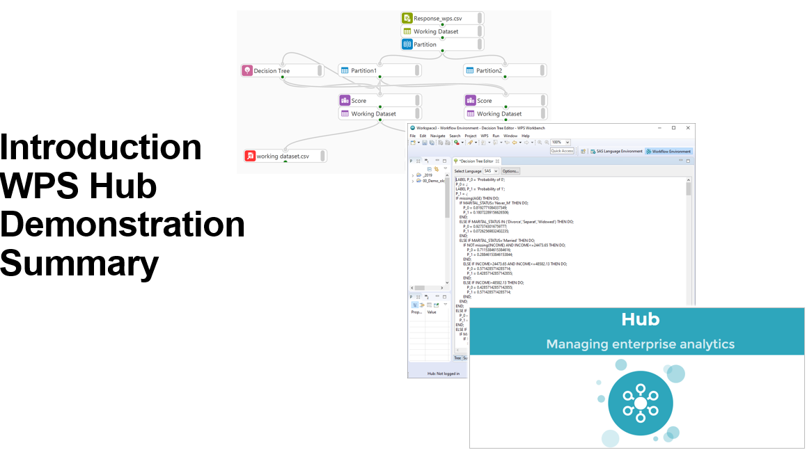

Model deployment is colloquially referred to as the last mile and sometimes this can seemingly be made longer when complexities such as data sources required, derivations applied, system requirements and model code format are taken into consideration.

Figure 2: Introduction

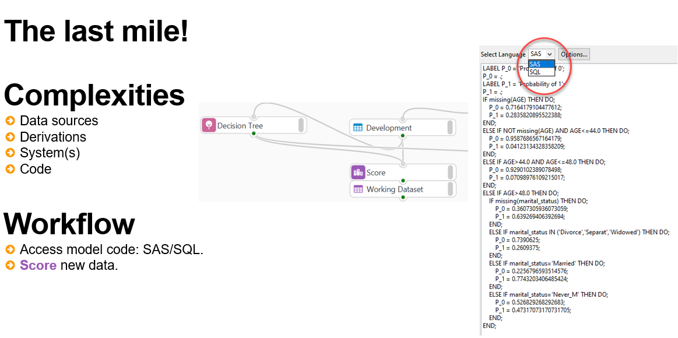

When developing models, these aspects should be taken into consideration to smooth the process and make model deployment straightforward.

Altair Analytics Workbench provides the facility to access model code for any created model. Code is output predominantly in either SAS or SQL format and can subsequently be applied as necessary.

Additionally, the score node can be used to score data and results can be exported using an appropriate Export group block.

ALTAIR provides an additional facility to assist in deployment, this is called Altair SmartWorks Analytics Hub.

Figure 3: Altair SmartWorks Analytics Hub

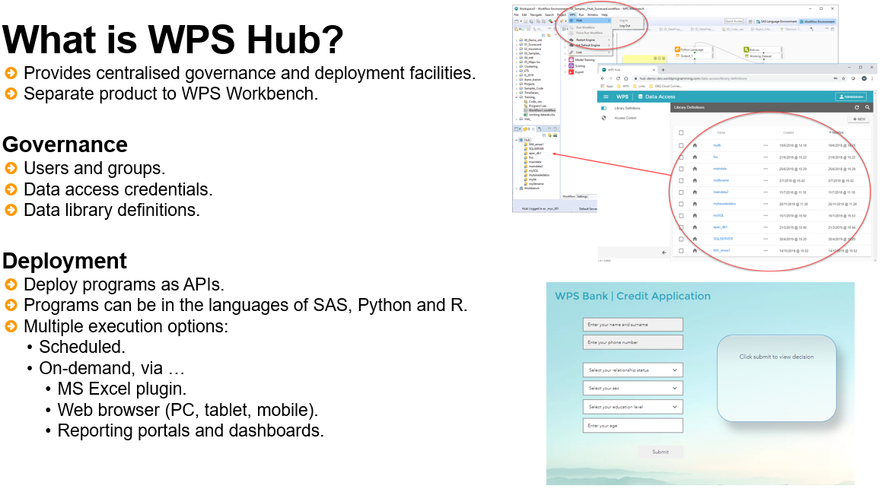

Altair Analytics Workbench Hub is accessed via browser and provides the facility to govern users, data sources, and deploy programs written in the languages of SAS, Python, R and SQL or a combination of these as APIs for use in real time, on-demand and scheduled processes.

Altair SmartWorks Analytics Hub will be used to illustrate the deployment of a SAS language program as an API for a real-time application.

## Demonstration

So, let’s demonstrate. This demonstration uses a project developed in a previous lesson. As can be seen, a decision tree, logistic regression and a decision forest model were developed.

Model code is available for each of these models from the Scoring code tab of the respective

Model reports.

Accessing the code for the decision tree it can be seen that the model code is available in either the language of SAS or SQL. The code creates two variables *P_bad* and *P_good* and assigns propensity scores to each observation based on the leaf node they are members of.

The code for any model code can be easily copied and used in a program file in the SAS Language perspective or in a code block in the Workflow perspective to score data.

The Score block can also be used to score data with any model. Here a new dataset, *Risk_to_score.csv*, is added to the Workflow. Opening this dataset shows that it contains 19024 observations and 12 variables, and some of these were used to build the decision tree model.

Connecting the decision tree and this data to the Score block automatically outputs a scored dataset.

Opening the dataset with the data profiler shows that two new variables have been added: *P_bad* and *P_good*.

The scored data can easily be exported to a desired destination format using an appropriate export block available from the Export group.

To illustrate, an Excel Export block is used to export the scored results to an Excel file. The scored file is output to the project folder for convenience and named *scored_dt.*

Once complete the scored dataset is accessed and notice the new scored variables added. The scored dataset contains propensities scores and this may be all that is warranted.

To apply strategies based on the resulting propensities and include an outcome can also be accomplished.

## Adding Outcomes

To put this into perspective let’s say there is interest in assigning an outcome of either *accepted* or *rejected* based on the propensity contained in the variable *P_bad* exceeding a threshold.

The threshold can be determined in a number of different ways but here let’s use an arbitrary cut-off of .5. An observation will be accepted if *P_bad* is less than .5 and rejected otherwise.

This can easily be accomplished with a SAS Code block. Once dragged onto the Workflow canvas and the scored dataset connected the SAS Code block can be accessed.

A new dataset is added and its named changed to *scored_strat*. Some code is added that assigns the value *accepted* to a variable named *Outcome* based on the variable *P_bad* exhibiting a value less than 0.5, otherwise a value of *rejected* is assigned.

**data** &Output_1;

set &Input_1;

if P_bad < 0.5 then outcome = 'accepted';

else outcome = 'rejected';

**run**;

Viewing the distribution of the resulting variable *outcome* from the Univariate Charts tab of the Data Profiler it can be seen that approximately 85% of the observations in this dataset have been assigned the value *accepted* and approximately 15% assigned the value *rejected.*

Even though a simple strategy was used here based on a simple cut-off, more complexity can be included in a similar way.

## Deploying programs as APIs using Altair SmartWorks Analytics Hub

Program code written in the languages of SAS, R, Python and SQL or a combination of these languages can be deployed as an API using Altair SmartWorks Analytics Hub.

To illustrate this deployment functionality, a scorecard model that assesses whether an applicant will be accepted or rejected will be used to demonstrate.

The scorecard includes four variables: *age*, *education_num*, *relationship* and *sex* and as can be seen scores are assigned based on characteristics and summed to output a total score.

Based on the total score, the applicant is either accepted or rejected and there is interest in automating this process whereby applicants are directed to a webpage where they can supply their details and get a decision in real time.

The development, configuration, testing and uploading of programs to Altair SmartWorks Analytics Hub to deploy as APIs can be conducted solely from Altair Analytics Workbench.

The first step is to create a new Altair SmartWorks Analytics Hub project. Here a new project named scorecard_ is created. This type of project is specific to the deployment of programs as APIs.

To deploy a program as an API requires two elements: the program code and the definition of the API endpoints. Adding any program to this type of project includes tabs to add code via the SAS Language Code tab and also configure the APIs endpoints via the Hub Configuration tab.

Once the program has been added the code for the scorecard is copied and pasted into the SAS Language Code page.

The scorecard assigns points based on variable characteristics and sums results. Rather than an applicant being faced with a score, some additional code is included to output a message based on the score. If the score exceeds the threshold of 550 a message contained in a variable called Decision is returned congratulating the application on being approved and if not, a message requesting the applicant call is returned.

Finally, the code is wrapped in a datastep. Here, the dataset will be called output, and the only detail that is retained is the response, contained in the variable 'decision', a *keep* statement is used to retain this variable only.

The API endpoints which are simply the inputs the program accepts, in this case values for the variables *age*, *education*, *relationship* and *sex* and the output returned are easily configured from the Hub Configuration tab.

First, the program path is supplied. It is advised to assign a value here that corresponds with the name of the program file and here scorecard_ is assigned.

The input parameters to this API will be supplied as Macro variables and this is selected from the Parameter style drop-down from the Parameters pane.

Clicking the Add button enables the definition of each input parameter with the ability to assign a default value among other characteristics and here defaults are supplied for all parameters.

From the Results pane, output is added by clicking Add. The output type is selected as a dataset and its name corresponds with that used in the code, here, output.

Some of the results details are populated from the results parameter definition. Additional details include providing a dataset name and the results format. The dataset name used here corresponds with the name supplied previously, and the results format is selected as JSON, but note other options are available.

Once complete clicking CTRL+S saves the configuration. The API can be selected and tested from the Workflow perspective by right-clicking the API and selecting either Run Program or Run Program With Parameters.

Here, Run Program With Parameters is selected and a dialog is displayed that provides the ability to supply parameters, notice that the defaults supplied earlier are used and values are automatically populated.

Clicking Run executes the program and a message displays stating:

The result from running a Hub API Program are shown in the ‘Hub API Executions’ view. Would you like to open this view now?

Clicking Yes opens this view with details in relation to execution accessible. Clicking the output shows that a congratulatory message has been returned and this reflects that the program is successful and configured correctly.

Note also that a log is generated and this can be referenced in the event the program does not run successfully.

The next steps is to relay the API to Altair SmartWorks Analytics Hub. This requires that the Hub is logged into and this can be accomplished by selecting ALTAIR > Hub > Log In.

Once logged, the project can be uploaded to Hub by right-clicking the project and selecting the option: Upload to Hub… and providing details such as the Repository and Group the API should be saved to and its Name and Version.

Once OK is clicked, a message displays relaying that the upload has been successful. Once this is complete, the program can be deployed, and its API URL accessed and used as necessary.

This is accomplished by logging in to Altair SmartWorks Analytics Hub via browser and selecting the tile: Deployment Services.

From Deployment, New is clicked and the Deployment type selected as Artefact the uploaded program can be easily selected and using simple click steps the program can be deployed to any configured environment – note that environments are installed at the point of initially configuring Altair SmartWorks Analytics Hub, these are machines that house the APIs and from which they can be called.

Once these steps are complete the environment is published and the API is now available from the directory, where its URL is accessible.

Note that the directory provides the facility to test the API via the Execute tab and clicking Run. Here, as is already understood the API is functioning correctly.

The crudest method of calling the API is to pass the variable values along with the call to the API. Using this in a browser, it can be seen that a response is successfully received.

A much more elegant way to deploy this is to create a web page to accept the model input values and return a response once submitted and this is the method employed here.

The web page is programmed to take the input values, pass these along with a call to the API and display a response.

Note that the scorecard can be easily updated by changing the code, here, a shorter message is used. Deploying an updated version is a matter of click steps to save results, upload to Altair SmartWorks Analytics Hub and publish to the environment used.

Returning to the web page and entering the same values used previously and clicking Submit returned the updated response.

Altair SmartWorks Analytics Hub not only provides the facility to call deployed programs via web service but also from Microsoft Excel using the Altair SmartWorks Analytics Hub Excel plugin.

The program deployed previously was modified to accept an input dataset to batch score observations with the scorecard and outputs a score and a decision.

This program can be called via Microsoft Excel from the Altair SmartWorks Analytics Hub tab. Once logged to Altair SmartWorks Analytics Hub, all programs contained there are accessible. Here the scorecard is called and the data to score supplied via familiar Microsoft Excel dialog.

The existing worksheet is selected as The Results Location and an appropriate cell selected to display results.

Clicking Run calls the program and returns, in this instance a score and a decision to the Microsoft Excel spreadsheet.

Note that these are two examples of the ability to deploy programs as APIs using Altair Analytics Workbench and a myriad of other possibilities can be addressed.

It should suffice to say that any process, whether that be for etl, real-time scoring, on-demand, batch scoring or scheduling processing, as long as the process can be coded in the language of SAS, R, Python, SQL or a combination of these, it can be deployed as an API using Altair Analytics Workbench.

## Interactive Questions

Q1:

When developing models, model deployment should be taken into consideration to ensure models can be easily and efficiently deployment. Which of the following is not a consideration for model deployment:

Data sources required.

Variable derivations.

**The data used to develop the model**.

The code the model will be deployed as.

The system(s) the model will be deployed to

A:

When deploying models, the data used to develop the model is not a consideration.

Q2:

Only decision tree models generate accessible model code. t/**f**

A:

All models available from the Model Training group generate accessible model code.

Q3:

The Altair Analytics Workbench Decision Tree block automatically generates code in the languages of SAS and SQL. **t**/f

A:

The Altair Analytics Workbench Decision Tree block automatically generates code in the languages of SAS and SQL.

Q4:

Drag and drop the words to complete the sentence correctly.

The ____ block can be used to score any Workflow data with any model

Score Decision Tree Logistic Regression Analyse Models

A:

The Score block can be used to score any Workflow data with any model

Q5:

Altair SmartWorks Analytics Hub is:

Accessible via desktop application.

A server application.

**Accessible via browser**

Not accessible, it can only be used to deploy and call programs.

A:

Altair SmartWorks Analytics Hub is accessed via browser.

Q6:

Select the incorrect statement:

Program development including API endpoints can be configured from Altair Analytics Workbench.

Programs deployed as APIs can be called from Microsoft Excel using the Altair SmartWorks Analytics Hub Microsoft Excel plugin.

**User credential and library definitions cannot be stored in Altair SmartWorks Analytics Hub**

Altair SmartWorks Analytics Hub enables the deployment of programs written in the languages of SAS, R or Python as APIs.

Altair SmartWorks Analytics Hub can be used to deploy programs written in the languages of SAS, R and Python or a combination of these as APIs. Deployed programs can be called and used in Microsoft Excel via the Altair SmartWorks Analytics Hub Microsoft Excel plugin. Additionally, user credentials and library definitions can be stored in Altair SmartWorks Analytics Hub.

## Summary

This lesson included an introduction to model deployment and highlighted Altair SmartWorks Analytics Hub as a means to easily deploy programs as APIs.

## Exercises - Interactive



Q1:

Use the Workflow and decision tree created in the previous exercise or open the Workflow: *tree_2*. This is included with course data. Note that the import block may need to be configured correctly. Score the dataset *score.csv* with the decision tree.

Question: What is the range of *P_Yes* values?

A:

The dataset *score.csv* is located from the File Explorer, dragged onto the Workflow canvas, configured and opened. Bear in mind the variables used in the model need to be present in the Dataset to score, the model dependent variable DV, does not need to be present. A score node is added and the decision tree model and the dataset to score connected.

The scored dataset is automatically output. From the Univariate View tab of the Data Profiler, the range of *P_Yes* values are 0.061 - 0.845.

Q3:

The variable *P_Yes* reflects the propensity to default. Using the scored development partition, create three equally sized groups based on the variable *P_Yes.*

Add a strategy such that:

The group with lowest *P_Yes* values is assigned a value: Accept.

The group with intermediate *P_Yes* values is assigned a value: Manually assess.

The group with highest *P_Yes* values is assigned a value: Reject.

Apply the strategy to the imported dataset score.csv

Name the variable *Strategy.*

Question: How many observations have been assigned the value: Manually assess?

A:

To create three equal sized groups a Binning block is used. This is added to the Workflow and the scored development partition connected.

*P_Yes* is moved to the Selected Variables list. From the Binning type drop-down, the only option available is Optimal. This is due to the variable *P_Yes* having only 11 distinct values and being classified as Categorical. To ensure the option Equal Height is available for this variable its classification must be Continuous. From the Configure data profiler icon, Data is selected and the Classification threshold is lowered to 10 and Apply clicked. Now the Classification for the variable *P_Yes* is Continuous. The binning block is closed and then reopened to ensure changes take effect, once complete, it can be seen that Equal Height is available from the Binning Type drop-down. From Binning Preferences, the Default bin count is changed to 3, OK clicked and the variable binned by clicking Bin Variables. The binning code is copied from the Binning Code tab. A SAS Code block is added and the imported and scored dataset *score.csv* connected. The binning code is pasted into a SAS code block. A new dataset is added from Outputs and additional code elements included to wrap the binning code in a DATASTEP. The code is modified further to name the output variable *Strategy* and assign the values *Accept*, *Manually* assess and *Reject* to the lowest, intermediate and highest bins respectively. The code is applied and viewing the variable *Strategy* from the Univariate Charts tab it can be seen that 2936 observations have been assigned the value *Manually assess*.

Q2:

Score the dataset: *score_.sas7bdat* using a SAS Code block and the decision tree.

Question: What is the range of values of *P_Yes*?

A:

Score_ is a *sas7bdat* file and cannot be read directly into the Workflow. It can be scored by using the decision tree code in a SAS Code block. A LIBNAME statement is used to ensure the file can be read from the Directory the file resides in:

libname dir sas7bdat 'C:\00_ALTAIR eLearning\data';

An output file is added and included in a DATASTEP with the dataset score_.sas7bdat

The decision tree code is pasted and this will score the input dataset. The code is completed with a run statement and a semi-colon, the code run and the dataset created. From the Univariate View tab of the Data Profiler, the range of values for the variable *P_Yes* are 0.107 to 0.845.

# Chapter 12: Exporting data

## Introduction

This lesson includes an introduction and highlights five blocks available from the Export group prior to a demonstration and wraps up with a summary.

Figure 1: Contents

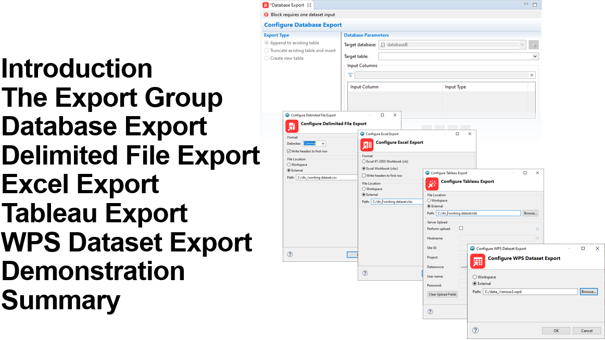

An essential requirement of any analytics platform is the ability to not only import data from various sources, but also to provide functionality to export data and results.

Figure 2: Introduction

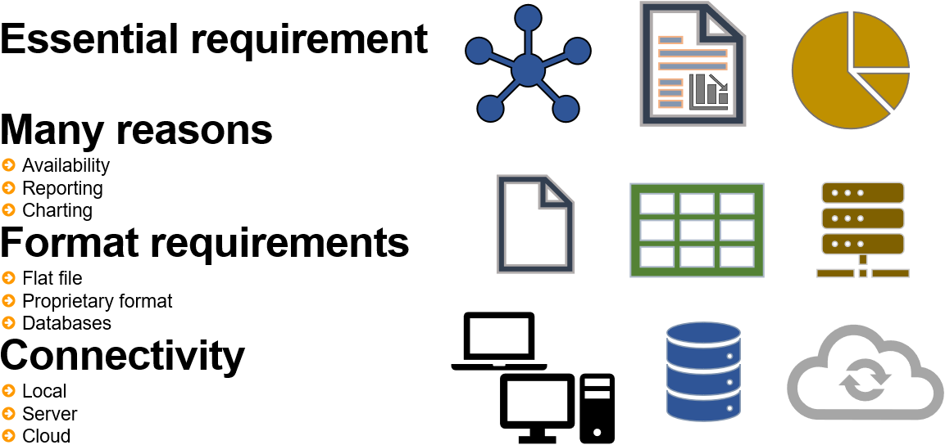

There are many reasons to export including making files and results available to others for additional analysis, reporting and charting purposes.

Data and output may need to be made available in a variety of formats including flat files such as *.txt* and *.csv*, proprietary file formats such as Microsoft Excel, Tableau or to a database table.

An additional component is to ensure results can be output to many locations; locally, to a server or to the cloud.

## The Export group

Figure 3: Export group

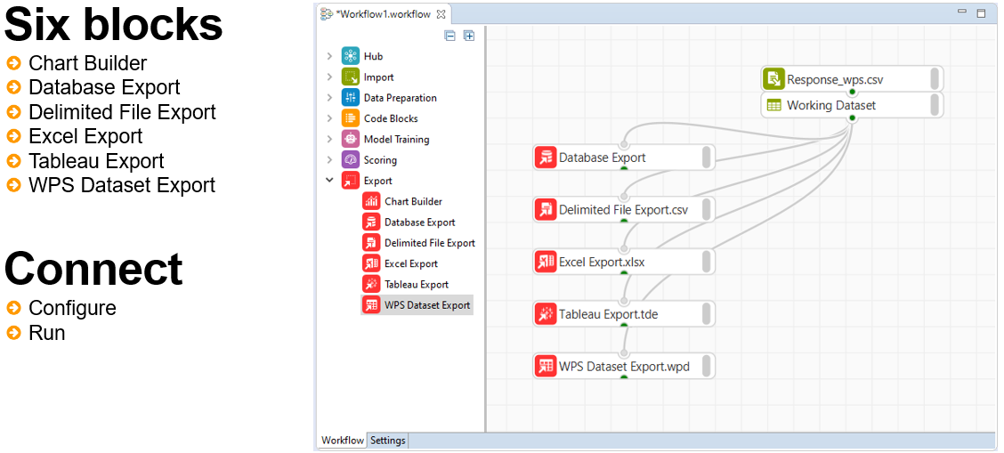

 Database Export block

The Database Export block enables export to a database with three export type options available.

Data can be appended to an already existing table by selecting append to existing table.

Figure 4: Database Export

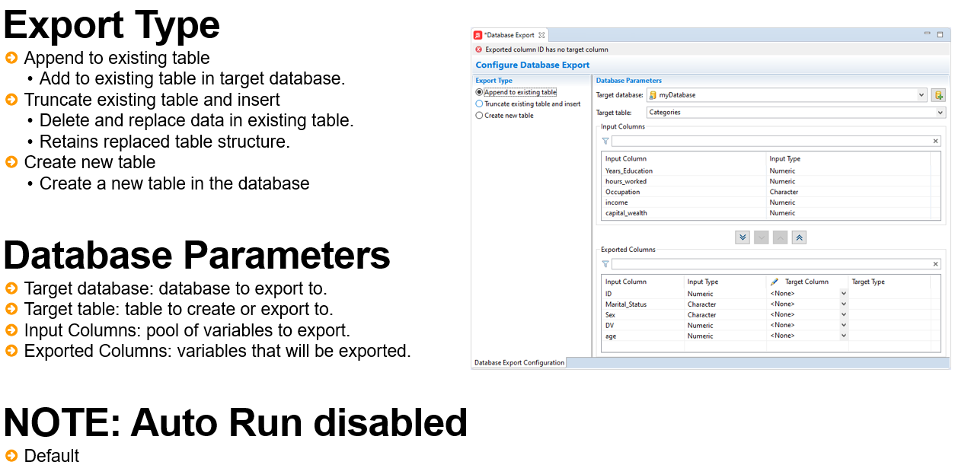

The option truncate existing table and insert will delete all existing data in the target table and replace it with the exported data. The structure of the table the data is exported to is however, retained.

Additionally, a new table can be created via the create new table option. Note that if selected,

if the table already exists in the database it will be deleted and replaced with the exported data.

The database parameters panel provides options to select the target database, table and columns to export. The target database can be an already existing Database reference which can be selected from the dropdown or a new connection can be defined via the create a new database icon, which will open the Add database wizard where the database reference can be configured.

The target table is the database table to export the data to. All columns in the connected dataset are evident in the input columns area and detailed in the input columns list.

The exported columns area details the columns from the connected dataset to export to the database and requires specification of the target column the input column is to be associated with.

The connected dataset variables available from the input columns area via the input columns list can can be moved either singularly or in bulk to the input column list in the exported columns area by either double clicking a variable, alternatively the chevrons can be used to move one or more columns.

Delimited File Export block

The delimited file export block enables export to a text file.

Figure 5: Delimited File Export block

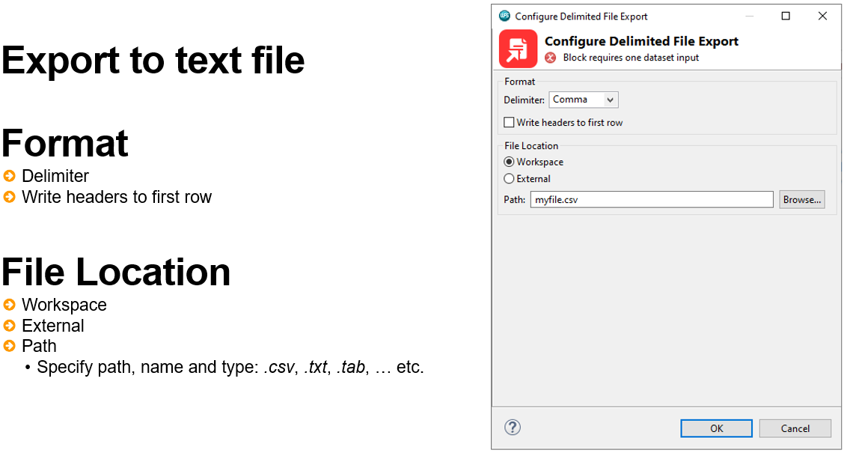

The format area provides options to specify the delimiter and also whether to include variable names via the write headers to first row option.

The data can be exported to either a workspace or external by clicking the appropriate option in the file location area. Note that data exported to a Workspace means it is only accessible when using Local Engine.

The location can be browsed to using the browse button and here also the file format can be included and should be specified. For example, if a *.txt* file is being exported, the *.txt* extension must be included. This is also the case for other delimited file types such as *.csv* and *.dat*, however the default extension evident is *.csv*.

Excel Export block

Exporting to a Microsoft Excel file has the same file location options and specifications as that of the Delimited File Export block. Permissible formats are either Excel 97-2003 workbook (*xls*), or Excel Workbook (*xlsx*).

Figure 6: Excel Export block

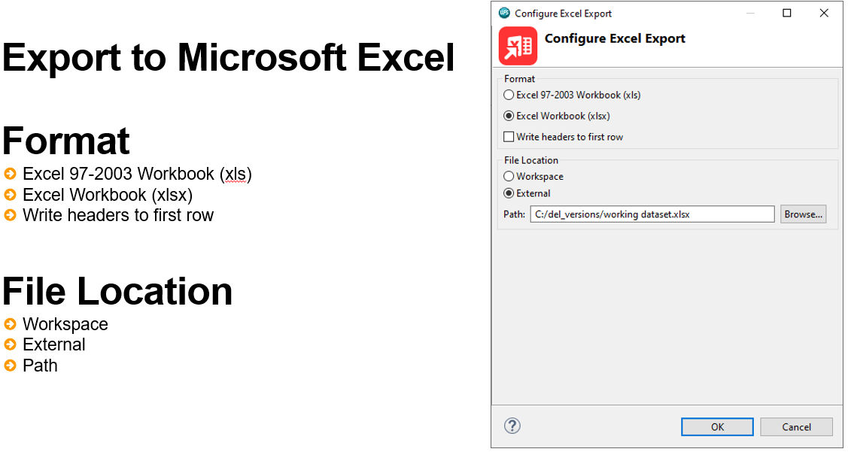

Tableau Export block

The tableau export block enables the export of files to the tableau data extract format: .*tde* and automatically assigns the *.tde* extension.

Figure 7: Tableau Export block

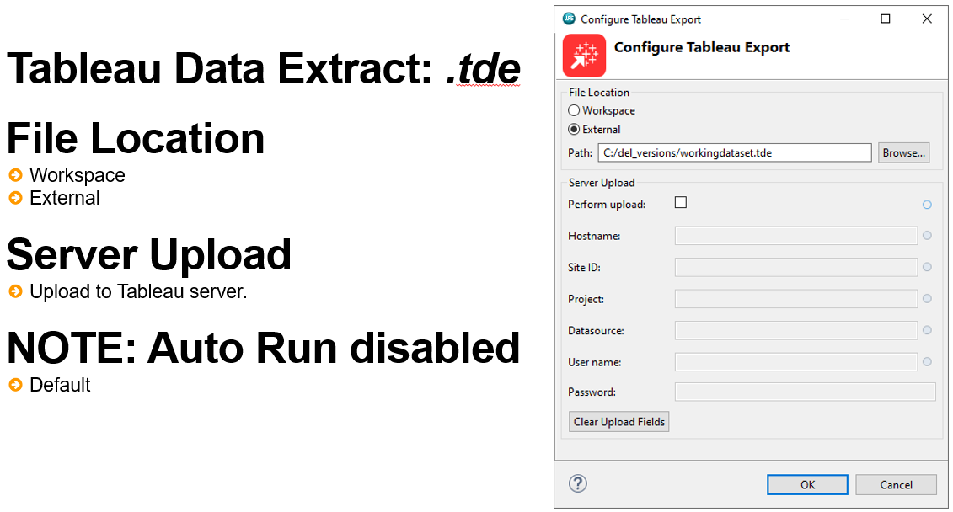

The export can be to a Workspace or an external location. Additionally, the data can be uploaded to a Tableau Server by clicking the Perform upload check box. Once complete server particulars and credentials will need to be supplied.

ALTAIR Dataset Export block

The ALTAIR Dataset Export block provides the facility to export data to a *.wpd* format file. This is ALTAIR proprietary file format. Export options are few, familiar and straightforward such that data can be exported to a Workspace or an External location.

One thing to bear in mind is that the *.wpd* extension must be present. Providing a file name from the browse dialog must include the *.wpd* extension explicitly.

Figure 8: ALTAIR Dataset Export block

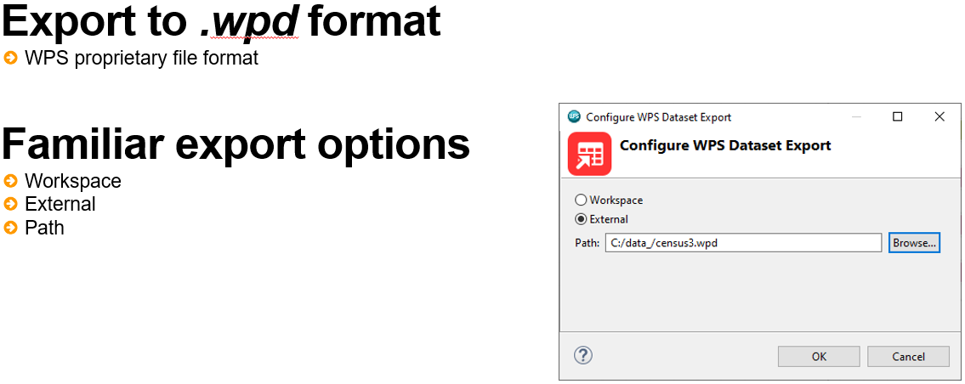

## Interactive Questions

Q1:

Arrange the following items in the correct order when exporting data from the Altair Analytics Workbench Workflow perspective:

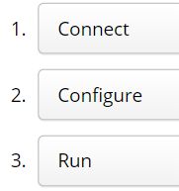

A:

Connect configure run

Q2:  
Databases to export to must already exist and be defined before using the Database Export block. t/**f**

A:

Databases to export can already exist but they can also be defined from within the Database Export block.

Q3:

The Delimited File Export, Excel Export and Tableau Export blocks include the option to export to either a Workspace or an External File location. What is the limitation of choosing the File Location option: Workspace?

**The file is only accessible when using the Local Engine.**

The file is only accessible when using a laptop.

The file is only accessible when using a desktop machine.

The file is accessible via server only.

A:

When exporting to a Workspace, the file is only accessible when using Local Engine.

Q4:

When exporting to a delimited file format, is the file extension added automatically? y/**n**

A:

The format must be explicitly added. The default is *.csv* but if a different format is required or a file name is added, an extension must be explicitly included.

Q5:

The ALTAIR Dataset Export block is used to:

Export a dataset to a *.wpd* format file only.

Export a dataset to a *.wpd* or delimited file format.

Export a dataset to a *.wpd* or .*xls*/*.xlsx* file format.

The ALTAIR Dataset Export block can be used to export to any file format but not to a database.

A:

The ALTAIR Dataset Export block is used to export a dataset to a .wpd format file only.

## Demonstration

So onto a demonstration.

This demonstration uses a project developed in a previous lesson. The dataset *risk_to_score.csv* was scored with a decision tree model.

Viewing the scored results two new variables were added: *P_bad* and *P_good*. These add propensity scores to each observation based on the model.

This demonstration will illustrate 5 blocks from the Export group. Database Export, Delimited File Export, Excel Export, Tableau Export and ALTAIR Dataset Export.

The Chart Builder will not be demonstrated here as this was covered in the lesson: Data exploration and profiling.

Let’s start with the Database Export. Once dragged onto the canvas and the data to export connected, the Database Export block configuration is accessed by double-clicking.

The Add Database wizard may open at this point if no databases have been previously defined. Two databases exist currently and these are evident from the dropdown: databaseB and databaseB2. These were created in a previous lesson and the target database selected here is databaseB.

There are three export types available. Note that help for the Database Export block can be located from the Help files. Here, search is selected and *database export* entered as the search term. Clicking Database Export block from the results navigates to the appropriate pages containing information in relation to its use.

Clicking Configure database export opens a page that gives information on available options and from the Export Type section, the three options are detailed.

Append to existing table is selected by default, this will add the selected exported data to an already existing table, which can be selected from the target table dropdown.

Truncate existing table and insert will delete a selected target table and replace it with the data to export.

Bear in mind that if any of these two options are selected, not only is there a need to select the target table but also to map each column to export to a column in the target table in the database, this is accomplished via the Target Column drop-down in the Exported Columns area.

Figure 9: Mapping columns

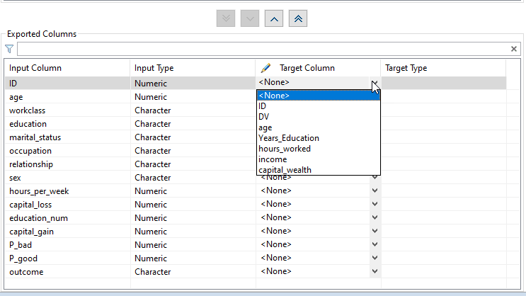

Performing this means that the column data to export will be placed in the database table column selected. For this example, there is interest in exporting the scored results to a new table and so the export type Create new table is selected.

A Confirmation required notification appears detailing that this option will cause the target table to be dropped and replaced each time this block is executed and here, Yes is clicked.

Figure 10: Confirmation Required notification

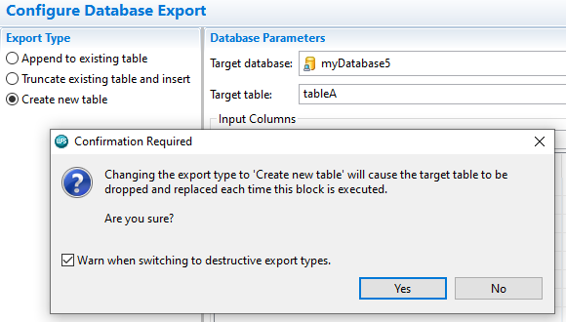

At this point, help is closed so that the Database export options occupy the entire screen.

Notice that as a result of selecting the export type: Create new table, the target table dropdown and the column to map the exported data to are no longer available from the Exported Columns area.

A new target table name is applied: *scored_data*, and only the ID variable and variables containing scores are retained.

Clicking CTRL+S updates settings. Returning to the Workflow, the block Execution Status reflects that the block has not yet been run, right-clicking reveals why: the block is not included in auto run.

Figure 11: Database Export block not included in Auto Run

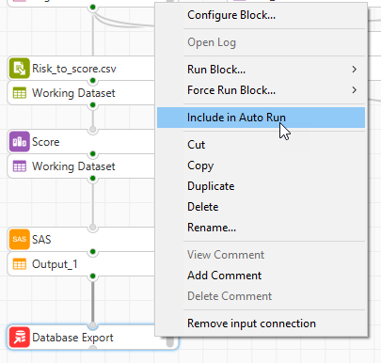

Here, the option Run Block > Run To Block is selected and once complete it can be seen that the block Execution Status is now green, meaning that the block has run and the export has been successful. Opening the log for the block also confirms this as there are no error messages.

To confirm results, a database import block is dragged onto the canvas, as there is only one database reference, it is listed by default in the Database dropdown with tables visible. The previously exported data is added to the Selected tables list and OK clicked.

Accessing the table, it can be seen that the exported data is evident with three variables *ID*, *P_bad* and *P_good*.

## Interactive Questions

Q1:

The Database Export block options: Append to existing table or Truncate existing table and insert, require the selection of a target database table. Additionally, the variables to export must be mapped to variables in the target table. **t**/f

A:

The Database Export block options: Append to existing table or Truncate existing table and insert, require the selection of a target database table. Additionally, the variables to export must be mapped to variables in the target table.

Q2:

The Database Export block option: Truncate existing table and insert will export the selected data and overwrite an existing database table. **t**/f

A:

The Database Export block option: Truncate existing table and insert will export the selected data and overwrite an existing database table.

Q3:

Does the Database Export block option: Truncate existing table and insert, retain the structure of

the existing database table? **y**/n

A:

The Database Export block option: Truncate existing table and insert, retains the structure of the existing database table.

Q4:

Can new tables be created in the database to export to? **y**/n

A:

The Database Export block option: Create new table will add a new table to the database to export to.

Q5:

If the Database Export block option: Create new table is selected, this creates a new table the first time it is run and for subsequent runs, will overwrite the target table. **t**/f

A:

If the Database Export block option: Create new table is selected, the table is created the first time it is run and for subsequent runs, will overwrite the target table.

## Exporting to a Text File

To export to a text file format, the Delimited File Export block is used. This is dragged onto the Workflow canvas and the same scored data connected. Configuration settings are accessed by double-clicking the block.

Figure 12: Delimited File Export block

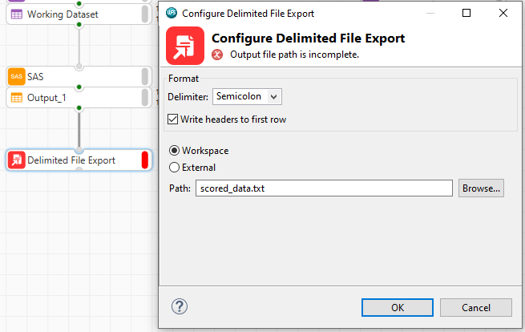

Here, the data will be exported to the Workspace project folder as a .txt file and named *scored_data*. Clicking browse lists all projects in the current Workspace and the current project is selected. The file name is changed to *scored_data* and the extension *.txt* added. Clicking OK returns to the main dialog.

From the Format area, the Delimiter is selected as Semicolon and the option Write headers to first row checked. Clicking OK runs the process. Notice the block Execution Status is now green.

Expanding the project from the Project Pane, the data is not visible. Right-clicking and selecting the option Refresh updates project contents and the data is now present.

Dragging onto the canvas and accessing configuration settings, notice that the delimiter is appropriately set to Semicolon. This is as a result of it being automatically detected.

## Exporting to a Microsoft Excel File

The scored results can be exported to a Microsoft Excel file using the Excel Export block. This is dragged onto the canvas, the data to export connected and configuration settings accessed by double-clicking.

Options are straightforward. Two Microsoft Excel workbook formats are available with the default being Excel Workbook (xlsx). This option is retained and Write headers to first row checked.

Figure 13: Excel Export

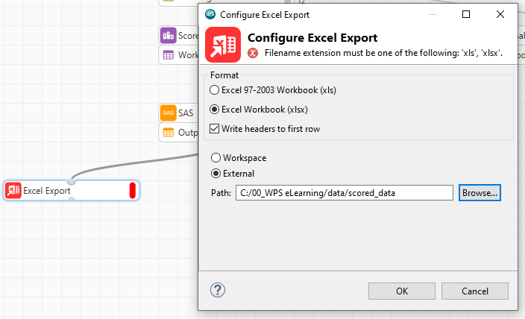

External is selected from file location and the data folder in the eLearning directory navigated to via the browse button and the filename is changed to *scored_data*.

Clicking Finish and OK runs the export. Notice that the configuration status of the block is red and hovering reveals the message: Filename extension must be one of the following: ‘xls’, ‘xlsx’.

Figure 14: Error message

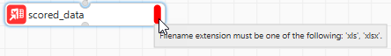

Accessing the block configuration, notice that the file name has no extension which must be present and is not automatically added when a name is supplied.

Adding the extension .*xlsx* and clicking OK addresses the issue and the block execution status is now green - meaning the process completed successfully. Right clicking the block, notice it is also included in auto run by default.

The exported results can be accessed via the File Explorer and double-clicking opens in Microsoft Excel with the exported data visible.

## Exporting to a ALTAIR Dataset

The ALTAIR Dataset Export block provides the facility to export any dataset to ALTAIR proprietary file format: WPD. Adding this block to the canvas and connecting the same dataset as before and opening configuration settings reveals few options.

Figure 15: ALTAIR Dataset Export

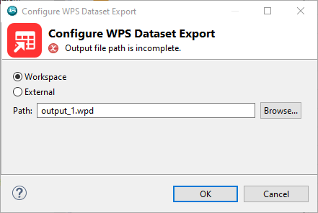

The dataset can be exported to a Workspace or an External location and the file can be named. Here the connected data is exported to the current project folder and named *scored_data*. Notice that the file extension is added automatically.

Clicking OK runs the export and refreshing the project shows this to be the case.

## Exporting to Tableau

The last block to illustrate is the Tableau Export block. This exports results to a tableau data extract: *.tde* file format and results can then be used in Tableau.

Options are straightforward, the *.tde* file can be exported to a Workspace or an External location with an option to upload to a server.

Figure 16: Tableau Export

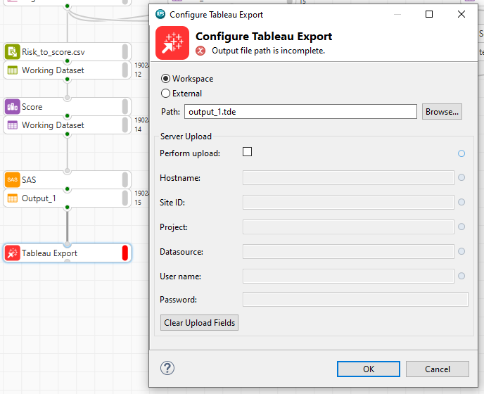

Selecting this option will require additional details to be supplied including Hostname, Site ID, Project, Datasource and authentication credentials.

Here, the data will be exported again to the current project folder. The file name is again changed to *scored_data* and notice that the *.tde* extension is added automatically. Clicking OK returns to the dialog and clicking OK again applies all settings.

Notice that the block Execution Status is grey. This is because the block is not included in auto run and this is the default for this block.

The block is right-clicked and Run Block, Run To Block is selected and the block execution status is now green, meaning the export was successful. Refreshing the project, the exported results are visible with the appropriate extension.

Bear in mind that the data has been exported to the Workspace. This means that the data is only accessible if using local engine. Selecting the option external, means that the exported results can be accessed whether using a local or remote engine.

The resulting *.tde* file is not available to import but double-clicking opens the file in a text reader, and

as can be seen the data is encoded so that it can be read by Tableau.

## Interactive Questions

Q1:

When using the Excel Export block, selecting the format will automatically update the file extension to *.xls* or *.xlsx* as appropriate. If the file name is changed and the extension removed, will the export run? Why/why not?

Yes, when the file name is changed the appropriate extension is added.

No, the Execution Status indicator is red.

**No, the block Configuration Status will be red. The block will not run as the appropriate extension must be included.**

Yes, the file will be output but no extension is evident.

A:  
The export will not run. The block configuration status will be red. The block will not run as the appropriate extension must be included.

Q2:

Which blocks from the Export group are included in Auto Run? Select all correct options.

Database Export

**Delimited File Export**

**Excel Export**

Tableau Export

**ALTAIR Dataset Export**

A:

The Delimited File Export, Excel Export and ALTAIR Dataset Export blocks are by default included in Auto Run. The Database Export and Tableau Export blocks are not.

Q3:

Select all applicable options. The Tableau Export block can export a *.tde* file to:

**Workspace**

**External**

SQL server

Any cloud database

**A Tableau server**

A:

A .tde format file can be exported to a Workspace, or an External File location, which may be a server. Additionally, a .tde file can be exported to a Tableau server.

Q4:

Select all correct options. How can a dataset be exported to ALTAIR proprietary file format: WPD?

**By right clicking any dataset and choose the option: Save Dataset.**

This file type cannot be exported to.

Data can be exported to ALTAIR' proprietary file format using the Delimited File Export block.

By right clicking any dataset and choose the option: Export to .wpd.

**By using the ALTAIR Dataset Export block.**

A:  
A dataset can be exported to ALTAIR' proprietary file format WPD, by right clicking any dataset and choosing the option: Save Dataset or by using the ALTAIR Dataset Export block.

## Summary

This lesson focused on the export capabilities available from the Altair Analytics Workbench Workflow export group and included an introduction prior to highlighting five blocks from the export group.

A demonstration illustrated capabilities to export to databases, delimited files, Microsoft Excel, ALTAIR’ proprietary file format and to the Tableau data extract format.

# Chapter 9: Course summary

## Introduction

Thank you for attending the course: Introduction to data profiling and modelling with Altair Analytics Workbench.

This course comprises a set of interactive modules illustrating the application and use of Altair Analytics Workbench to process data.

As a result of completing this course attendees should be able to use Altair Analytics Workbench to connect to, acquire, profile, prepare, manipulate, model, deploy and export data and results.

We hope you has an enjoyable eLearning experience. For further information, or to contact use, please email us at wither: [training@worldprogramming.com](mailto:training@worldprogramming.com) or [sales@worldprogamming.com](mailto:sales@worldprogamming.com).